

User Guide

(User Journeys)

U N I K R E W S O L U T I O N S

Contents

Login Page 3

Starting a Workflow 4

Uploading Documents 5

Trail Feature 8

Uploading Lead Generation Data in Bulk 10

Excel File 16

Product Codes 16

Product: Crop NTB 17

Product: Crop Renewal 39

Form Type: One Pager 41

Form Type: Full Form 42

Product: Fishery NTB 63

Product: Fishery Renewal 84

Form Type: One Pager 85

Form Type: Full Form 87

Product: Poultry NTB 106

Product: Poultry Renewal 126

Form Type: One Pager 129

Form Type: Full Form 131

Product: Dairy NTB 145

Product: Dairy Renewal 163

Form Type: One Pager 166

Form Type: Full Form 168

Product: Tractor (Conventional) 184

Product: Tractor (Islamic) 203

Product: Release Memo 222

Product: Group Renewal Approval 233

# Login Page

Log in with your credentials to proceed.



# Starting a Journey

Go to the Workflows tab to start a new Workflow.

1. Shows the user currently logged in.
2. Shows the selected tab.
3. Drop down menu to select a product.
4. Create button to start a workflow after selecting a product.
5. Shows all workflows depending on the filter selected (i.e., unassigned, completed).

**Note:** Products and workflows shown will vary according to the rights assigned to a user account.

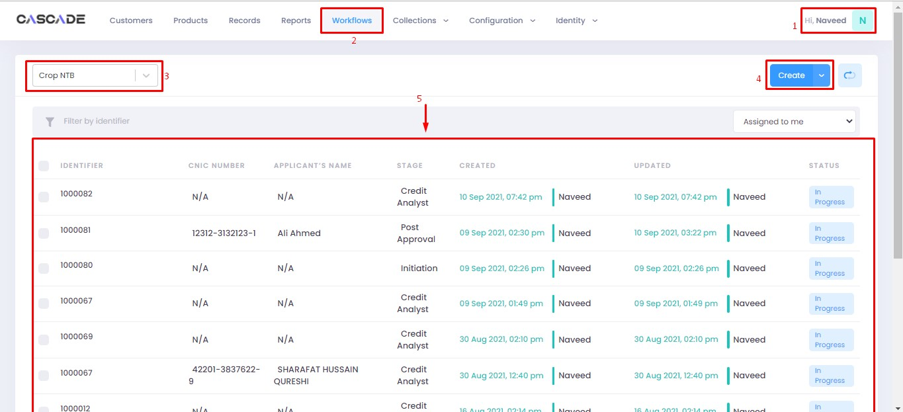

This is the first page you will see after starting a new workflow.

1. Header. Shows the basic details of the profile.
2. Shows the stages of the workflow.
3. Shows the groups under each stage.

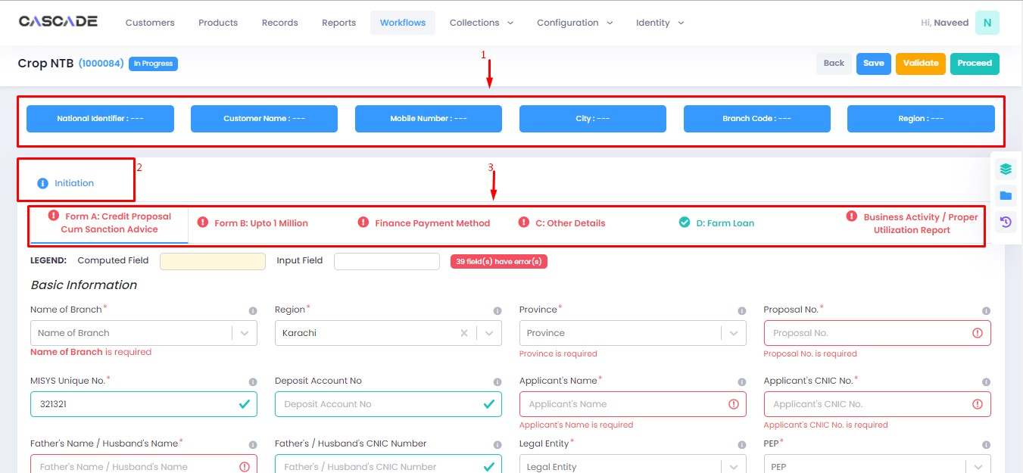

# Uploading Documents

1. To upload any documents pertaining to the application, click on the folder icon on the right side of the page.

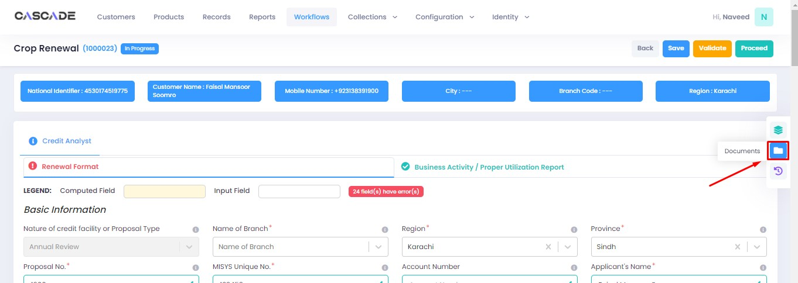

2. Then click on the upload button.

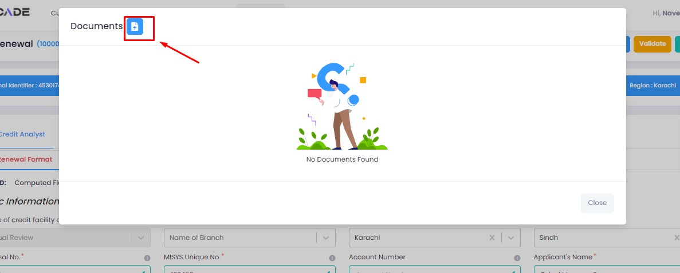

3. Drag ‘n’ drop any file inside the dotted box then click on upload.

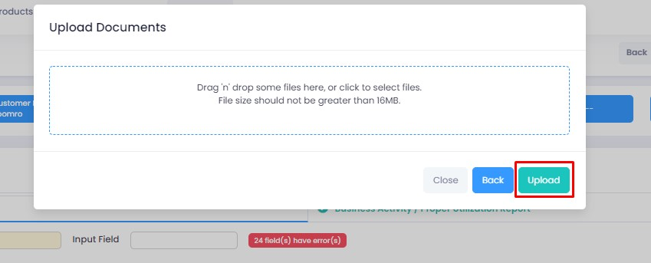

4. This is where all the uploaded documents will show. If you want to upload new version of a file, click on the upload icon next to any file then upload the new version.

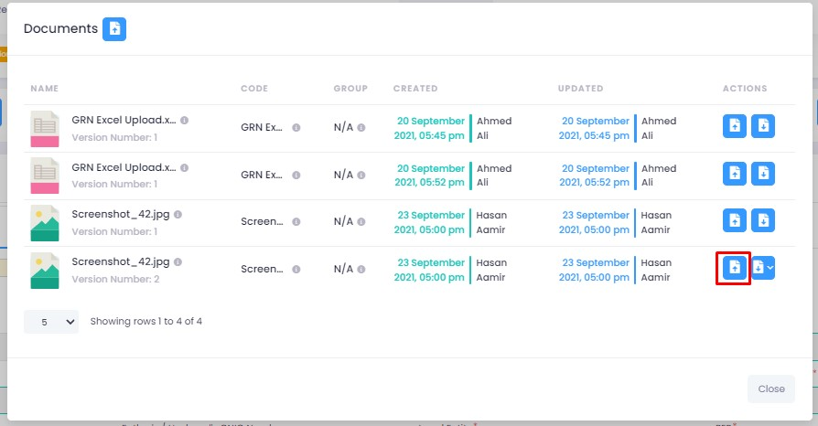

5. Select the file then click on open.

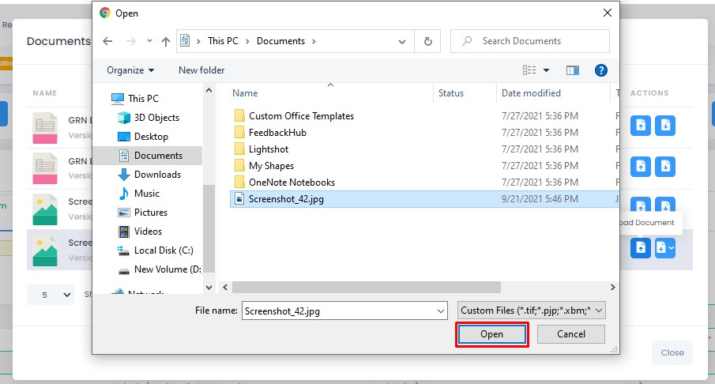

6. The file will now be uploaded and will display the new version. You can also click on the download icon to access the previous versions.

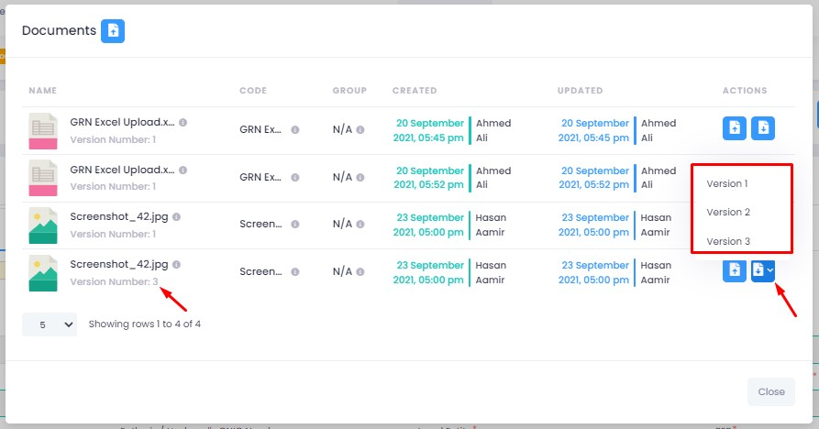

# Trail Feature

‘Trail’ allows you to view the stages and users the application has gone through so far along with the actions pertaining to it.

1. Select any application you want to view the trail of then click on ‘trail’.

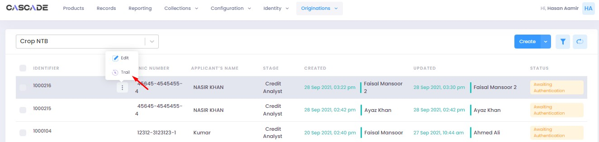

2. You will then see the current status of the application along with the stages it has gone through.

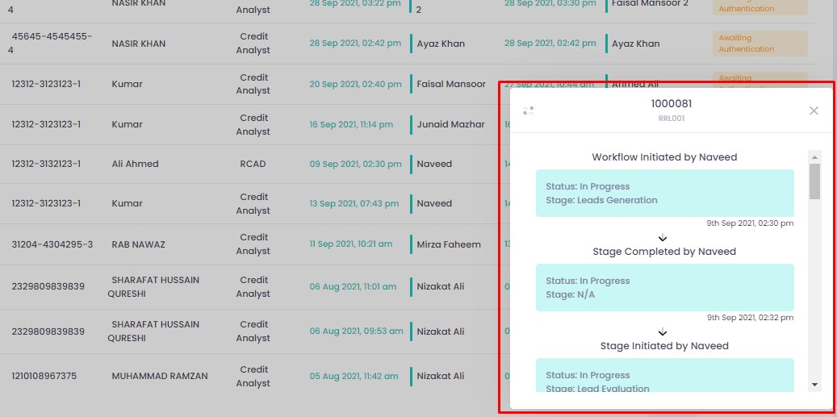

3. You can also view the ‘trail’ while working on the application by clicking on the ‘trail’ button on the right side of the page.

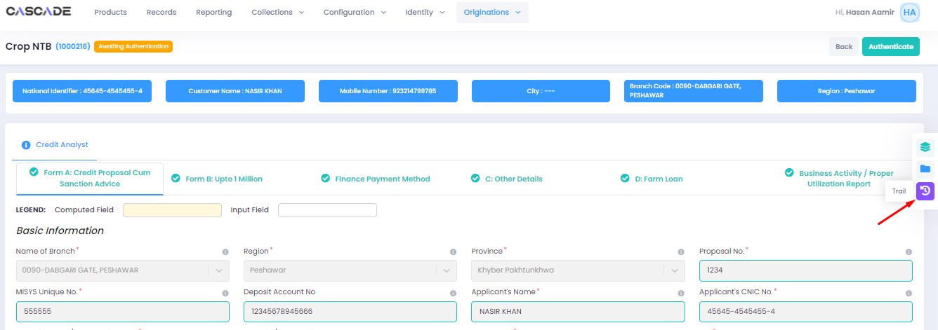

4. You will then see the current status of the application along with the stages it has gone through.

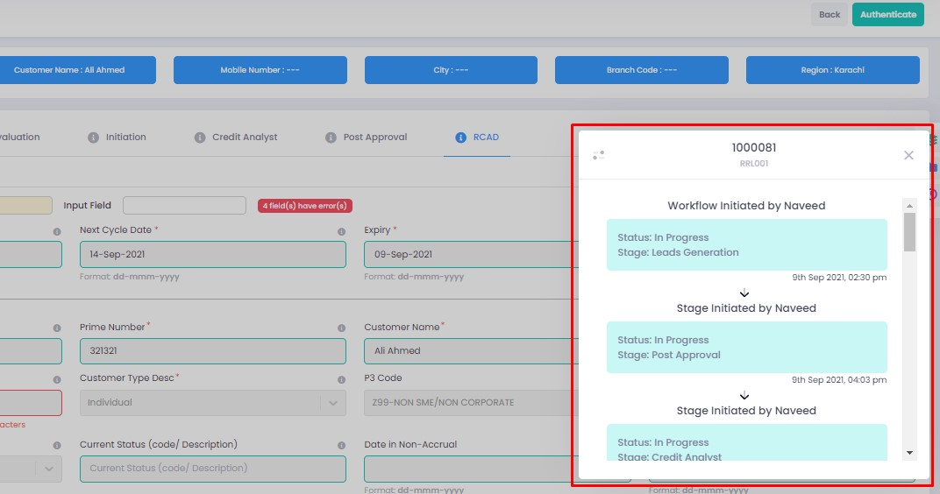

# Uploading Lead Generation Data in Bulk

1. Select your product, then click on the arrow next to ‘create’.

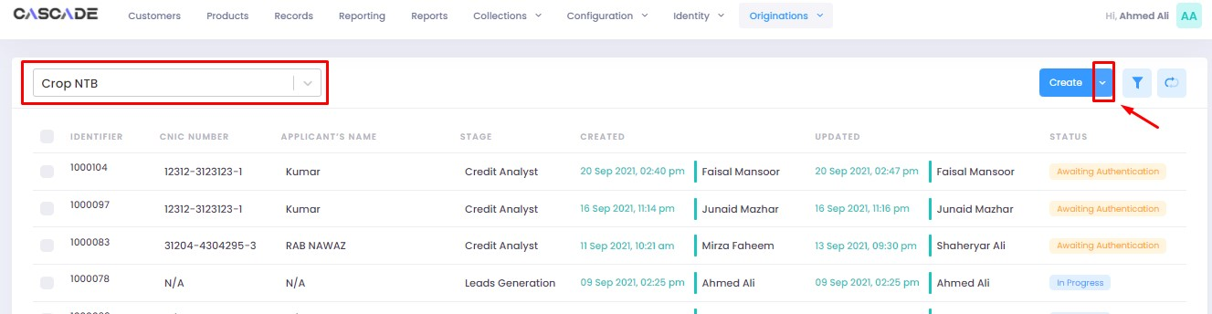

2. Click on ‘import from excel’. (Sample file attached)



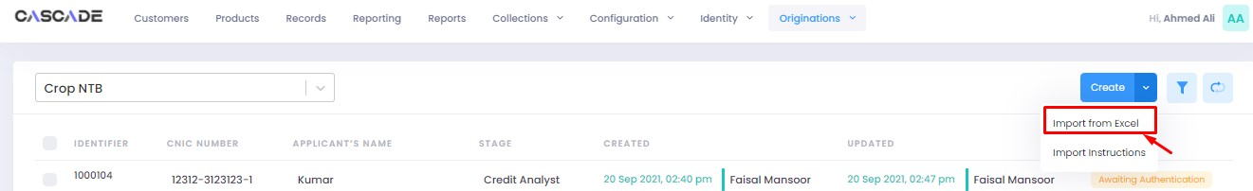

3. Browse to the excel file with the lead generation data then select that file.

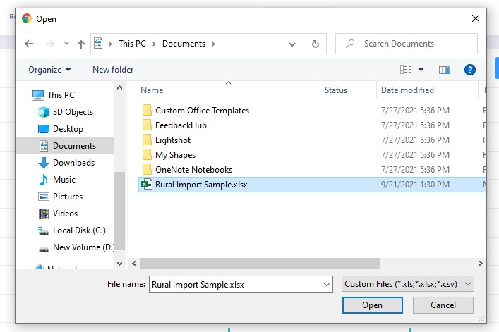

4. The data will now be uploaded…

1. Shows the number of entries that have successfully been added.
2. Shows the number of entries that have failed.
3. Shows the number of entries that are in the process of being uploaded.
4. Shows the list of all uploaded entries.
5. Click on ‘import from excel’ to upload more excel files. Or click on close if done.

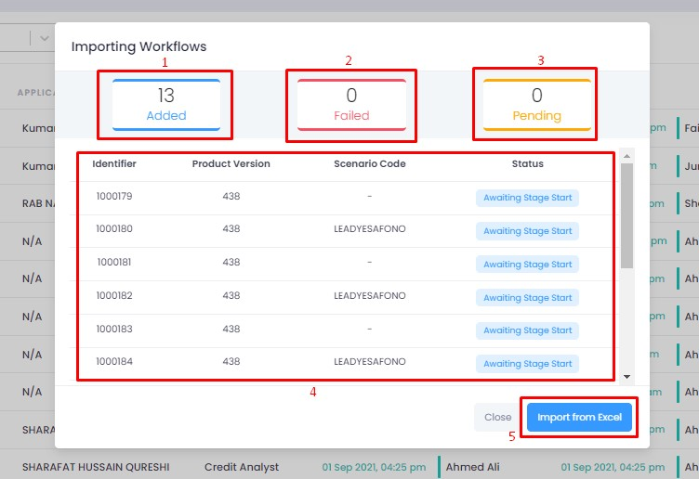

5. Now go to filters then select ‘unassigned’ to display all the uploaded data.

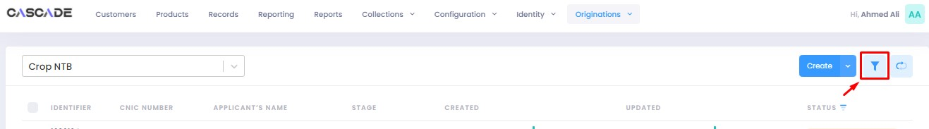

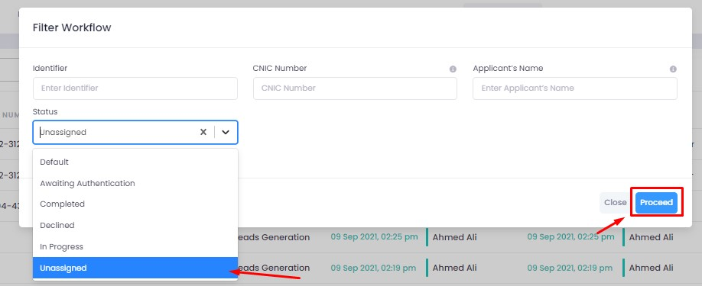

6. You will now see the all the entries uploaded through the excel file.

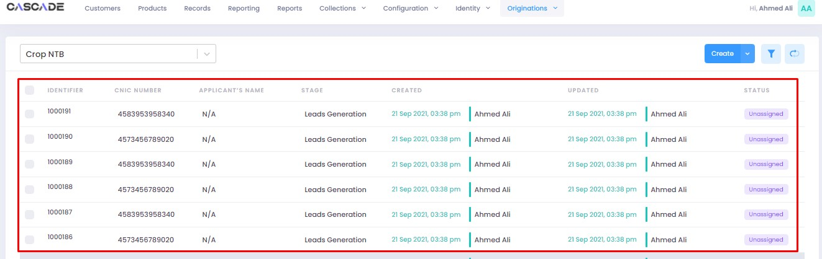

7. Select any entry and click on ‘edit’ to start the workflow.

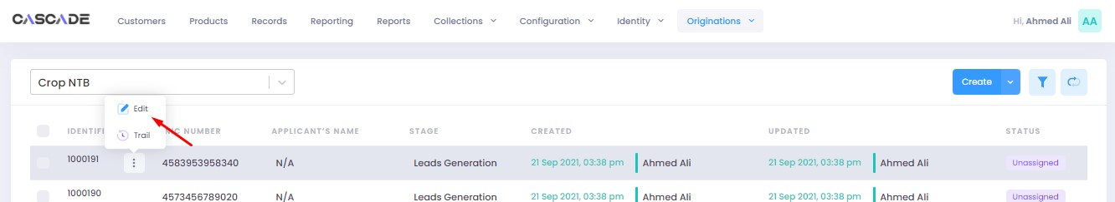

8. Then click on ‘start leads generation’.

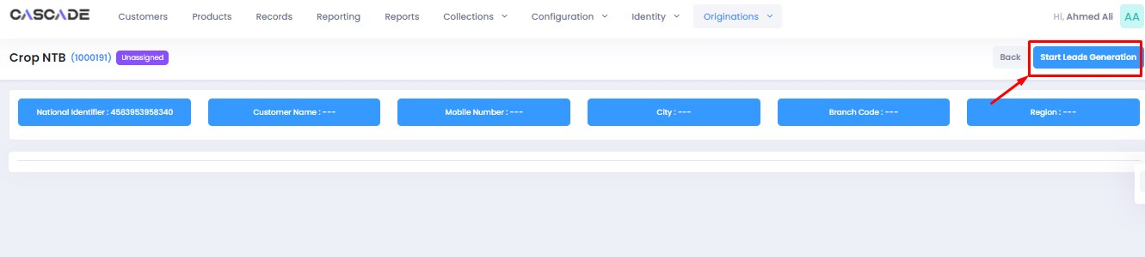

9. Fill all the data then click on ‘validate’ then ‘proceed’.

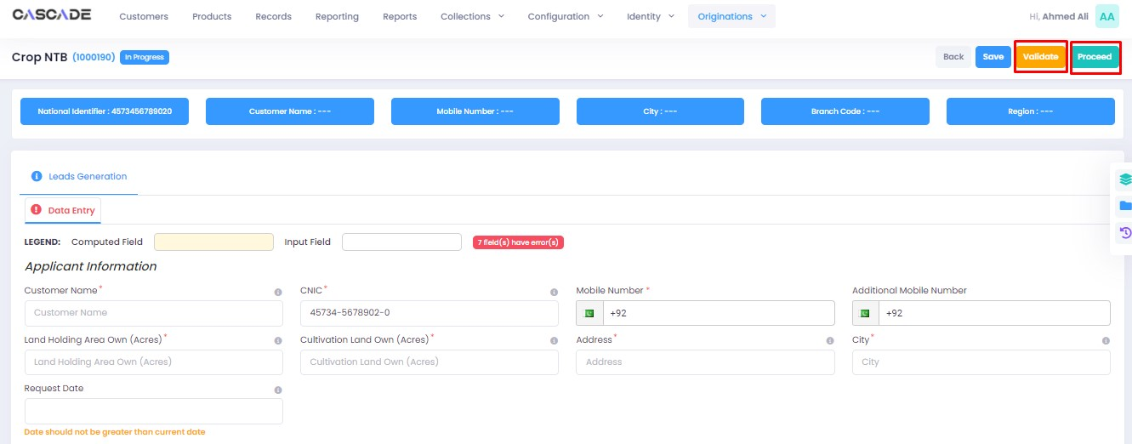

10. Then click on ‘start leads evaluation’.

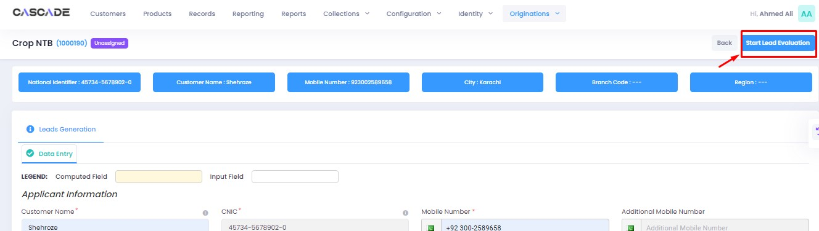

11. Select ‘lead generation status’, then click on ‘validate’ then ‘proceed’.

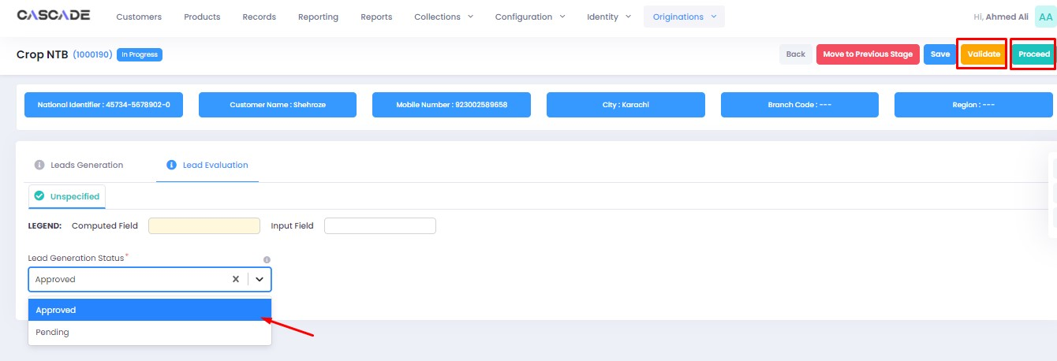

12. Select ‘unassigned’ under the filters to display your application then click on ’edit’.

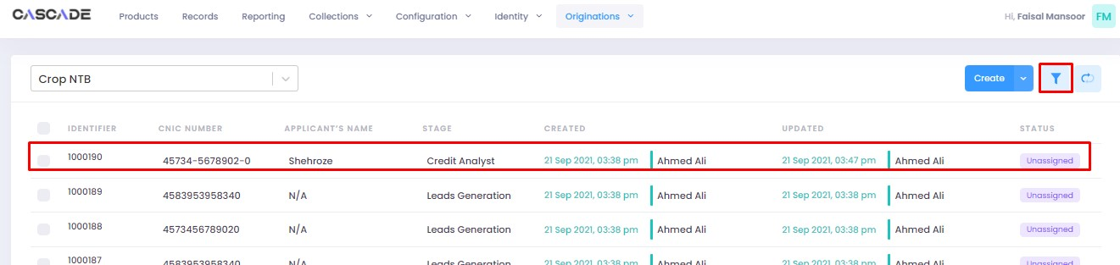

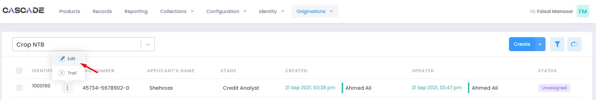

13. Then you can work on the application as per the process.

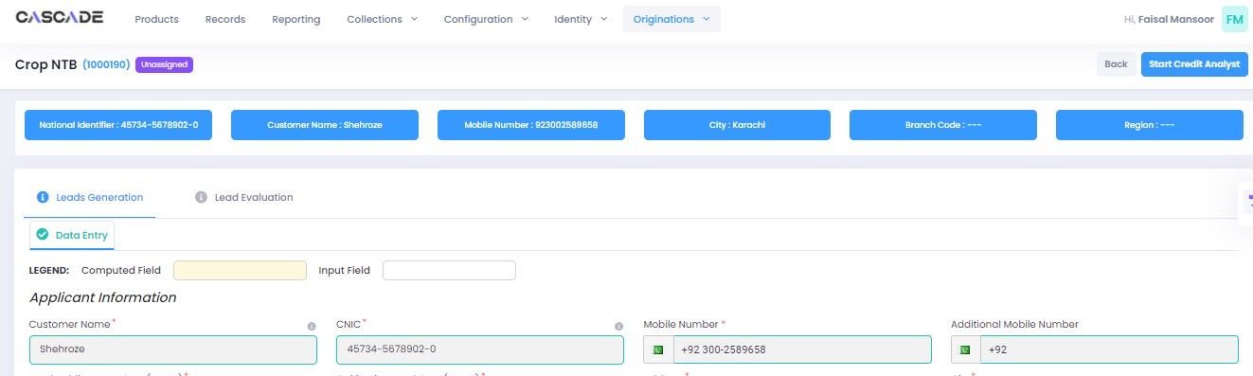

# Excel File

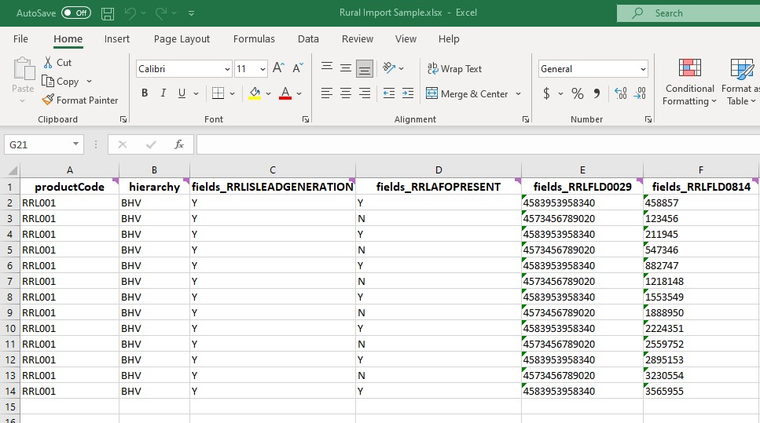

**productCode**: Product code pertaining to the product the application belongs to. (e.g., RRL001 = Crop NTB)

**Hierarchy**: Code for city (e.g., BHV = Bahawalpur)

**Fields_RRLISLEADGENERATION**: For the lead generation stage to appear in the workflow

**Fields_RRLFLD0029**: Prospect’s CNIC number

**Fields_RRLFLD0814**: CIF Number

## Product Codes

|  |  |
| --- | --- |
| **Product** | **Code** |
| Crop NTB | RRL001 |
| Poultry NTB | RRL003 |
| Fishery NTB | RRLFISHERY |
| Dairy NTB | RRLDAIRY |

# Product: Crop NTB

Maker

1. Under the Workflows tab, select the product (1), then click on ‘create’ (2) to start a new application.

**Note:** Products and workflows shown will vary according to the rights assigned to a user account.

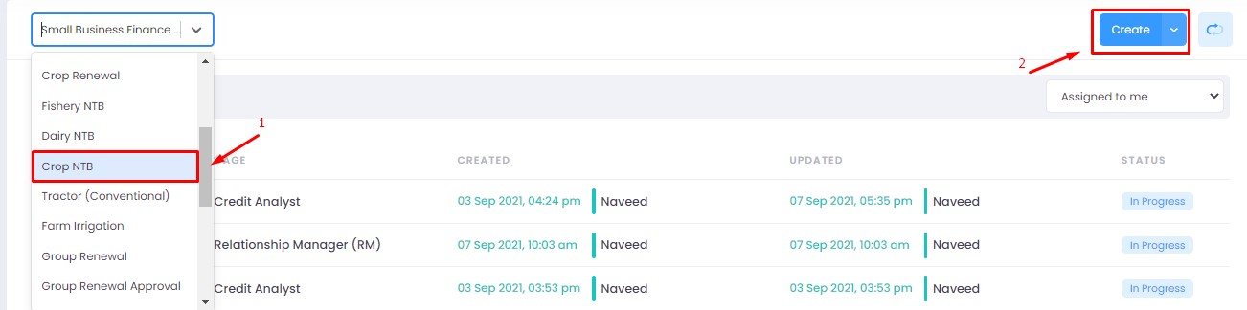

2. Fill the fields then click on proceed.

**Note**: Depending on the values selected under the fields ‘Is Lead Generation’ and ‘AFO’, new fields and stages in the journey will appear.

**Lead Generation**: Will allow to manually add details of a prospect.

**AFO**: Allows for ‘data entry’ prior to any stage. The details will then be carried into the ‘credit analyst stage’.

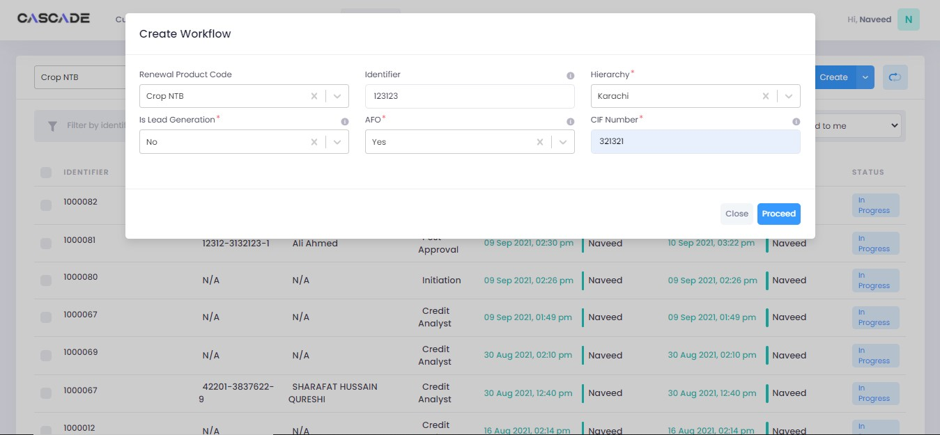

3. After filling all the fields, click on validate (1) to check for errors or missing fields (2). Once there are no errors left, click on the next Group (3) to proceed with the journey.

**Note**: Form B will appear according to the ‘proposed loan amount’ (Up to 1 million or Over 1 million) entered in Form A.

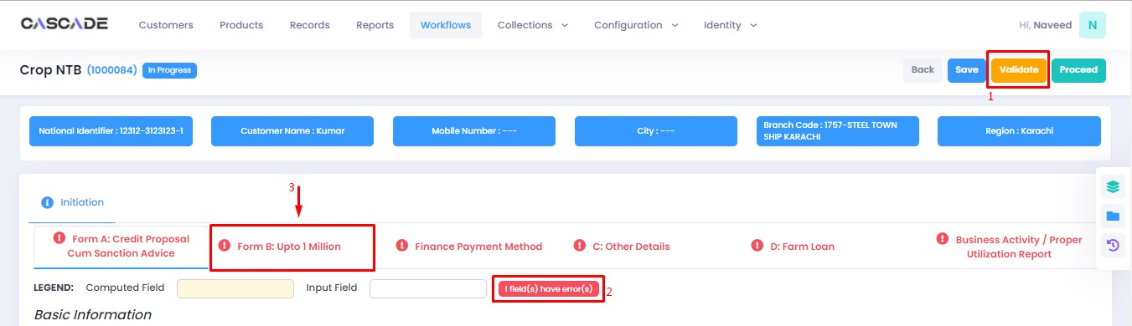

4. Fill all the required fields under this group, click on validate, then click on the next group.

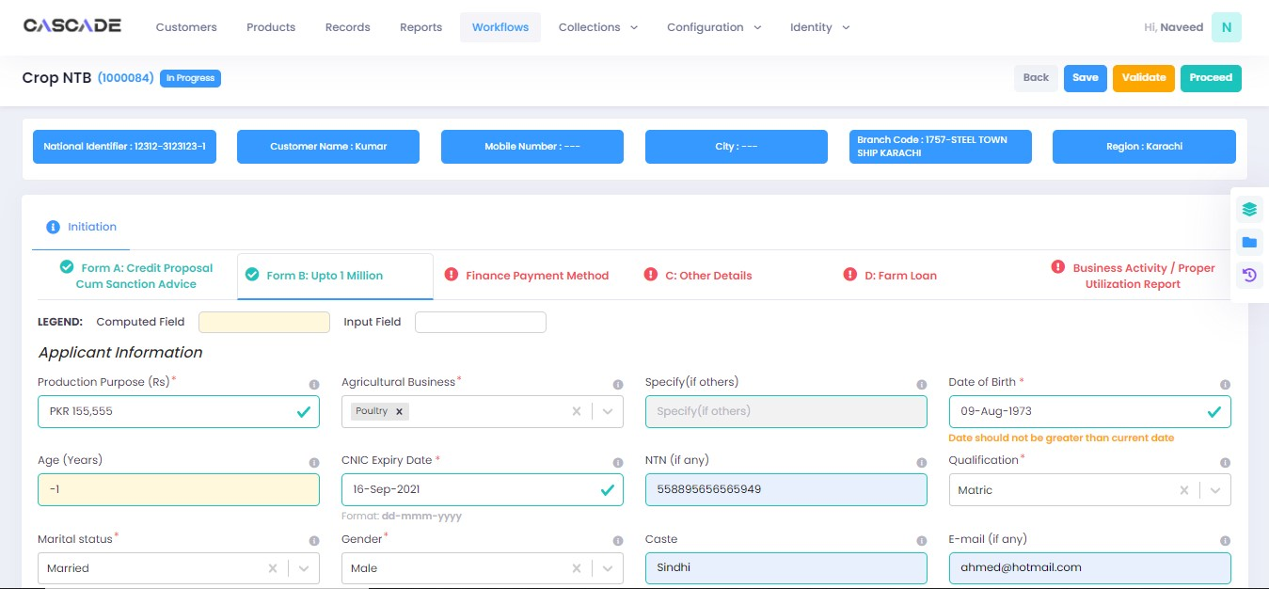

5. Fill all the required fields under this group then click on validate.

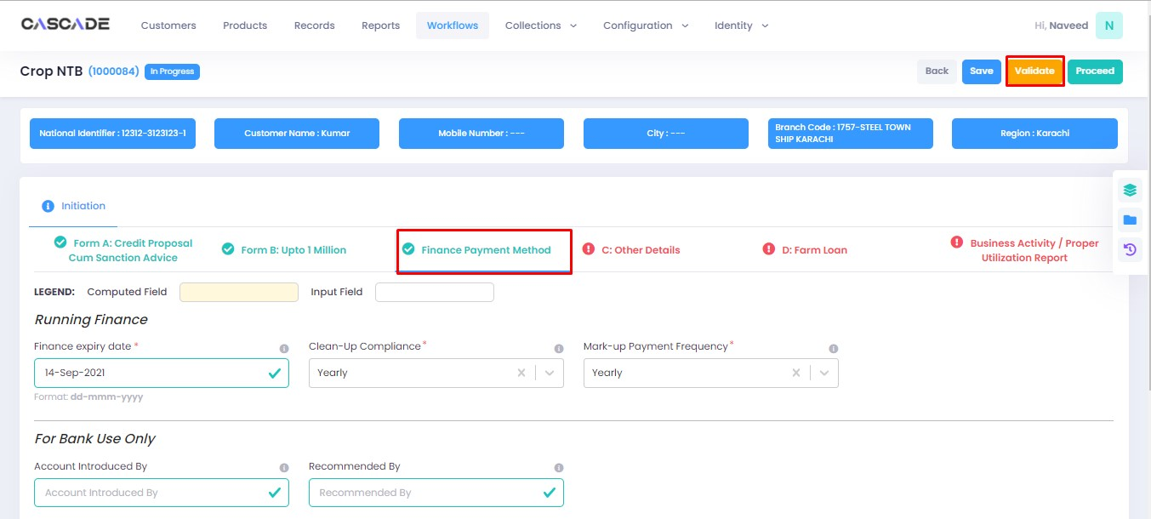

6. Keep proceeding with filling the required fields under all groups until the last one, then click on validate, followed by proceed.

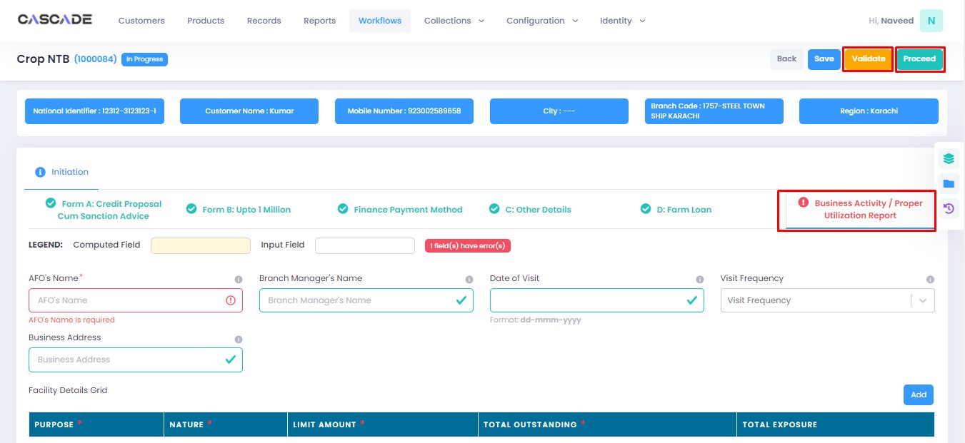

7. A button to proceed to the next stage will appear. Click on ‘credit analyst’ to start the next stage.

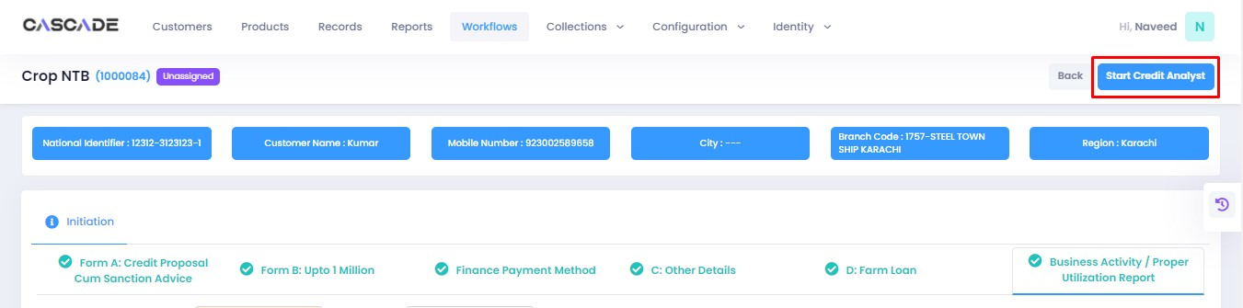

8. When on the ‘credit analyst’ stage, you can create a deviation by clicking on ‘quick panel’ on right side of the page.

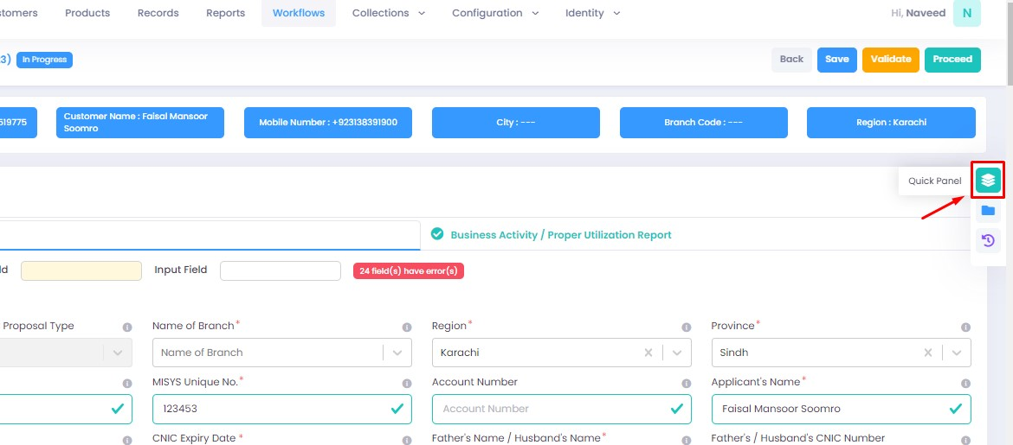

9. Then under ‘deviations/exceptions’ you will see all the available deviations. Click on the one applicable to the application, leave remarks then click ‘create’.

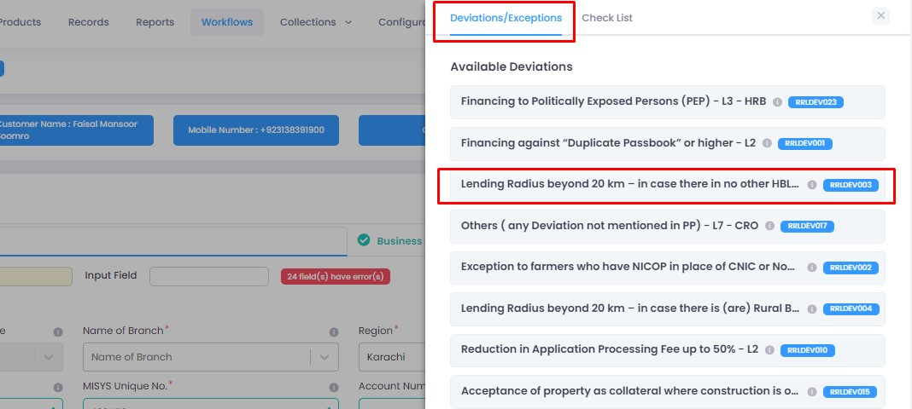

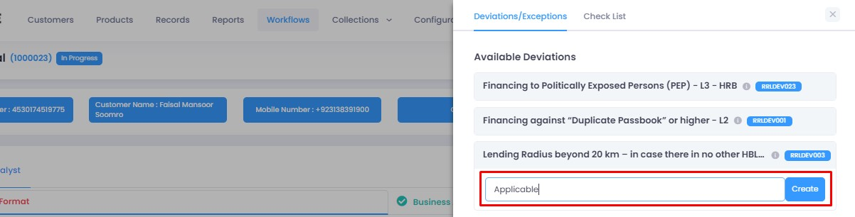

10. Once created, the created deviation will show as ‘pending’ in the quick panel and will require approval from an approving authority before the application can be processed further.

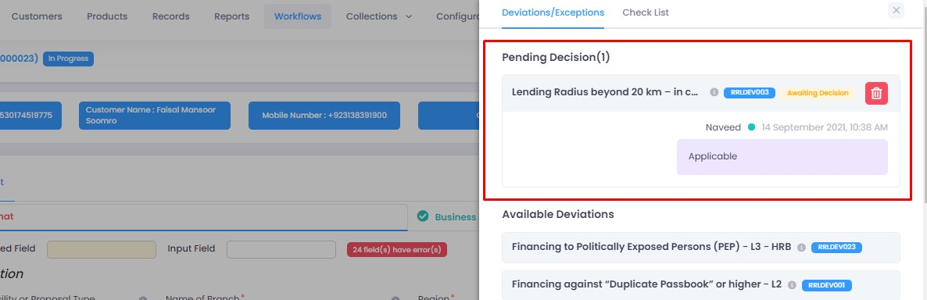

11. Similar to the last stage, fill all the required fields under this stage until all groups are duly filled. Make changes in this stage if any.

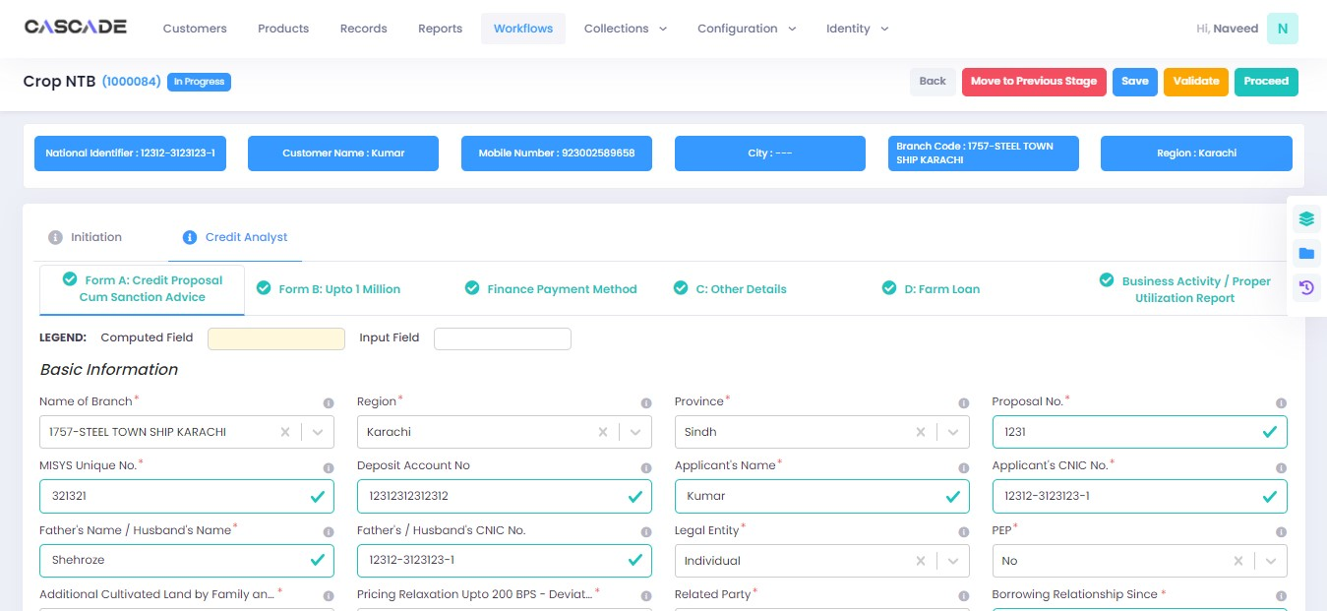

12. After filling all the fields under all groups, click on ‘validate’ then click on the ‘Quick Panel’ button on the right side of the page to check further requirements.

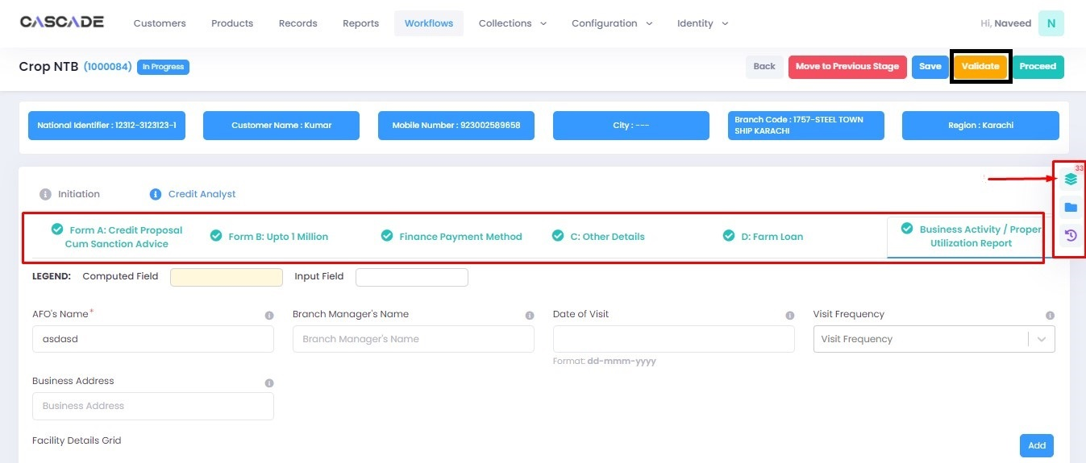

13. Under the ‘check list’ tab, you will see a list of the required documents and checks. Run all the checks and upload the required documents to proceed. Or defer if required.

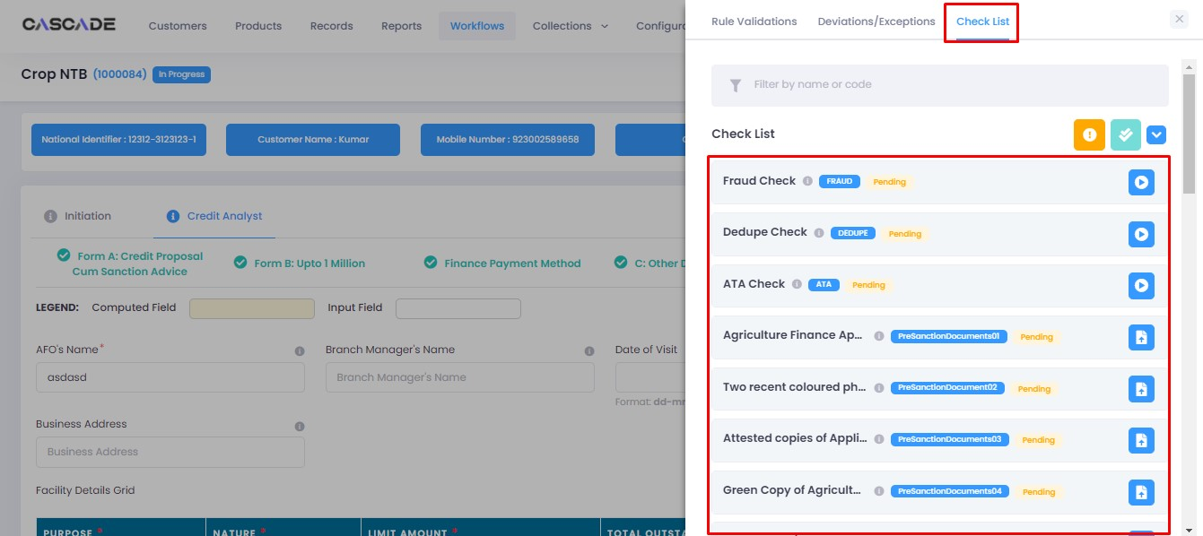

14. After going through the checklist, click on validate, and then proceed to move to the next stage.

**Note**: The workflow will now require approval from an approver.

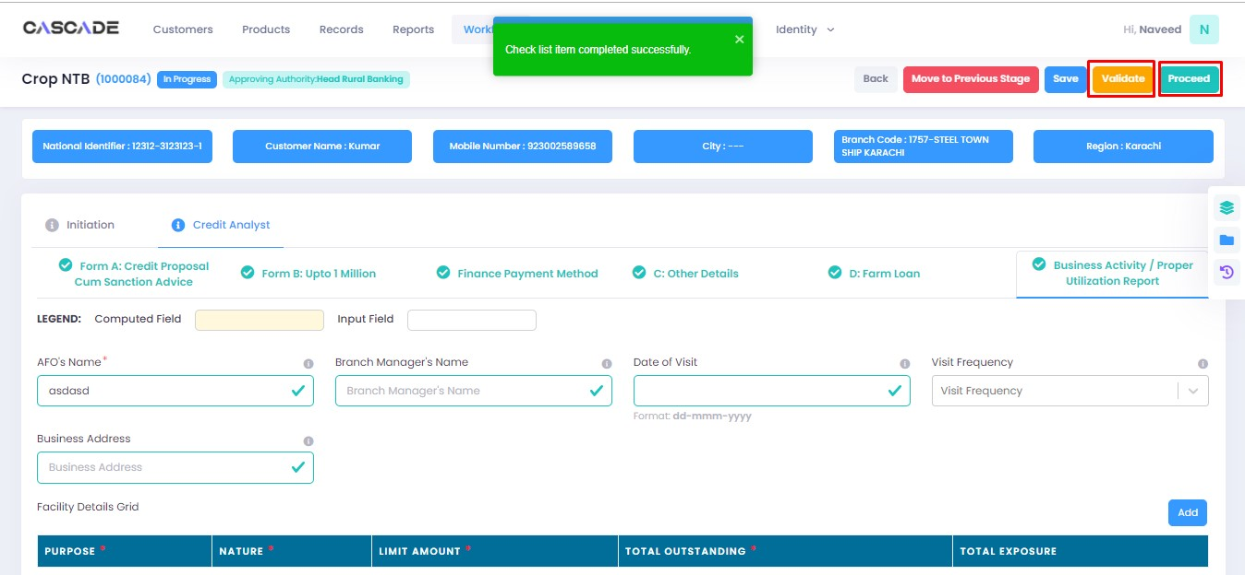

Checker

1. Now from the approver’s account, go to the workflows tab to view the in-progress journeys.

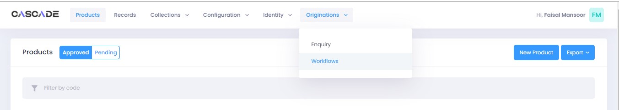

2. Select the product to show a list of the appropriate journeys. In this screenshot, you see a journey with the status of ‘Awaiting Authentication’.

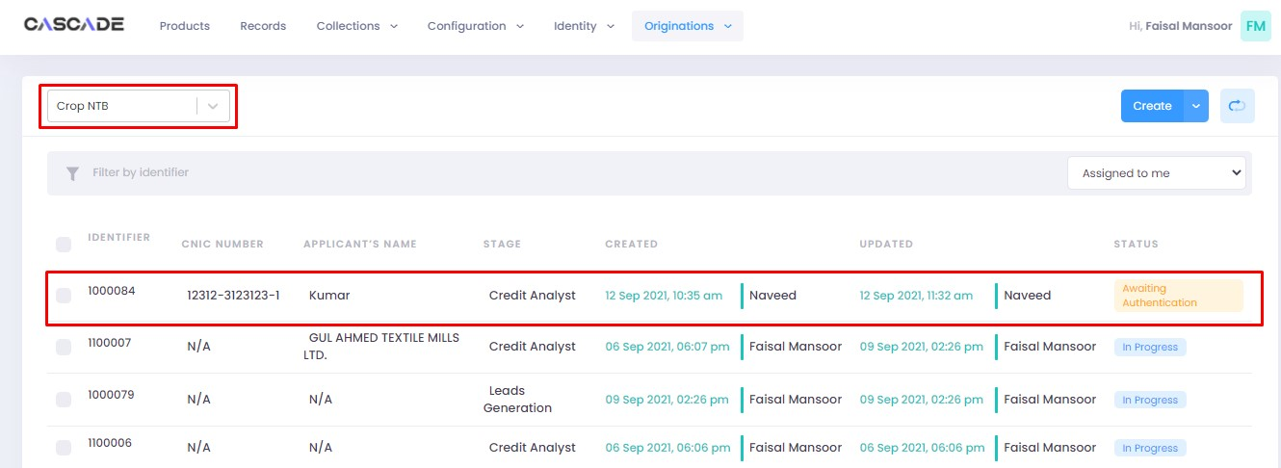

3. Click on ‘edit’ to proceed with the journey.



4. Now the approver will be able to see all the details of the journey filled by the maker of the workflow. After scrutinizing, click on the ‘authenticate’ button on the top right to approve or decline the application.

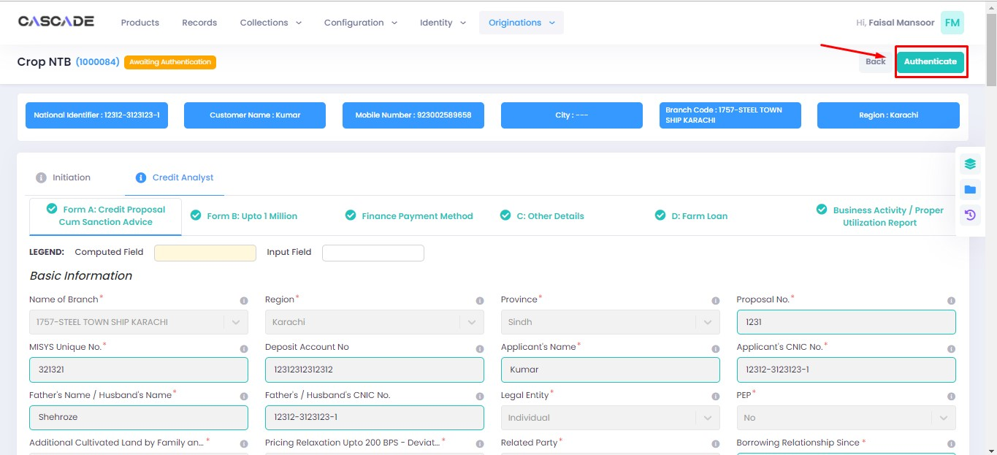

5. Fill the comment box with remarks, then ‘recommend’, ‘decline’ or discard the application. Recommending will move the application forward, declining it will destroy the application, and discarding it will send back the application to the maker.

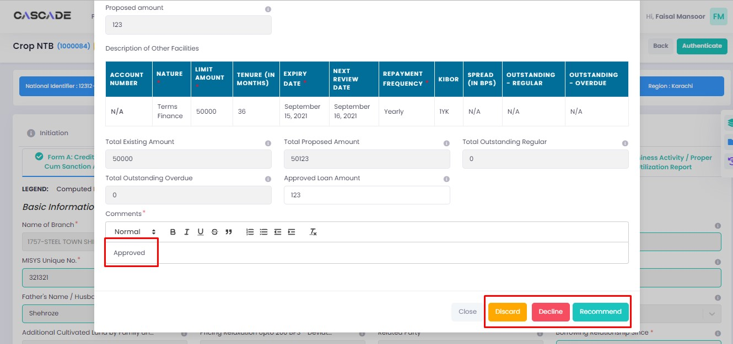

6. The application will require multiple recommendations from the relevant accounts until it is ‘approved’ by an account with appropriate rights. The screenshot below shows the names of the accounts the application has gone through so far with their comments.

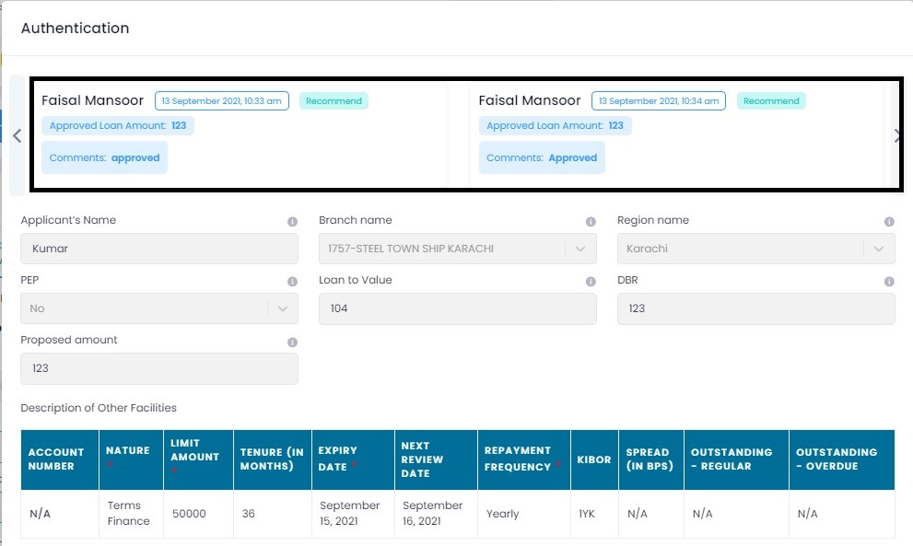

7. After the first recommendation, the second recommender will see the ‘move back’ button which will send the application back to the first recommender. In case of having gone through multiple recommendations the ‘move back’ button will send the application back to the previous approver.

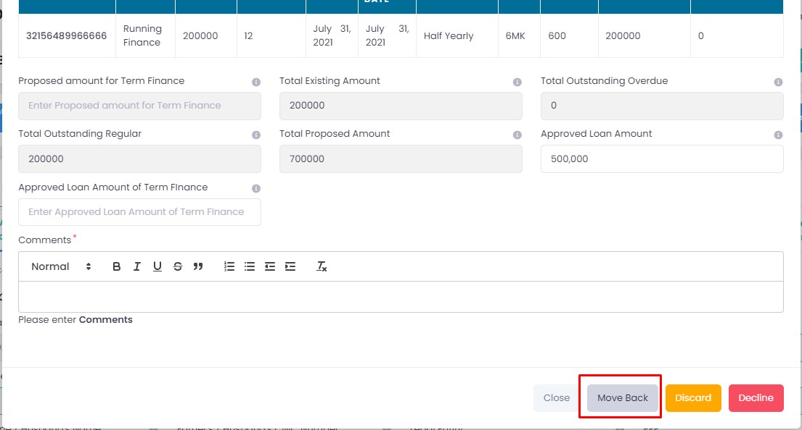

8. After all the ‘recommendations’, the application will require an ‘approval’ from an account with appropriate rights.

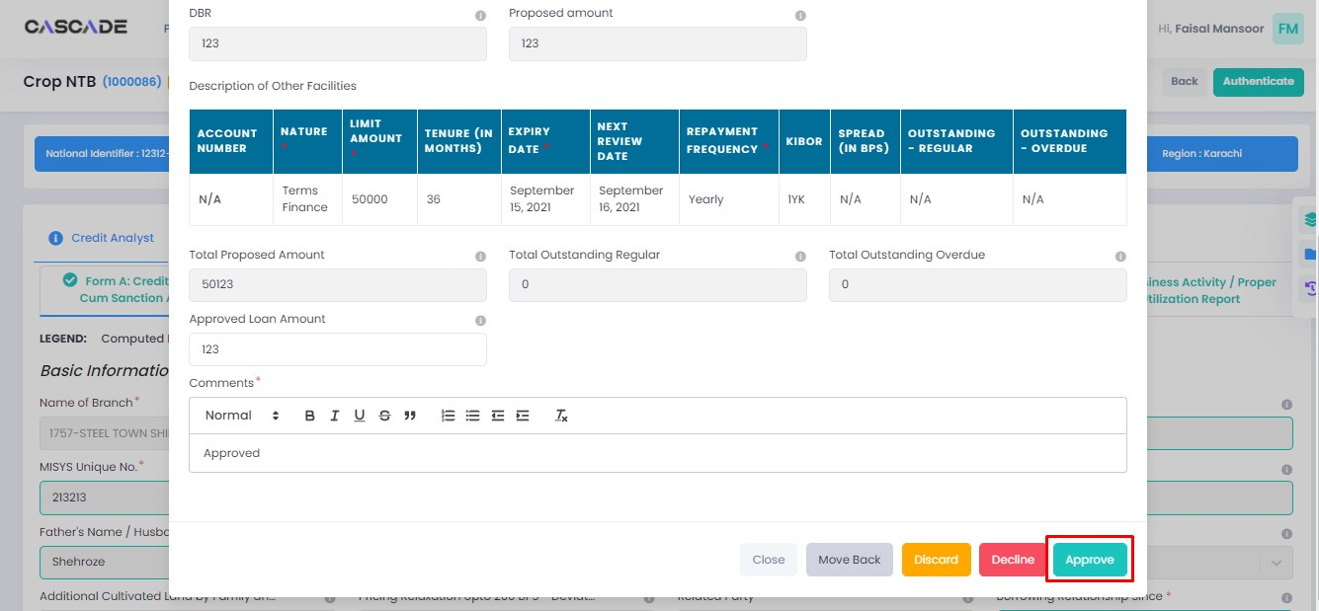

Maker

1. Once the application has been authenticated, it will reappear under the account of the ‘maker’. Go to the ‘workflows’ tab, then select the product, ‘Crop NTB’ in this case, to show relevant applications, then select ‘unassigned’ in the filters. You will now see the concerned application with a status of ‘unassigned’.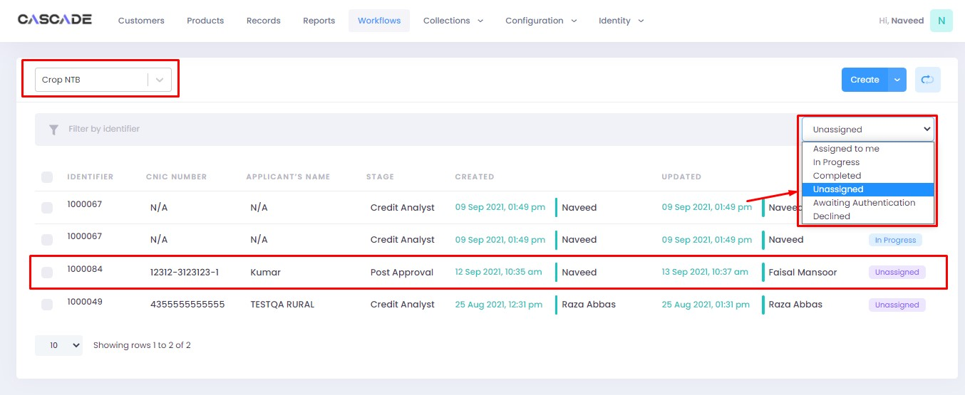

2. Click on ‘edit’, then click on ‘Start Post Approval’ to start the next stage.

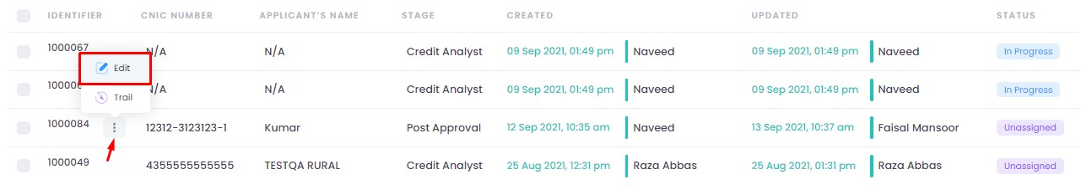

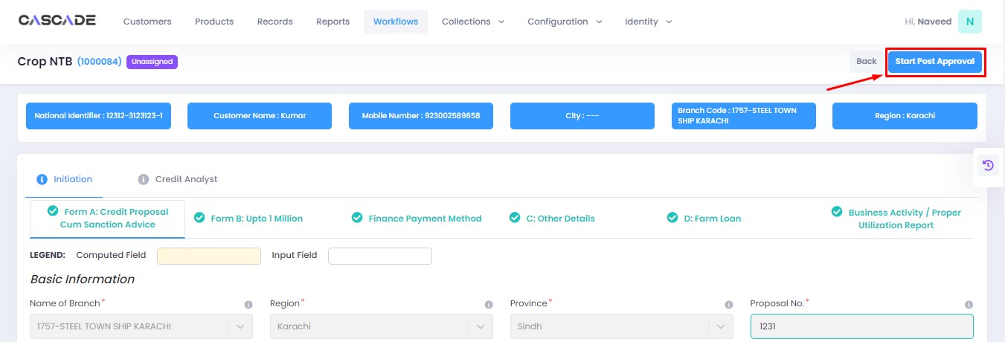

3. Fill all the required fields under ‘Post Approval Documents’ until no errors remain, then click on validate (1), then on the second group (2).

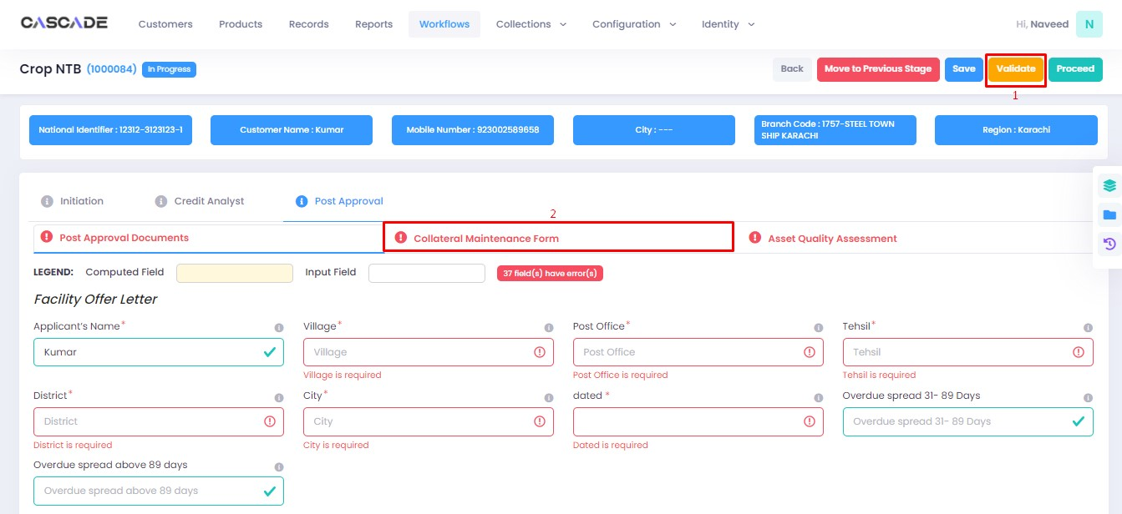

4. Fill all the required fields under ‘Collateral Maintenance Form’ until no errors remain, then click on validate (1), then on the next group (2).

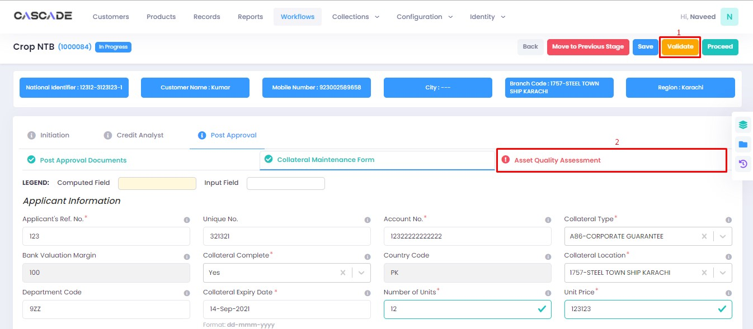

5. Fill all the required fields under ‘Asset Quality Assessment’ until no errors remain, then click on validate, then click on ‘quick panel’ on the right side of the page.

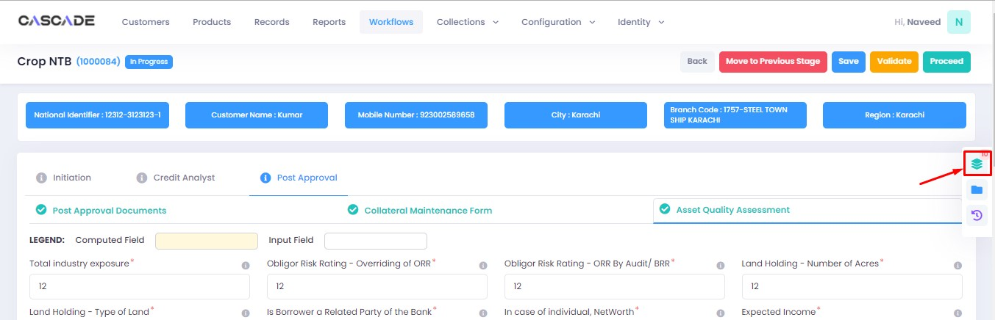

6. Here you will see the items that are pending before the application can be processed further. Upload the required documents to proceed. Or defer if inapplicable.

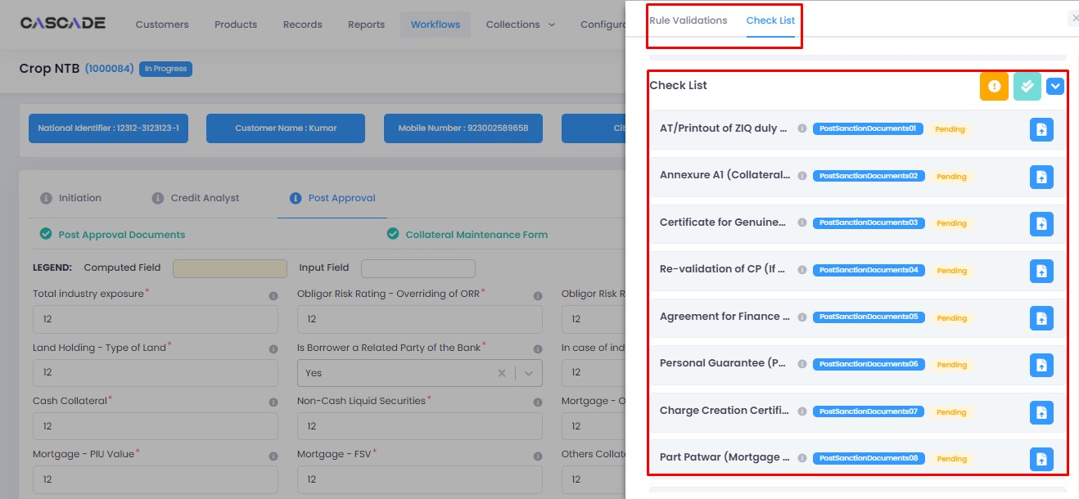

7. After uploading all the required documents, click on validate (1) then click on proceed (2).

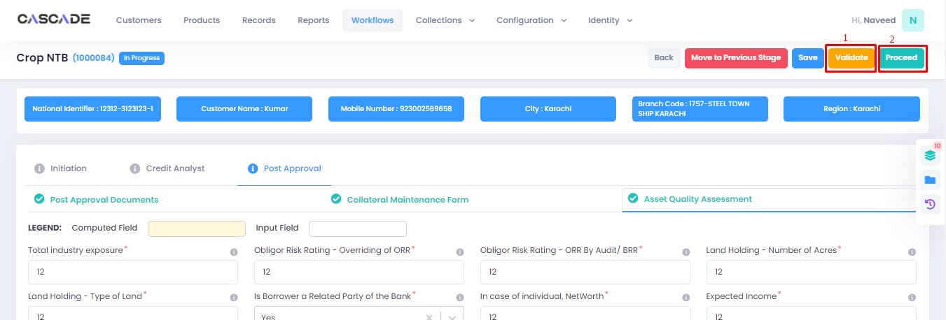

8. Now click on ‘Start RCAD’ to start the next stage in the journey.

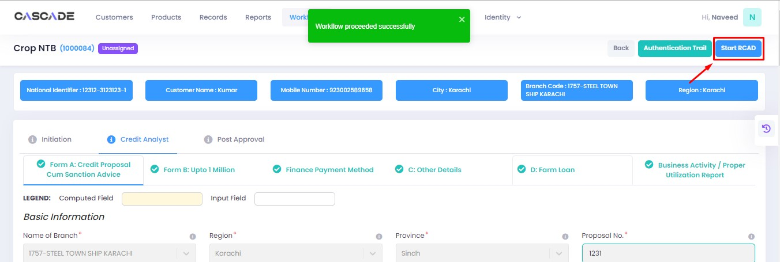

9. Fill all the required fields under ‘AT’ until no errors remain, then click on ‘validate’ (1), then on ‘proceed’ (2).

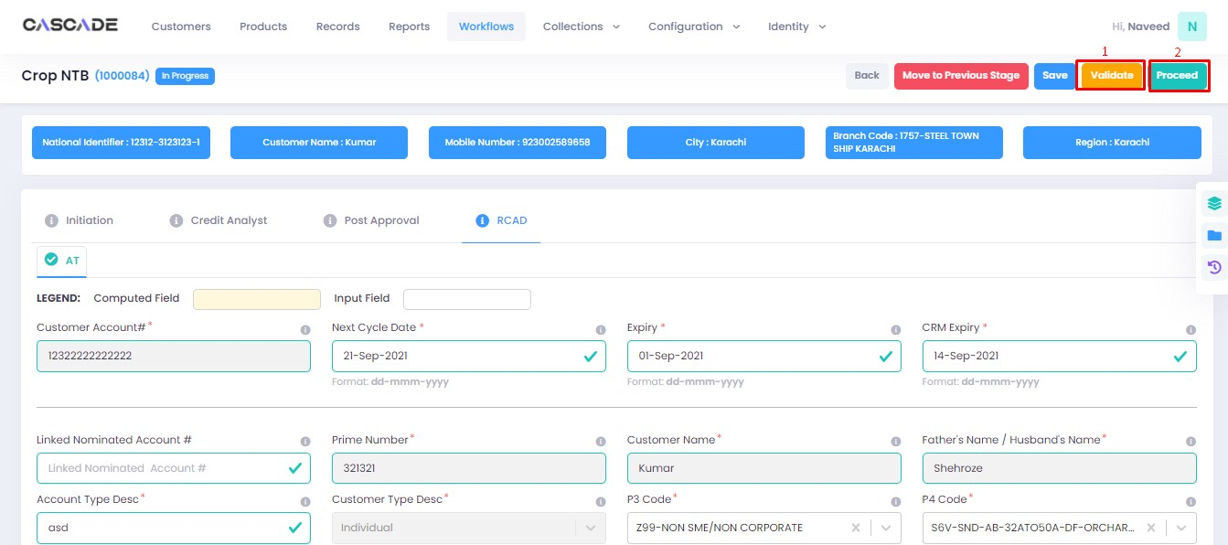

10. If an error shows, click on the ‘quick panel’ on the right side of the page.

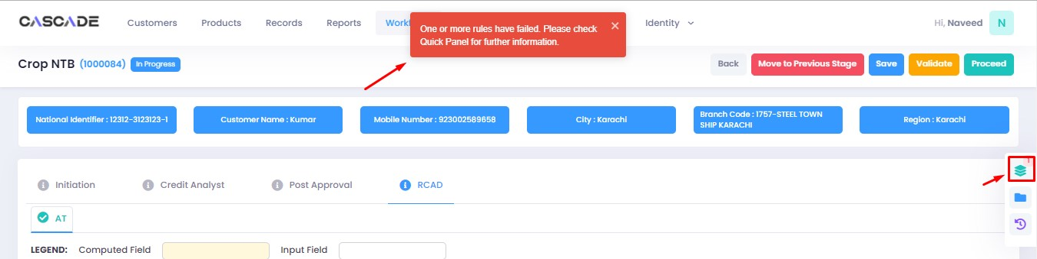

11. Upload the required documents, then click on validate then on proceed.

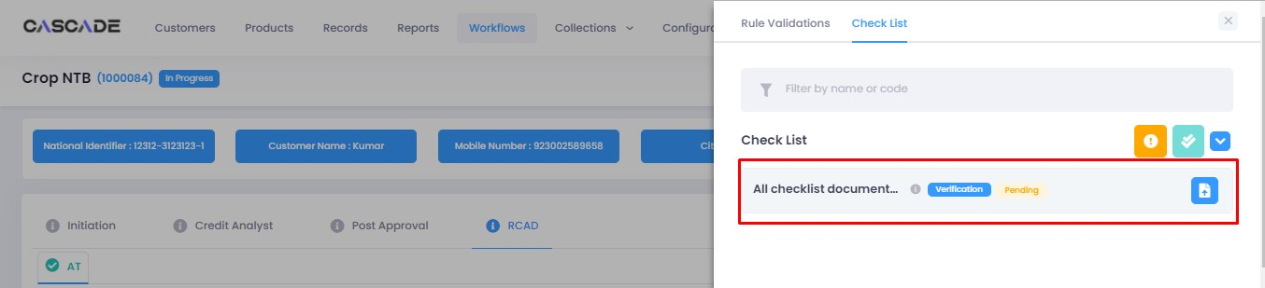

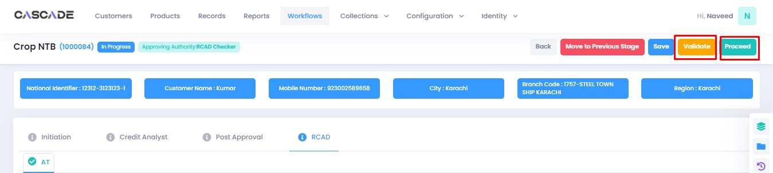

Checker

1. Now from the approver’s account, go to the workflows tab to view the in-progress journeys.



2. Select the product to show a list of the appropriate journeys. In this screenshot, you see the workflow with the status of ‘Awaiting Authentication’.

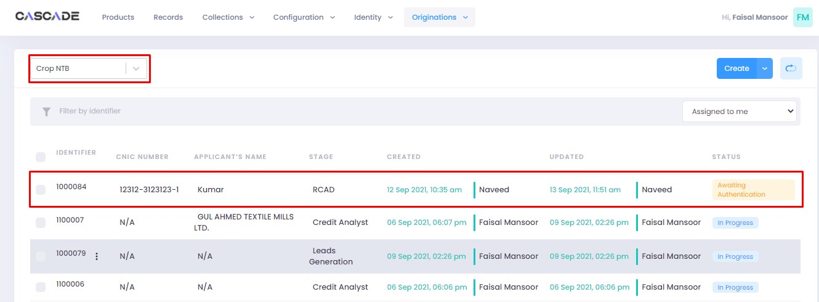

3. Click on ‘edit’ to proceed with the journey.

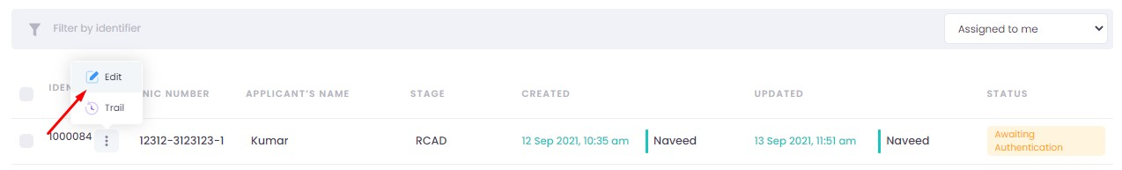

4. Now the approver will be able to see all the details of the journey filled by the maker of the workflow. After scrutinizing, click on the ‘authenticate’ button on the top right to approve or decline the application.

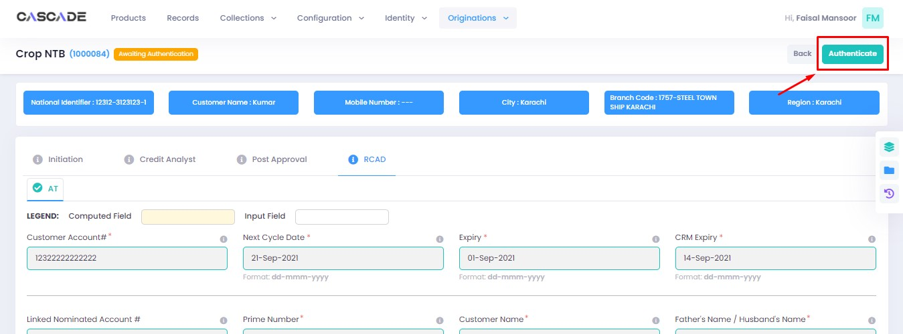

5. Fill the comment box with remarks, then ‘approve’, ‘decline’ or ‘discard’ the application. Recommending will move the application forward, declining it will destroy the application, and discarding it will send back the application to the maker.

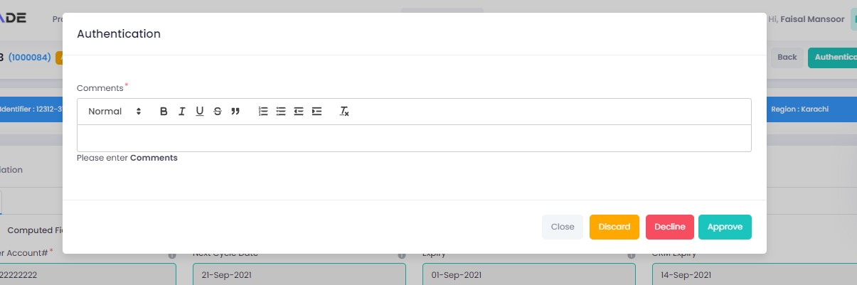

6. Under the workflows tab, select ‘Crop NTB’ as the product then ‘unassigned’ to display the relevant application.

Note: Application will only be visible to account with relevant rights

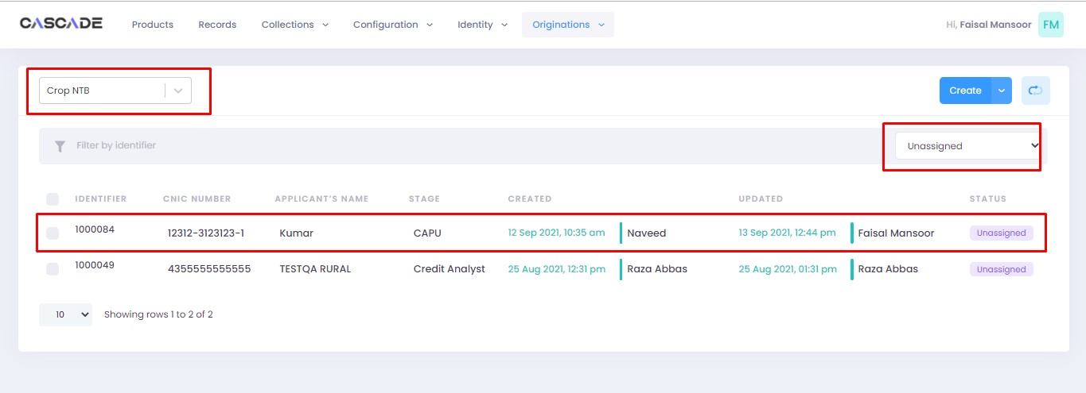

7. Then click on ‘edit’ to further proceed.

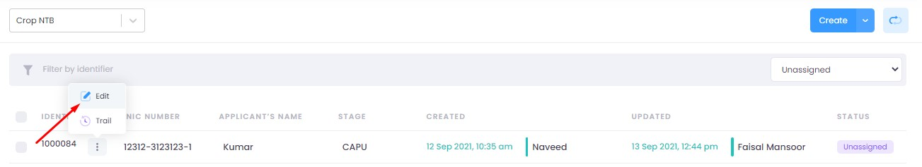

8. Now click on ‘Start CAPU’ to move to the next stage.

Note: CAPU can only be initiated and worked on from the account with relevant rights.

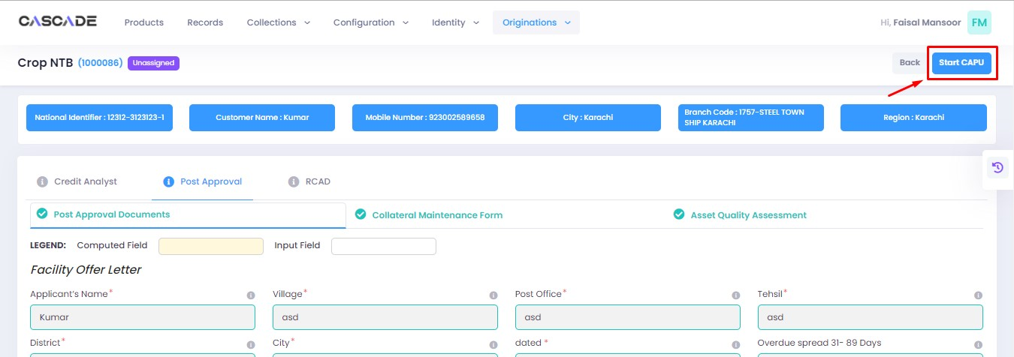

9. Fill all the required fields then click on validate (1) then on proceed (2).

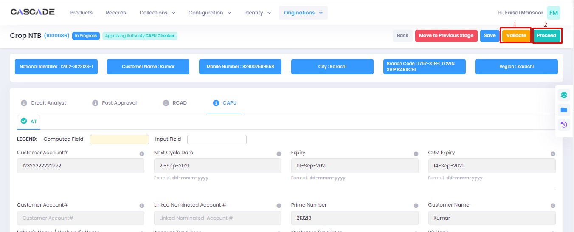

10. The application will now require approval by the CAPU checker.

CAPU checker will click on ‘authenticate’, leave remarks, then approve or decline the application

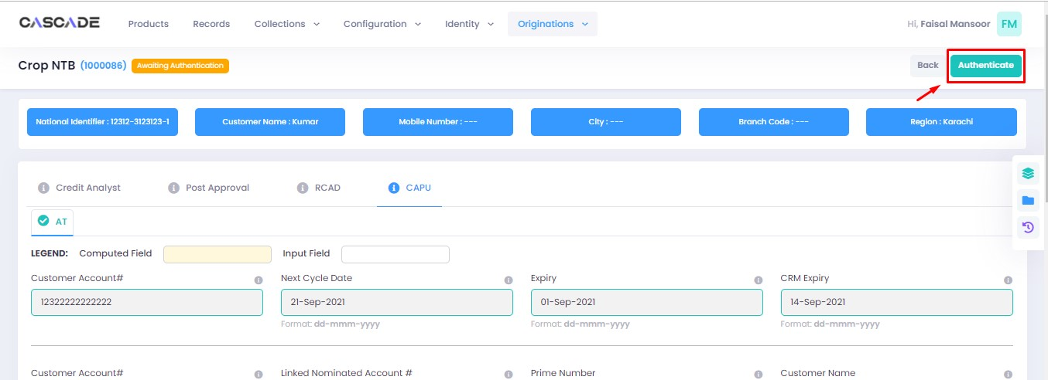

Fill the comment box with remarks, then ‘approve’, ‘decline’ or ‘discard’ the application. Recommending will move the application forward, declining it will destroy the application, and discarding it will send back the application to the maker.

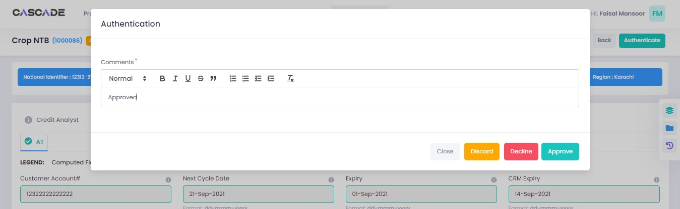

11. The application will now be marked as completed and as ready to be disbursed.

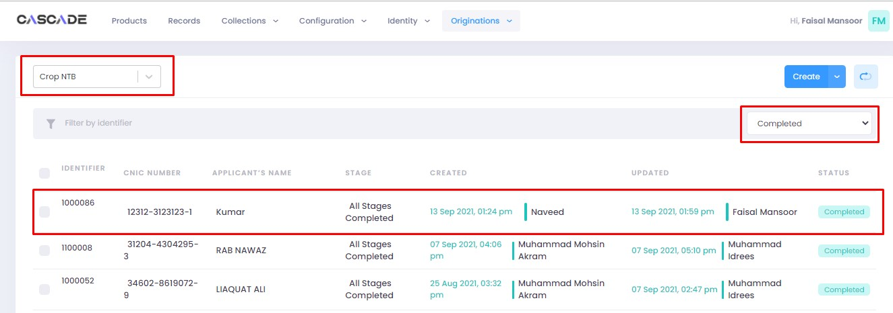

# Product: Crop Renewal

Maker

1. Under the Workflows tab, select the product, then click on ‘create’ to start a new application.

Note: Products and workflows shown will vary according to the rights assigned to a user account.

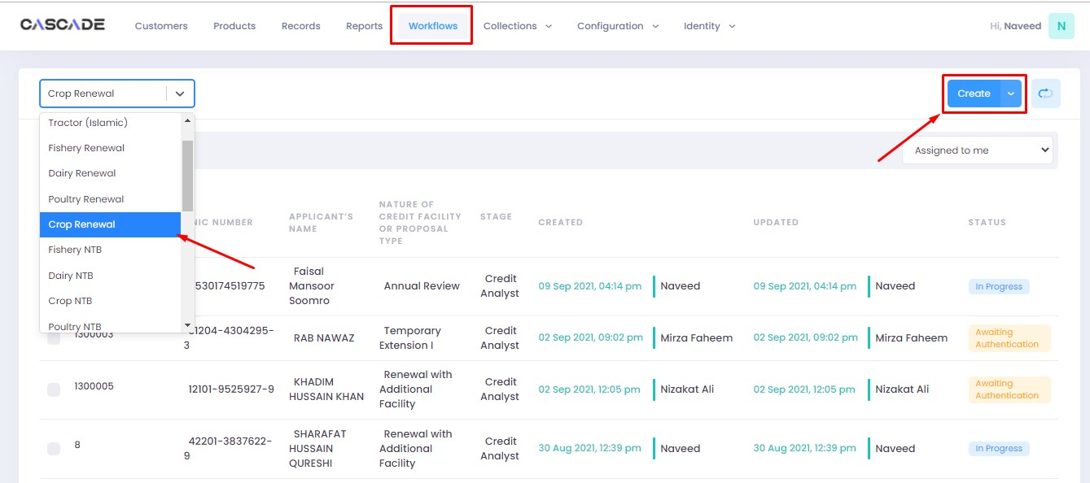

2. Fill the details, then click on ‘proceed’.

**Note**: Depending on the value selected under the field ‘form type’ and ‘AFO’, new fields in the application might appear.

**Form Type**: You will be able to choose form type between ‘one pager’ or ‘full form’. Fields and stages will vary in both form types (examples shown below).

**AFO**: Allows for ‘data entry’ prior to any stage. The details will then be carried into the ‘credit analyst stage’.

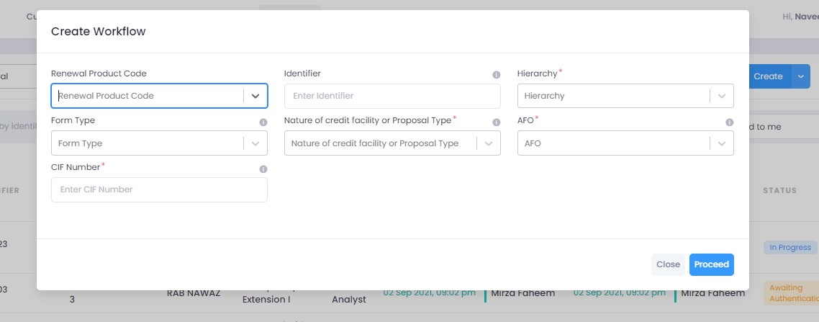

## Form Type: One Pager

3. After filling all the fields, click on validate (1) to check for errors or missing fields. Once there are no errors left, click on the next Group (2) to proceed with the journey.

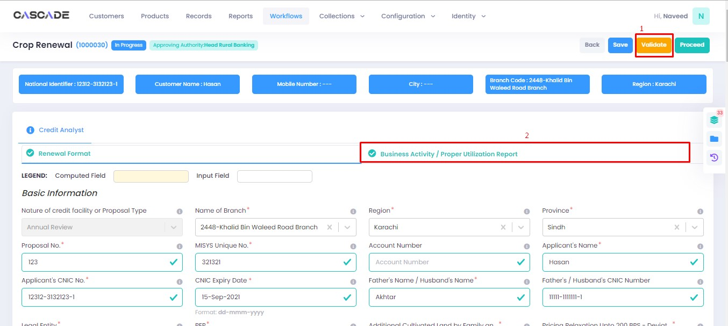

4. Fill all the required fields under this group. Then click on ‘validate’ (1) then on ‘quick panel’ (2) on the right side of the page to view the checklist of pending actions.

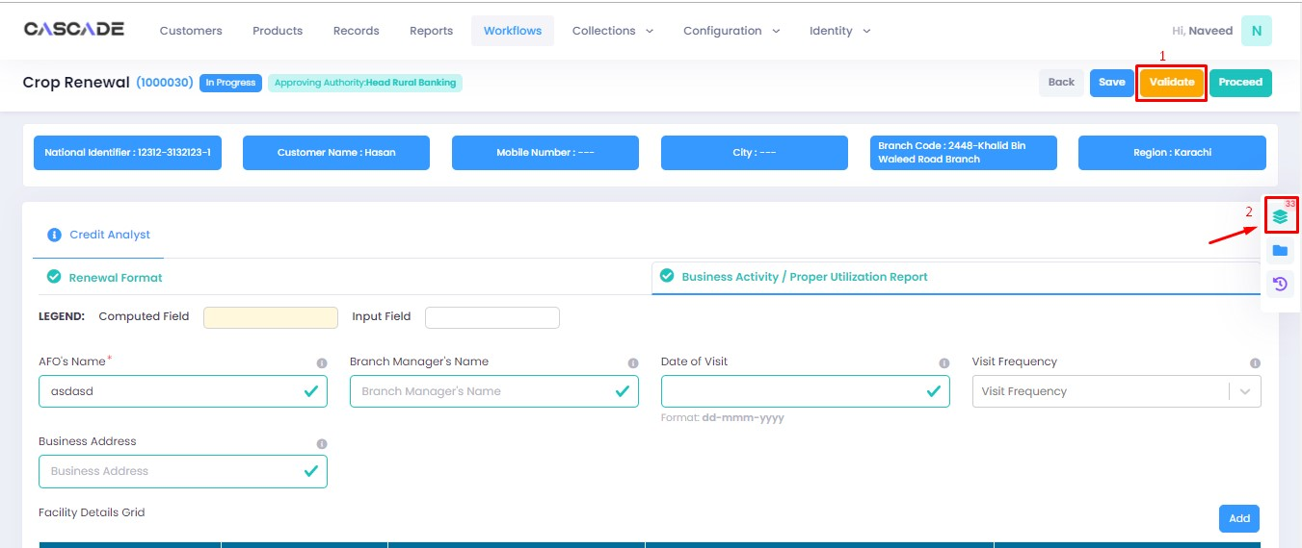

5. Under the ‘check list’ tab, you will see a list of the required documents and checks. Run all the checks and upload the required documents to proceed. Or defer if required.

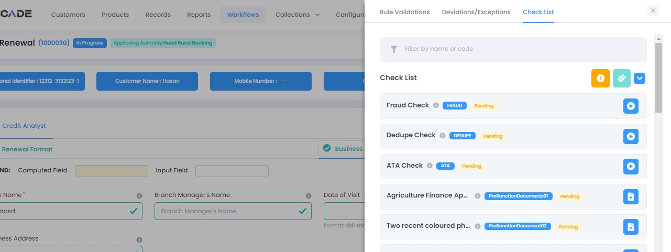

## Form Type: Full Form

6. After filling all the fields, click on validate (1) to check for errors or missing fields (2). Once there are no errors left, click on the next Group (3) to proceed with the journey.

**Note:** Form B will appear according to the ‘proposed loan amount’ (Up to 1 million or Over 1 million) entered in Form A.

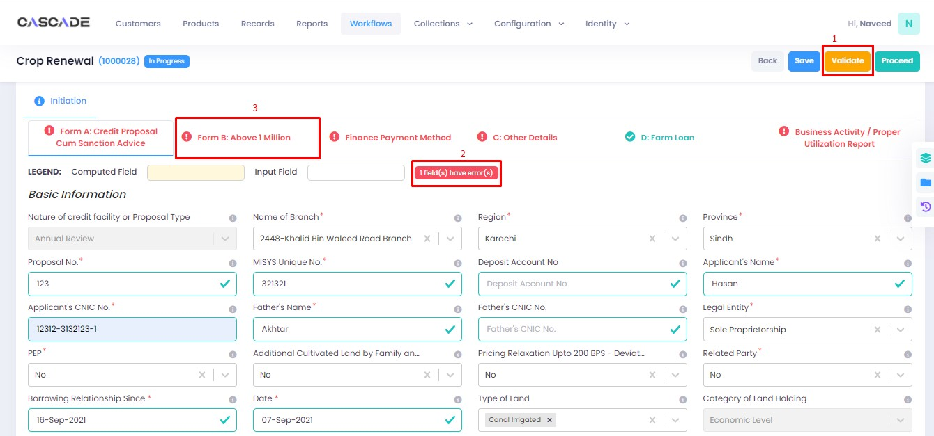

7. Fill all the required fields under this group, click on validate, then click on the next group.

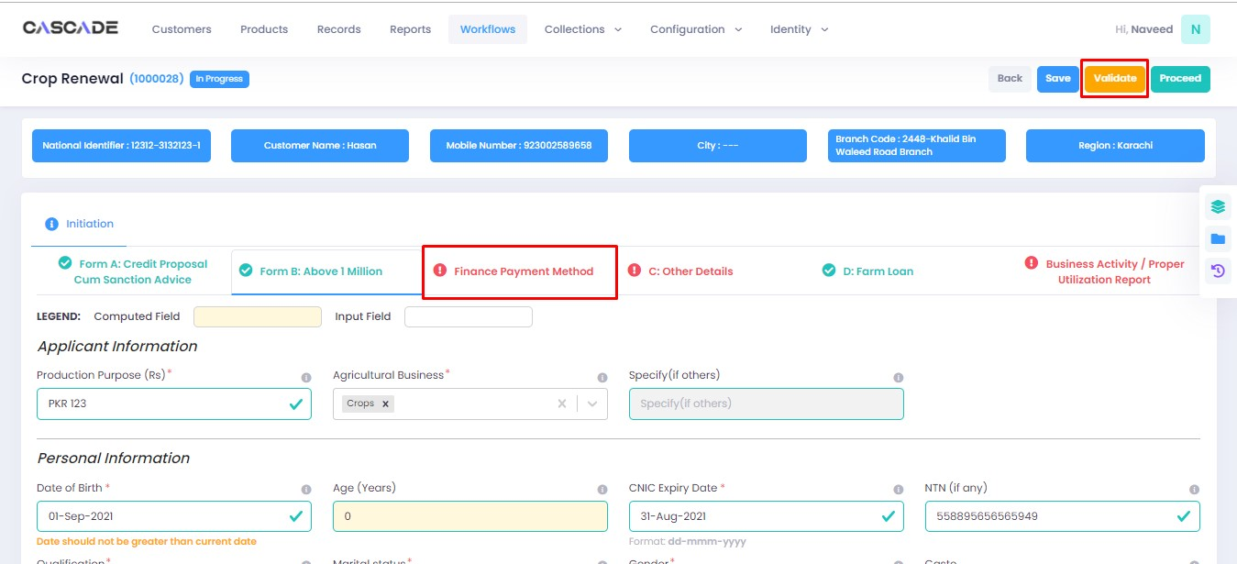

8. Fill all the required fields under this group, click on validate, then click on the next group.

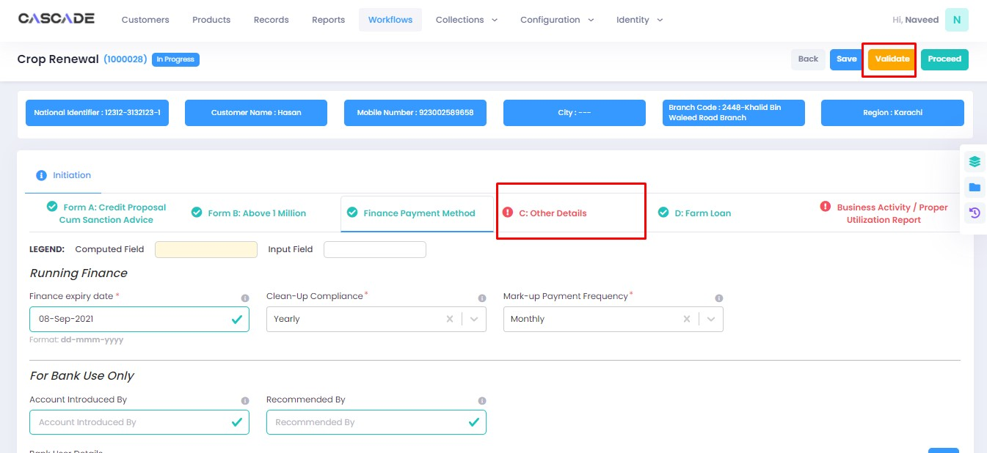

9. Fill all the required fields under this group, click on validate, then click on the next group.

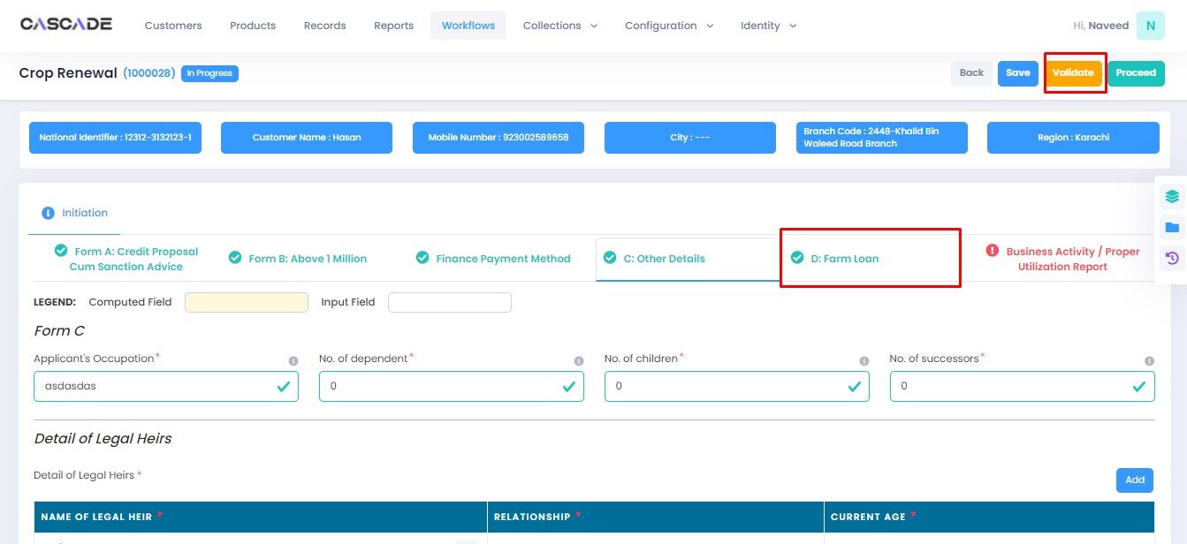

10. Fill all the required fields in the rest of the groups, then click on validate, then click on proceed.

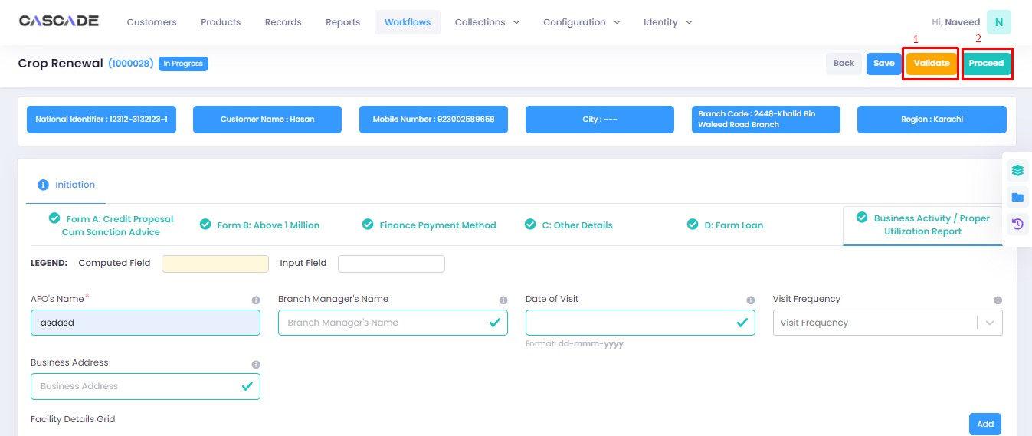

11. Click on ‘Start Credit Analyst’ to start the next stage.

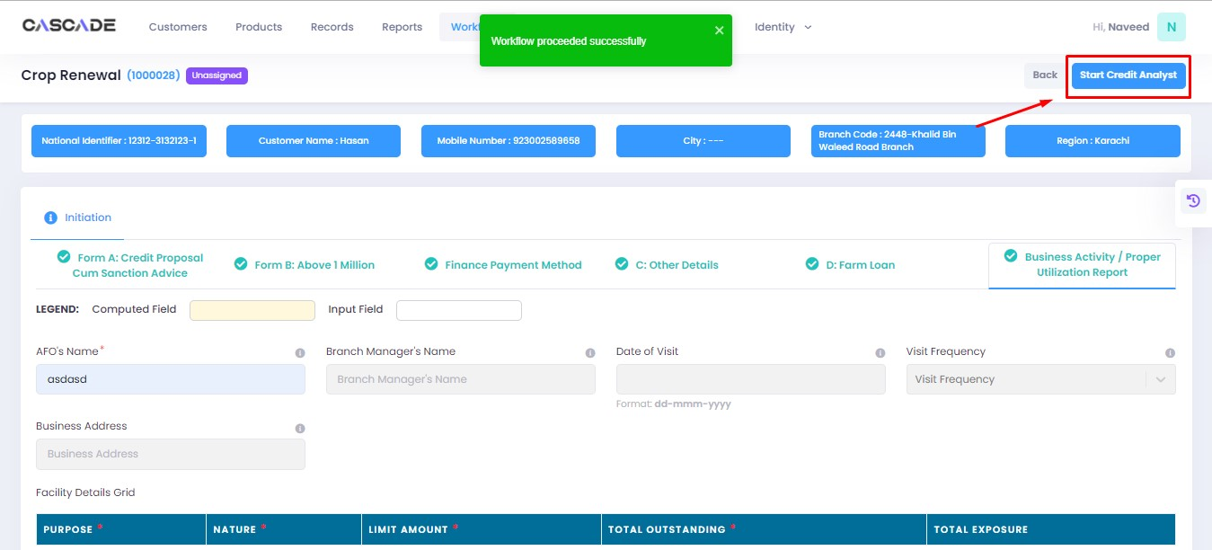

12. When on the ‘credit analyst’ stage, you can create a deviation by clicking on ‘quick panel’ on right side of the page.



13. Then under ‘deviations/exceptions’ you will see all the available deviations. Click on the one applicable to the application, leave remarks then click ‘create’.





14. Once created, the created deviation will show as ‘pending’ in the quick panel and will require approval from an approving authority before the application can be processed further.



15. Similar to the last stage, fill all the required fields under this stage until all groups are duly filled. Make changes in this stage if any. Then click on ‘validate’ then on ‘quick panel’ on the right side of the page to view the checklist of pending actions.

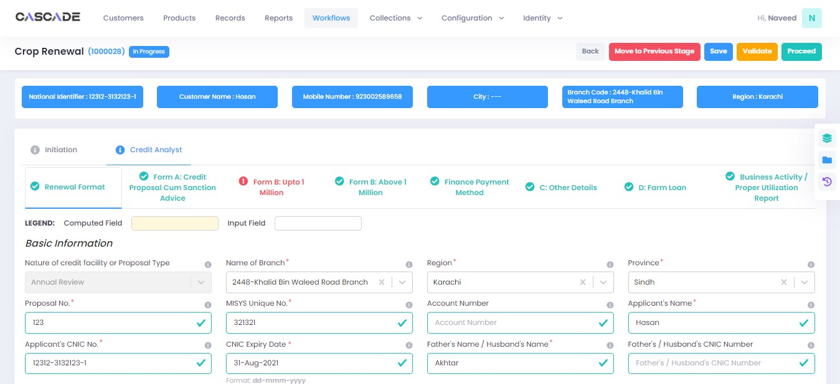

16. Under the ‘check list’ tab, you will see a list of the required documents and checks. Run all the checks and upload the required documents to proceed. Or defer if required.

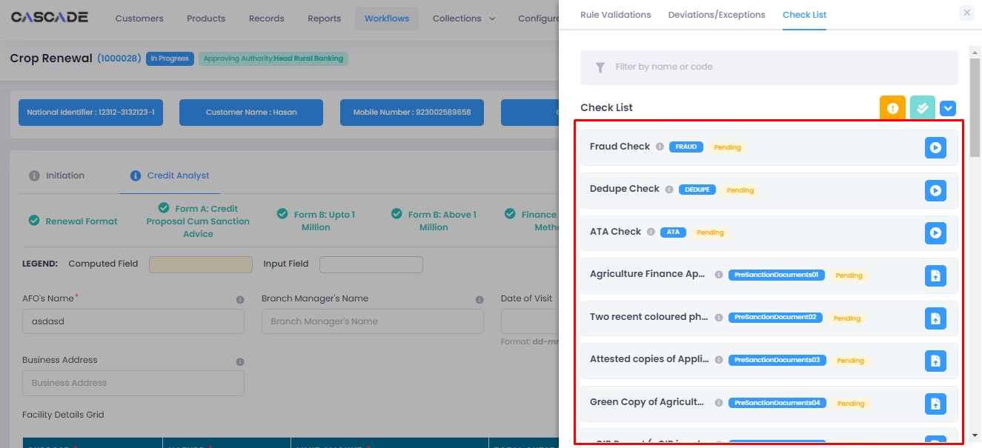

17. After going through the checklist, click on validate, and then proceed to move to the next stage.

**Note:** The workflow will now require approval from an approver.

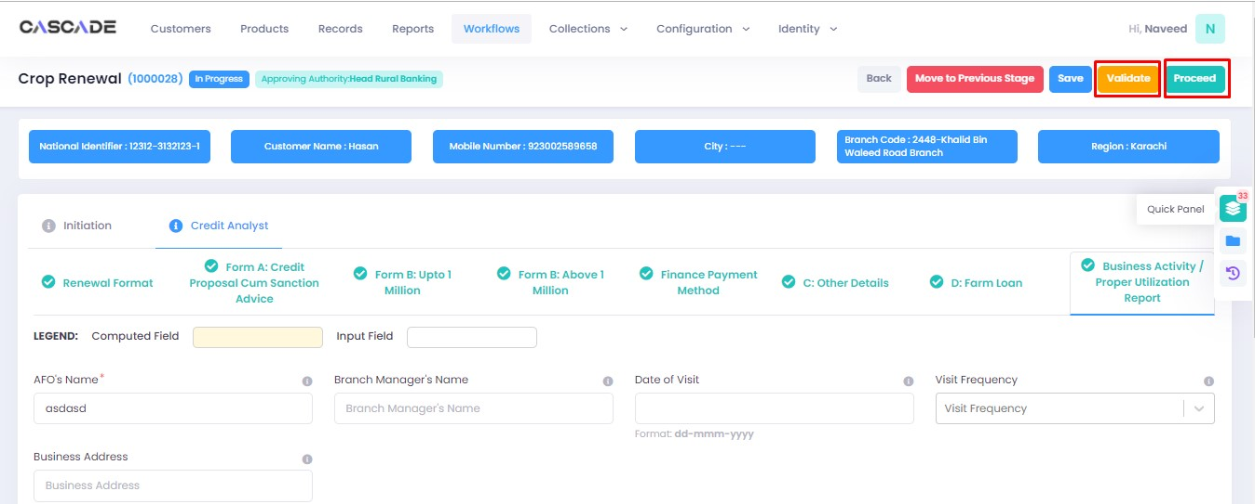

Checker

1. Now from the approver’s account, go to the workflows tab to view the in-progress journeys.



2. Select the product to show a list of the appropriate journeys. In this screenshot, you see the workflow with the status ‘Awaiting Authentication’.

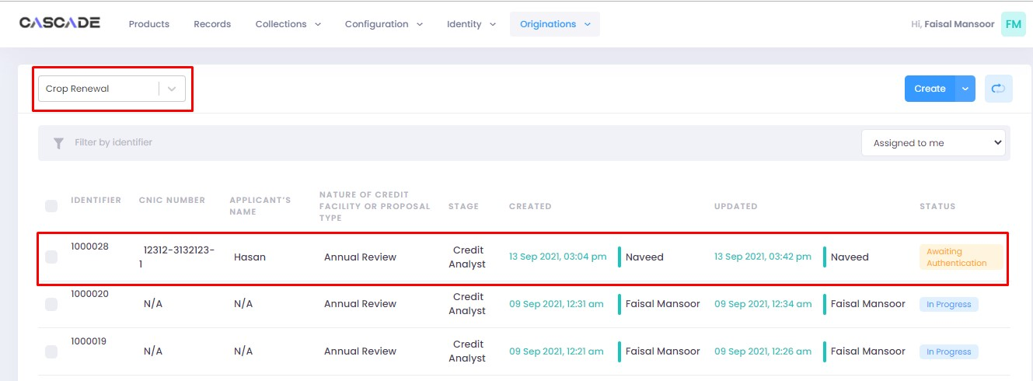

3. Click on ‘edit’ to proceed with the journey.

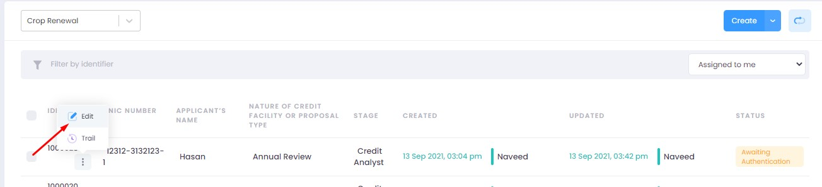

4. Now the approver will be able to see all the details of the journey filled by the maker of the workflow. After scrutinizing, click on the ‘authenticate’ button on the top right to recommend, approve or decline the application.

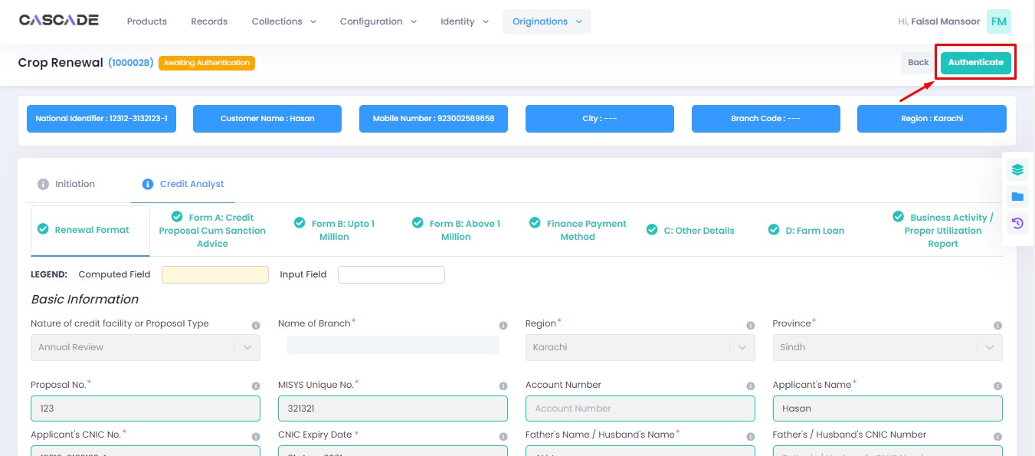

5. Fill the comment box with remarks, then ‘recommend’, ‘decline’ or ‘discard’ the application. Recommending will move the application forward, declining it will destroy the application, and discarding it will send back the application to the maker.

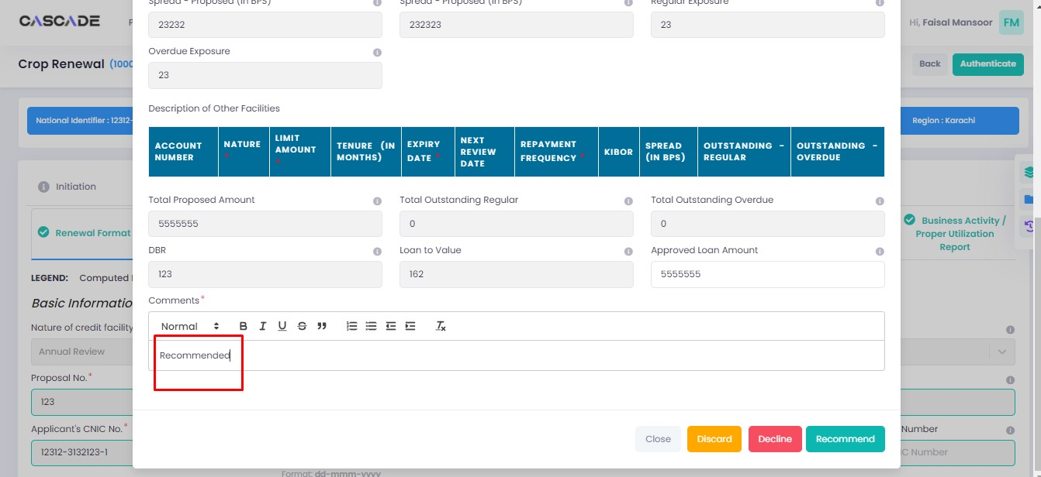

6. The application will require multiple recommendations from the relevant accounts until it is ‘approved’ by an account with appropriate rights. The screenshot below shows the names of the accounts the application has gone through so far with their comments.

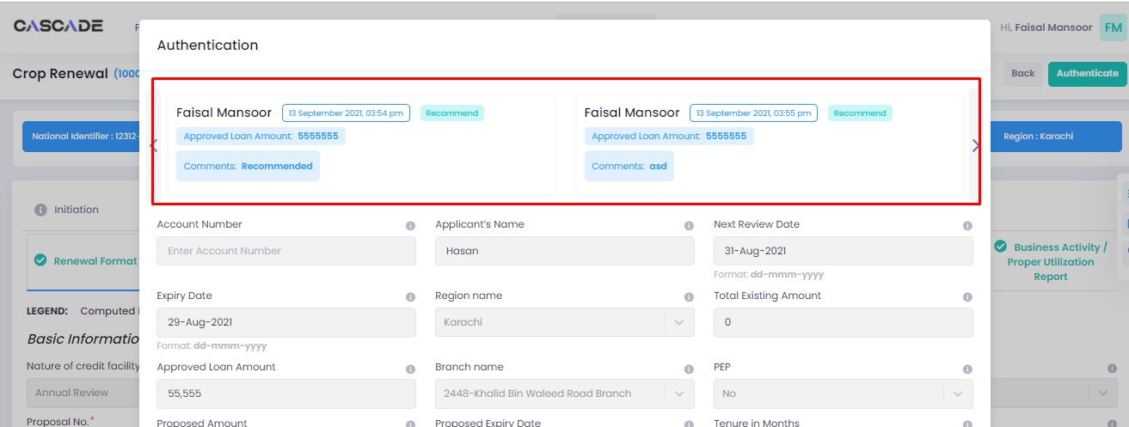

7. After the first recommendation, the second recommender will see the ‘move back’ button which will send the application back to the first recommender. In case of having gone through multiple recommendations the ‘move back’ button will send the application back to the previous approver.



8. After all the ‘recommendations’, the application will require an ‘approval’ from an account with appropriate rights.

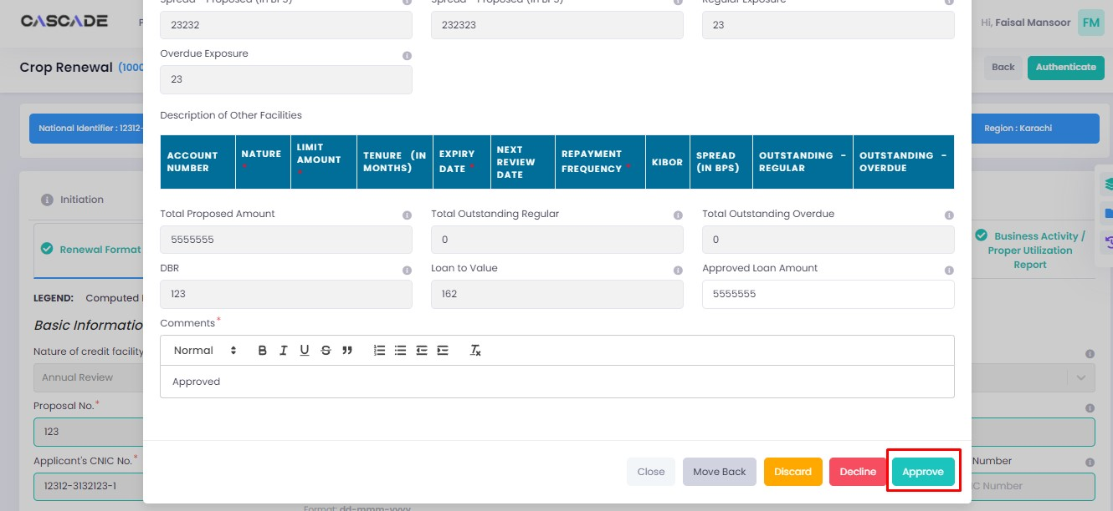

Maker

1. Once the application has been authenticated, it will reappear under the account of the ‘maker’. Go to the ‘workflows’ tab, then select the product, ‘Crop Renewal’ in this case, to show relevant applications, then select ‘unassigned’ in the drop down menu on the right. You will now see the concerned application with a status of ‘unassigned’.

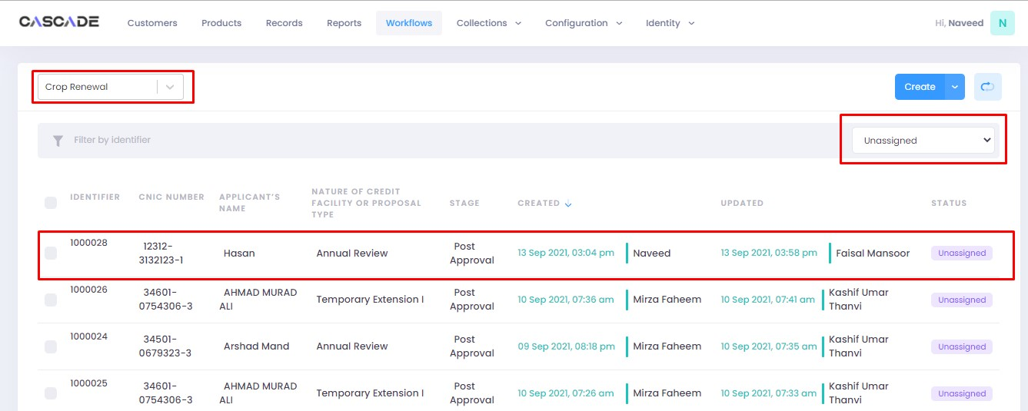

2. Click on ‘edit’, then click on ‘Start Post Approval’ to start the next stage.

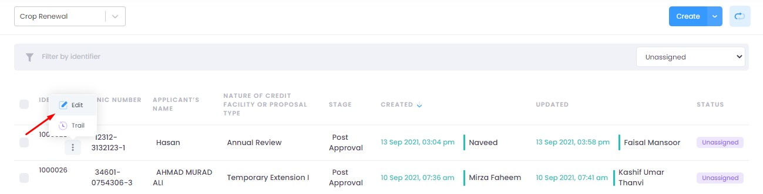

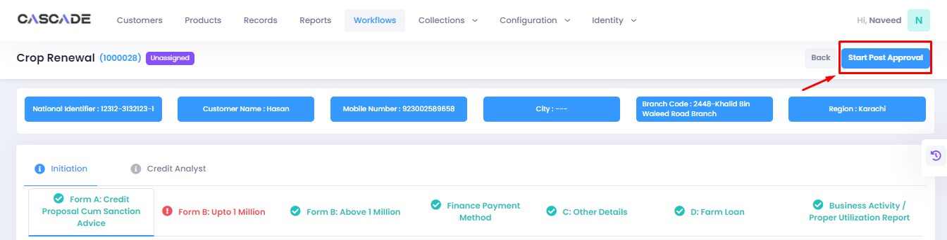

3. Fill all the required fields under ‘Post Approval Documents’ until no errors remain, then click on validate (1), then on the next group (2).

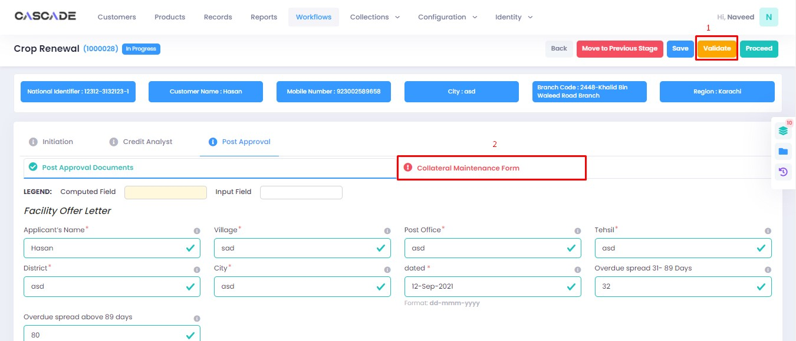

4. Fill all the required fields under ‘Collateral Maintenance Form’ until no errors remain, then click on validate (1). Then on the right side of the page, click on ‘quick panel’.

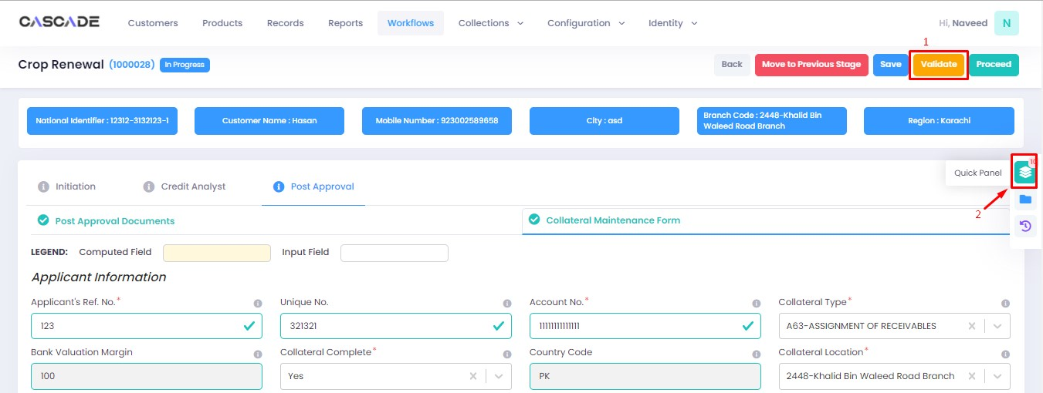

5. Here you will see the items that are pending before the application can be processed further. Upload the required documents to proceed. Or defer if inapplicable.

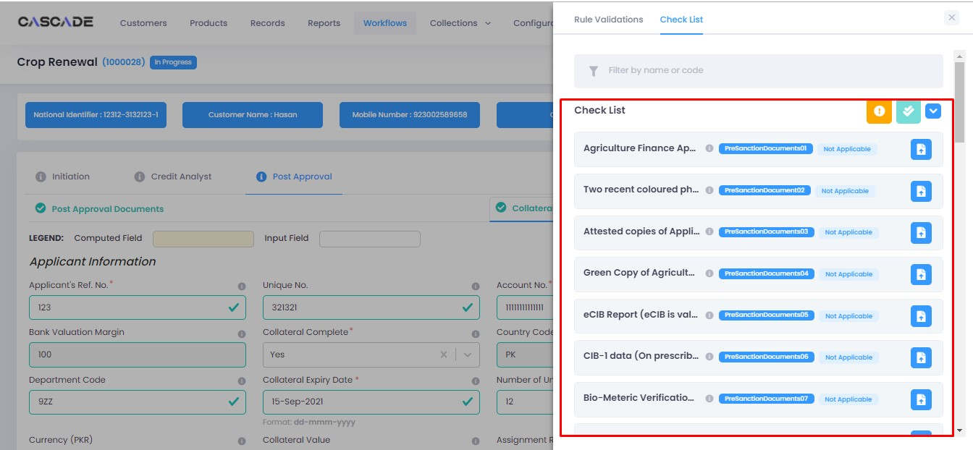

6. After uploading all the required documents, click on validate (1) then click on proceed (2).

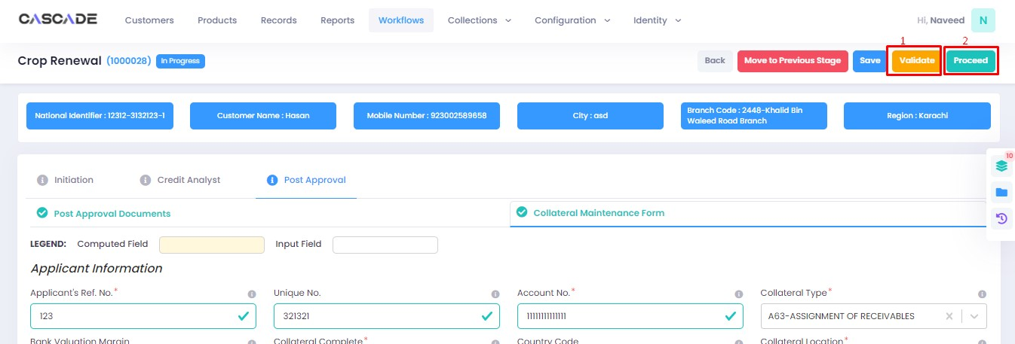

7. Now click on ‘Start RCAD’ to start the next stage in the workflow.

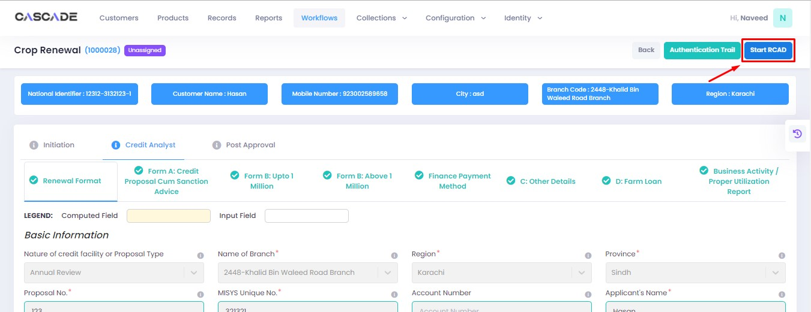

8. Fill all the required fields under ‘AT’ until no errors remain, then click on ‘validate’ (1), then on ‘quick panel’ on the right side of the page.

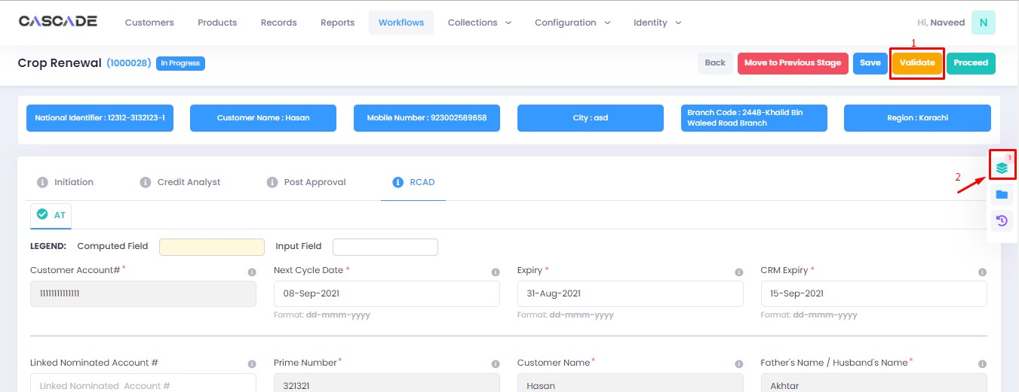

9. Upload the required documents or defer if required, then click on validate then on proceed.

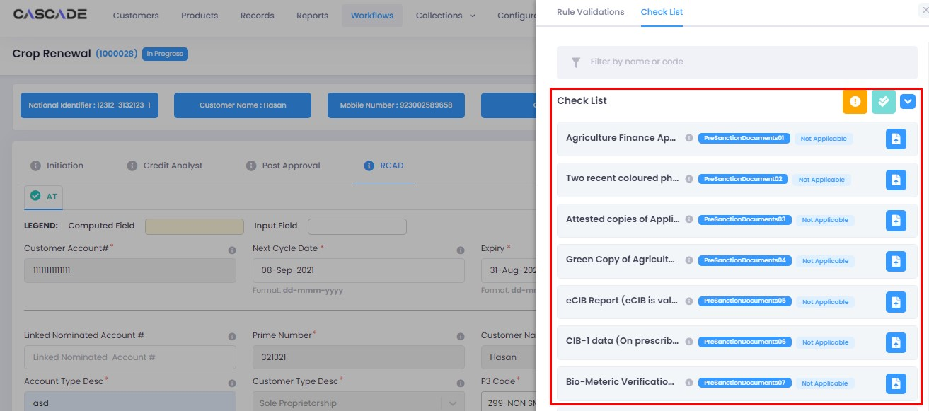

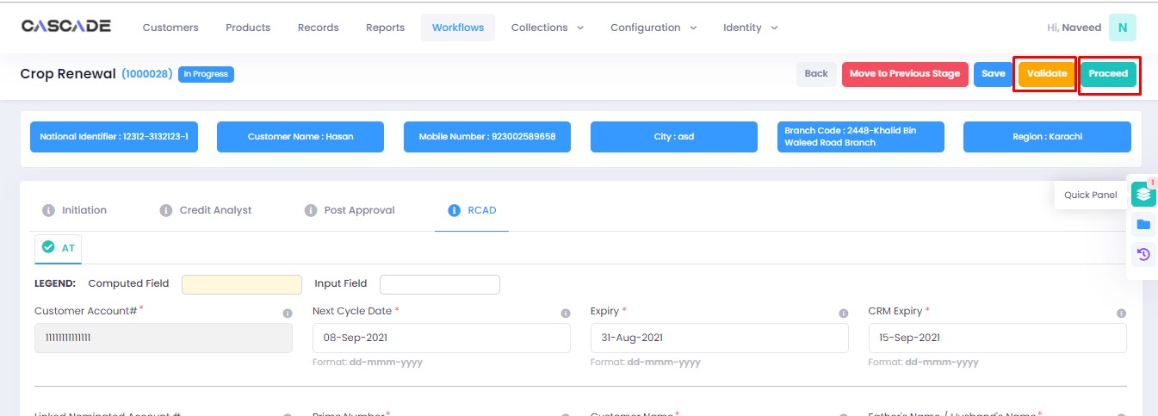

Checker

1. Now from the approver’s account, go to the workflows tab to view the in-progress journeys.



2. Select the product to show a list of the appropriate journeys. In this screenshot, you see the workflow with the status ‘Awaiting Authentication’.

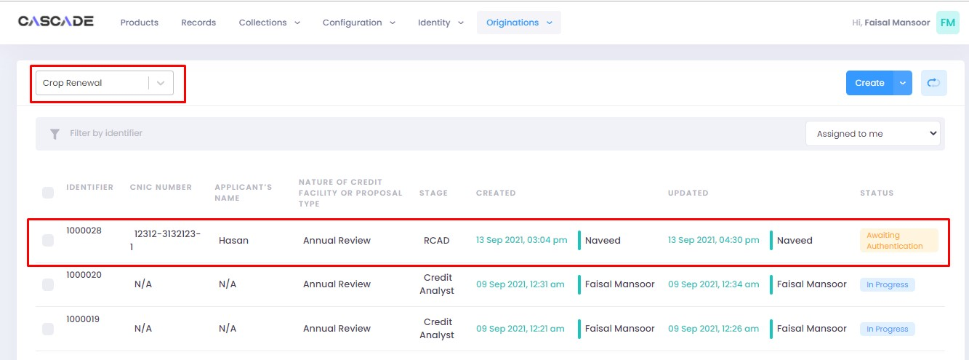

3. Click on ‘edit’ to proceed with the journey.

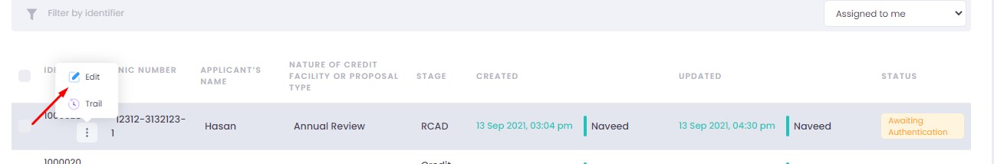

4. Now the approver will be able to see all the details of the journey filled by the maker of the workflow. After scrutinizing, click on the ‘authenticate’ button on the top right to approve or decline the application.

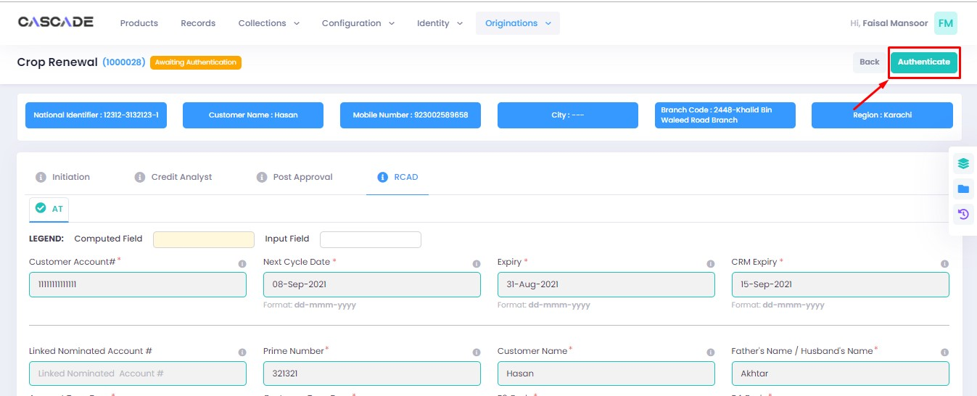

5. Fill the comment box with remarks, then ‘approve’, ‘decline’ or ‘discard’ the application. Recommending will move the application forward, declining it will destroy the application, and discarding it will send back the application to the maker.



6. Under the workflows tab, select ‘Crop Renewal’ as the product then ‘unassigned’ to display the relevant application.

**Note**: Application will only be visible to account with relevant rights

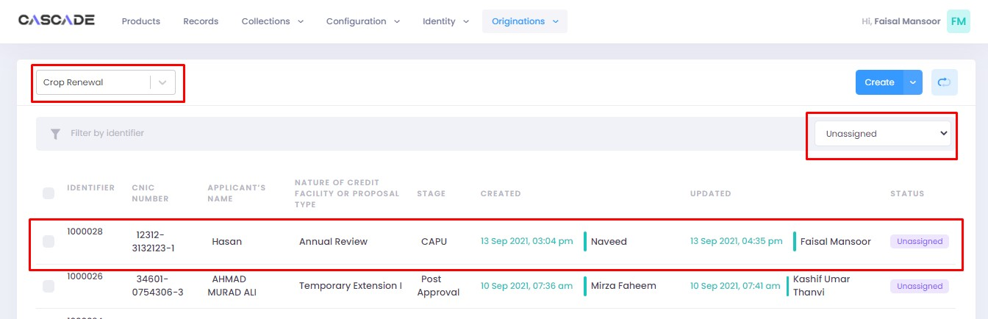

7. Then click on ‘edit’ to further proceed.

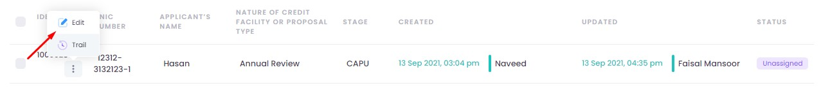

8. Now click on ‘Start CAPU’ to move to the next stage.

**Note**: CAPU can only be initiated and worked on from the account with relevant rights.

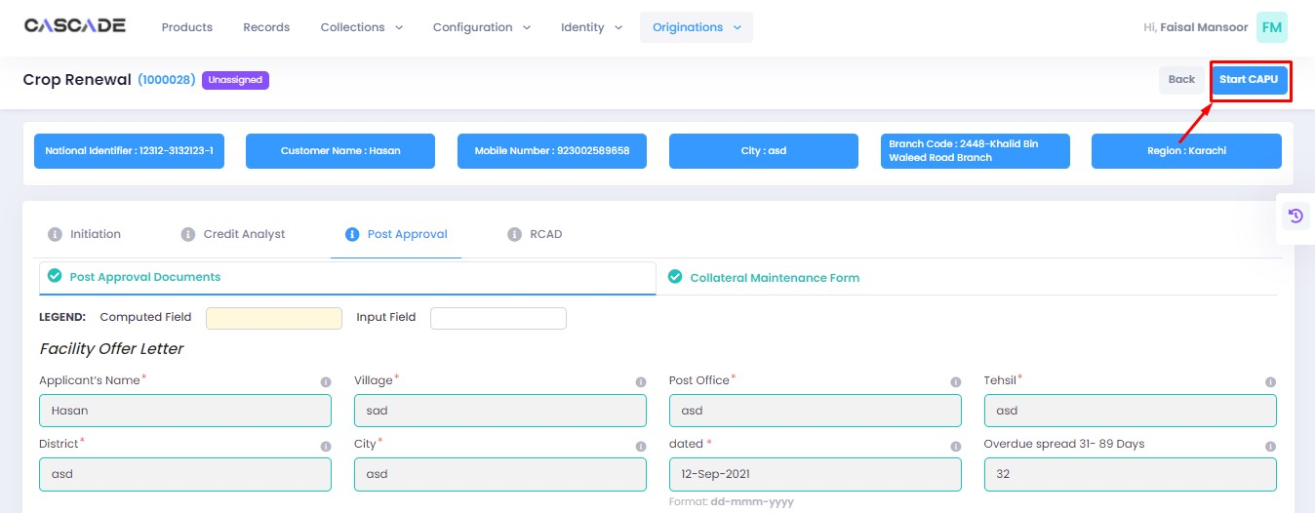

9. Fill all the required fields then click on validate (1) then on proceed (2).

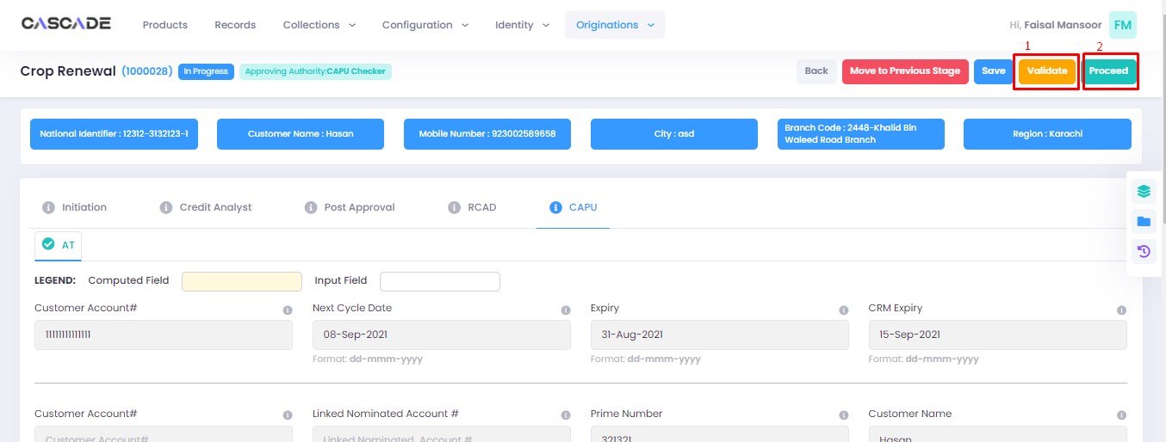

10. The application will now require approval by the CAPU checker.

CAPU checker will click on ‘authenticate’, leave remarks, then approve or decline the application

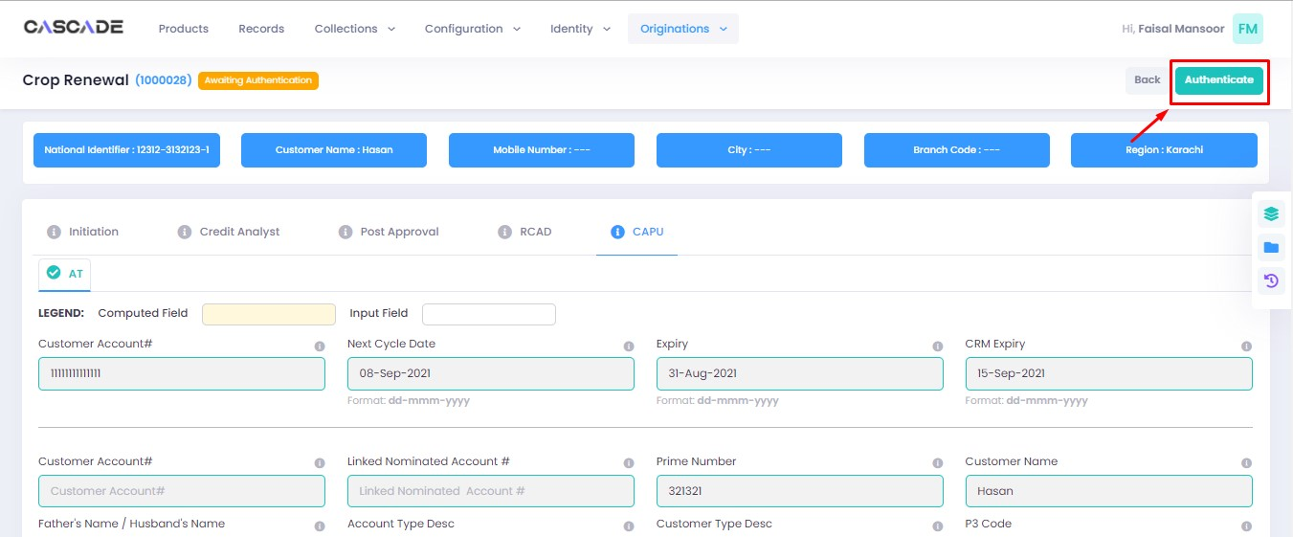

Fill the comment box with remarks, then ‘approve’, ‘decline’ or ‘discard’ the application. Recommending will move the application forward, declining it will destroy the application, and discarding it will send back the application to the maker.

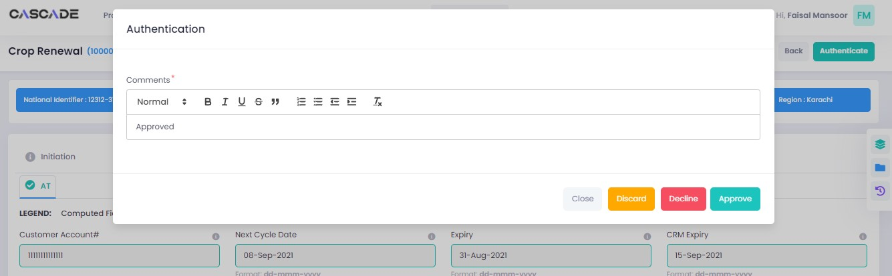

11. The application will now be marked as completed and ready to be disbursed.

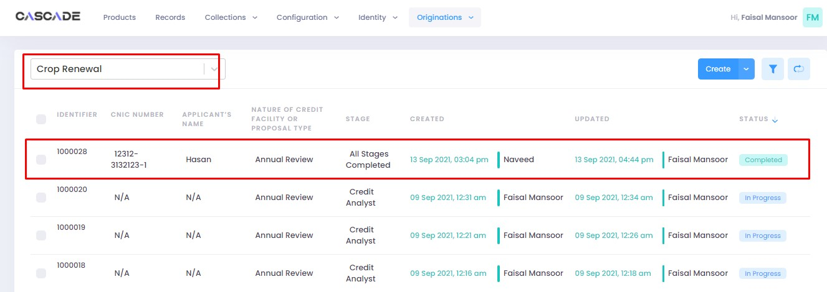

# Product: Fishery NTB

Maker

1. Under the Workflows tab, select the product, then click on ‘create’ to start a new application.

**Note:** Products and workflows shown will vary according to the rights assigned to a user account.

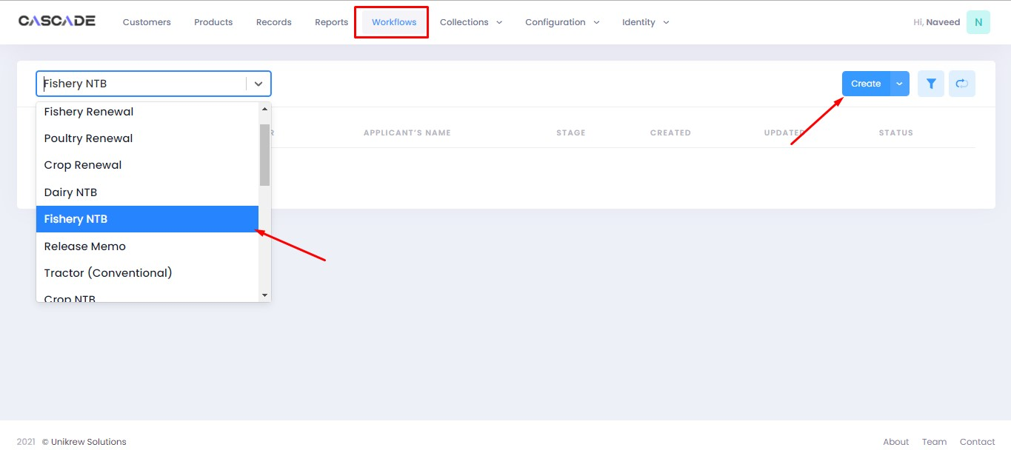

2. Fill the details, then click on ‘proceed’.

**Note**: Depending on the values selected under the fields ‘Is Lead Generation’ and ‘AFO’, new fields and stages in the workflow will appear.

**Lead Generation**: Will allow to manually add details of a prospect.

**AFO**: Allows for ‘data entry’ prior to any stage. The details will then be carried into the ‘credit analyst stage’.

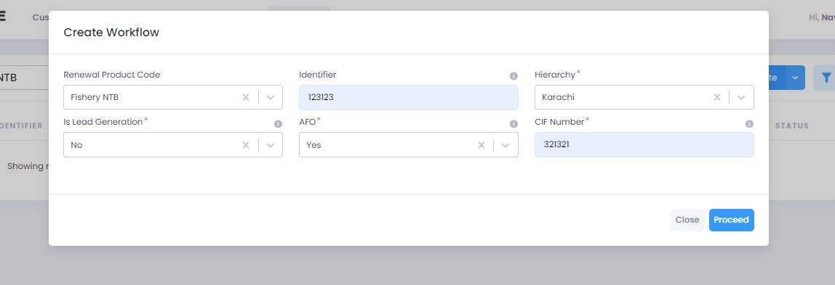

3. After filling all the fields, click on validate (1) to check for errors or missing fields (2). Once there are no errors left, click on the next Group (3) to proceed with the journey.

**Note:** Form B will appear according to the ‘proposed loan amount’ (Up to 1 million or Over 1 million) entered in Form A.

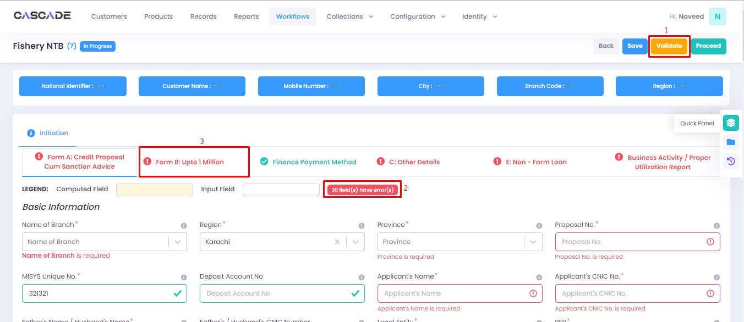

4. Fill all the required fields in the rest of the groups, then click on validate, then click on proceed.

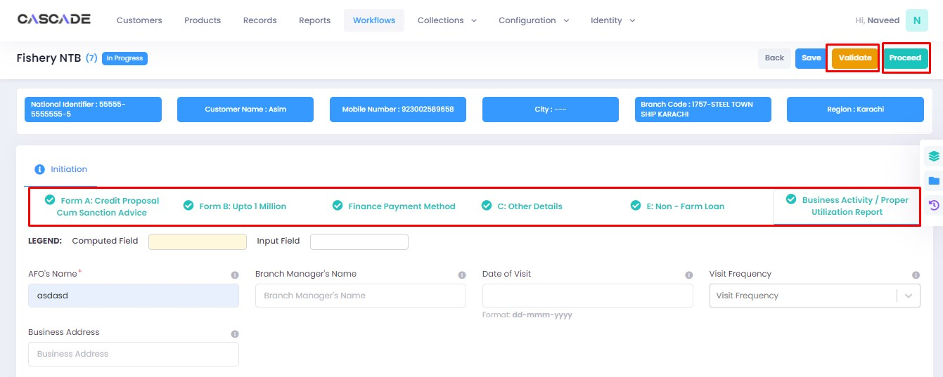

5. Click on ‘Start Credit Analyst’ to start the next stage.

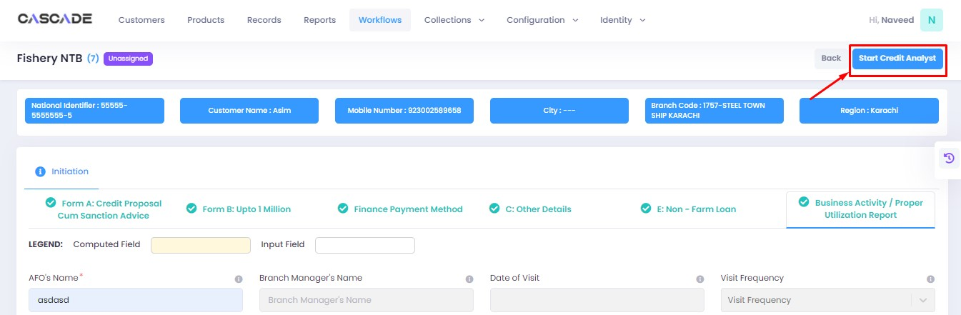

6. When on the ‘credit analyst’ stage, you can create a deviation by clicking on ‘quick panel’ on right side of the page.



7. Then under ‘deviations/exceptions’ you will see all the available deviations. Click on the one applicable to the application, leave remarks then click ‘create’.





8. Once created, the created deviation will show as ‘pending’ in the quick panel and will require approval from an approving authority before the application can be processed further.



9. Then similar to the last stage, fill all the required fields under this stage until all groups are duly filled. Make changes in this stage if any. Then click on ‘validate’, then on ‘quick panel’ on the right side of the page to view the checklist of pending actions.

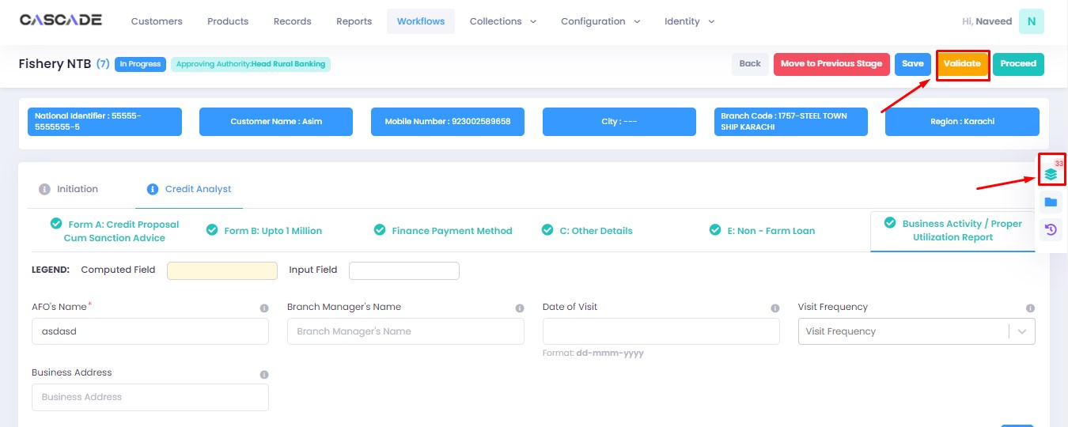

10. Under the ‘check list’ tab, you will see a list of the required documents and checks. Run all the checks and upload the required documents to proceed. Or defer if required.

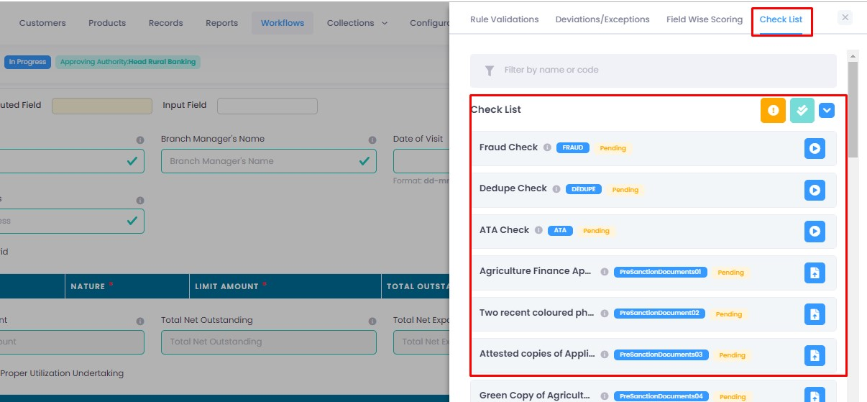

11. After going through the checklist, click on validate, and then proceed to move to the next stage.

**Note:** The workflow will now require approval from an approver.

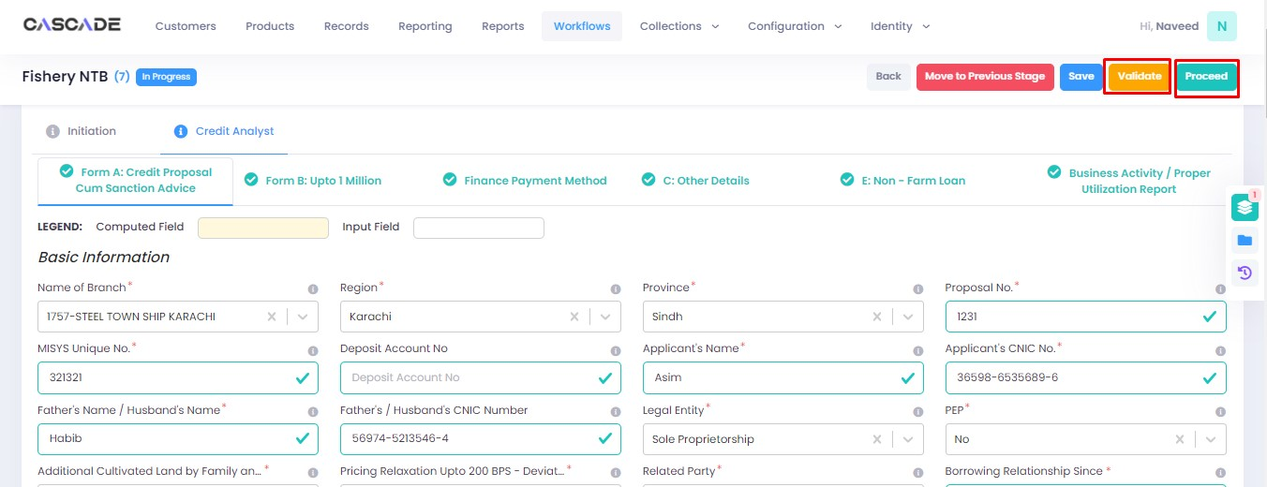

Checker

1. Now from the approver’s account, go to the workflows tab to view the in-progress journeys.



2. Select the product to show a list of the appropriate journeys. In this screenshot, you see the workflow with the status ‘Awaiting Authentication’.

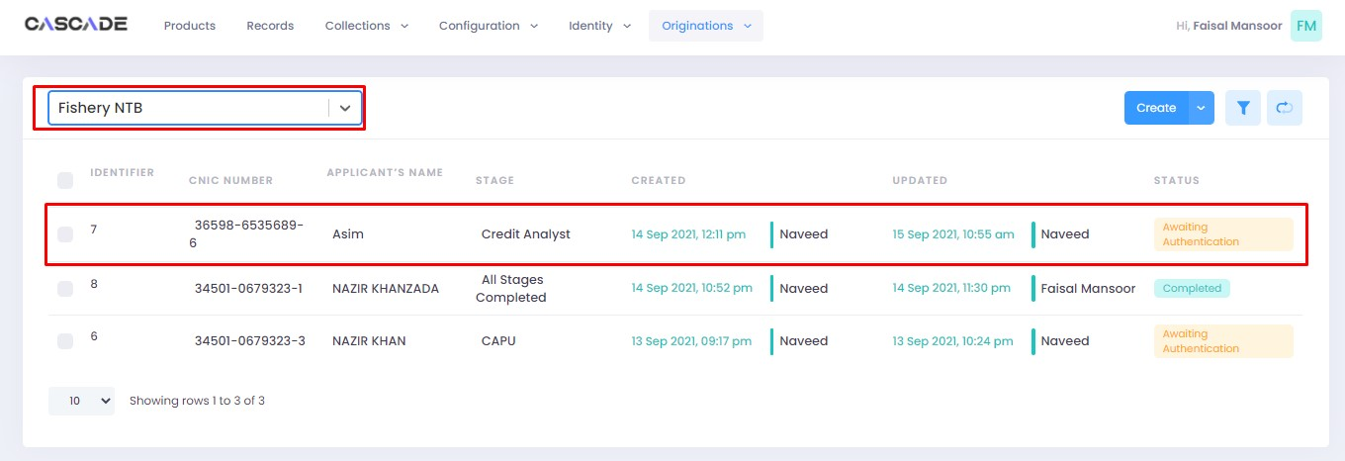

3. Click on ‘edit’ to proceed with the journey.

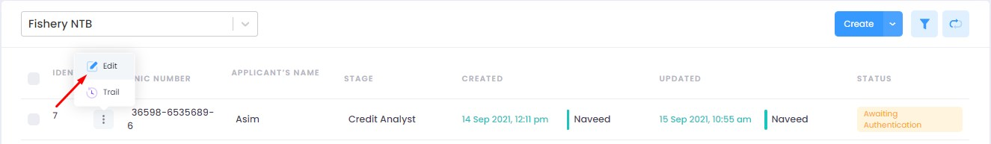

4. Now the approver will be able to see all the details of the journey filled by the maker of the workflow. After scrutinizing, click on the ‘authenticate’ button on the top right to approve or decline the application.

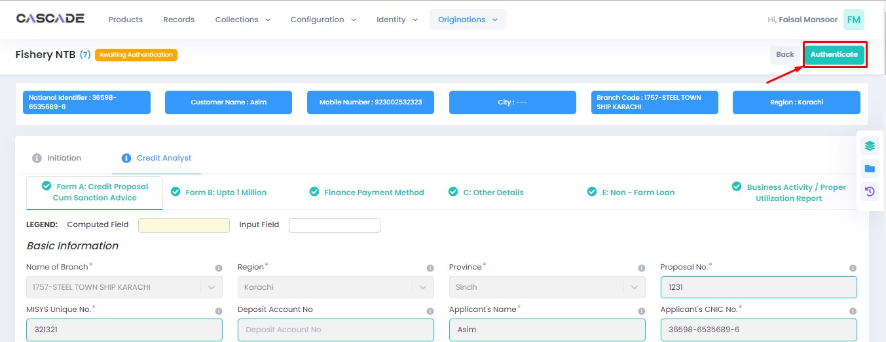

5. Fill the comment box with remarks, then ‘recommend’, ‘decline’ or ‘discard’ the application. Recommending will move the application forward, declining it will destroy the application, and discarding it will send back the application to the maker.

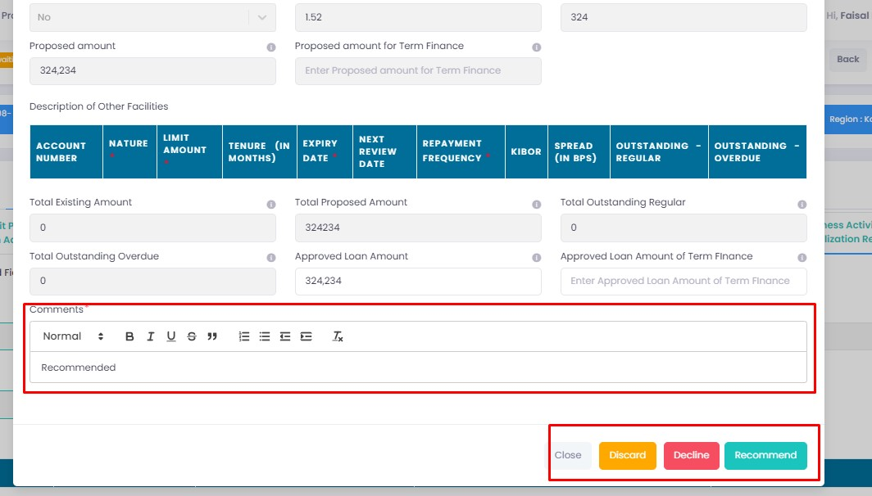

6. The application will require multiple recommendations from the relevant accounts until it is ‘approved’ by an account with appropriate rights. The screenshot below shows the names of the accounts the application has gone through so far with their comments.

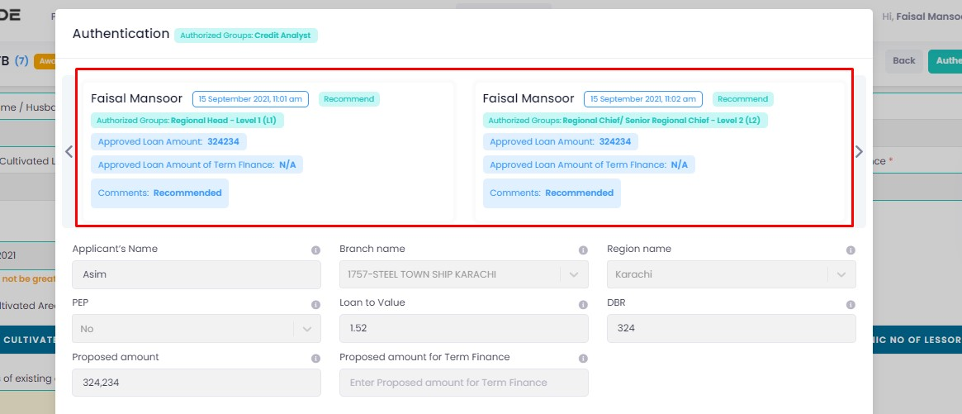

7. After the first recommendation, the second recommender will see the ‘move back’ button which will send the application back to the first recommender. In case of having gone through multiple recommendations the ‘move back’ button will send the application back to the previous approver.



8. After all the ‘recommendations’, the application will require an ‘approval’ from an account with appropriate rights.

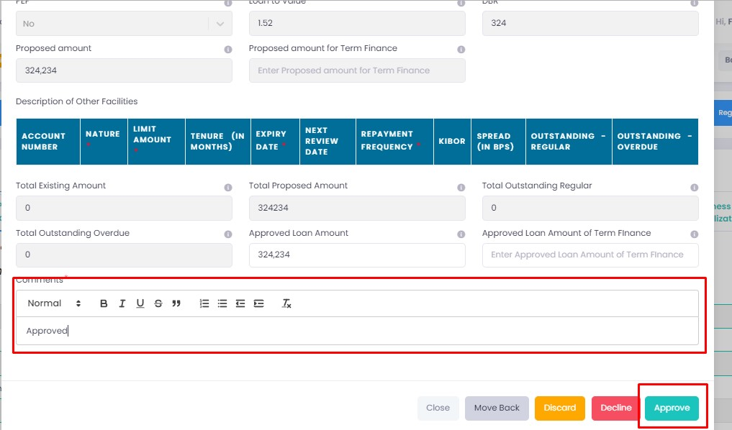

Maker

1. Once the application has been authenticated, it will reappear under the account of the ‘maker’. Go to the ‘workflows’ tab, then select the product, ‘Fishery NTB’ in this case, to show relevant applications, then select ‘unassigned’ in the filters. You will now see the concerned application with a status of ‘unassigned’.

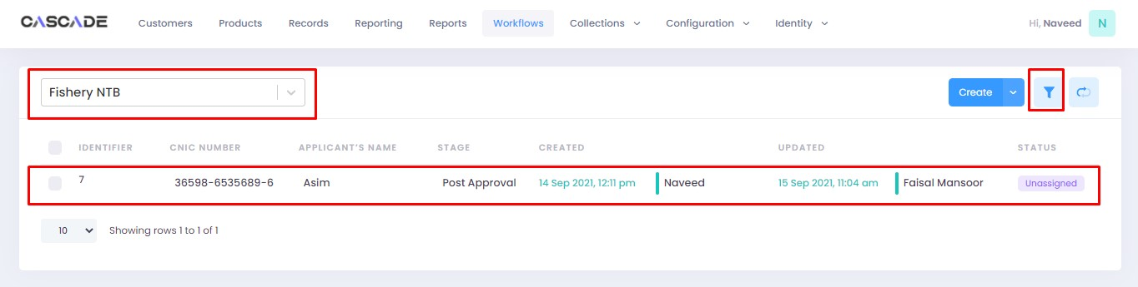

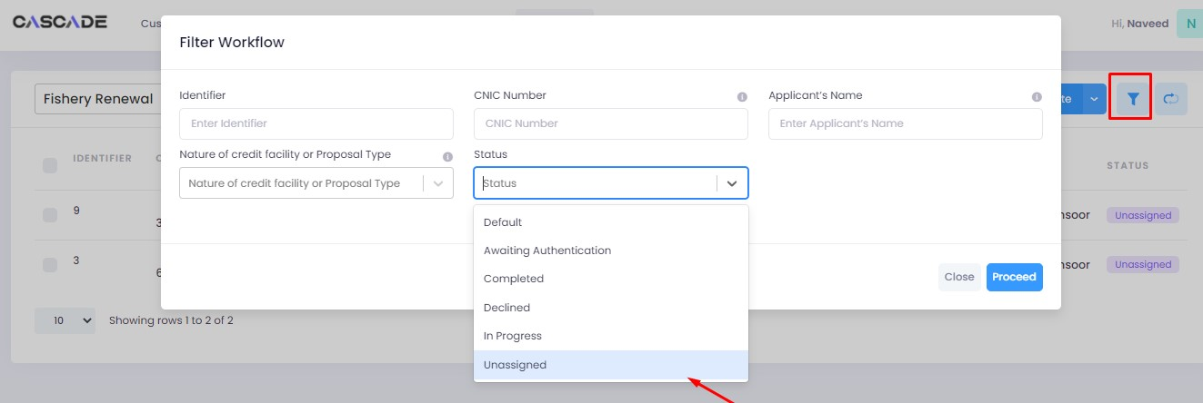

2. Click on ‘edit’, then click on ‘Start Post Approval’ to start the next stage.

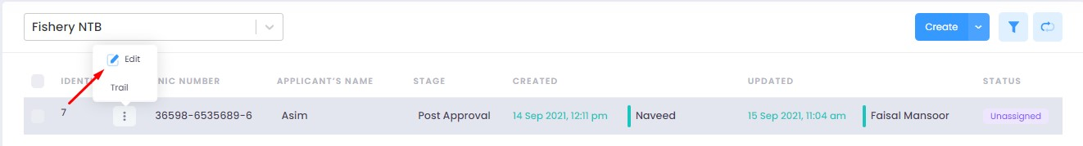

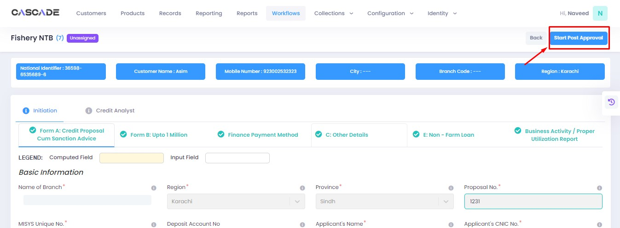

3. Fill all the required fields under ‘Post Approval Documents’ until no errors remain, then click on validate (1), then on the next group (2).

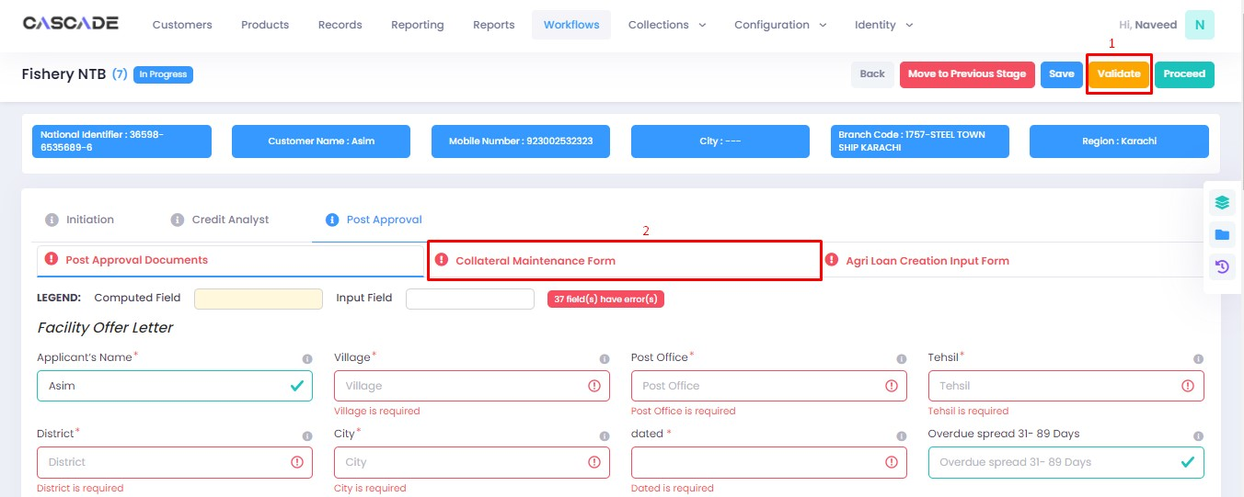

4. Fill all the required fields in rest of the groups, then click on validate (1), then on ‘quick panel’ (2).

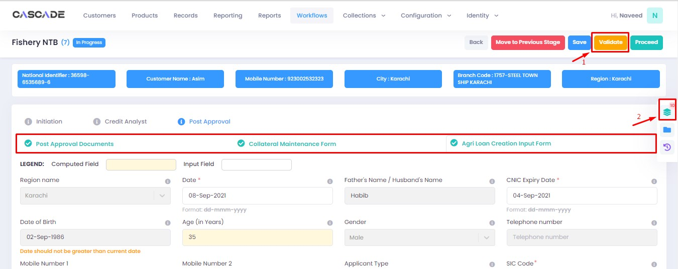

5. Here you will see the items that are pending before the application can be processed further. Upload the required documents to proceed. Or defer if inapplicable.

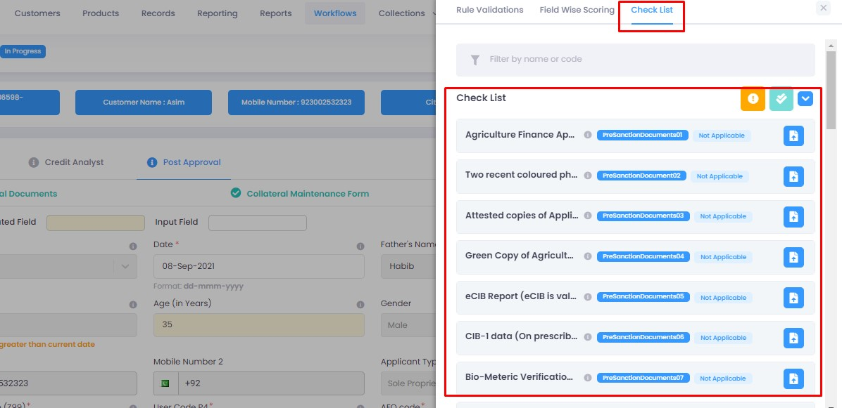

6. After uploading all the required documents, click on validate (1) then click on proceed (2).

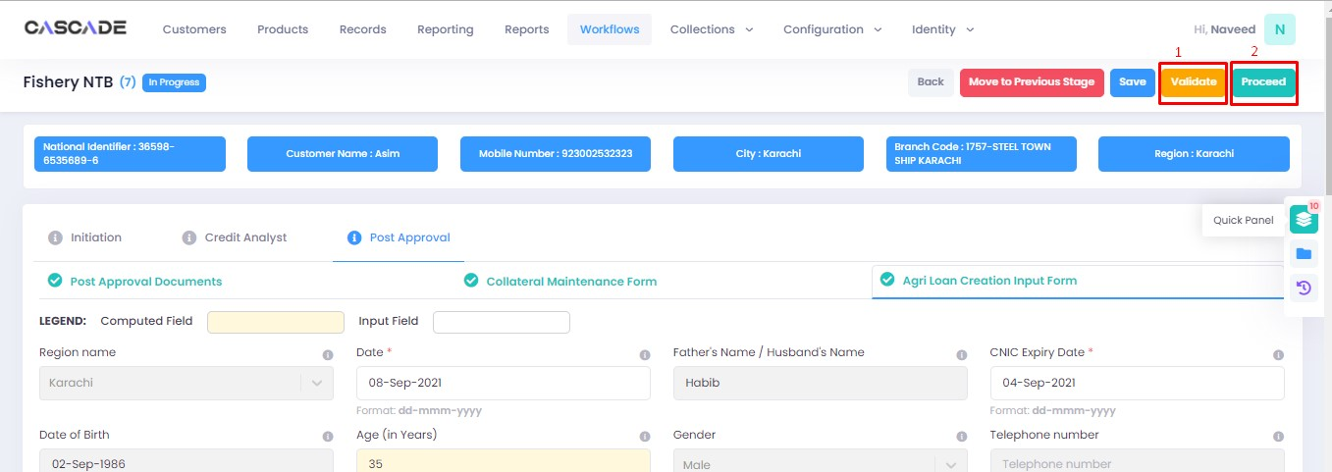

7. Now click on ‘Start RCAD’ to start the next stage in the workflow.

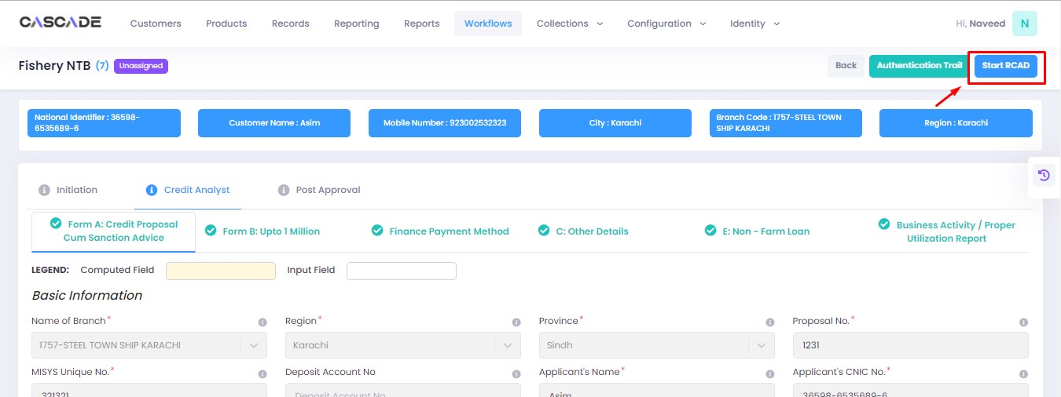

8. Fill all the required fields under ‘AT’ until no errors remain, then click on ‘validate’, then on ‘quick panel’ on the right side of the page.

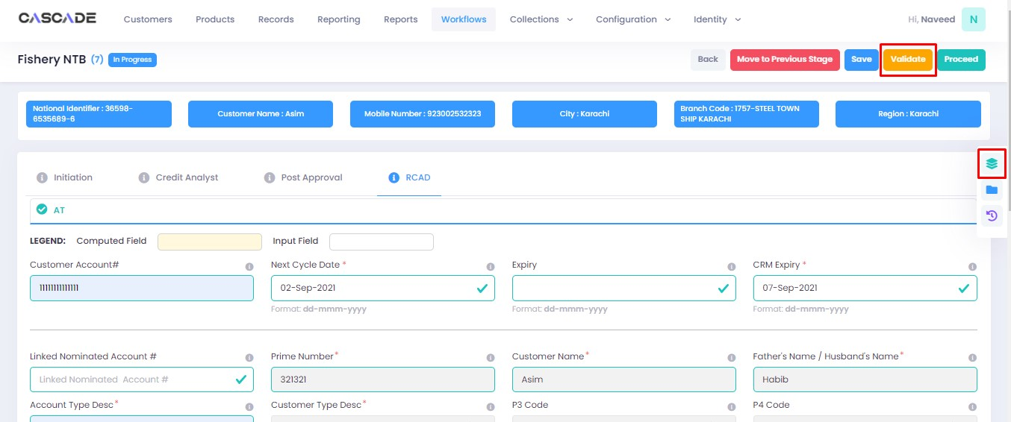

9. Upload the required documents or defer if required, then click on validate and then on proceed.

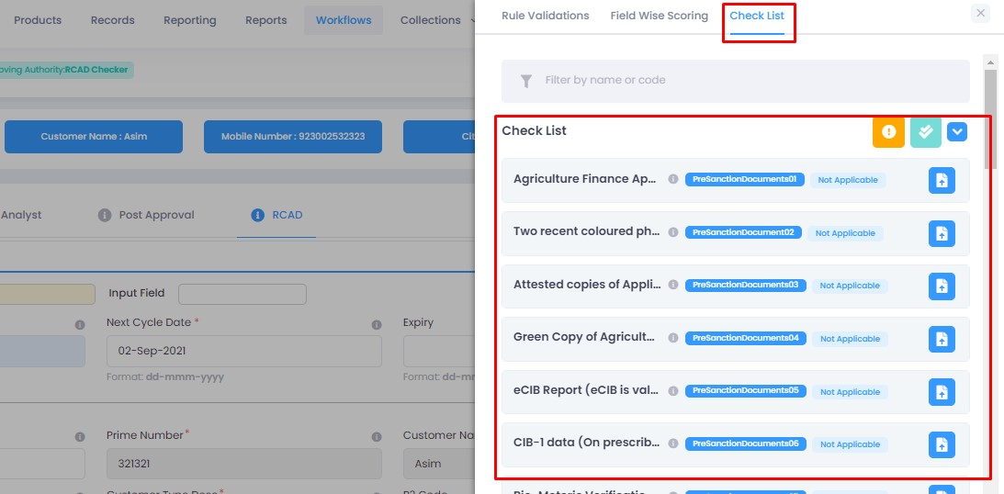

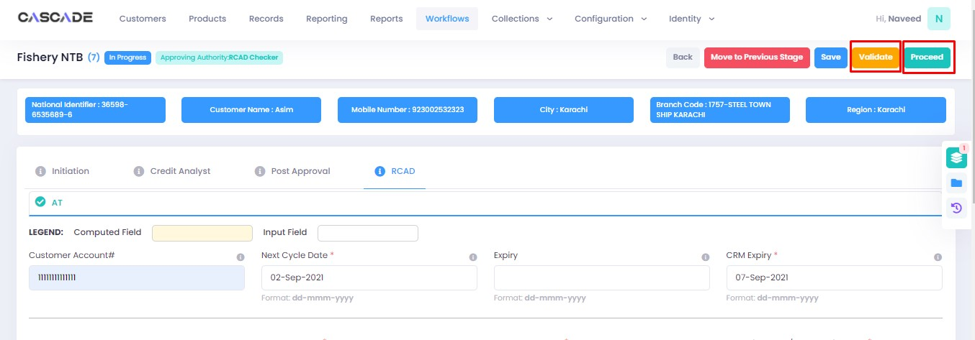

Checker

1. Now from the approver’s account, go to the workflows tab to view the in-progress journeys.



2. Select the product to show a list of the appropriate journeys. In this screenshot, you see the workflow with the status ‘Awaiting Authentication’.

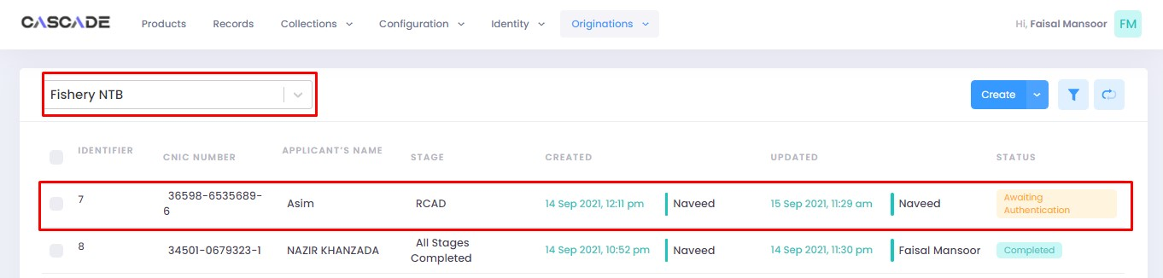

3. Click on ‘edit’ to proceed with the journey.

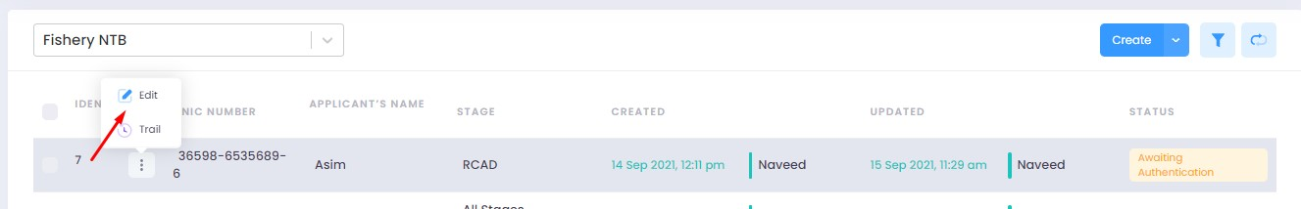

4. Now the approver will be able to see all the details of the journey filled by the maker of the workflow. After scrutinizing, click on the ‘authenticate’ button on the top right to approve or decline the application.

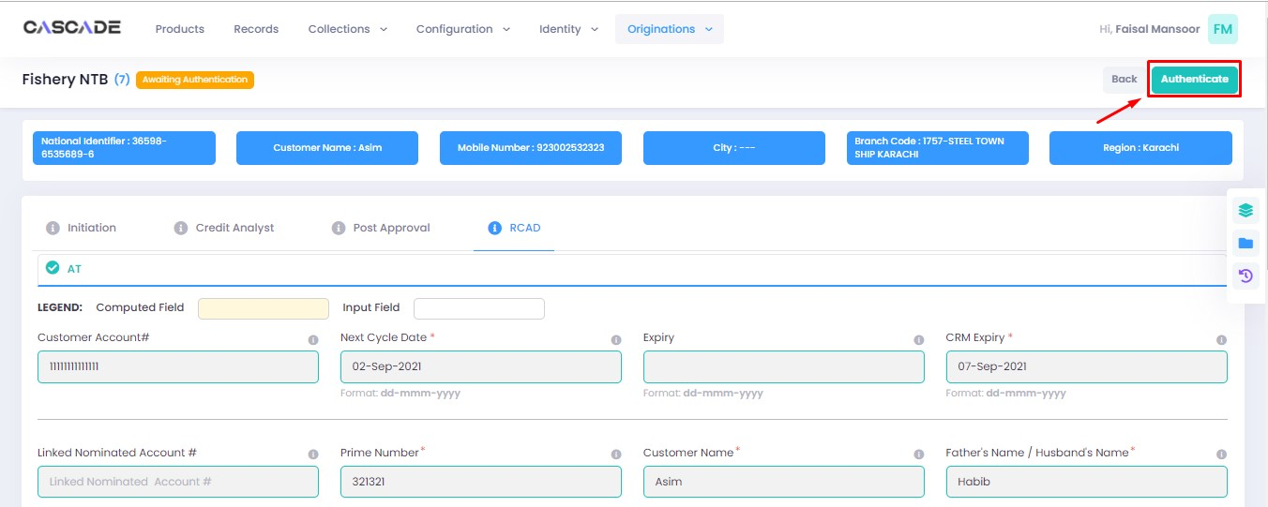

5. Fill the comment box with remarks, then ‘approve’, ‘decline’ or ‘discard’ the application. Recommending will move the application forward, declining it will destroy the application, and discarding it will send back the application to the maker.

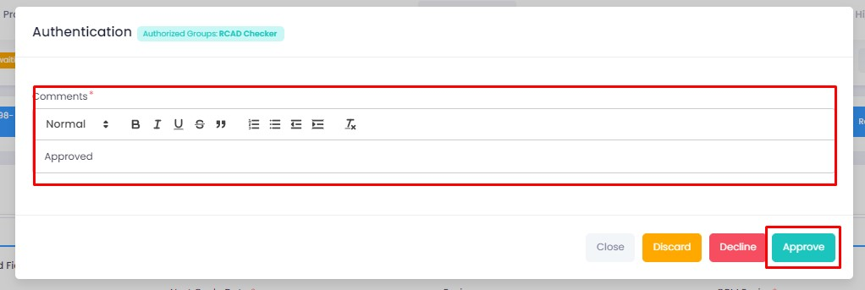

6. Under the workflows tab, select ‘Fishery NTB’ as the product then ‘unassigned’ from the filters to display the relevant application.

**Note:** Application will only be visible to account with relevant rights.

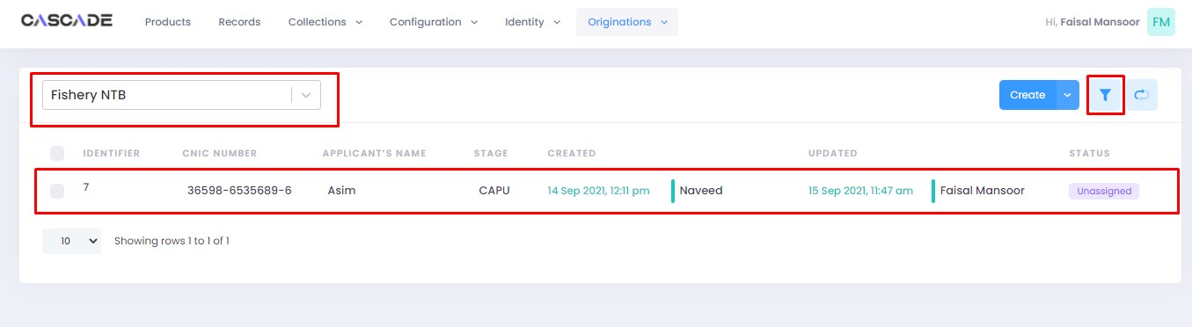

7. Then click on ‘edit’ to further proceed.

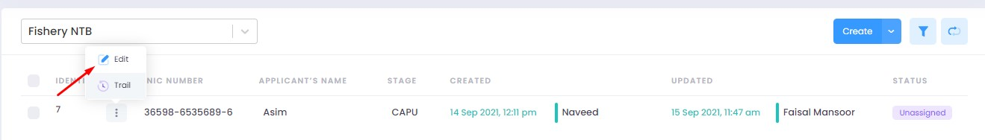

8. Now click on ‘Start CAPU’ to move to the next stage.

**Note**: CAPU can only be initiated and worked on from the account with relevant rights.

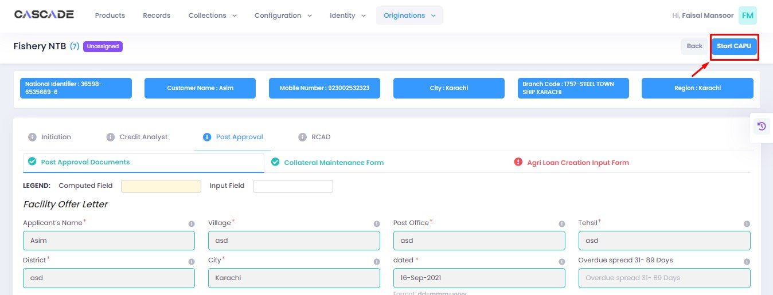

9. Fill all the required fields under all groups then click on validate then on proceed.

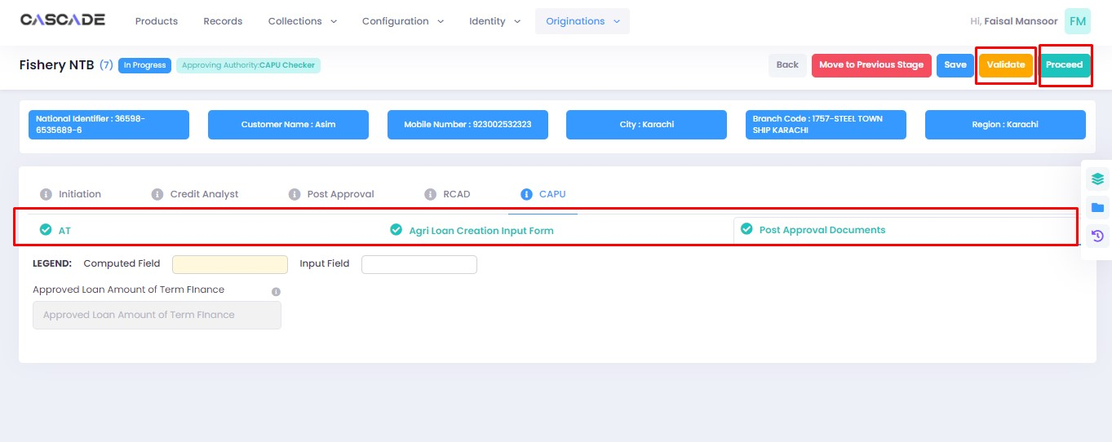

10. The application will now require approval by the CAPU checker.

CAPU checker will click on ‘authenticate’, leave remarks, then approve or decline the application.

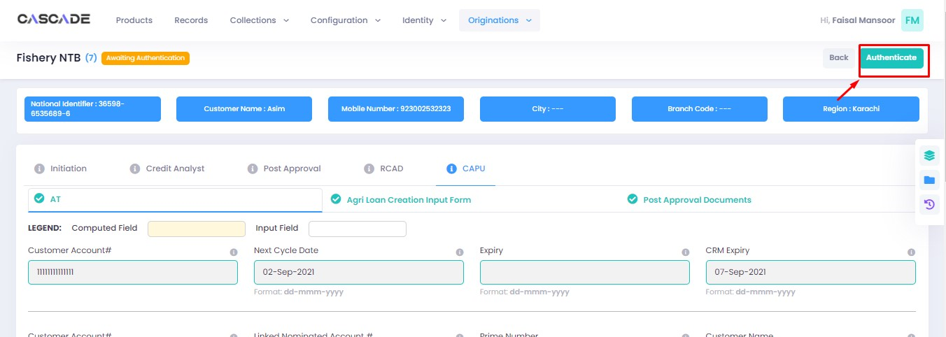

Fill the comment box with remarks, then ‘approve’, ‘decline’ or ‘discard’ the application. Recommending will move the application forward, declining it will destroy the application, and discarding it will send back the application to the maker.

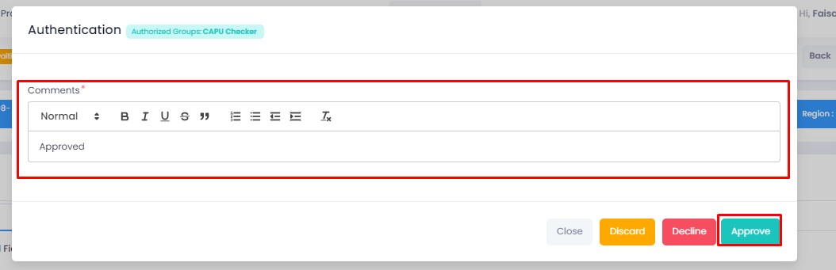

11. The application will now be marked as completed and ready to be disbursed.

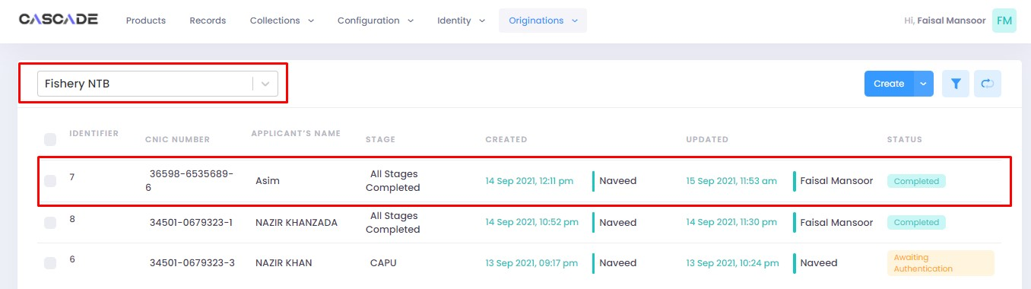

# Product: Fishery Renewal

Maker

1. Under the Workflows tab, select the product, then click on ‘create’ to start a new application.

**Note**:Products and workflows shown will vary according to the rights assigned to a user account.

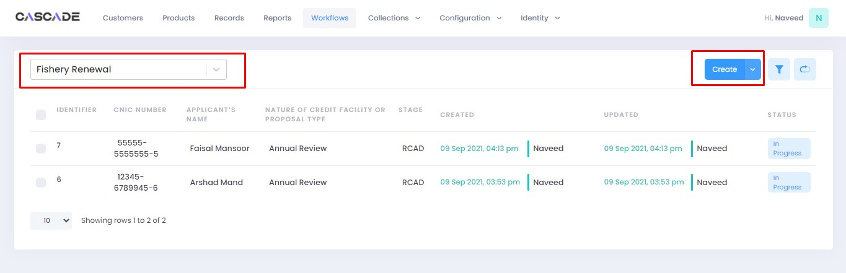

2. Fill the details, then click on ‘proceed’.

**Note**: Depending on the value selected under the field ‘form type’ and ‘AFO’, new fields in the application might appear.

**Form Type:** You will be able to choose form type between ‘one pager’ or ‘full form’. Fields and stages will vary in both form types (examples shown below).

**AFO**: Allows for ‘data entry’ prior to any stage. The details will then be carried into the ‘credit analyst stage’.

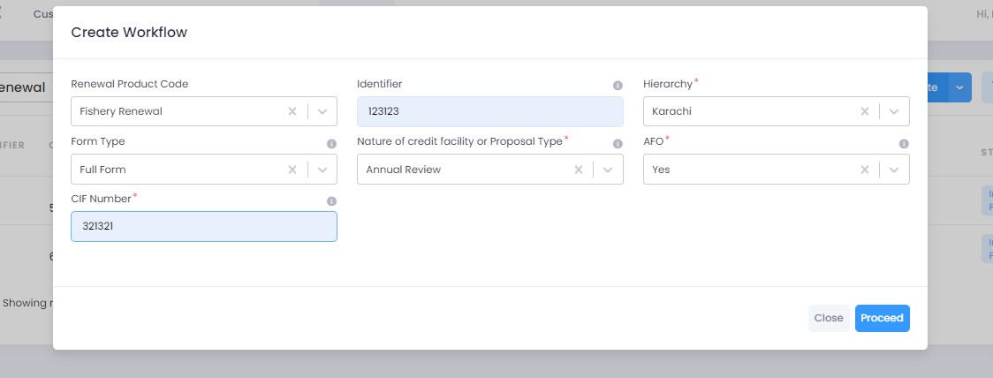

## Form Type: One Pager

3. After filling all the fields, click on validate (1) to check for errors or missing fields. Once there are no errors left, click on the next Group (2) to proceed with the journey.



4. Fill all the required fields under this group. Then click on ‘validate’ (1) then on ‘quick panel’ (2) on the right side of the page to view the checklist of pending actions.



5. Under the ‘check list’ tab, you will see a list of the required documents and checks. Run all the checks and upload the required documents to proceed. Or defer if required.



## Form Type: Full Form

6. After filling all the fields, click on validate (1) to check for errors or missing fields (2). Once there are no errors left, click on the next Group (3) to proceed with the journey.

**Note:** Form B will appear according to the ‘proposed loan amount’ (Up to 1 million or Over 1 million) entered in Form A.

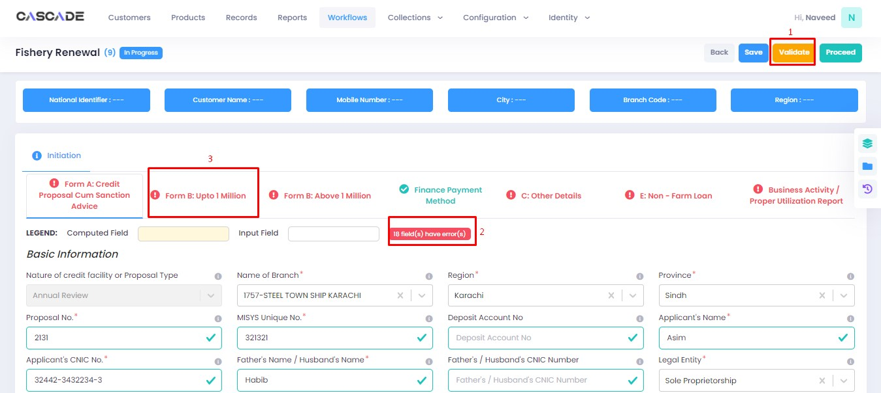

7. Fill all the required fields in the rest of the groups, then click on validate, then click on proceed.

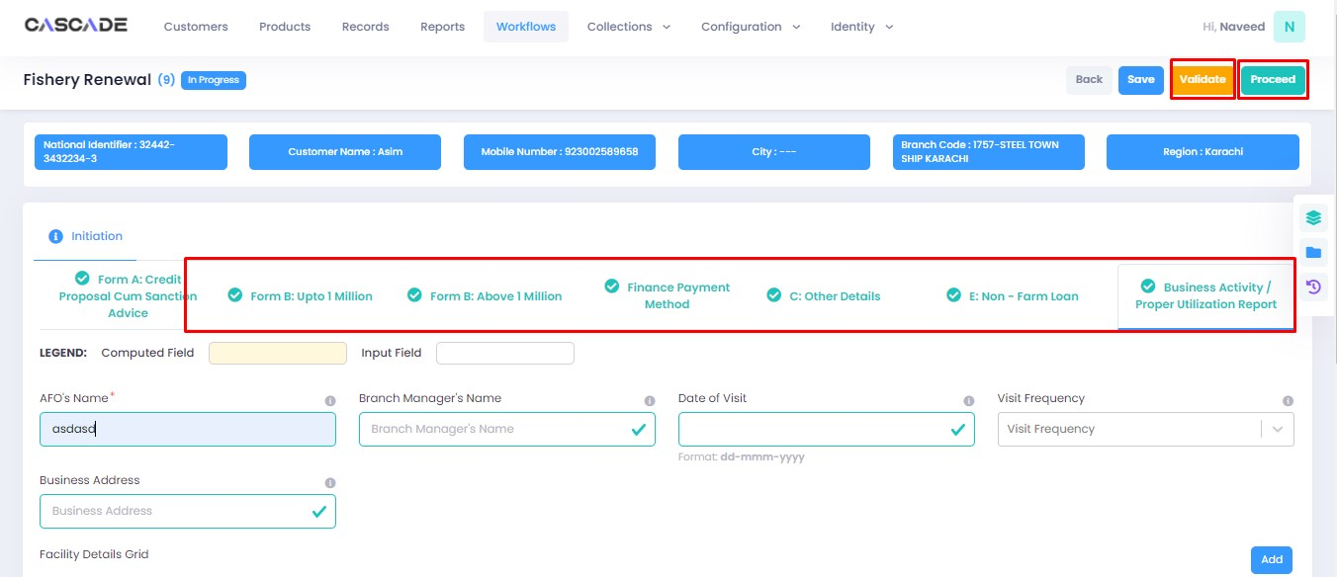

8. Click on ‘Start Credit Analyst’ to start the next stage.



9. When on the ‘credit analyst’ stage, you can create a deviation by clicking on ‘quick panel’ on right side of the page.



10. Then under ‘deviations/exceptions’ you will see all the available deviations. Click on the one applicable to the application, leave remarks then click ‘create’.





11. Once created, the created deviation will show as ‘pending’ in the quick panel and will require approval from an approving authority before the application can be processed further.



12. Then similar to the last stage, fill all the required fields under this stage until all groups are duly filled. Make changes in this stage if any. Then click on ‘validate’, then on ‘quick panel’ on the right side of the page to view the checklist of pending actions.

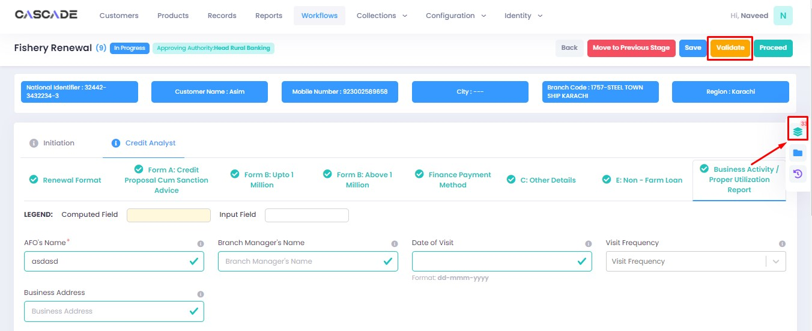

13. Under the ‘check list’ tab, you will see a list of the required documents and checks. Run all the checks and upload the required documents to proceed. Or defer if required.



14. After going through the checklist, click on validate, and then proceed to move to the next stage.

**Note:** The workflow will now require approval from an approver.

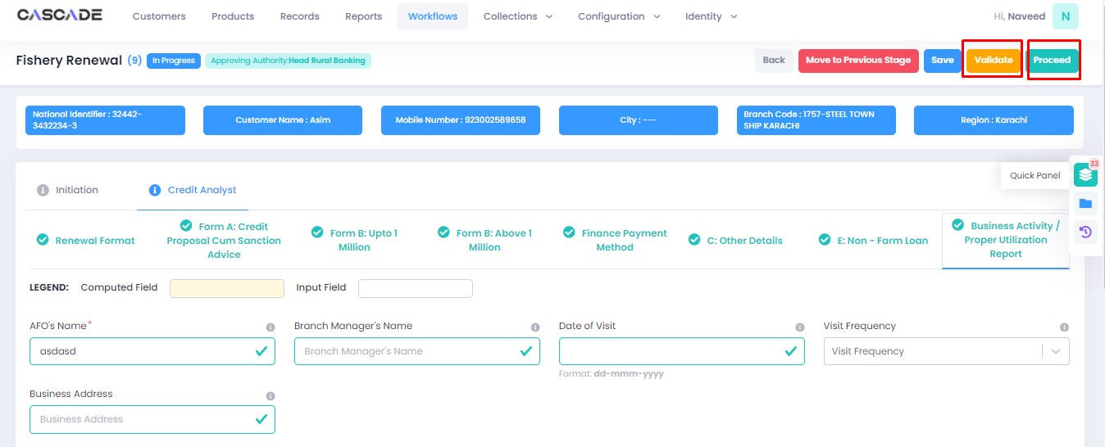

Checker

1. Now from the approver’s account, go to the workflows tab to view the in-progress journeys.



2. Select the product to show a list of the appropriate journeys. In this screenshot, you see the workflow with the status ‘Awaiting Authentication’.

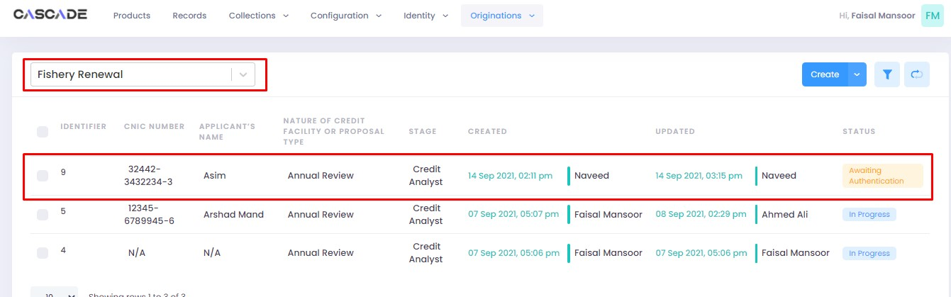

3. Click on ‘edit’ to proceed with the journey.

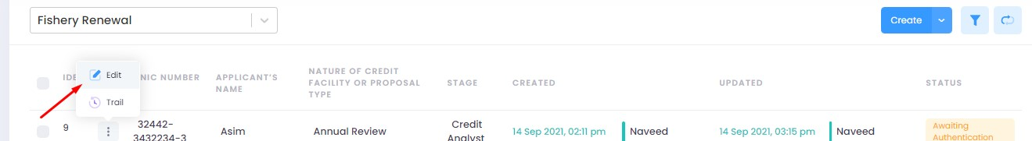

4. Now the approver will be able to see all the details of the journey filled by the maker of the workflow. After scrutinizing, click on the ‘authenticate’ button on the top right to recommend, approve or decline the application.

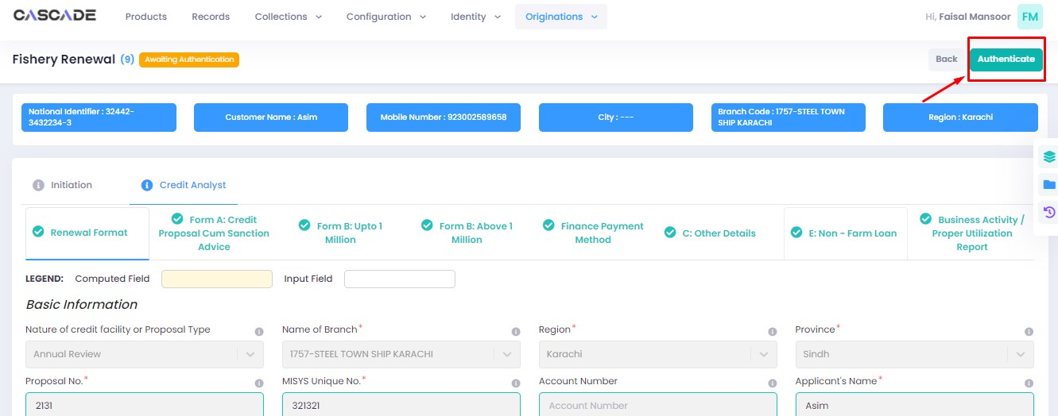

5. Fill the comment box with remarks, then ‘recommend’, ‘decline’ or ‘discard’ the application. Recommending will move the application forward, declining it will destroy the application, and discarding it will send back the application to the maker.

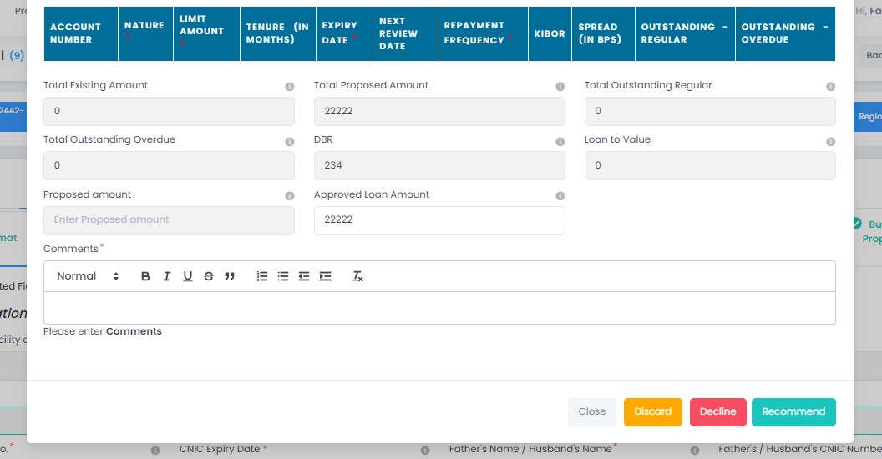

6. The application will require multiple recommendations from the relevant accounts until it is ‘approved’ by an account with appropriate rights. The screenshot below shows the names of the accounts the application has gone through so far with their comments.

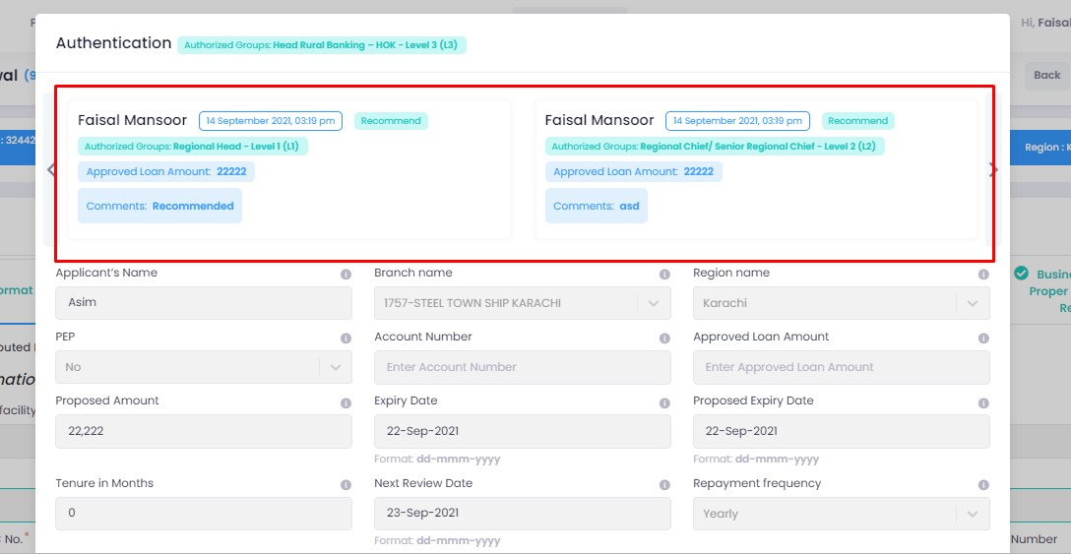

7. After the first recommendation, the second recommender will see the ‘move back’ button which will send the application back to the first recommender. In case of having gone through multiple recommendations the ‘move back’ button will send the application back to the previous approver.



8. After all the ‘recommendations’, the application will require an ‘approval’ from an account with appropriate rights.

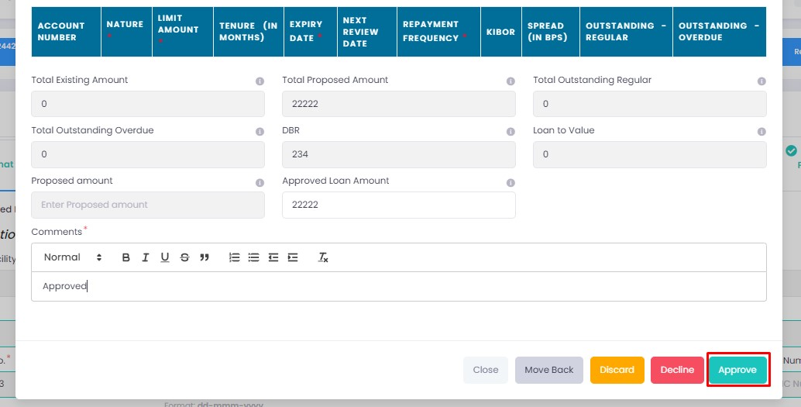

Maker

1. Once the application has been authenticated, it will reappear under the account of the ‘maker’. Go to the ‘workflows’ tab, then select the product, ‘Fishery Renewal’ in this case, to show relevant applications, then select ‘unassigned’ in the filters. You will now see the concerned application with a status of ‘unassigned’.

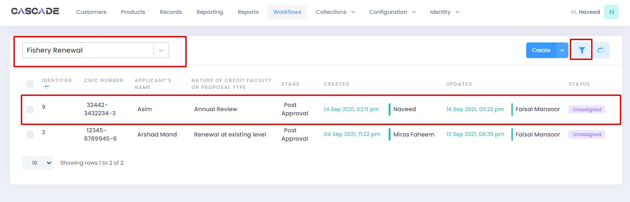



2. Click on ‘edit’, then click on ‘Start Post Approval’ to start the next stage.

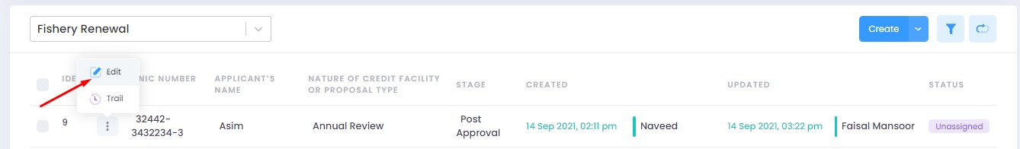

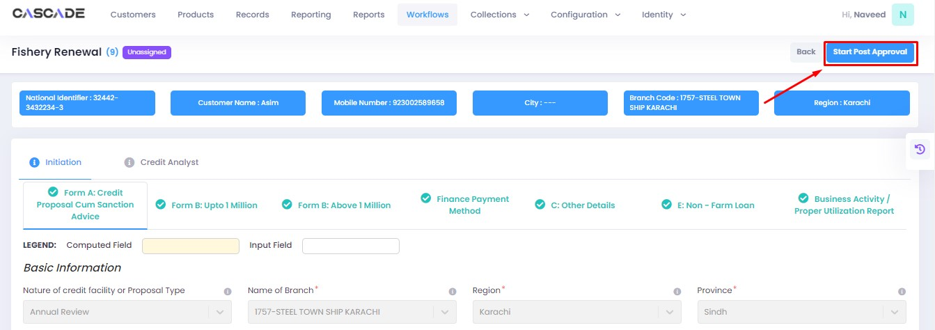

3. Fill all the required fields under ‘Post Approval Documents’ until no errors remain, then click on validate (1), then on the next group (2).

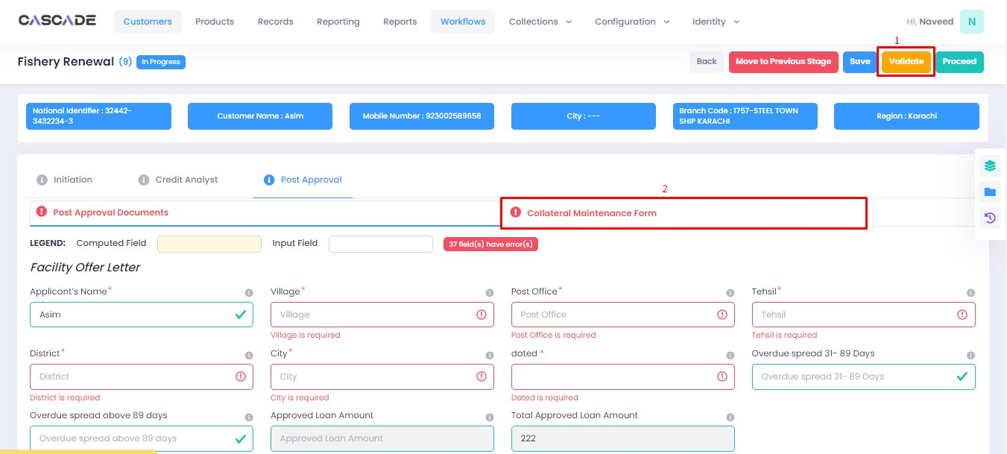

4. Fill all the required fields under ‘Collateral Maintenance Form’ until no errors remain, then click on validate (1). Then on the right side of the page, click on ‘quick panel’.

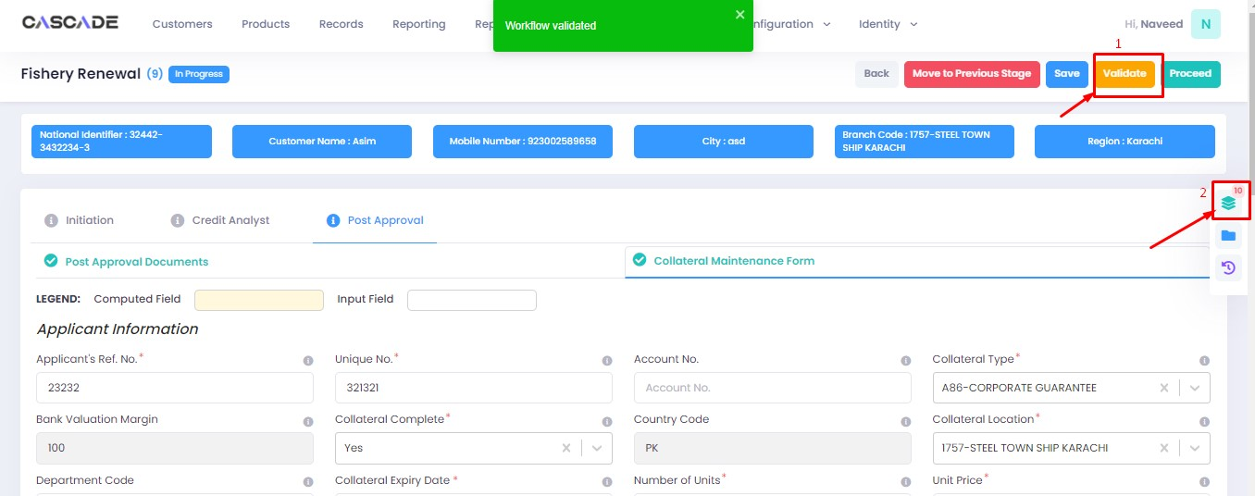

5. Here you will see the items that are pending before the application can be processed further. Upload the required documents to proceed. Or defer if inapplicable.

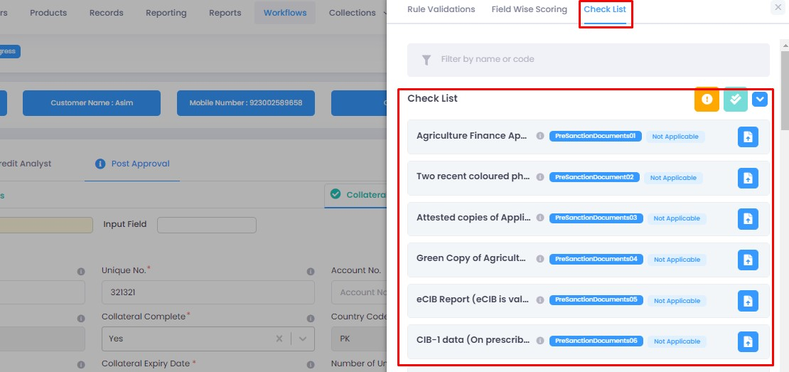

6. After uploading all the required documents, click on validate (1) then click on proceed (2).

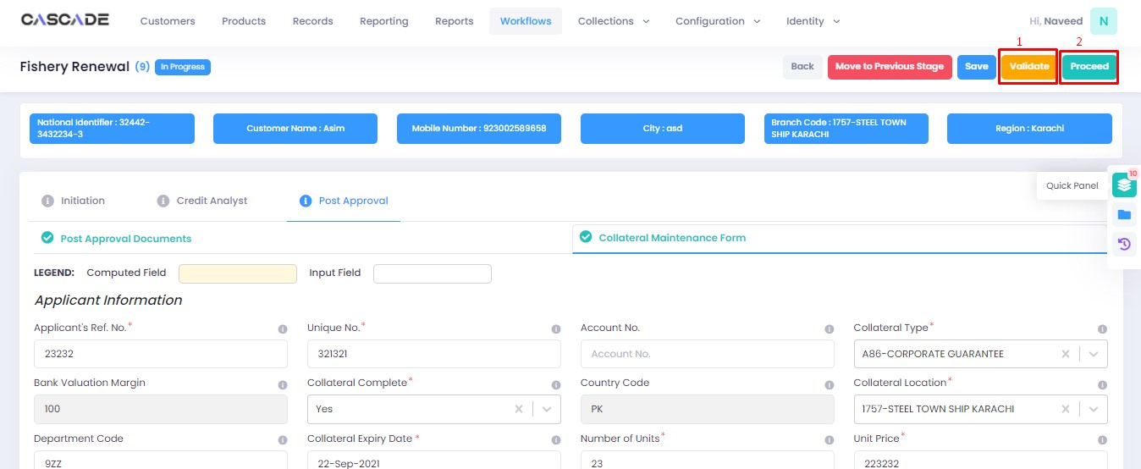

7. Now click on ‘Start RCAD’ to start the next stage in the workflow.

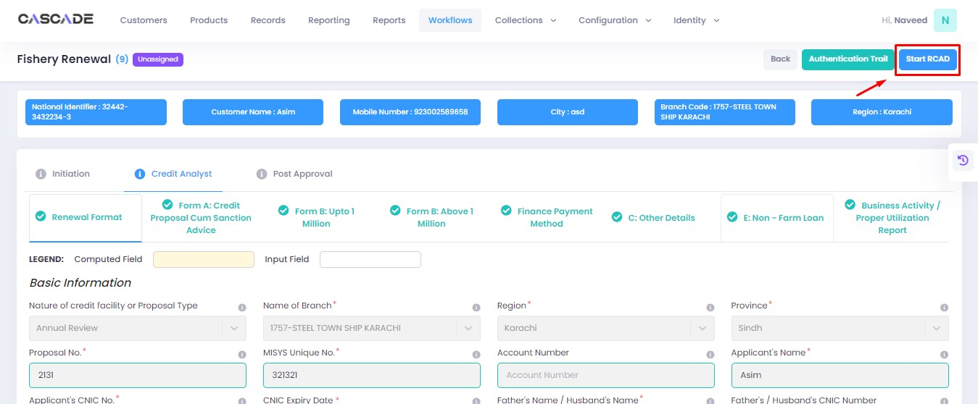

8. Fill all the required fields under ‘AT’ until no errors remain, then click on ‘validate’ (1), then on ‘quick panel’ on the right side of the page.

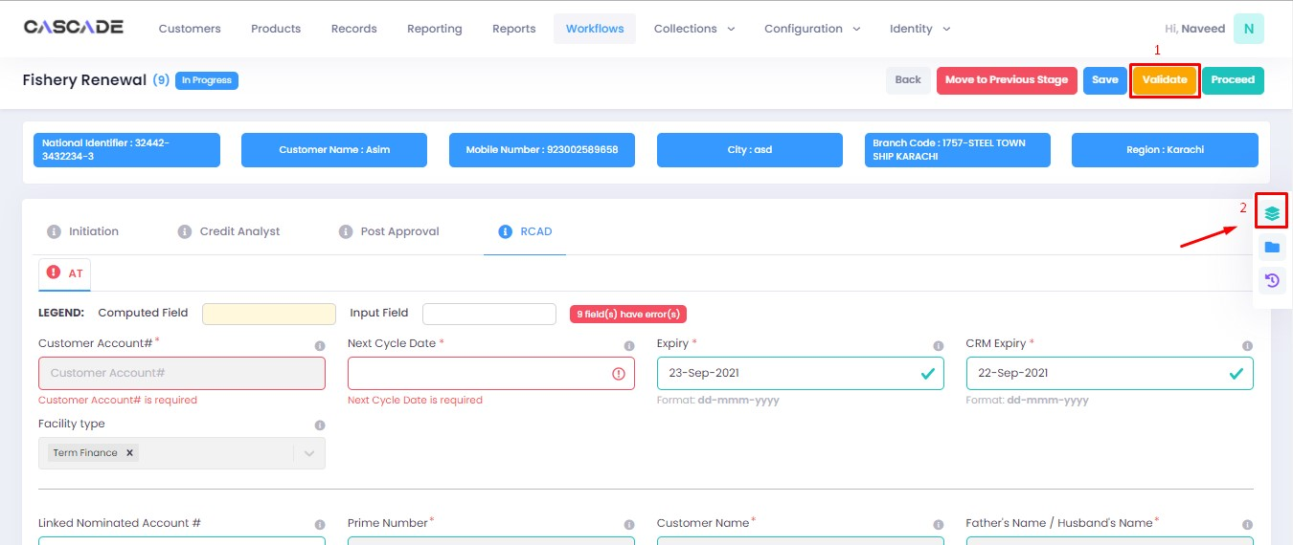

9. Upload the required documents or defer if required, then click on validate and then on proceed.

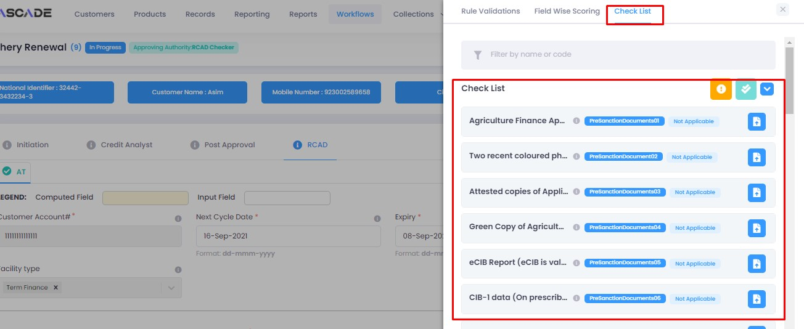

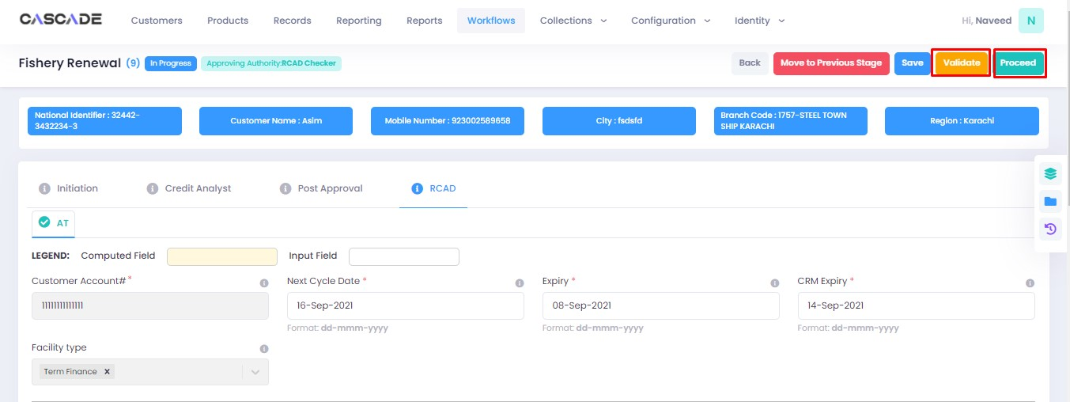

Checker

1. Now from the approver’s account, go to the workflows tab to view the in-progress journeys.



2. Select the product to show a list of the appropriate journeys. In this screenshot, you see the workflow with the status ‘Awaiting Authentication’.

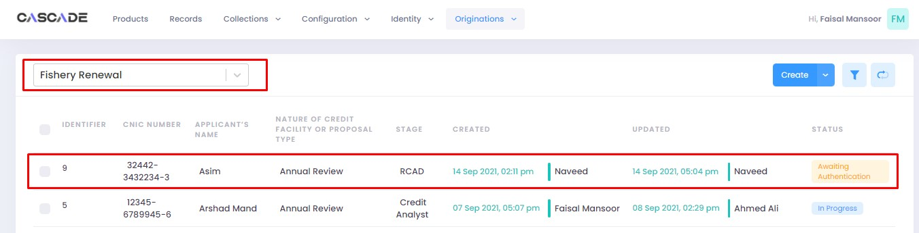

3. Click on ‘edit’ to proceed with the journey.

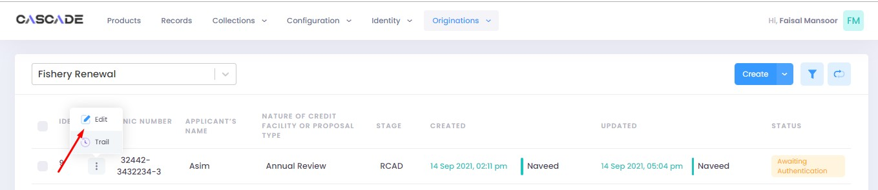

4. Now the approver will be able to see all the details of the journey filled by the maker of the workflow. After scrutinizing, click on the ‘authenticate’ button on the top right to approve or decline the application.

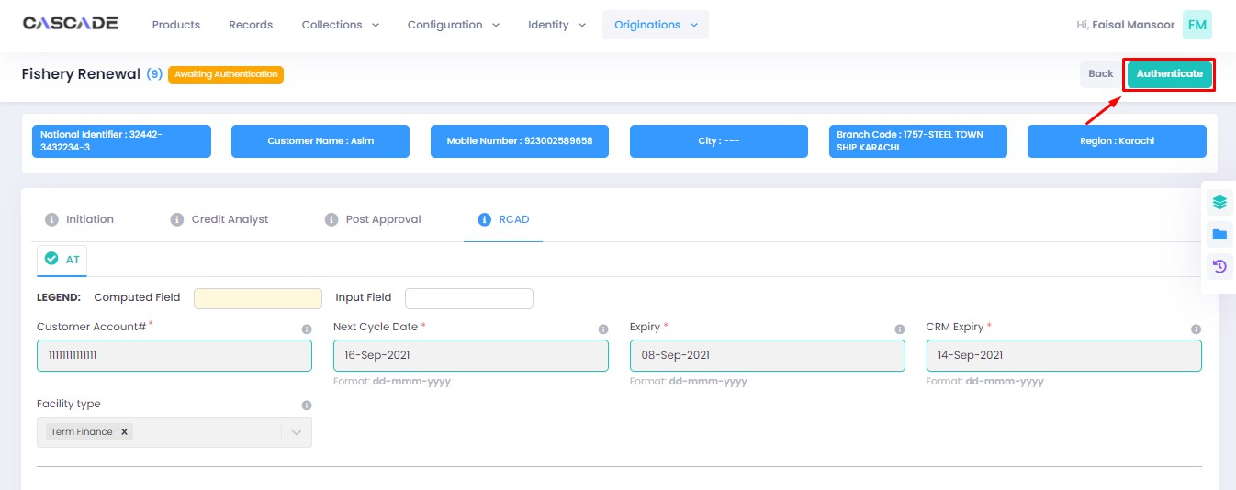

5. Fill the comment box with remarks, then ‘approve’, ‘decline’ or ‘discard’ the application. Recommending will move the application forward, declining it will destroy the application, and discarding it will send back the application to the maker.



6. Under the workflows tab, select ‘Fishery Renewal’ as the product then ‘unassigned’ from the filters to display the relevant application.

**Note**: Application will only be visible to account with relevant rights

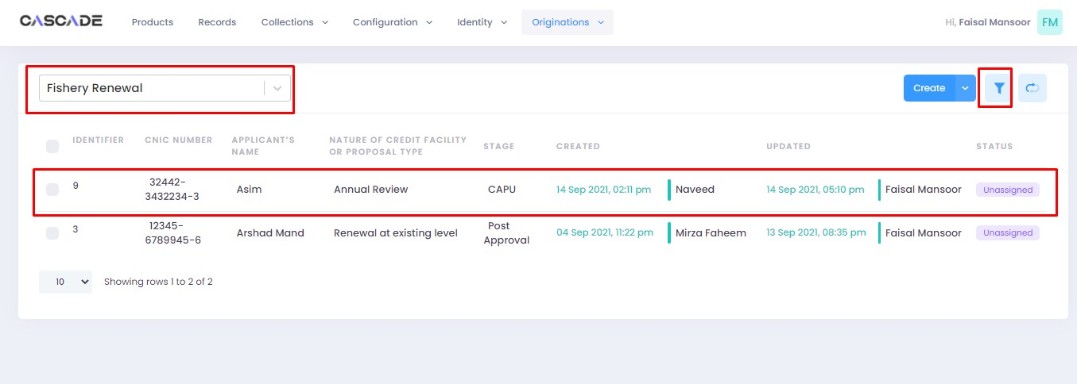

7. Then click on ‘edit’ to further proceed.

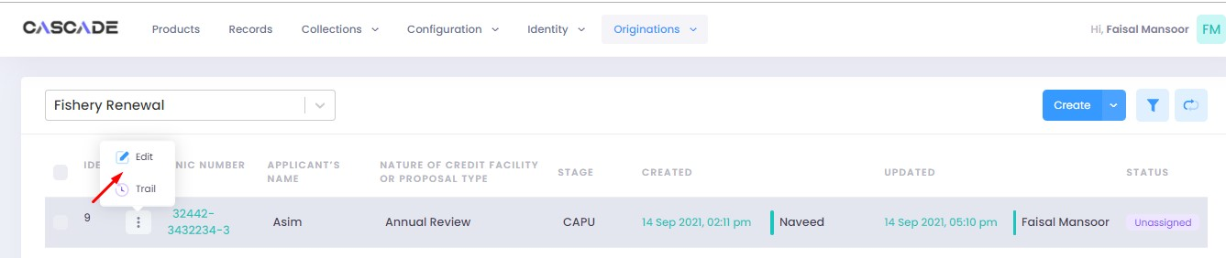

8. Now click on ‘Start CAPU’ to move to the next stage.

**Note**: CAPU can only be initiated and worked on from the account with relevant rights.

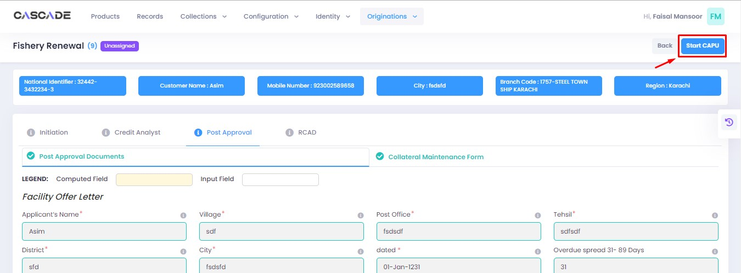

9. Fill all the required fields then click on validate (1) then on proceed (2).

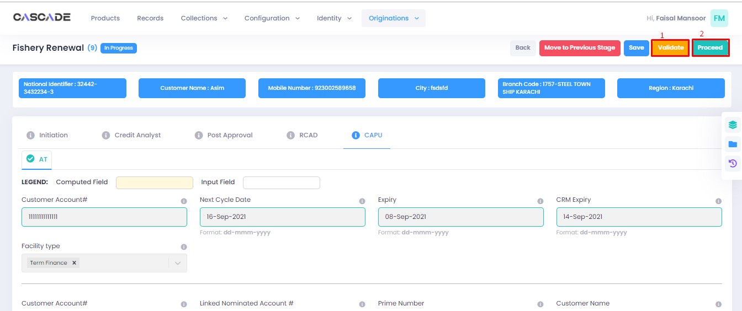

10. The application will now require approval by the CAPU checker.

CAPU checker will click on ‘authenticate’, leave remarks, then approve or decline the application

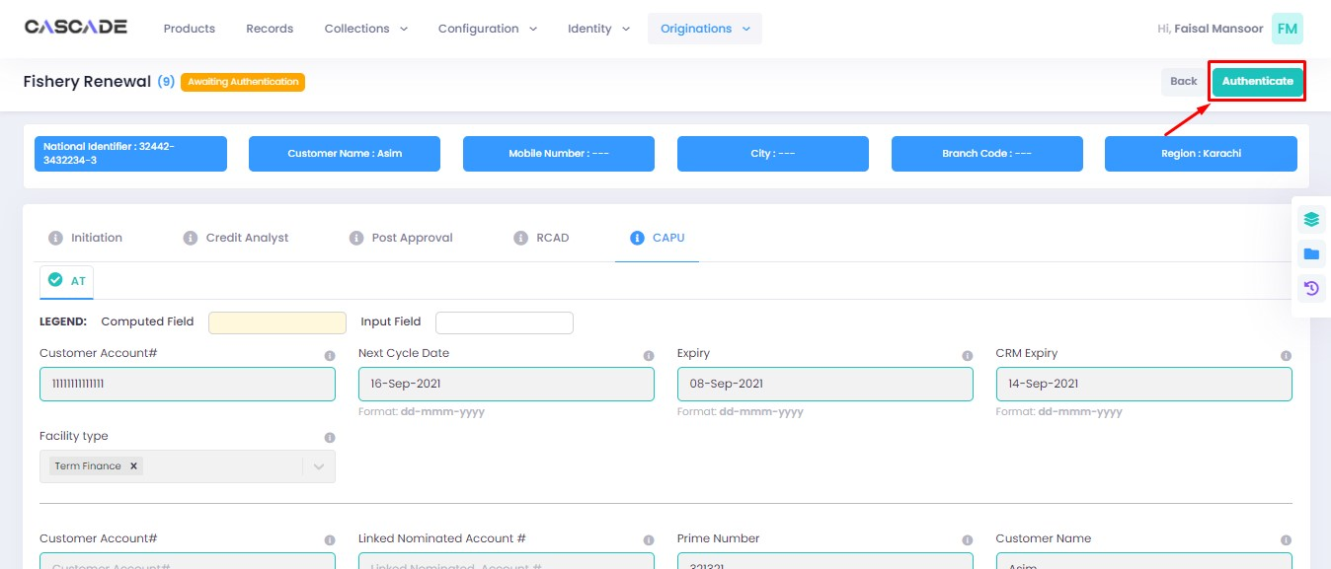

Fill the comment box with remarks, then ‘approve’, ‘decline’ or ‘discard’ the application. Recommending will move the application forward, declining it will destroy the application, and discarding it will send back the application to the maker.

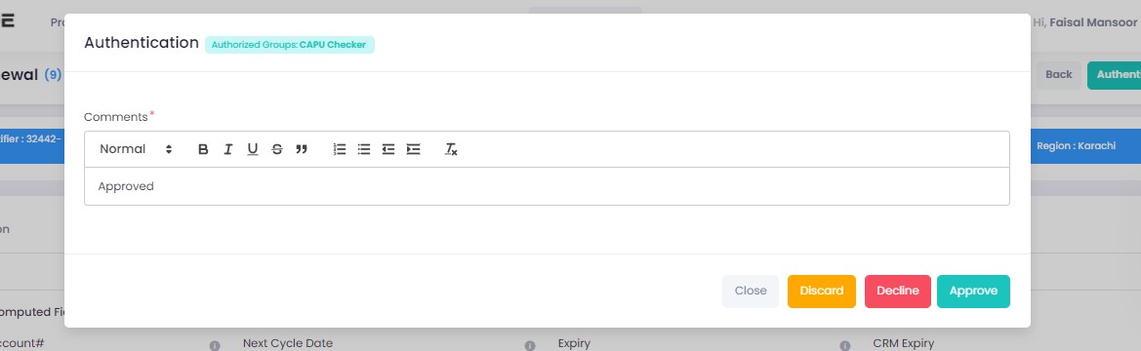

11. The application will now be marked as completed and as ready to be disbursed.

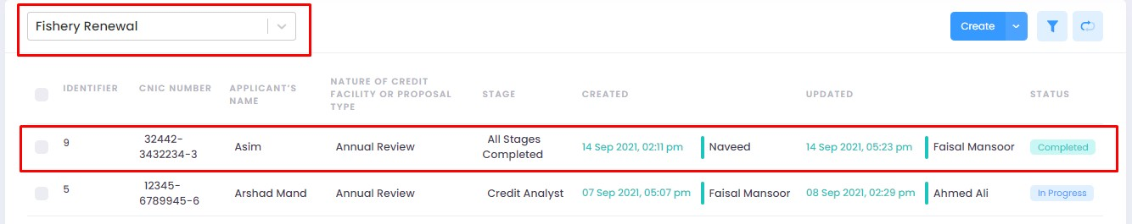

# Product: Poultry NTB

Maker

1. Under the Workflows tab, select the product, then click on ‘create’ to start a new application.

**Note**: Products and workflows shown will vary according to the rights assigned to a user account.

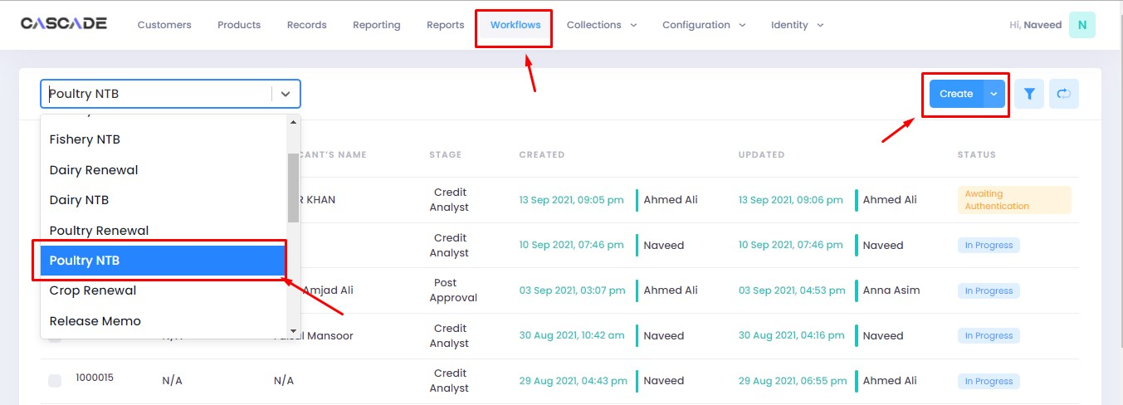

2. Fill the details, then click on ‘proceed’.

**Note**: Depending on the values selected under the fields ‘Is Lead Generation’ and ‘AFO’, new fields and stages in the workflow will appear.

**Lead Generation**: Will allow to manually add details of a prospect.

**AFO**: Allows for ‘data entry’ prior to any stage. The details will then be carried into the ‘credit analyst stage’.

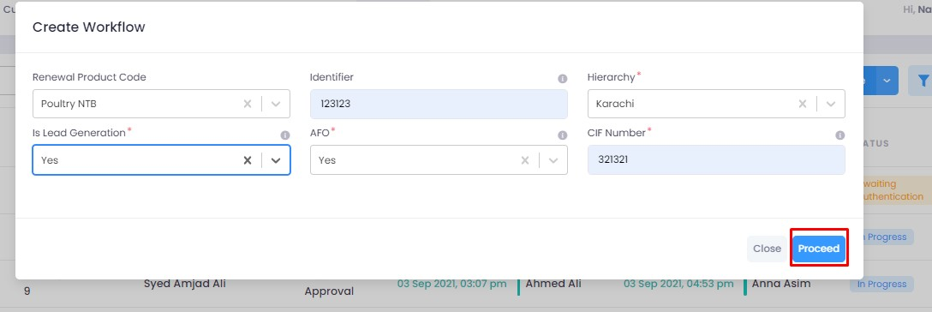

3. After filling all the fields, click on validate to check for errors or missing fields. Once there are no errors left, click on the next Group to proceed with the journey.

**Note**: Form B will appear according to the ‘proposed loan amount’ (Up to 1 million or Over 1 million) entered in Form A.

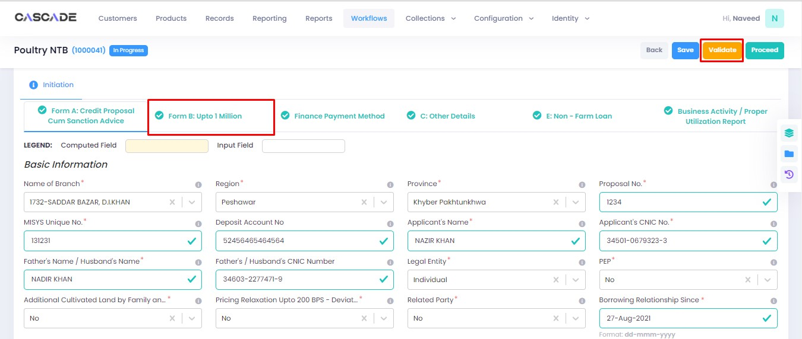

4. Fill all the required fields in the rest of the groups, then click on validate, then click on proceed.

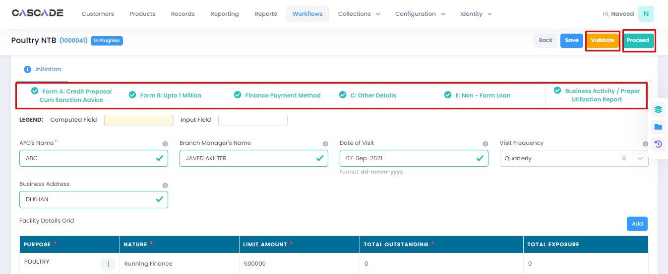

5. Click on ‘Start Credit Analyst’ to start the next stage.

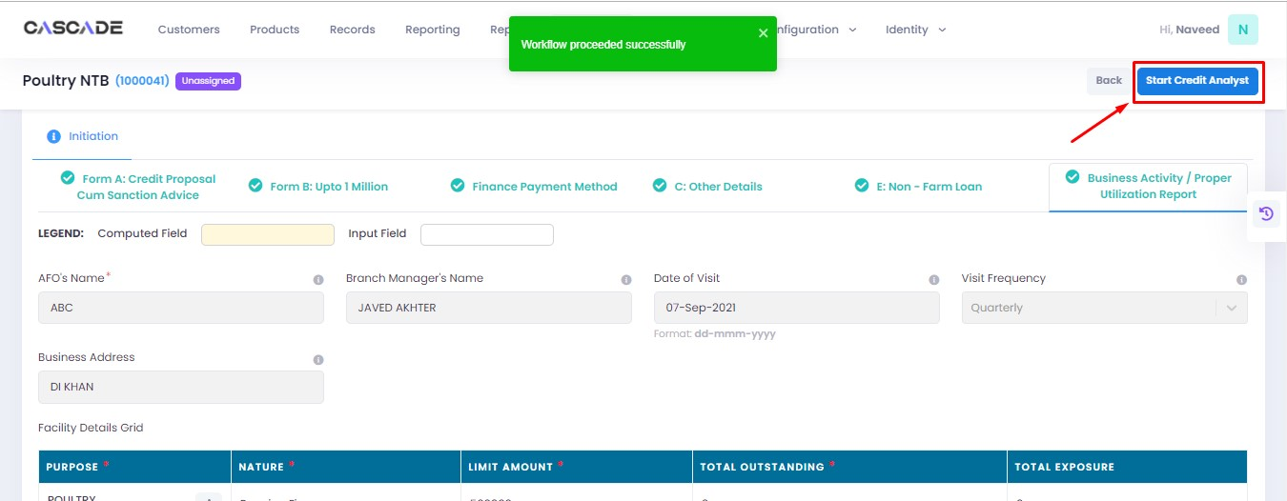

6. When on the ‘credit analyst’ stage, you can create a deviation by clicking on ‘quick panel’ on right side of the page.



7. Then under ‘deviations/exceptions’ you will see all the available deviations. Click on the one applicable to the application, leave remarks then click ‘create’.





8. Once created, the created deviation will show as ‘pending’ in the quick panel and will require approval from an approving authority before the application can be processed further.



9. Then similar to the last stage, fill all the required fields under this stage until all groups are duly filled. Make changes in this stage if any. Then click on ‘validate’, then on ‘quick panel’ on the right side of the page to view the checklist of pending actions.

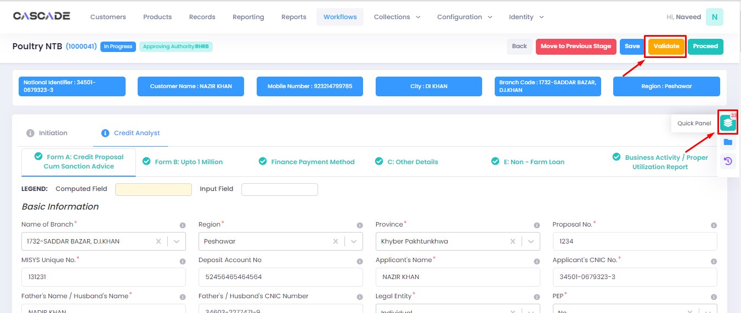

10. Under the ‘check list’ tab, you will see a list of the required documents and checks. Run all the checks and upload the required documents to proceed. Or defer if required.



11. After going through the checklist, click on validate, and then proceed to move to the next stage.

**Note:** The workflow will now require approval from an approver

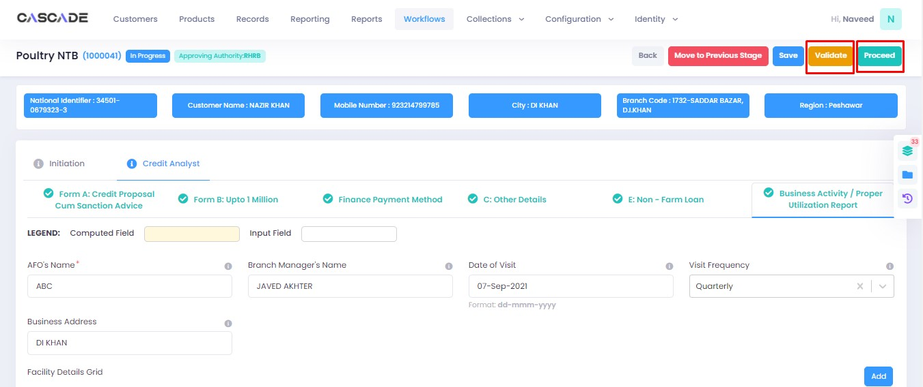

Checker

1. Now from the approver’s account, go to the workflows tab to view the in-progress journeys.



2. Select the product to show a list of the appropriate journeys. In this screenshot, you see the workflow with the status ‘Awaiting Authentication’.

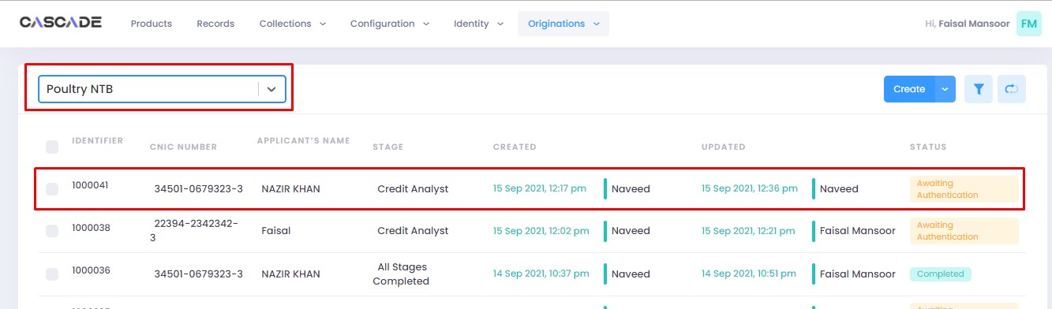

3. Click on ‘edit’ to proceed with the journey.

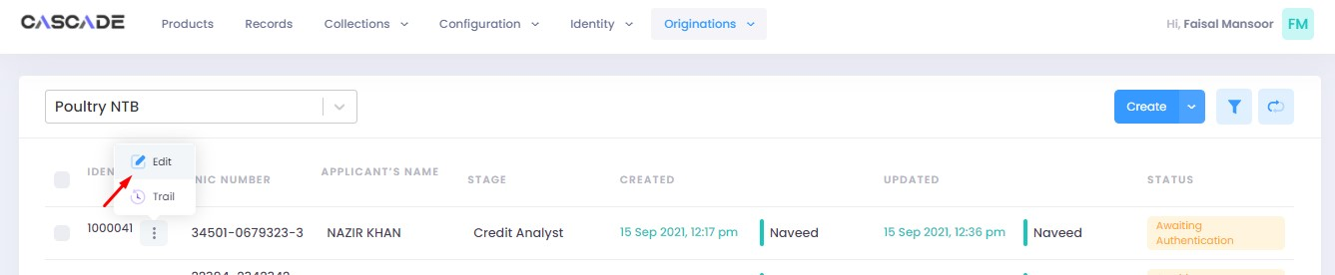

4. Now the approver will be able to see all the details of the journey filled by the maker of the workflow. After scrutinizing, click on the ‘authenticate’ button on the top right to approve or decline the application.

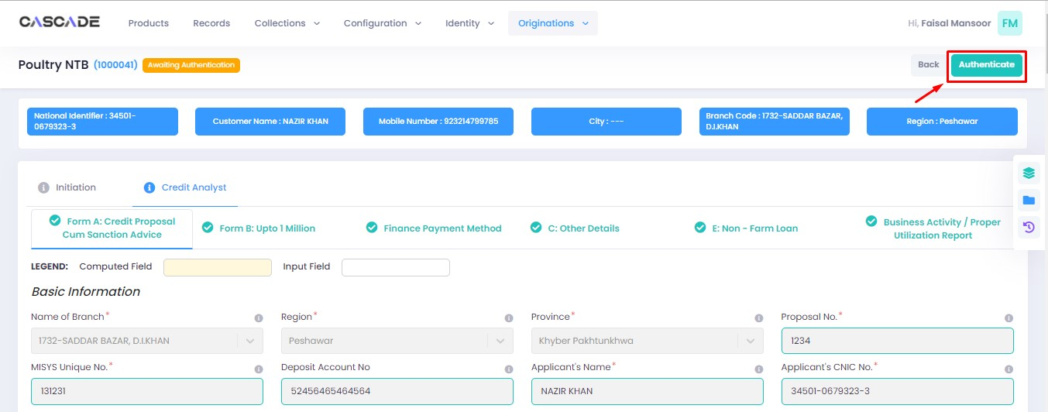

5. Fill the comment box with remarks, then ‘recommend’, ‘decline’ or ‘discard’ the application. Recommending will move the application forward, declining it will destroy the application, and discarding it will send back the application to the maker.



6. The application will require multiple recommendations from the relevant accounts until it is ‘approved’ by an account with appropriate rights. The screenshot below shows the names of the accounts the application has gone through so far with their comments.



7. After the first recommendation, the second recommender will see the ‘move back’ button which will send the application back to the first recommender. In case of having gone through multiple recommendations the ‘move back’ button will send the application back to the previous approver.



8. After all the ‘recommendations’, the application will require an ‘approval’ from an account with appropriate rights.



Maker

1. Once the application has been authenticated, it will reappear under the account of the ‘maker’. Go to the ‘workflows’ tab, then select the product, ‘Poultry NTB’ in this case, to show relevant applications, then select ‘unassigned’ in the filters. You will now see the concerned application with a status of ‘unassigned’.

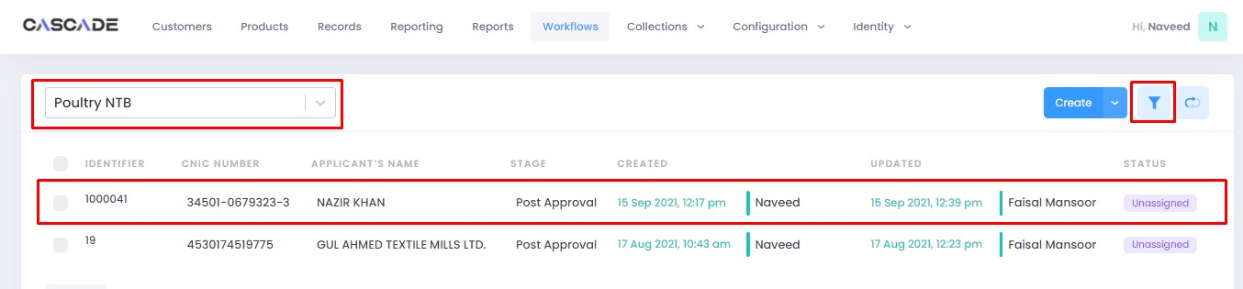



2. Click on ‘edit’, then click on ‘Start Post Approval’ to start the next stage.

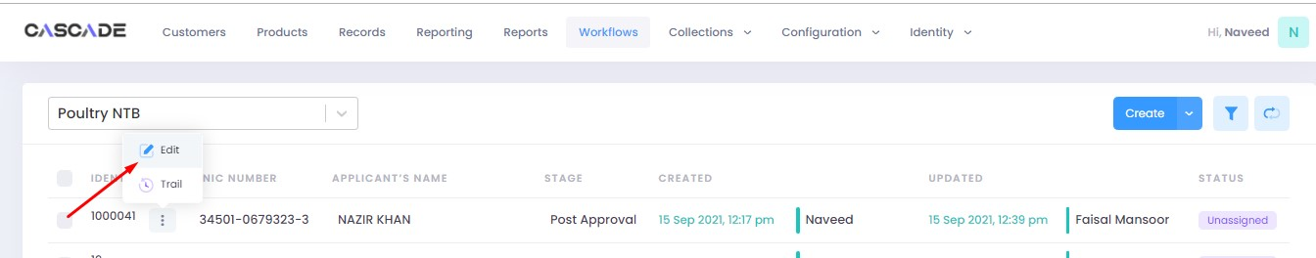

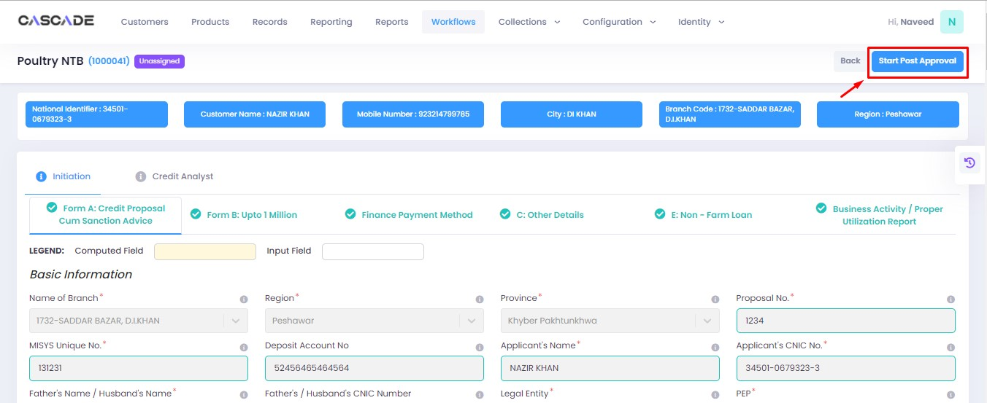

3. Fill all the required fields under ‘Post Approval Documents’ until no errors remain, then click on validate (1), then on the next group (2).

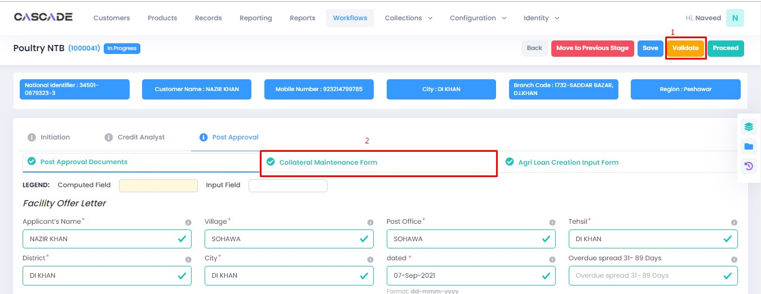

4. Fill all the required fields in rest of the groups, then click on validate (1), then on ‘quick panel’ (2).

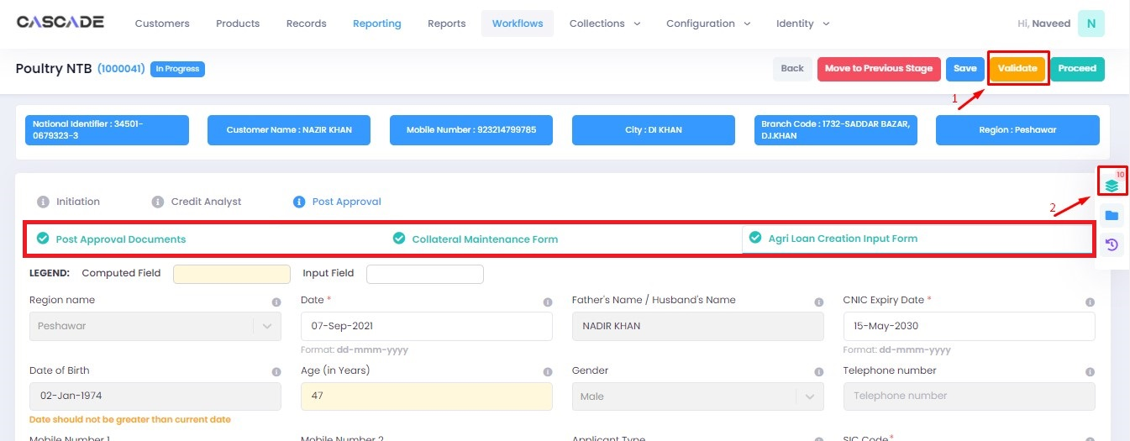

5. Here you will see the items that are pending before the application can be processed further. Upload the required documents to proceed. Or defer if inapplicable.



6. After uploading all the required documents, click on validate (1) then click on proceed (2).

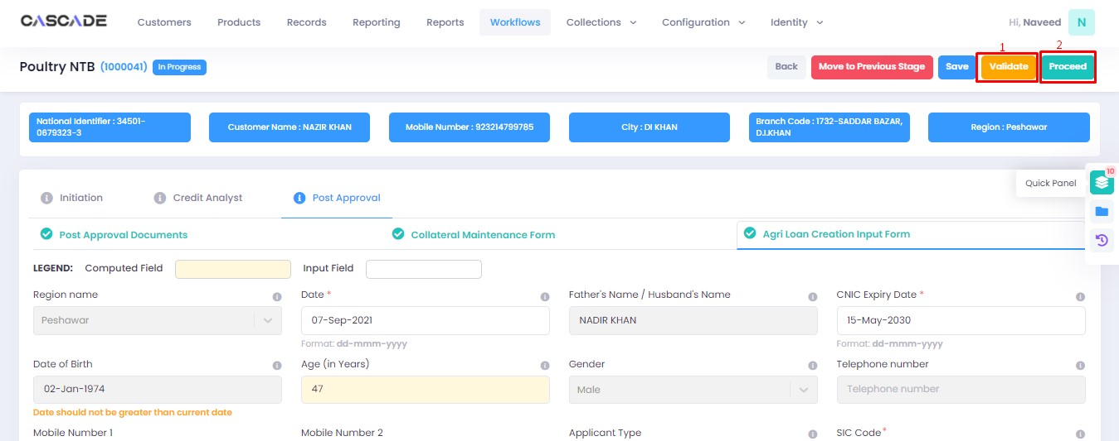

7. Now click on ‘Start RCAD’ to start the next stage in the workflow.

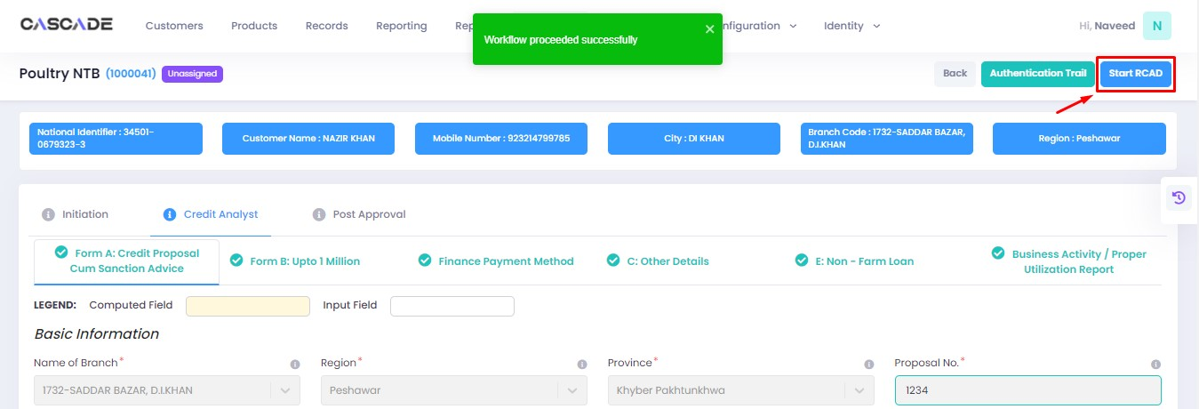

8. Fill all the required fields under all groups until no errors remain, then click on ‘validate’, then on ‘quick panel’ on the right side of the page.

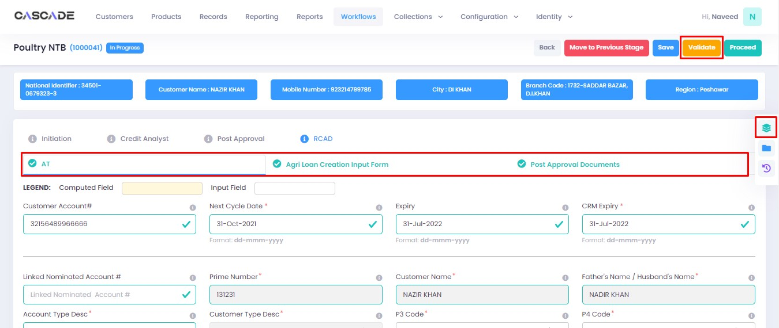

9. Upload the required documents or defer if required, then click on validate and then on proceed.



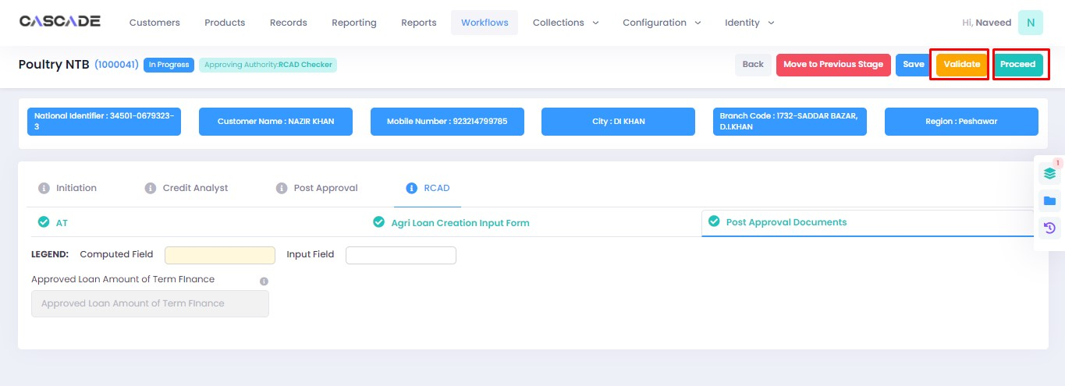

Checker

1. Now from the approver’s account, go to the workflows tab to view the in-progress journeys.



2. Select the product to show a list of the appropriate journeys. In this screenshot, you see the workflow with the status ‘Awaiting Authentication’.

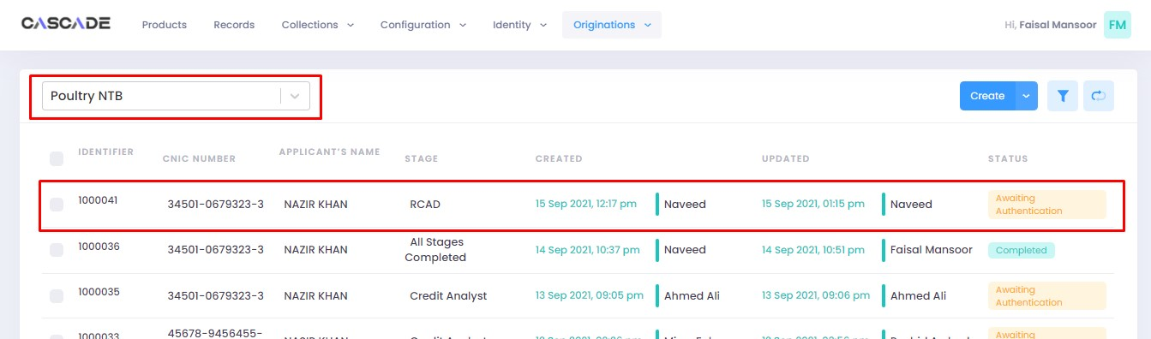

3. Click on ‘edit’ to proceed with the journey.

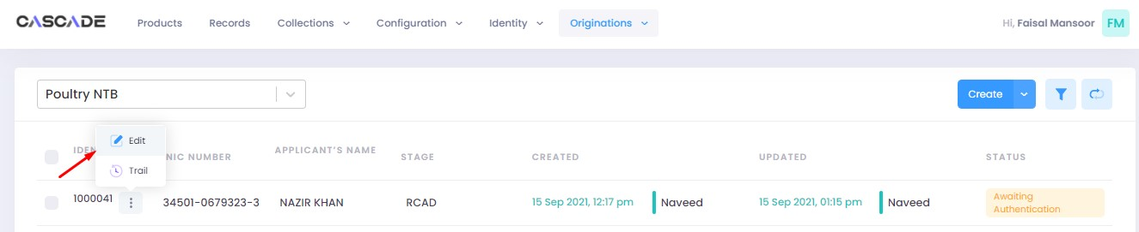

4. Now the approver will be able to see all the details of the journey filled by the maker of the workflow. After scrutinizing, click on the ‘authenticate’ button on the top right to approve or decline the application.

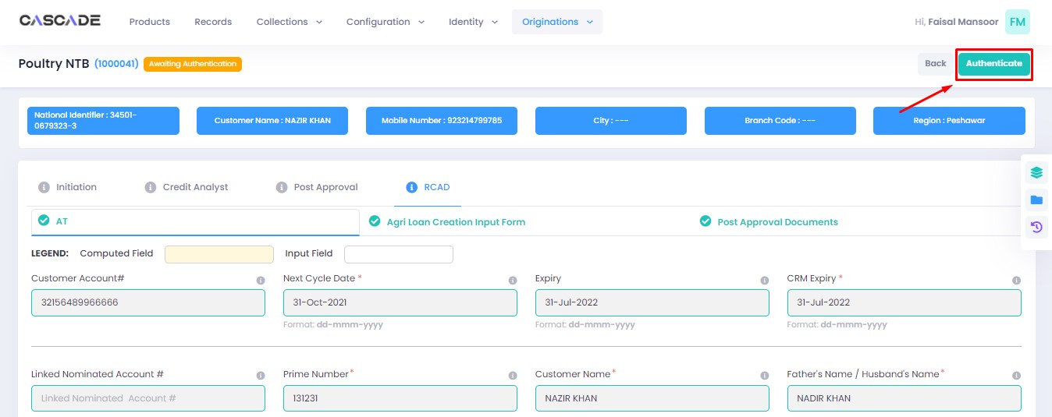

5. Fill the comment box with remarks, then ‘approve’, ‘decline’ or ‘discard’ the application. Recommending will move the application forward, declining it will destroy the application, and discarding it will send back the application to the maker.



6. Under the workflows tab, select ‘Poultry NTB’ as the product then ‘unassigned’ from the filters to display the relevant application.

**Note:** Application will only be visible to account with relevant rights.

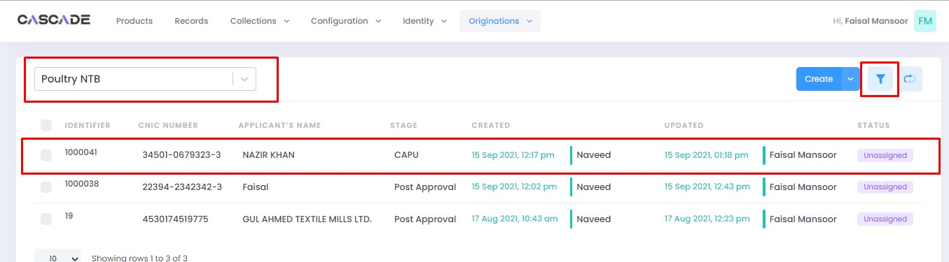

7. Then click on ‘edit’ to further proceed.

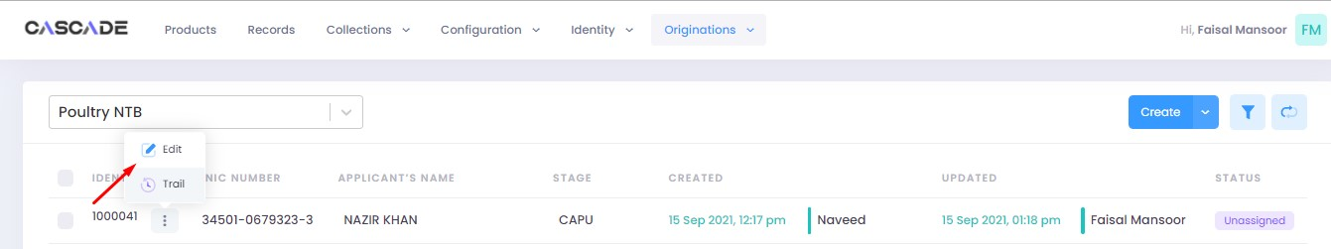

8. Now click on ‘Start CAPU’ to move to the next stage.

**Note:** CAPU can only be initiated and worked on from the account with relevant rights.

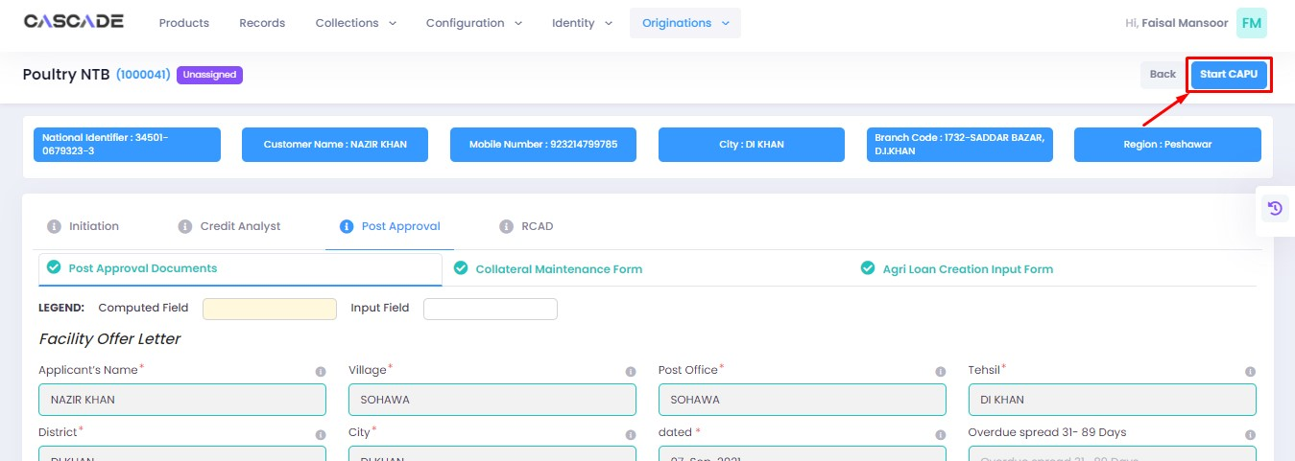

9. Fill all the required fields under all groups then click on validate then on proceed.

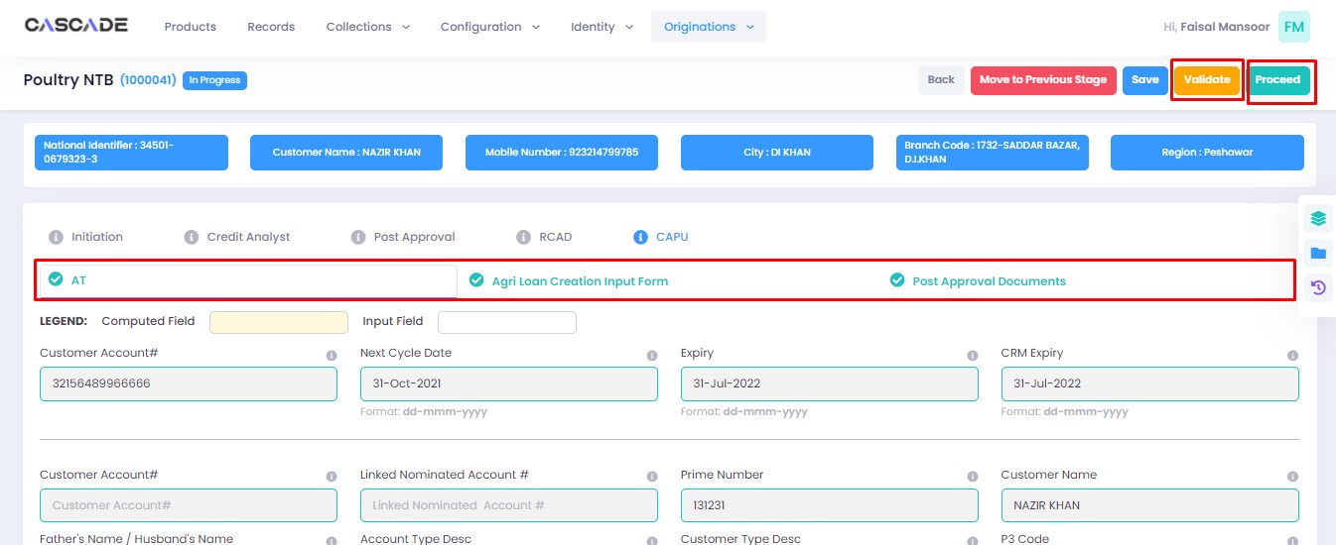

10. The application will now require approval by the CAPU checker.

CAPU checker will click on ‘authenticate’, leave remarks, then approve or decline the application.

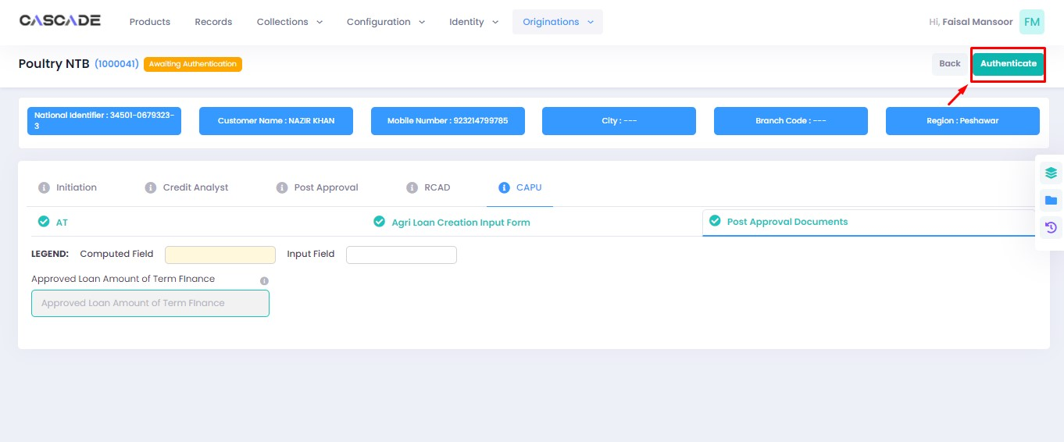

Fill the comment box with remarks, then ‘approve’, ‘decline’ or ‘discard’ the application. Recommending will move the application forward, declining it will destroy the application, and discarding it will send back the application to the maker.



11. The application will now be marked as completed and ready to be disbursed.

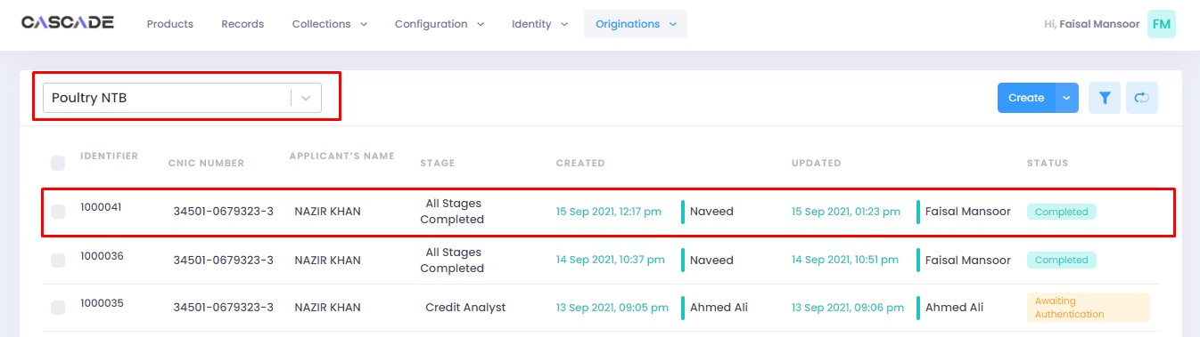

# Product: Poultry Renewal

Maker

1. Under the Workflows tab, select the product, then click on ‘create’ to start a new application.

**Note:** Products and workflows shown will vary according to the rights assigned to a user account.

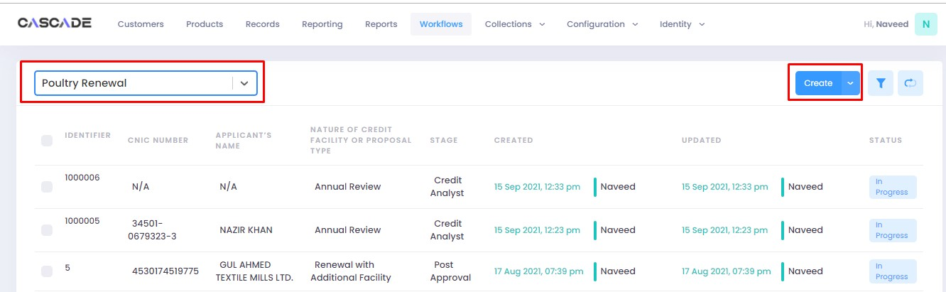

2. Fill the details, then click on ‘proceed’.

**Note**: Depending on the value selected under the field ‘Form Type’ and ‘AFO’, new fields in the application might appear.

**Form Type:** You will be able to choose form type between ‘one pager’ or ‘full form’. Fields and stages will vary in both form types (examples shown below).

**AFO**: Allows for ‘data entry’ prior to any stage. The details will then be carried into the ‘credit analyst stage’.

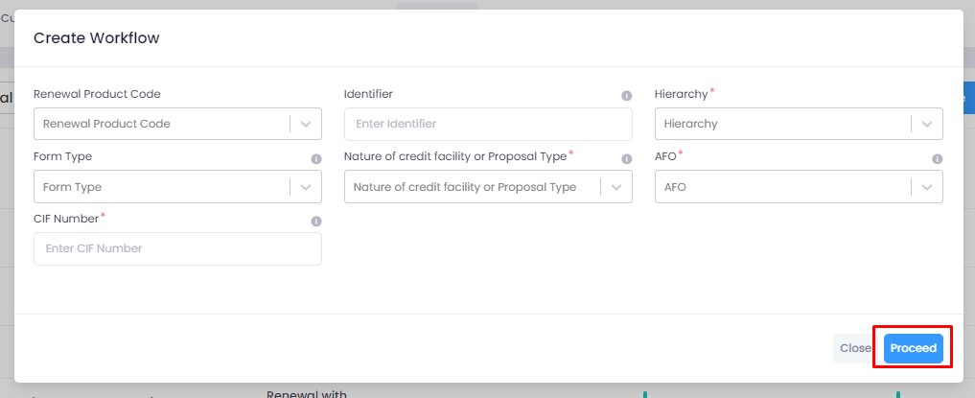

3. When on the ‘credit analyst’ stage, you can create a deviation by clicking on ‘quick panel’ on right side of the page.



4. Then under ‘deviations/exceptions’ you will see all the available deviations. Click on the one applicable to the application, leave remarks then click ‘create’.





5. Once created, the created deviation will show as ‘pending’ in the quick panel and will require approval from an approving authority before the application can be processed further.



## Form Type: One Pager

6. After filling all the fields, click on validate (1) to check for errors or missing fields. Once there are no errors left, click on the next Group (2) to proceed with the journey.

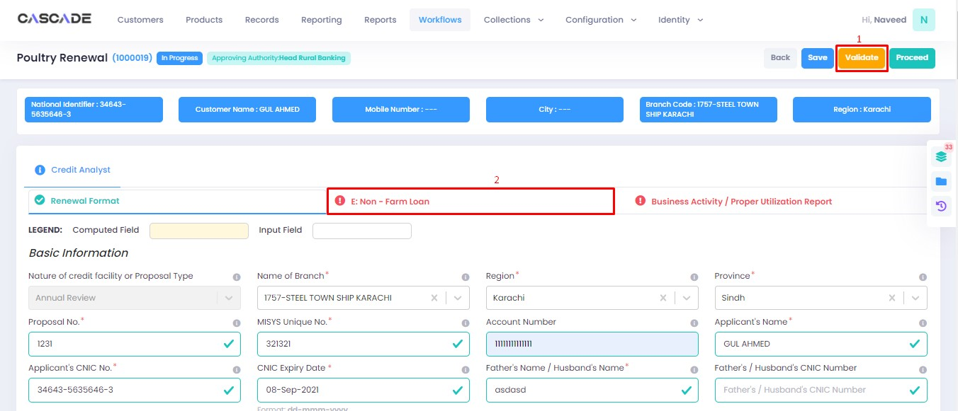

7. Fill all the required fields under all groups. Then click on ‘validate’ (1) then on ‘quick panel’ (2) on the right side of the page to view the checklist of pending actions.

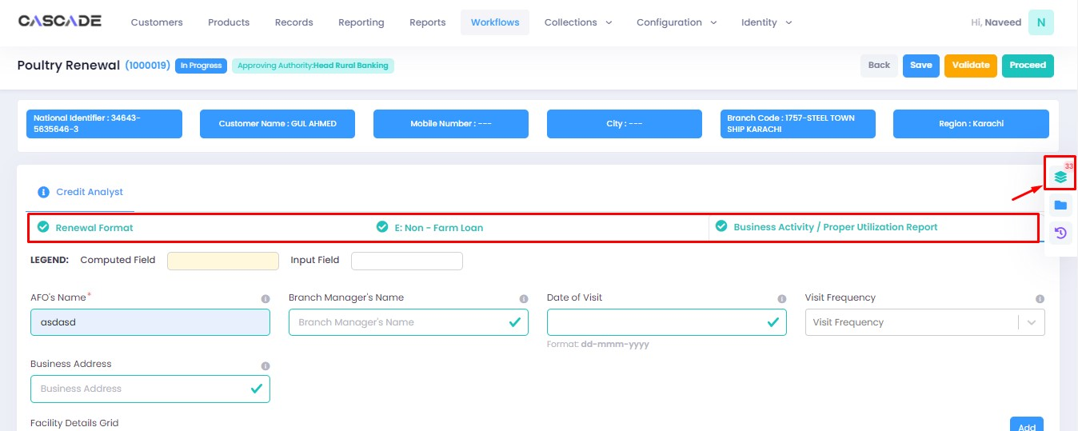

8. Under the ‘check list’ tab, you will see a list of the required documents and checks. Run all the checks and upload the required documents to proceed. Or defer if required.



9. After going through the checklist, click on validate, and then proceed to move to the next stage.

**Note:** The workflow will now require approval from an approver.

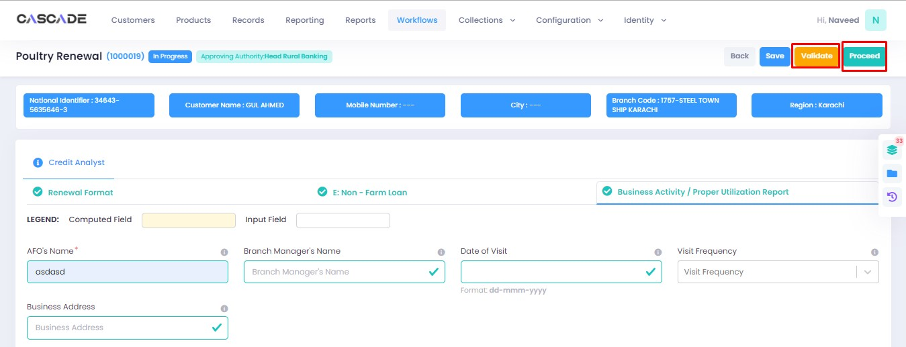

## Form Type: Full Form

10. After filling all the fields, click on validate to check for errors or missing fields. Once there are no errors left, click on the next Group to proceed with the journey.

**Note**: Form B will appear according to the ‘proposed loan amount’ (Up to 1 million or Over 1 million) entered in Form A.

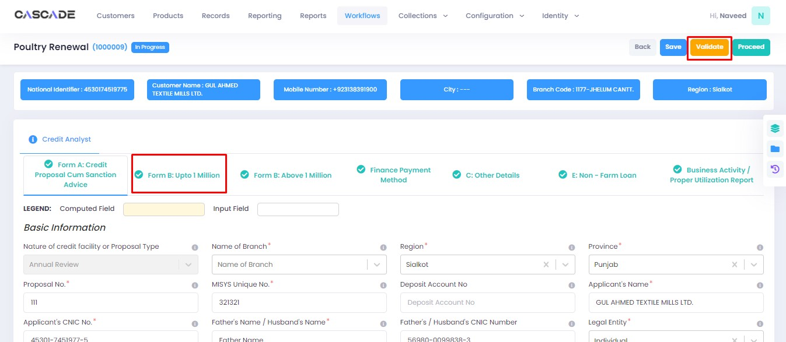

11. Fill all the required fields in the rest of the groups, then click on ‘validate’, then on ‘quick panel’ on the right side of the page to view the checklist of pending actions.

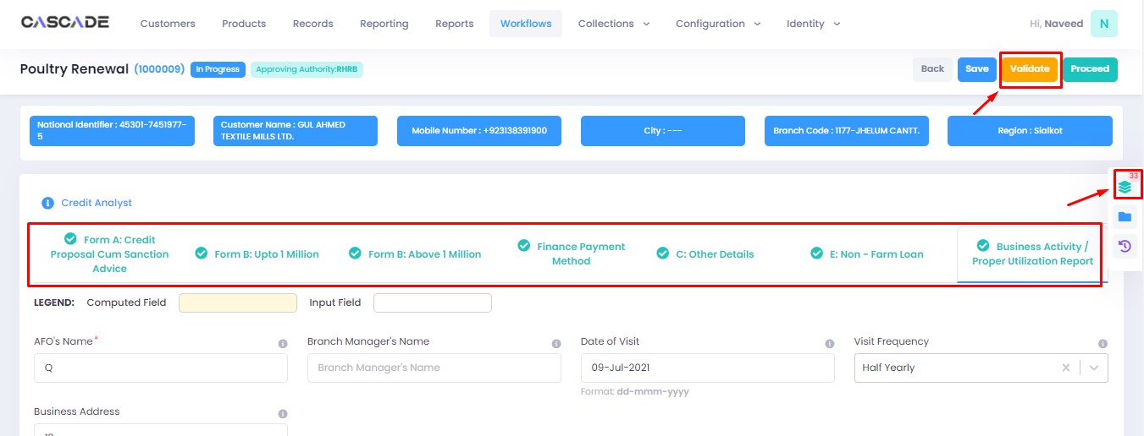

12. Under the ‘check list’ tab, you will see a list of the required documents and checks. Run all the checks and upload the required documents to proceed. Or defer if required.

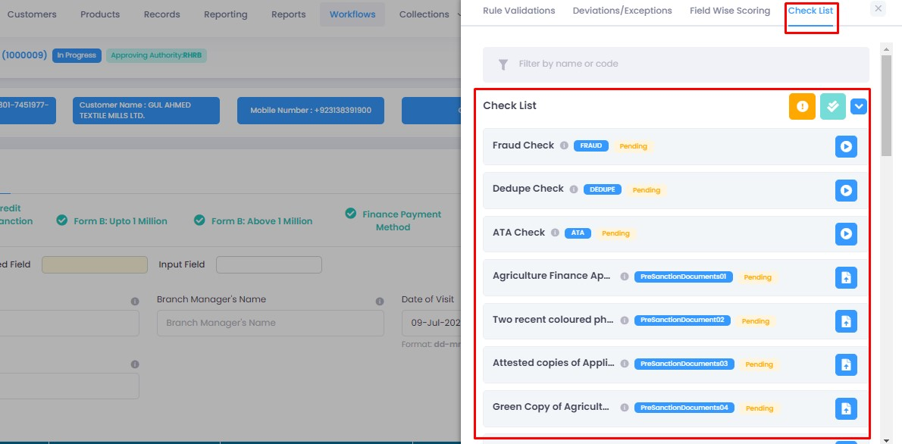

13. After going through the checklist, click on validate, and then proceed to move to the next stage.

**Note:** The workflow will now require approval from an approver.

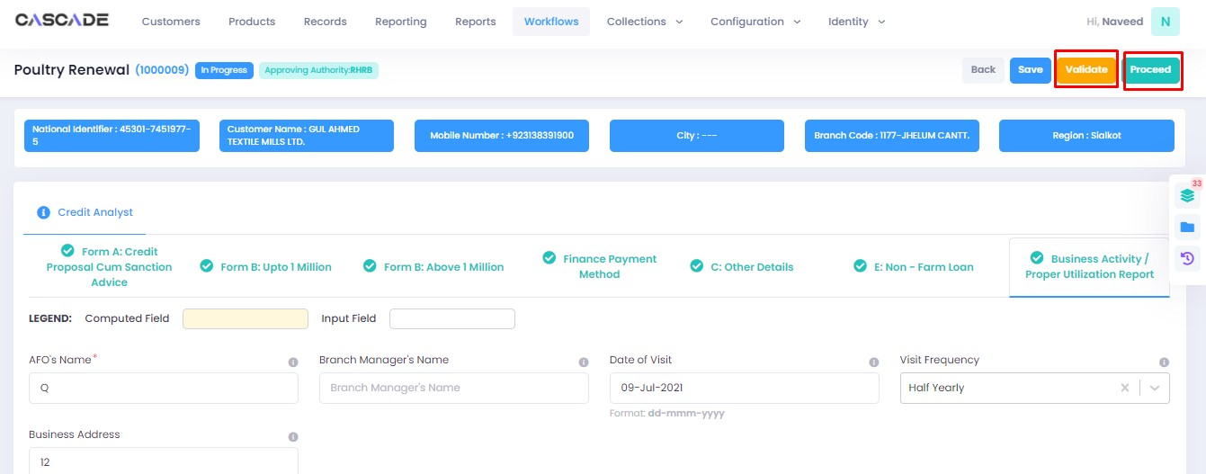

Checker

1. Now from the approver’s account, go to the workflows tab to view the in-progress journeys.



2. Select the product to show a list of the appropriate journeys. In this screenshot, you see the workflow with the status ‘Awaiting Authentication’.

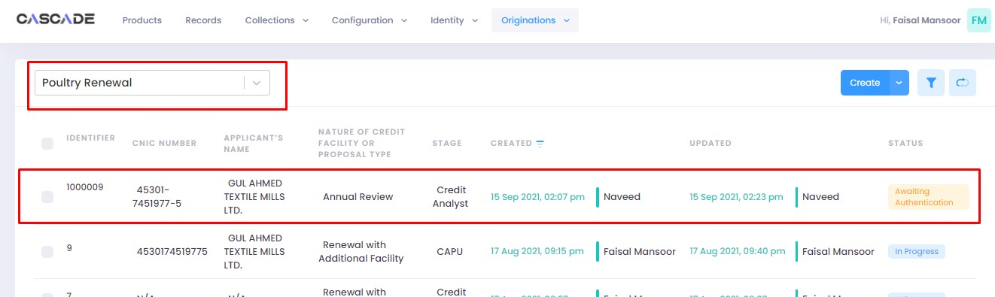

3. Click on ‘edit’ to proceed with the journey.

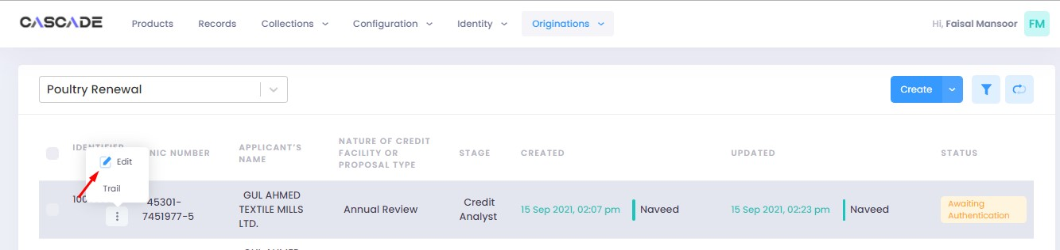

4. Now the approver will be able to see all the details of the journey filled by the maker of the workflow. After scrutinizing, click on the ‘authenticate’ button on the top right to recommend, approve or decline the application.

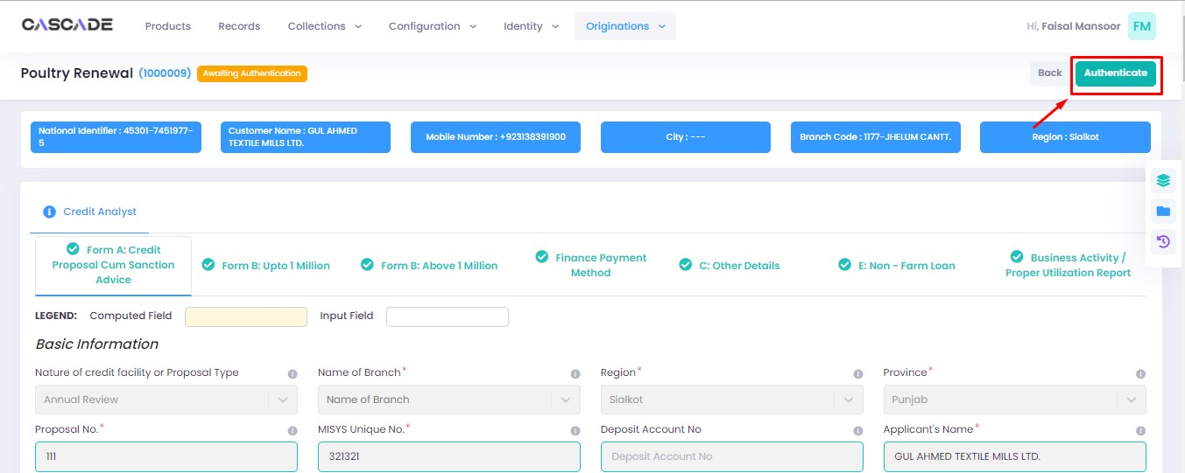

5. Fill the comment box with remarks, then ‘recommend’, ‘decline’ or ‘discard’ the application. Recommending will move the application forward, declining it will destroy the application, and discarding it will send back the application to the maker.



6. The application will require multiple recommendations from the relevant accounts until it is ‘approved’ by an account with appropriate rights. The screenshot below shows the names of the accounts the application has gone through so far with their comments.



7. After all the ‘recommendations’, the application will require an ‘approval’ from an account with appropriate rights.



Maker

1. Once the application has been authenticated, it will reappear under the account of the ‘maker’. Go to the ‘workflows’ tab, then select the product, ‘Poultry Renewal’ in this case, to show relevant applications, then select ‘unassigned’ in the filters. You will now see the concerned application with a status of ‘unassigned’.

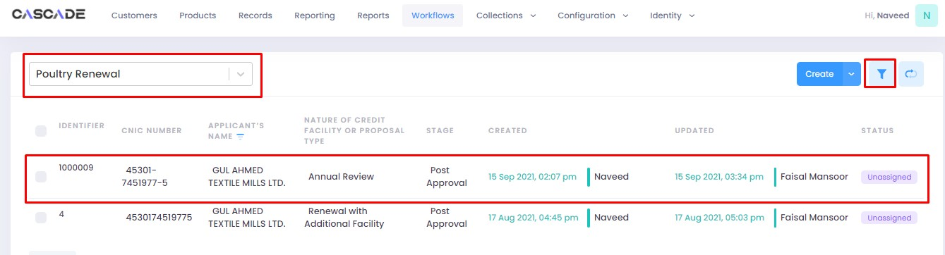



2. Click on ‘edit’, then click on ‘Start Post Approval’ to start the next stage.

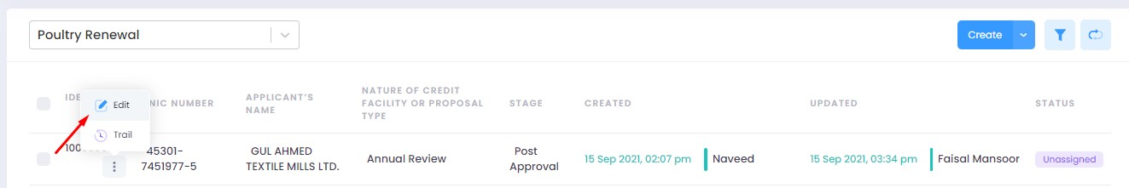

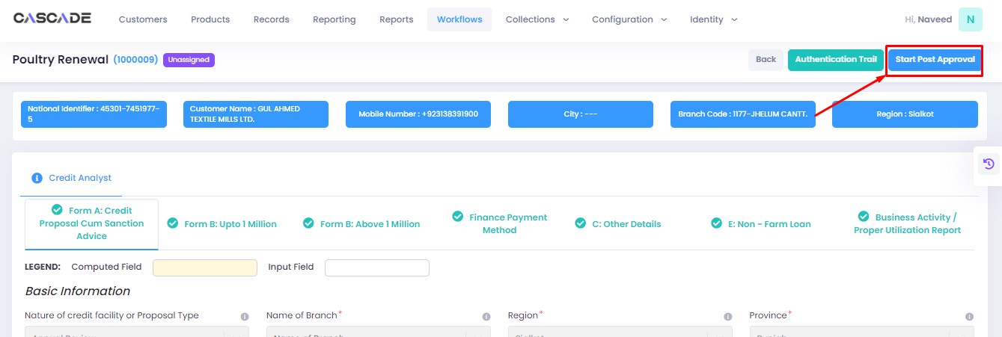

3. Fill all the required fields under ‘Post Approval Documents’ until no errors remain, then click on validate (1), then on the next group (2).

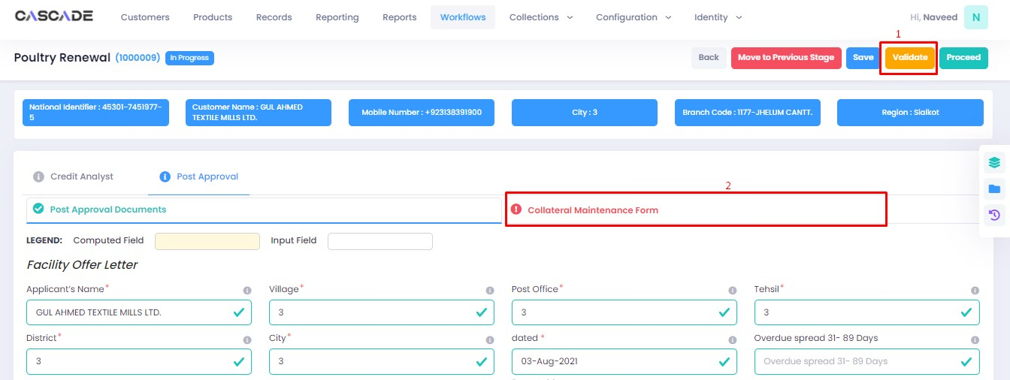

4. Fill all the required fields under ‘Collateral Maintenance Form’ until no errors remain, then click on validate (1). Then on the right side of the page, click on ‘quick panel’.

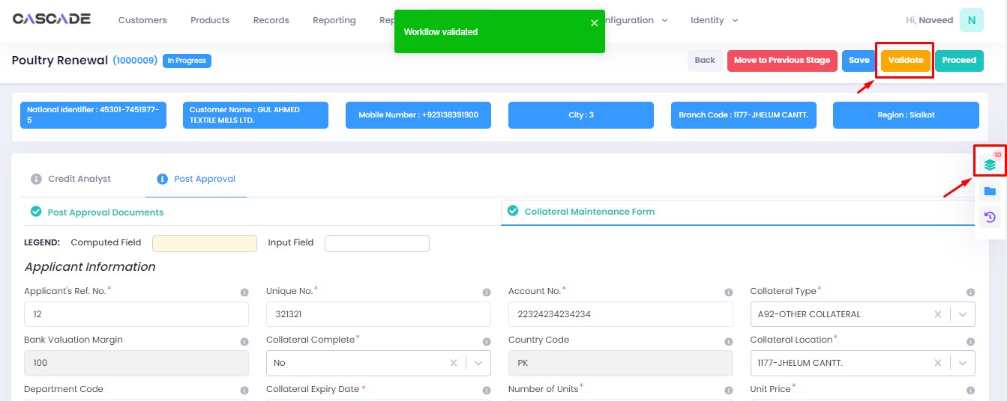

5. Here you will see the items that are pending before the application can be processed further. Upload the required documents to proceed. Or defer if inapplicable.



6. After uploading all the required documents, click on validate (1) then click on proceed (2).

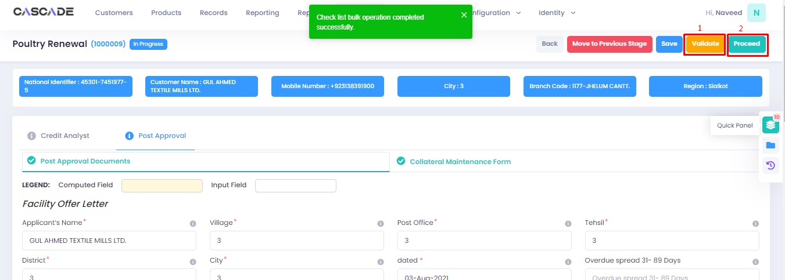

7. Now click on ‘Start RCAD’ to start the next stage in the workflow.

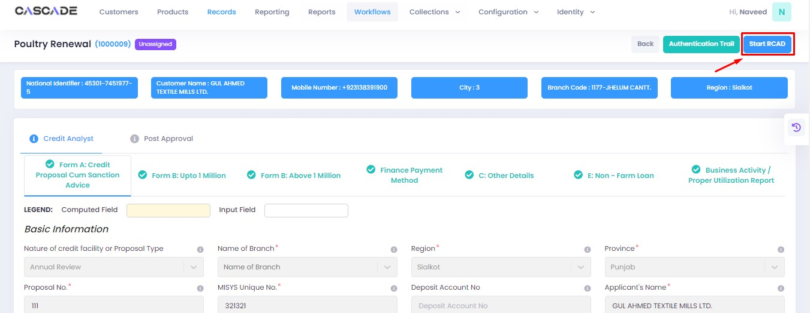

8. Fill all the required fields under ‘AT’ until no errors remain, then click on ‘validate’ (1), then on ‘quick panel’ on the right side of the page.

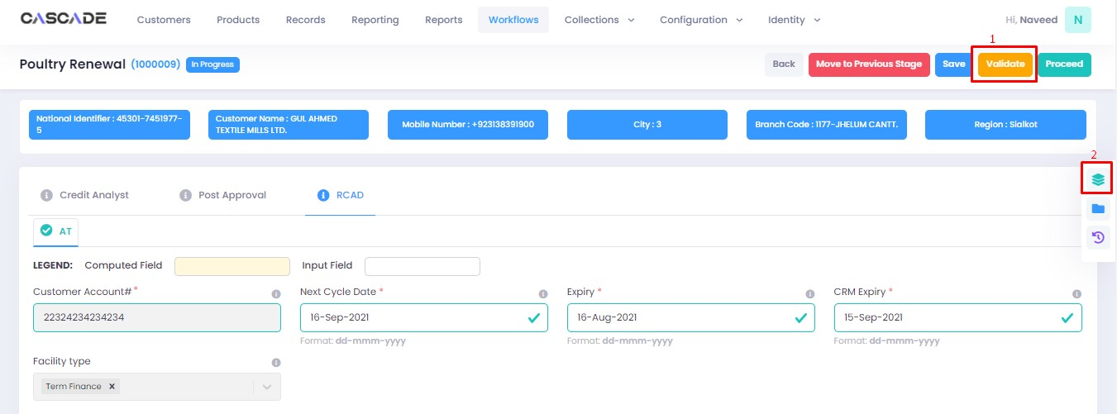

9. Upload the required documents or defer if required, then click on validate and then on proceed.



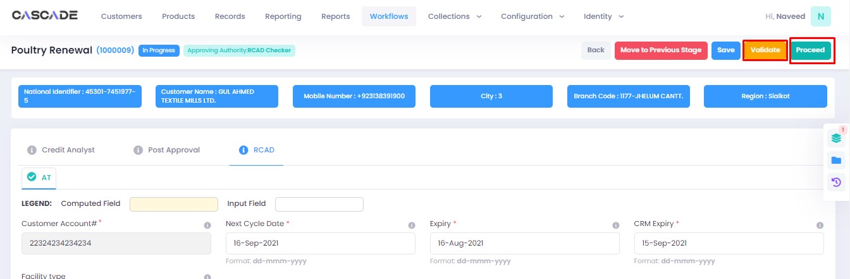

Checker

1. Now from the approver’s account, go to the workflows tab to view the in-progress journeys.



2. Select the product to show a list of the appropriate journeys. In this screenshot, you see the workflow with the status ‘Awaiting Authentication’.

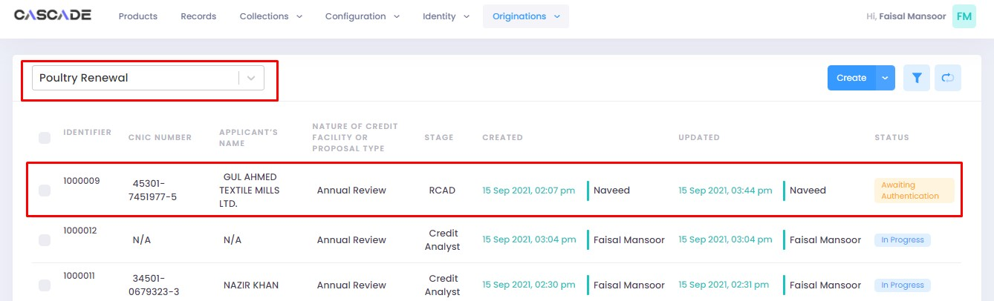

3. Click on ‘edit’ to proceed with the journey.

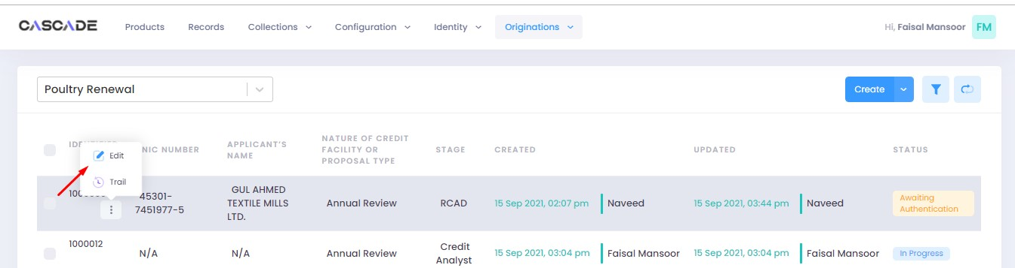

4. Now the approver will be able to see all the details of the journey filled by the maker of the workflow. After scrutinizing, click on the ‘authenticate’ button on the top right to approve or decline the application.

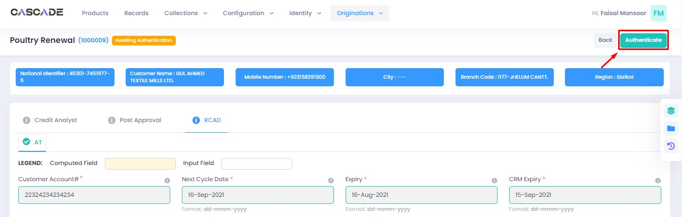

5. Fill the comment box with remarks, then ‘approve’, ‘decline’ or ‘discard’ the application. Recommending will move the application forward, declining it will destroy the application, and discarding it will send back the application to the maker.

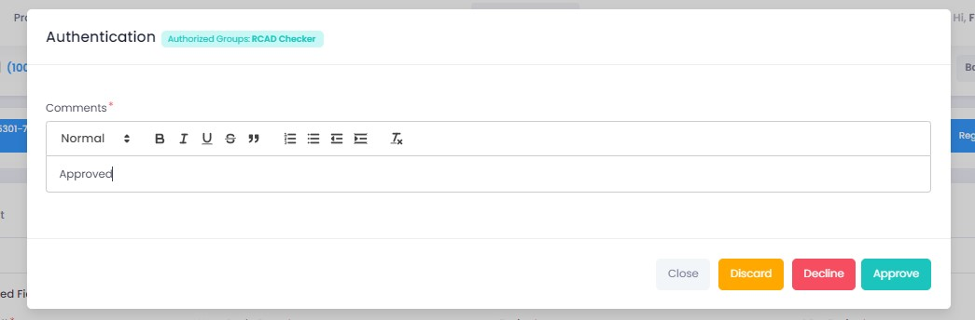

6. Under the workflows tab, select ‘Poultry Renewal’ as the product then ‘unassigned’ from the filters to display the relevant application.

**Note:** Application will only be visible to account with relevant rights

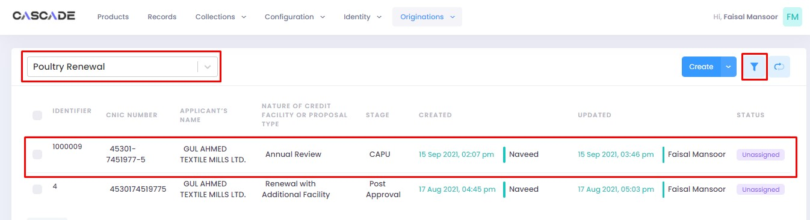

7. Then click on ‘edit’ to further proceed.

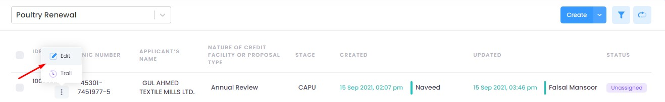

8. Now click on ‘Start CAPU’ to move to the next stage.

**Note:** CAPU can only be initiated and worked on from the account with relevant rights.

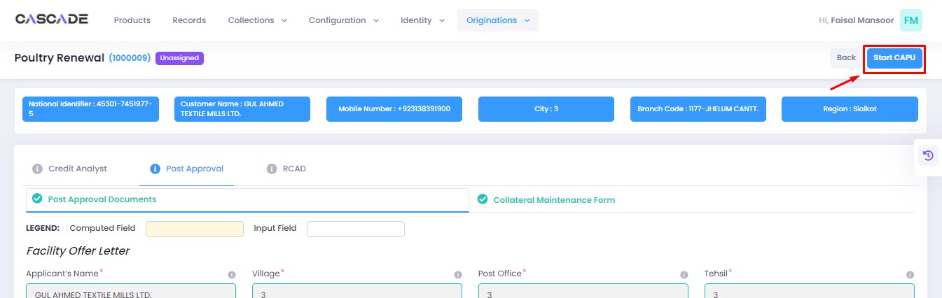

9. Fill all the required fields then click on validate (1) then on proceed (2).

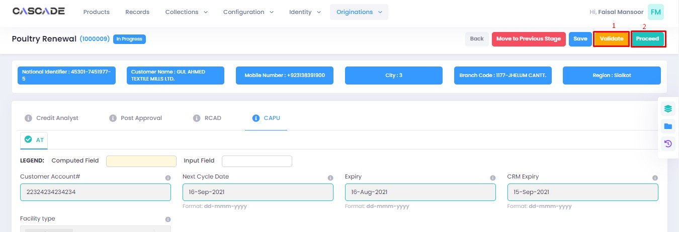

10. The application will now require approval by the CAPU checker.

CAPU checker will click on ‘authenticate’, leave remarks, then approve or decline the application.

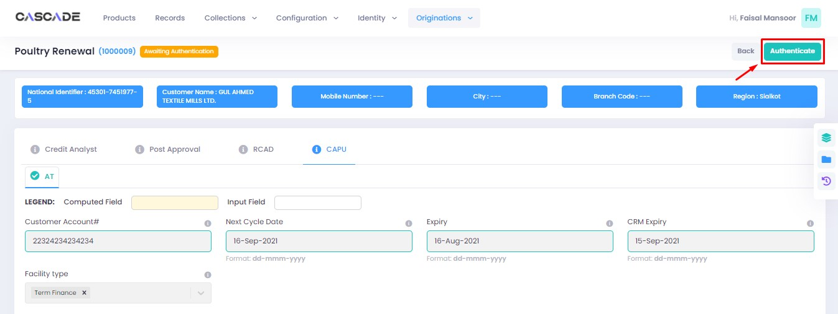

Fill the comment box with remarks, then ‘approve’, ‘decline’ or ‘discard’ the application. Recommending will move the application forward, declining it will destroy the application, and discarding it will send back the application to the maker.



11. The application will now be marked as completed and as ready to be disbursed.

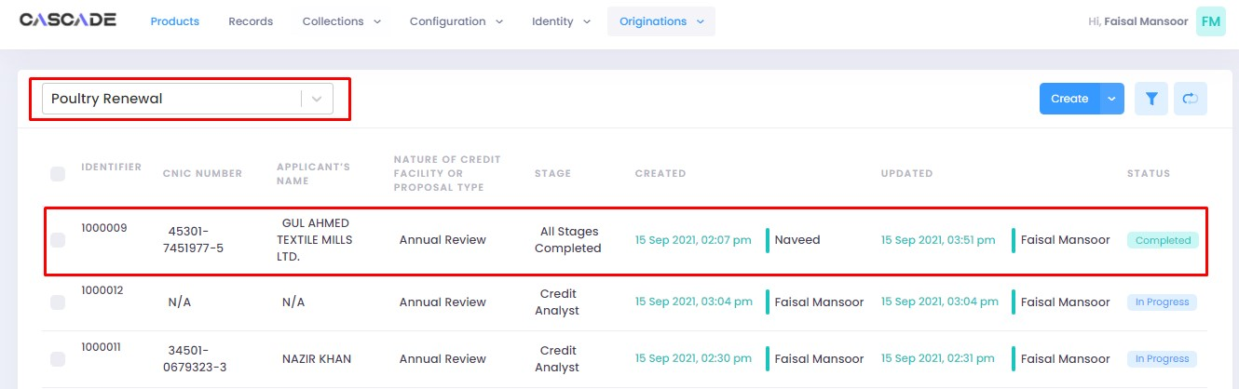

# Product: Dairy NTB

Maker

1. Under the Workflows tab, select the product, then click on ‘create’ to start a new application.

**Note:** Products and workflows shown will vary according to the rights assigned to a user account.

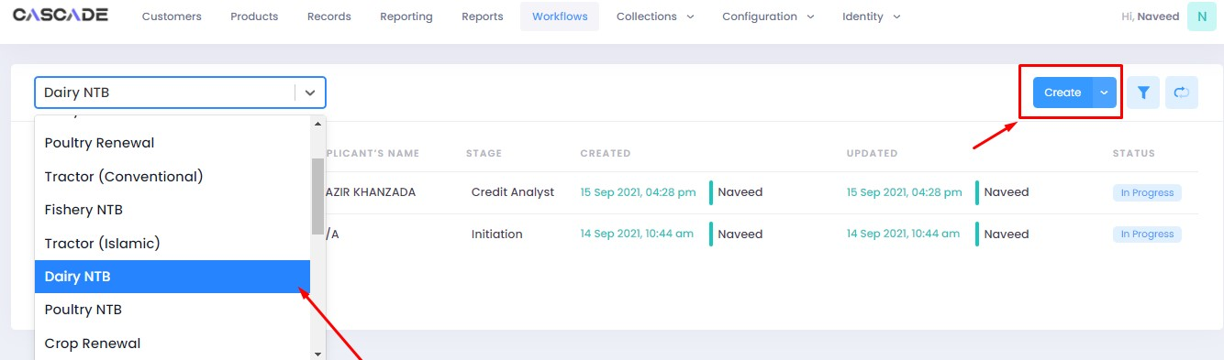

2. Fill the details, then click on ‘proceed’.

**Note**: Depending on the values selected under the fields ‘Is Lead Generation’ and ‘AFO’, new fields and stages in the workflow will appear.

**Lead Generation**: Will allow to manually add details of a prospect.

**AFO**: Allows for ‘data entry’ prior to any stage. The details will then be carried into the ‘credit analyst stage’.

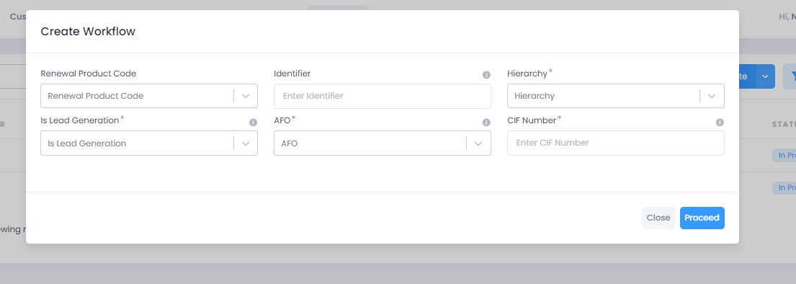

3. When on the ‘credit analyst’ stage, you can create a deviation by clicking on ‘quick panel’ on right side of the page.



4. Then under ‘deviations/exceptions’ you will see all the available deviations. Click on the one applicable to the application, leave remarks then click ‘create’.





5. Once created, the created deviation will show as ‘pending’ in the quick panel and will require approval from an approving authority before the application can be processed further.



6. After filling all the fields, click on validate to check for errors or missing fields. Once there are no errors left, click on the next Group to proceed with the journey.

**Note:** Form B will appear according to the ‘proposed loan amount’ (Up to 1 million or Over 1 million) entered in Form A.

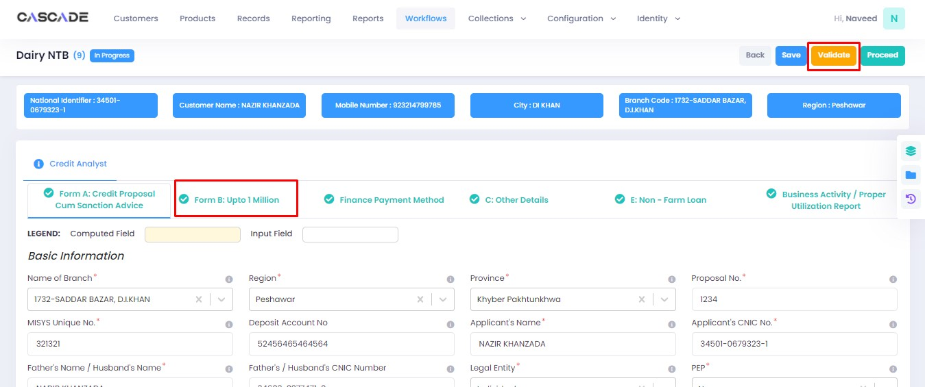

7. Fill all the required fields in the rest of the groups, then click on validate, then click on quick panel.

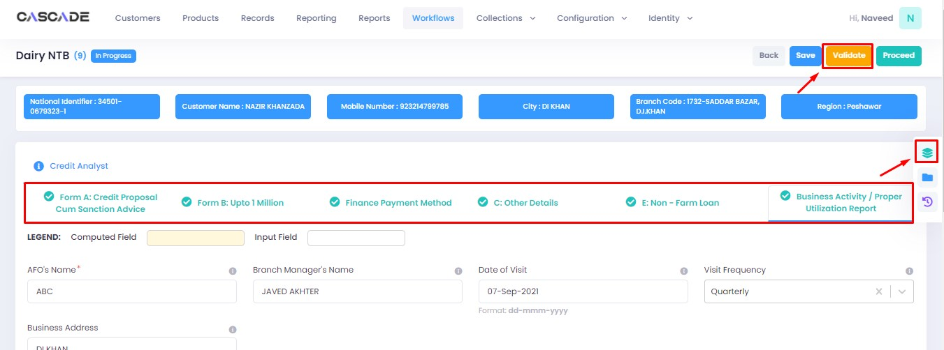

8. Under the ‘check list’ tab, you will see a list of the required documents and checks. Run all the checks and upload the required documents to proceed. Or defer if required.

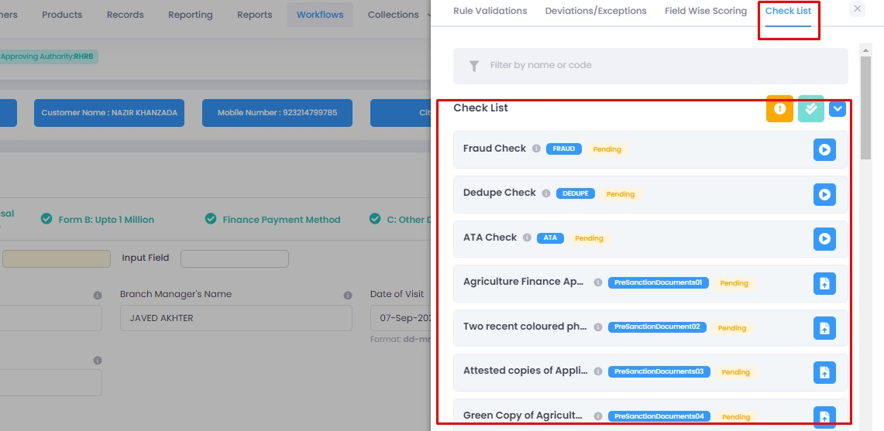

9. After going through the checklist, click on validate, and then proceed to move to the next stage.

**Note:** The workflow will now require approval from an approver.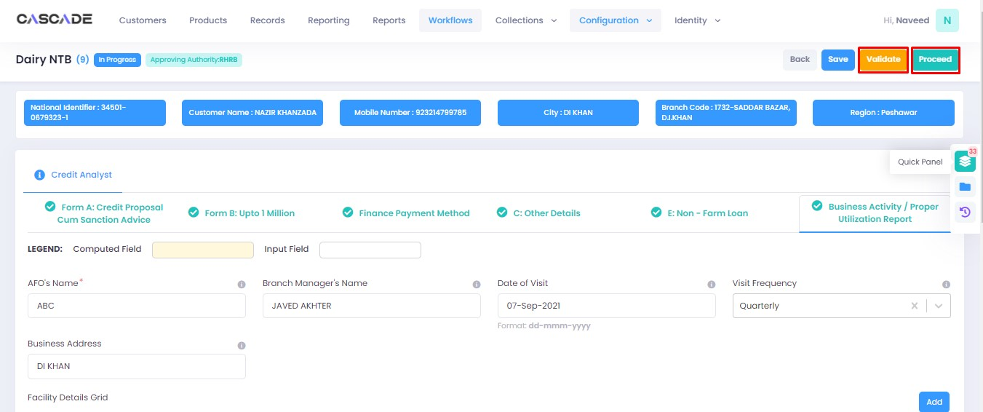

Checker

1. Now from the approver’s account, go to the workflows tab to view the in-progress journeys.



2. Select the product to show a list of the appropriate journeys. In this screenshot, you see the workflow with the status ‘Awaiting Authentication’.

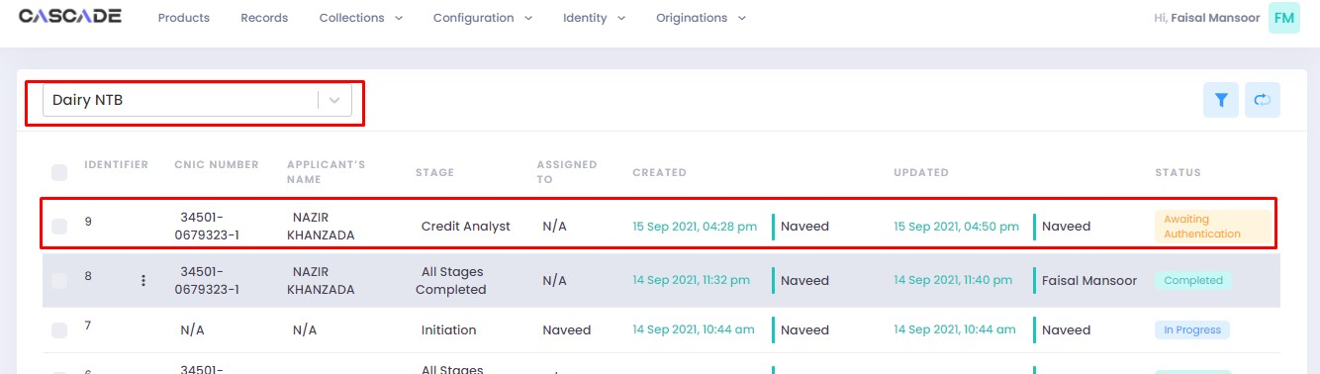

3. Click on ‘edit’ to proceed with the journey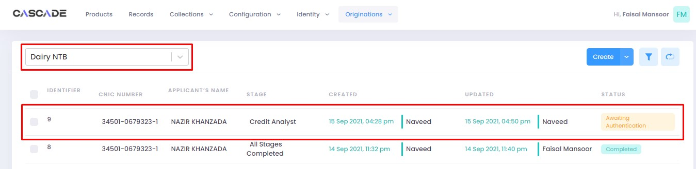

4. Now the approver will be able to see all the details of the journey filled by the maker of the workflow. After scrutinizing, click on the ‘authenticate’ button on the top right to approve or decline the application.

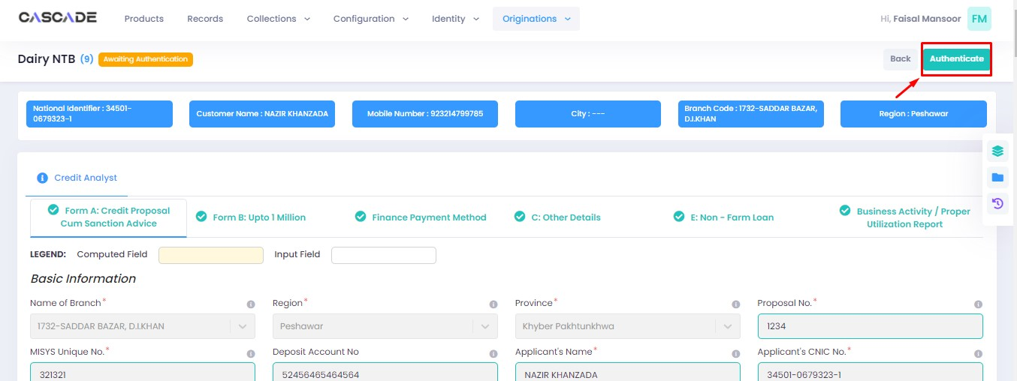

5. Fill the comment box with remarks, then ‘recommend’, ‘decline’ or ‘discard’ the application. Recommending will move the application forward, declining it will destroy the application, and discarding it will send back the application to the maker.



6. The application will require multiple recommendations from the relevant accounts until it is ‘approved’ by an account with appropriate rights. The screenshot below shows the names of the accounts the application has gone through so far with their comments.



7. After the first recommendation, the second recommender will see the ‘move back’ button which will send the application back to the first recommender. In case of having gone through multiple recommendations the ‘move back’ button will send the application back to the previous approver.



8. After all the ‘recommendations’, the application will require an ‘approval’ from an account with appropriate rights.



Maker

1. Once the application has been authenticated, it will reappear under the account of the ‘maker’. Go to the ‘workflows’ tab, then select the product, ‘Dairy NTB’ in this case, to show relevant applications, then select ‘unassigned’ in the filters. You will now see the concerned application with a status of ‘unassigned’.

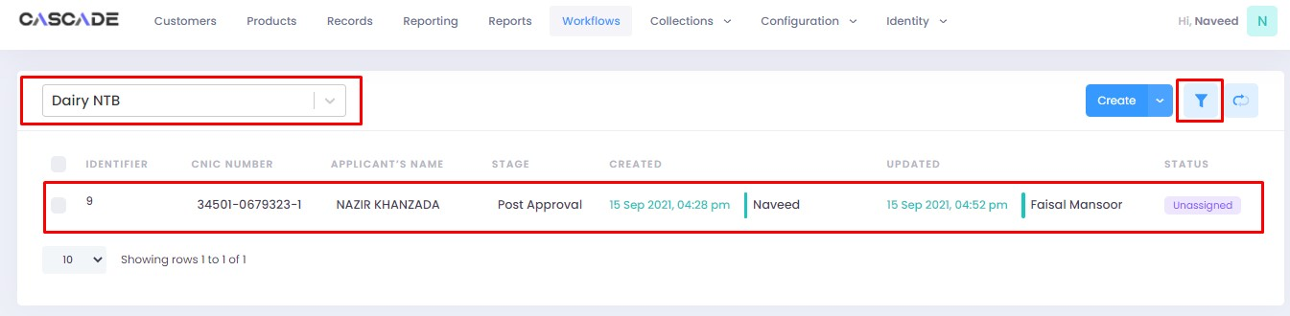



2. Click on ‘edit’, then click on ‘Start Post Approval’ to start the next stage.

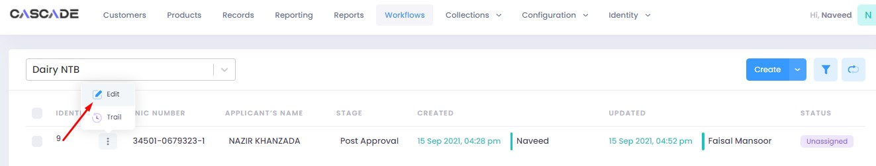

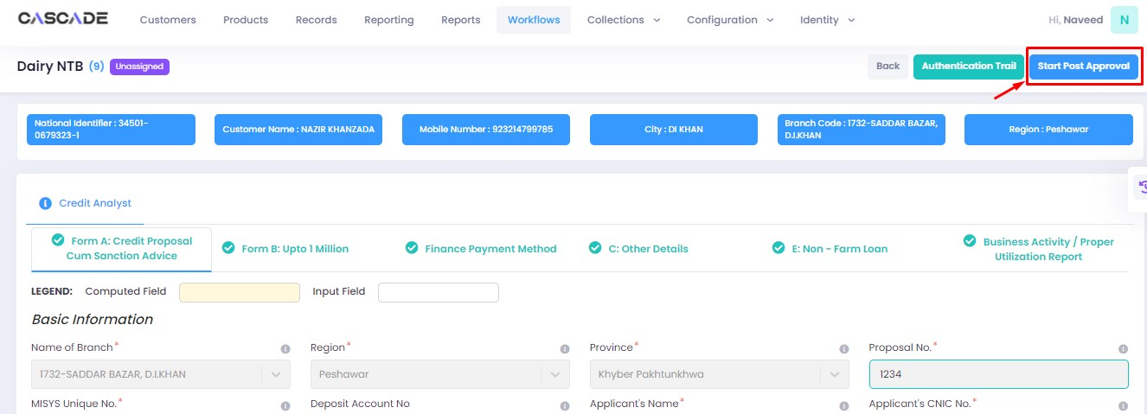

3. Fill all the required fields under ‘Post Approval Documents’ until no errors remain, then click on validate (1), then on the next group (2).

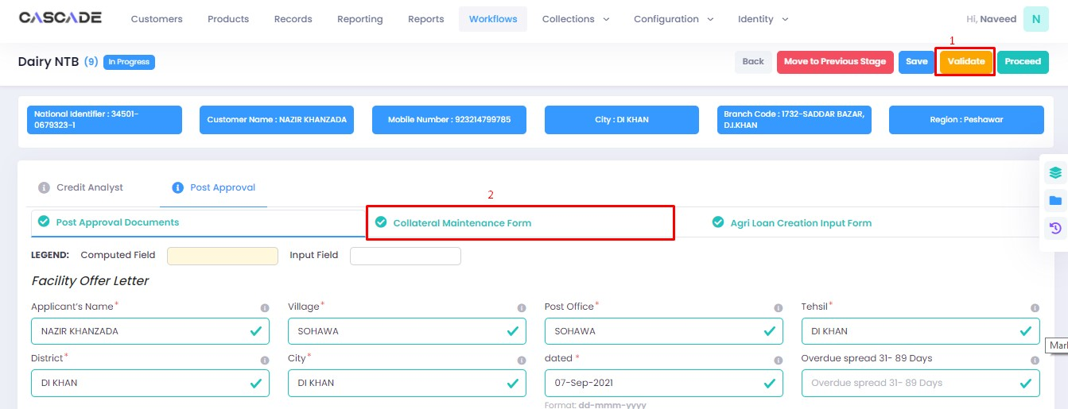

4. Fill all the required fields in rest of the groups, then click on validate (1), then on ‘quick panel’ (2).

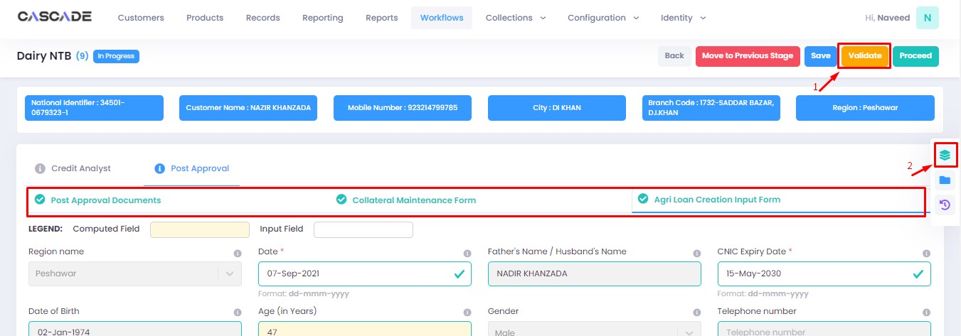

5. Here you will see the items that are pending before the application can be processed further. Upload the required documents to proceed. Or defer if inapplicable.



6. After uploading all the required documents, click on validate (1) then click on proceed (2).

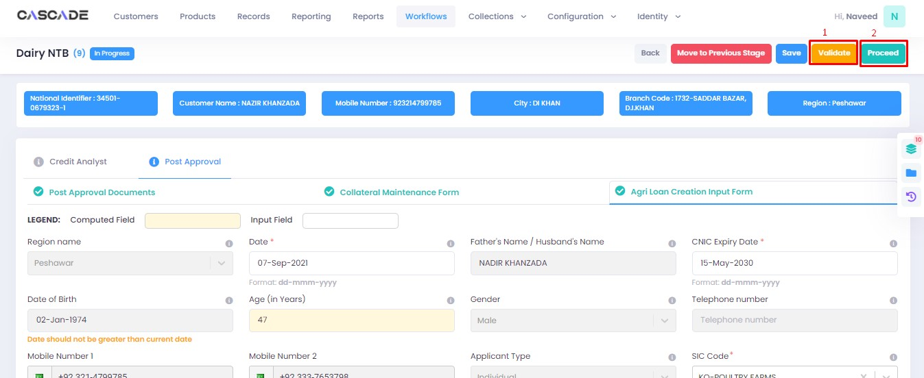

7. Now click on ‘Start RCAD’ to start the next stage in the workflow.

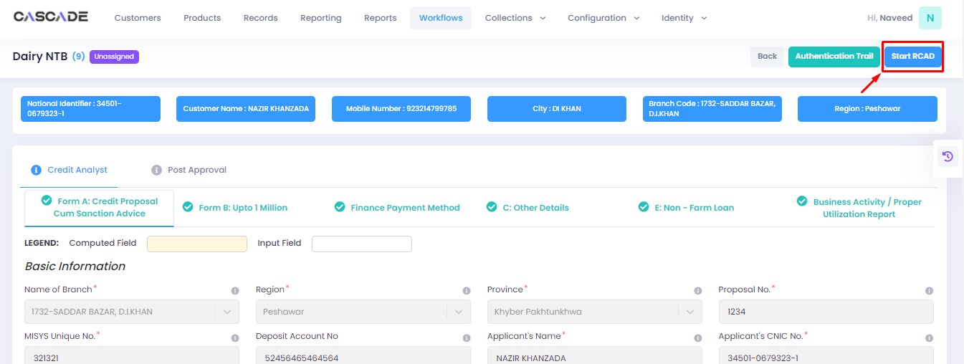

8. Fill all the required fields under all groups until no errors remain, then click on ‘validate’, then on ‘quick panel’ on the right side of the page.

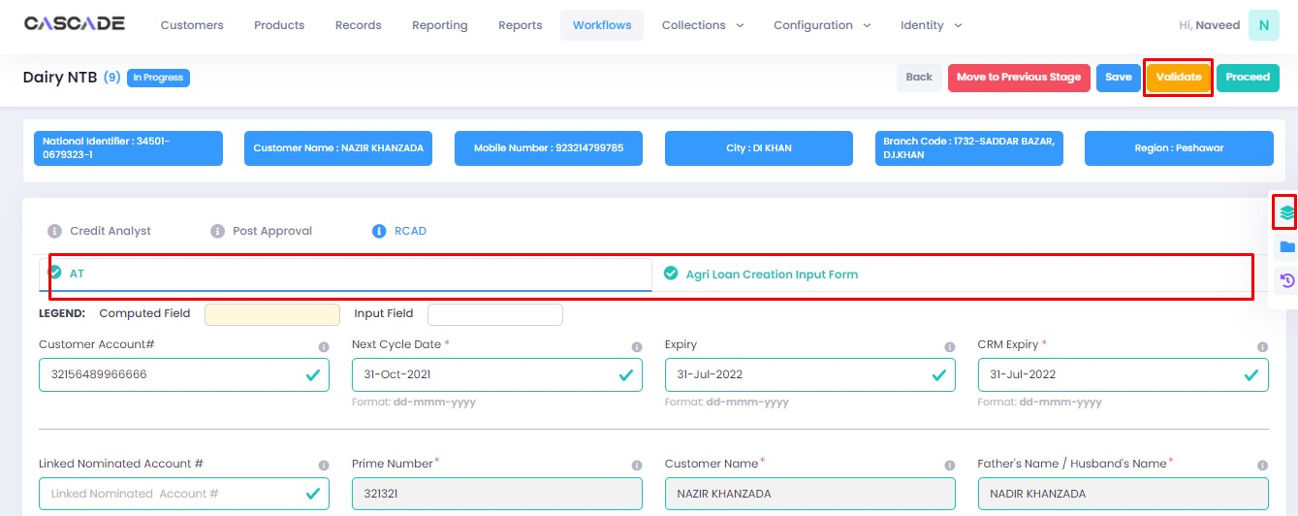

9. Upload the required documents or defer if required, then click on validate and then on proceed.



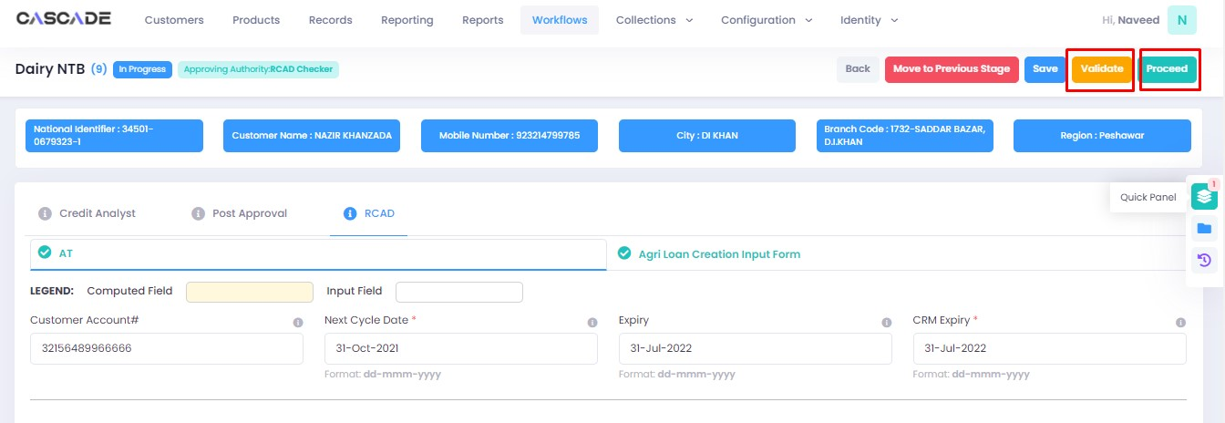

Checker

1. Now from the approver’s account, go to the workflows tab to view the in-progress journeys.



2. Select the product to show a list of the appropriate journeys. In this screenshot, you see the workflow with the status ‘Awaiting Authentication’.

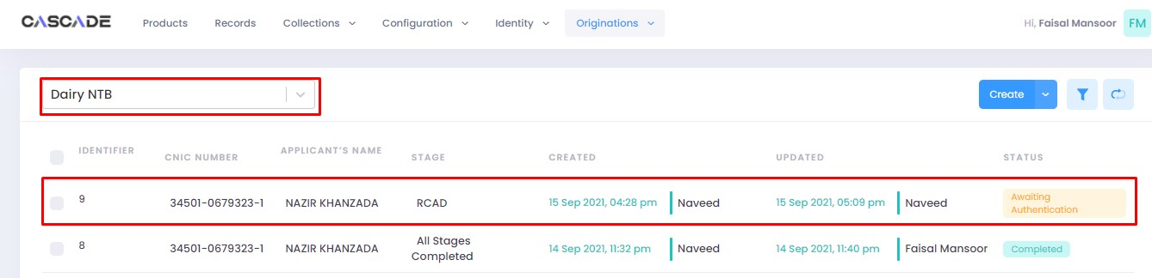

3. Click on ‘edit’ to proceed with the journey.

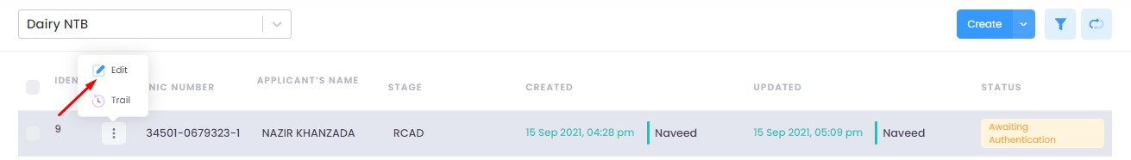

4. Now the approver will be able to see all the details of the journey filled by the maker of the workflow. After scrutinizing, click on the ‘authenticate’ button on the top right to approve or decline the application.

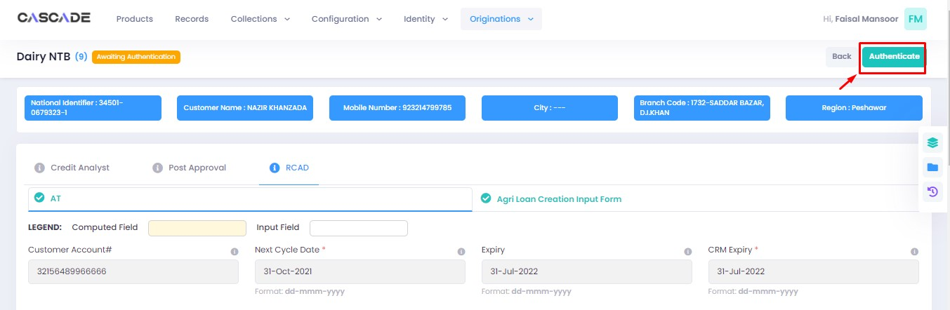

5. Fill the comment box with remarks, then ‘approve’, ‘decline’ or ‘discard’ the application. Recommending will move the application forward, declining it will destroy the application, and discarding it will send back the application to the maker.



6. Under the workflows tab, select ‘Dairy NTB’ as the product then ‘unassigned’ from the filters to display the relevant application.

**Note:** Application will only be visible to account with relevant rights.

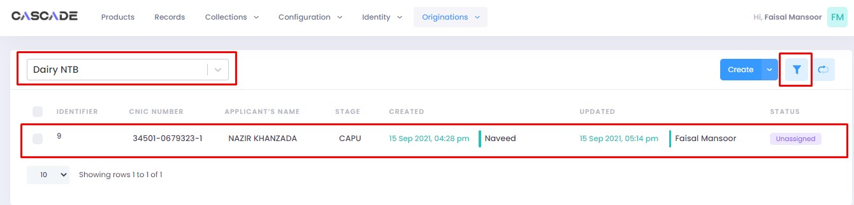

7. Then click on ‘edit’ to further proceed.

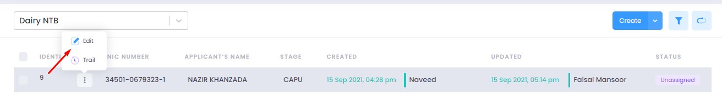

8. Now click on ‘Start CAPU’ to move to the next stage.

**Note:** CAPU can only be initiated and worked on from the account with relevant rights.

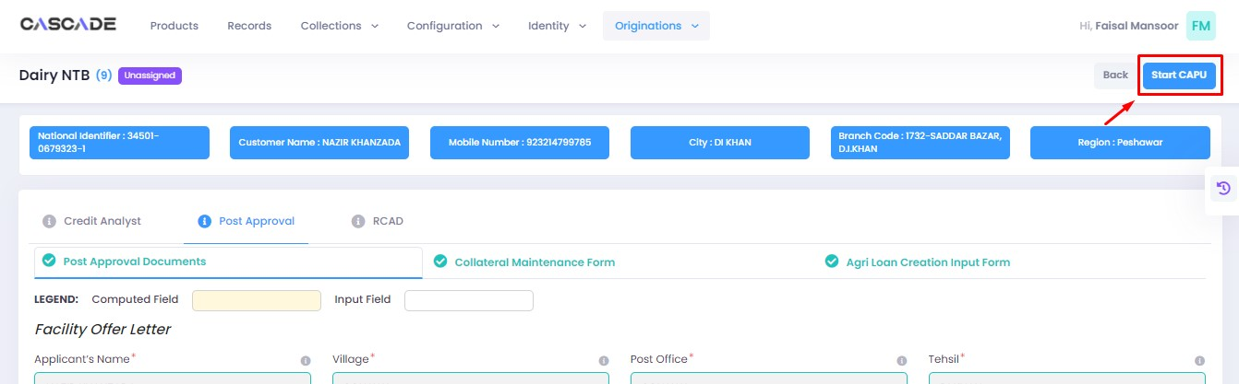

9. Fill all the required fields under all groups then click on validate then on proceed.

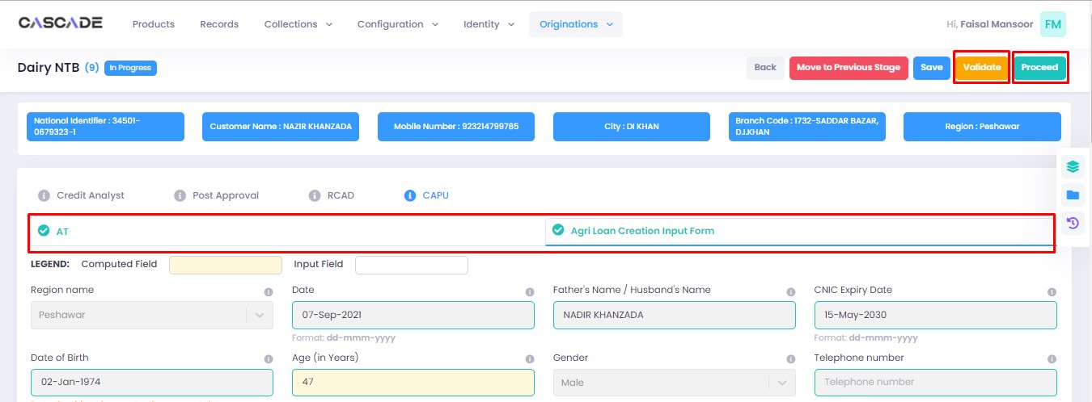

10. The application will now require approval by the CAPU checker.

CAPU checker will click on ‘authenticate’, leave remarks, then approve or decline the application.

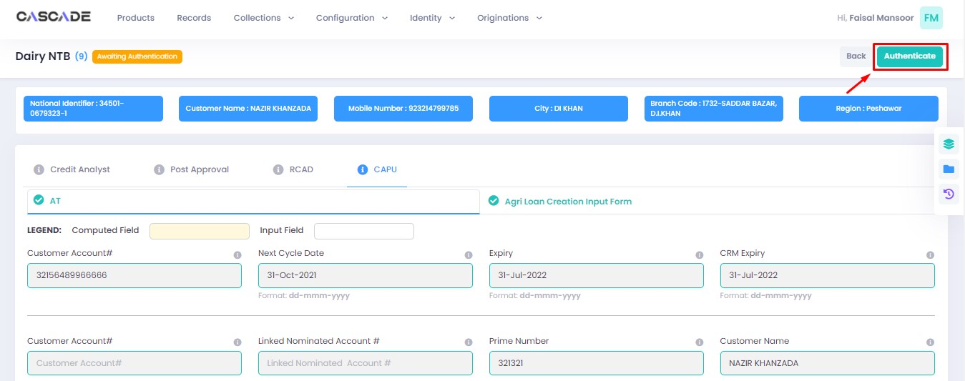

Fill the comment box with remarks, then ‘approve’, ‘decline’ or ‘discard’ the application. Recommending will move the application forward, declining it will destroy the application, and discarding it will send back the application to the maker.



11. The application will now be marked as completed and ready to be disbursed.

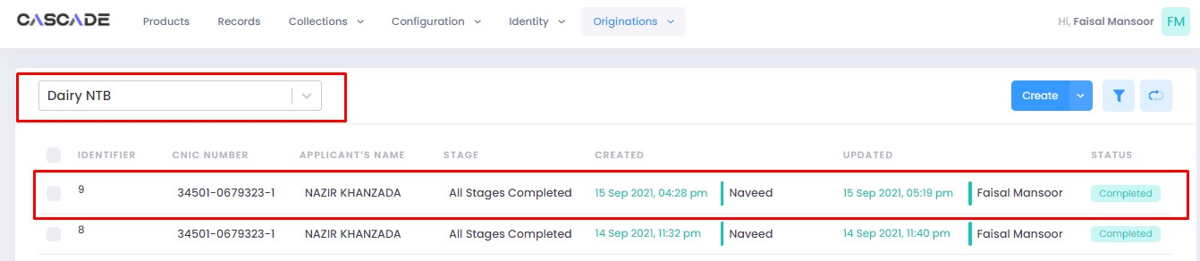

# Product: Dairy Renewal

Maker

1. Under the Workflows tab, select the product, then click on ‘create’ to start a new application.

**Note:** Products and workflows shown will vary according to the rights assigned to a user account.

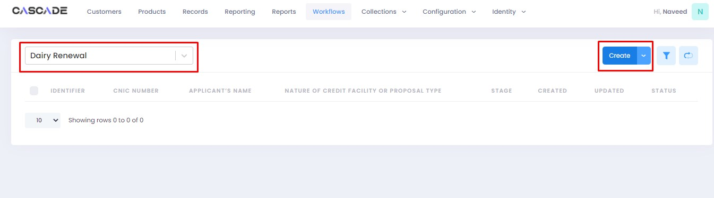

2. Fill the details, then click on ‘proceed’.

**Note**: Depending on the value selected under the field ‘form type’ and ‘AFO’, new fields in the application might appear.

**Form Type:** You will be able to choose form type between ‘one pager’ or ‘full form’. Fields and stages will vary in both form types (examples shown below).

**AFO**: Allows for ‘data entry’ prior to any stage. The details will then be carried into the ‘credit analyst stage’.



3. When on the ‘credit analyst’ stage, you can create a deviation by clicking on ‘quick panel’ on right side of the page.



4. Then under ‘deviations/exceptions’ you will see all the available deviations. Click on the one applicable to the application, leave remarks then click ‘create’.





5. Once created, the created deviation will show as ‘pending’ in the quick panel and will require approval from an approving authority before the application can be processed further.



## Form Type: One Pager

6. After filling all the fields, click on validate (1) to check for errors or missing fields. Once there are no errors left, click on the next Group (2) to proceed with the journey.



7. Fill all the required fields under all groups. Then click on ‘validate’ (1) then on ‘quick panel’ (2) on the right side of the page to view the checklist of pending actions.



8. Under the ‘check list’ tab, you will see a list of the required documents and checks. Run all the checks and upload the required documents to proceed. Or defer if required.



9. After going through the checklist, click on validate, and then proceed to move to the next stage.

**Note:** The workflow will now require approval from an approver.



## Form Type: Full Form

10. After filling all the fields, click on validate to check for errors or missing fields. Once there are no errors left, click on the next Group to proceed with the journey

**Note:** Form B will appear according to the ‘proposed loan amount’ (Up to 1 million or Over 1 million) entered in Form A.

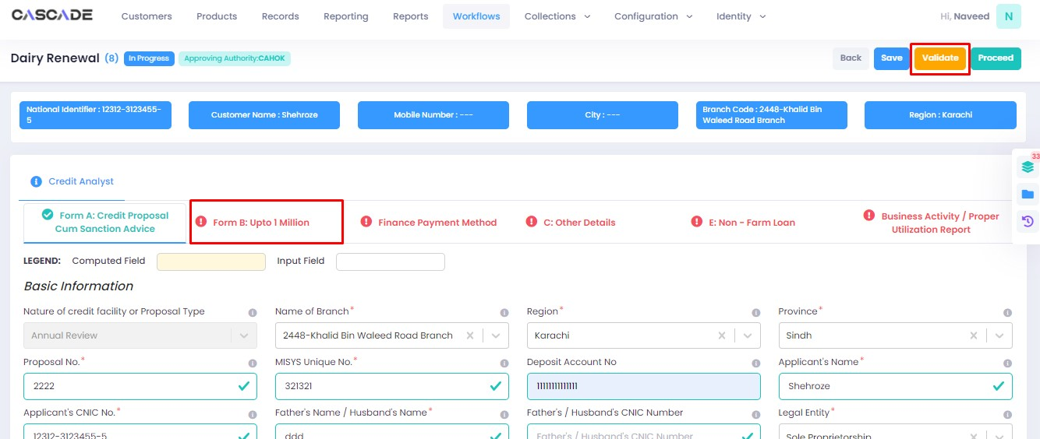

11. Fill all the required fields in the rest of the groups, then click on ‘validate’, then on ‘quick panel’ on the right side of the page to view the checklist of pending actions.

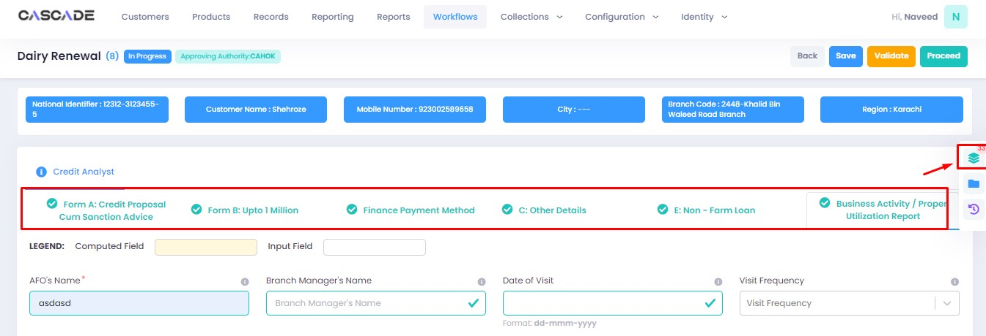

12. Under the ‘check list’ tab, you will see a list of the required documents and checks. Run all the checks and upload the required documents to proceed. Or defer if required.



13. After going through the checklist, click on validate, and then proceed to move to the next stage.

**Note:** The workflow will now require approval from an approver.

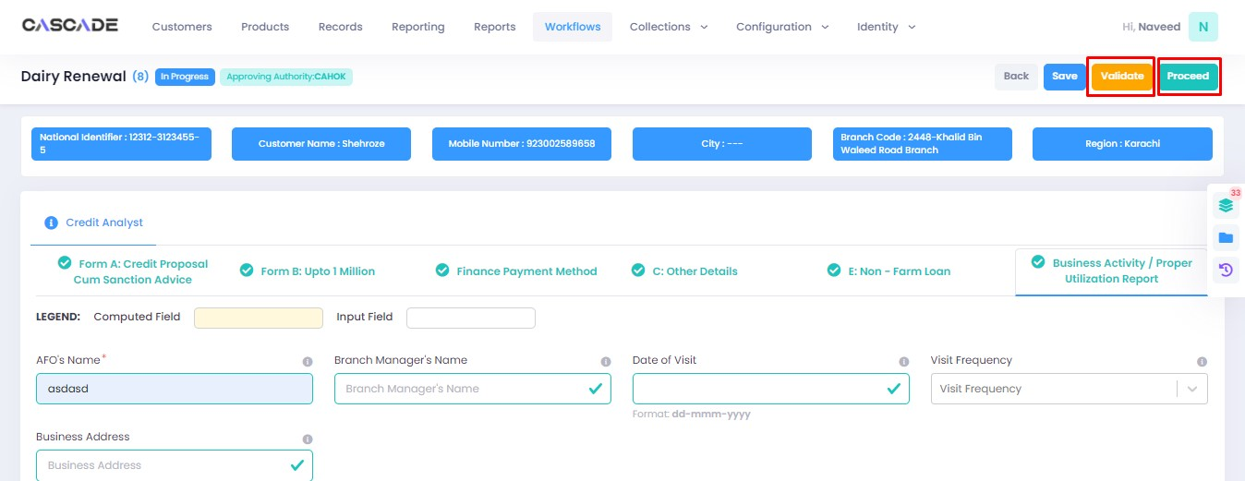

Checker

1. Now from the approver’s account, go to the workflows tab to view the in-progress journeys.



2. Select the product to show a list of the appropriate journeys. In this screenshot, you see the workflow with the status ‘Awaiting Authentication’.

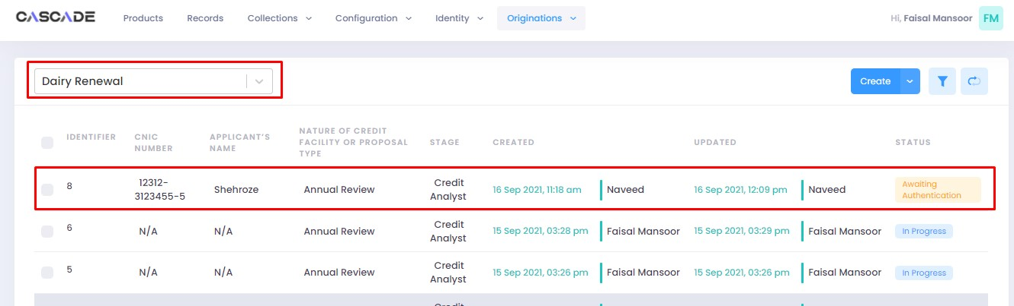

3. Click on ‘edit’ to proceed with the journey.

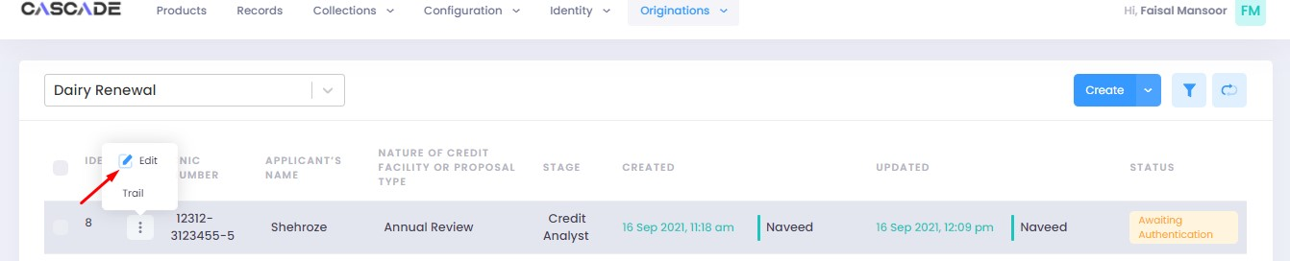

4. Now the approver will be able to see all the details of the journey filled by the maker of the workflow. After scrutinizing, click on the ‘authenticate’ button on the top right to recommend, approve or decline the application.

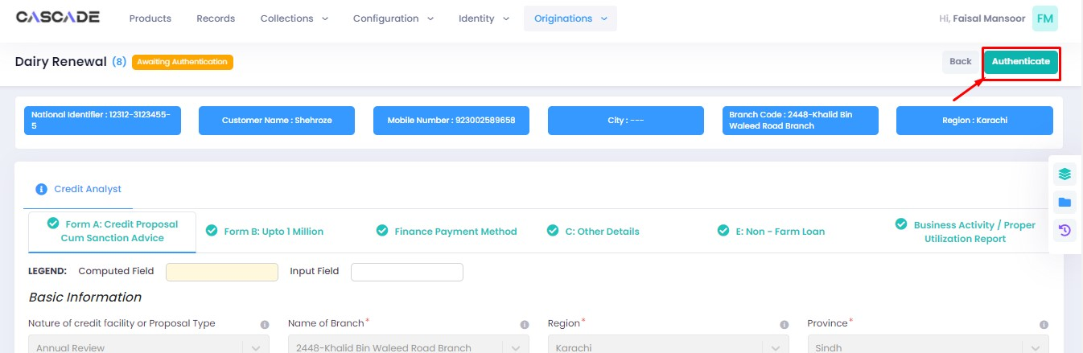

5. Fill the comment box with remarks, then ‘recommend’, ‘decline’ or ‘discard’ the application. Recommending will move the application forward, declining it will destroy the application, and discarding it will send back the application to the maker.



6. The application will require multiple recommendations from the relevant accounts until it is ‘approved’ by an account with appropriate rights. The screenshot below shows the names of the accounts the application has gone through so far with their comments.



7. After the first recommendation, the second recommender will see the ‘move back’ button which will send the application back to the first recommender. In case of having gone through multiple recommendations the ‘move back’ button will send the application back to the previous approver.



8. After all the ‘recommendations’, the application will require an ‘approval’ from an account with appropriate rights.



Maker

1. Once the application has been authenticated, it will reappear under the account of the ‘maker’. Go to the ‘workflows’ tab, then select the product, ‘Dairy Renewal’ in this case, to show relevant applications, then select ‘unassigned’ in the filters. You will now see the concerned application with a status of ‘unassigned’.

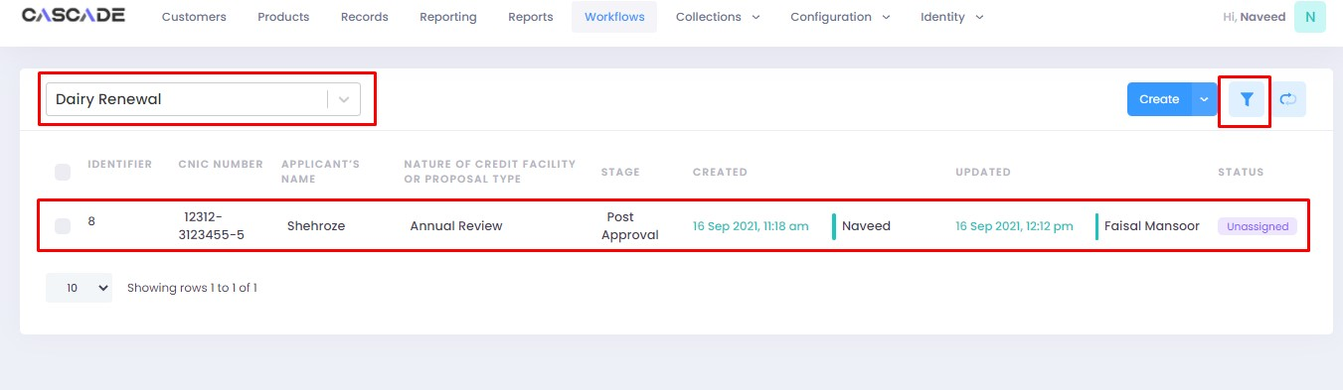



2. Click on ‘edit’, then click on ‘Start Post Approval’ to start the next stage.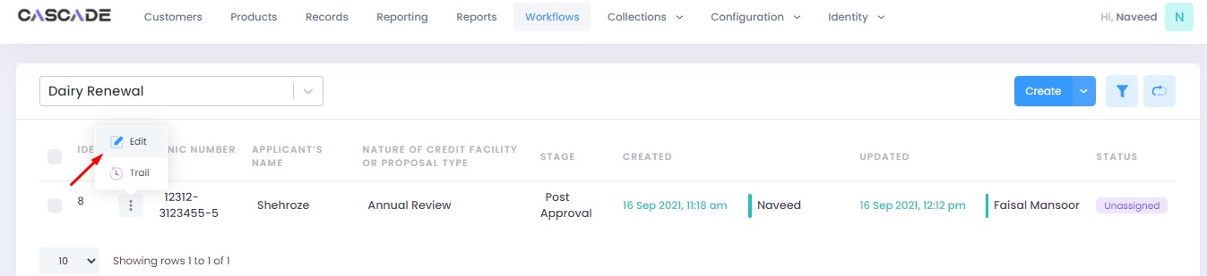

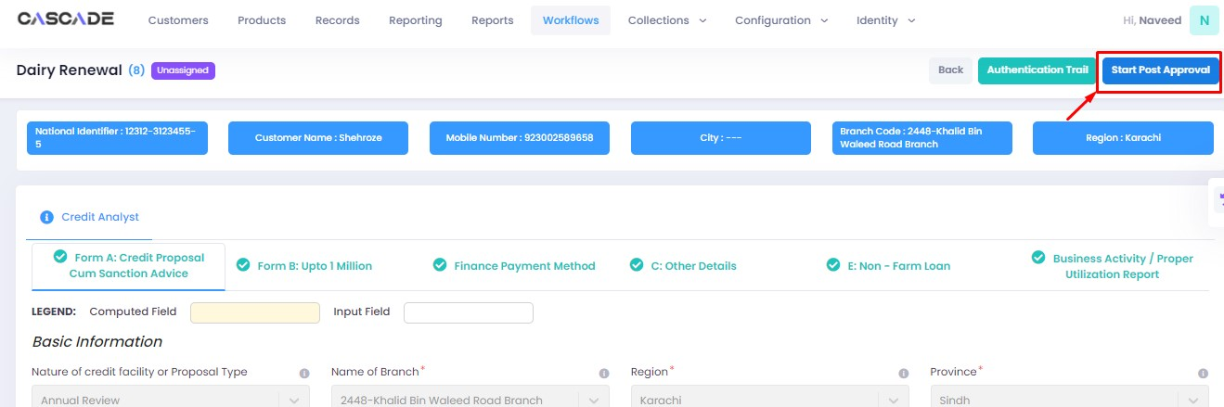

3. Fill all the required fields under ‘Post Approval Documents’ until no errors remain, then click on validate (1), then on the next group (2).

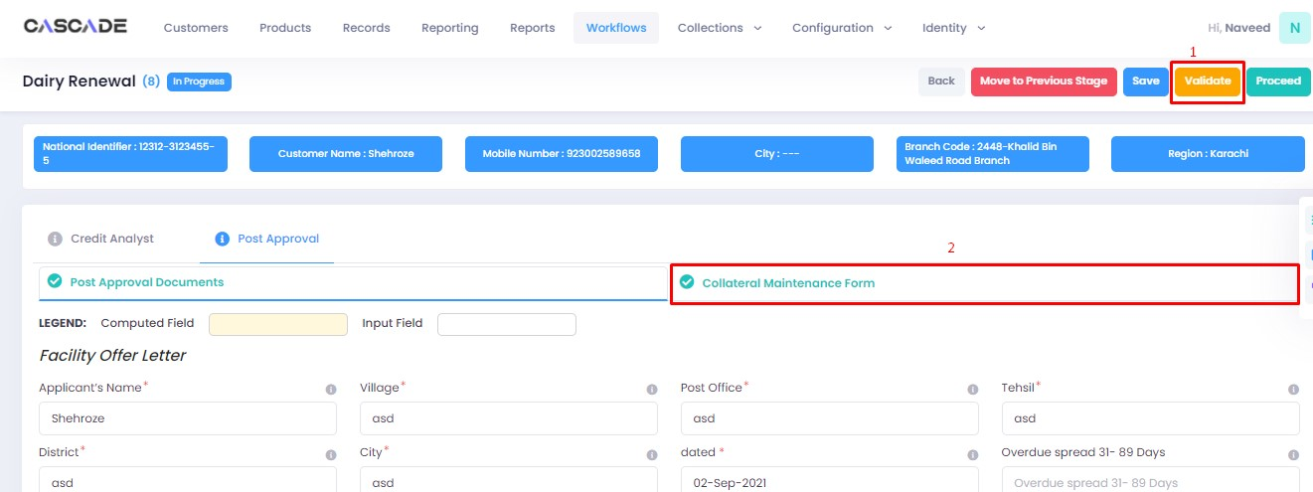

4. Fill all the required fields under ‘Collateral Maintenance Form’ until no errors remain, then click on validate. Then on the right side of the page, click on ‘quick panel’.

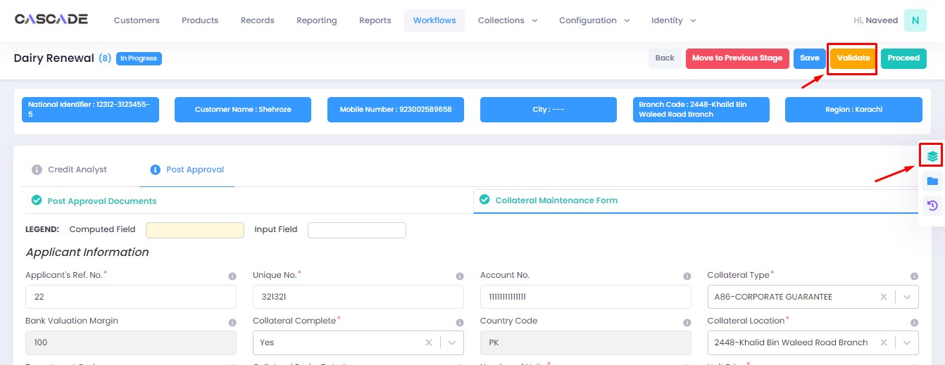

5. Here you will see the items that are pending before the application can be processed further. Upload the required documents to proceed. Or defer if inapplicable.



6. After uploading all the required documents, click on validate (1) then click on proceed (2).

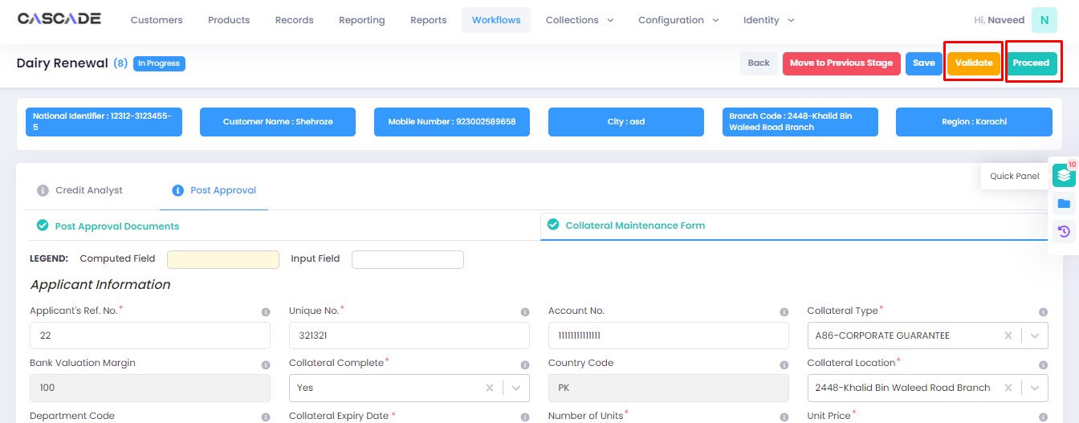

7. Now click on ‘Start RCAD’ to start the next stage in the workflow.

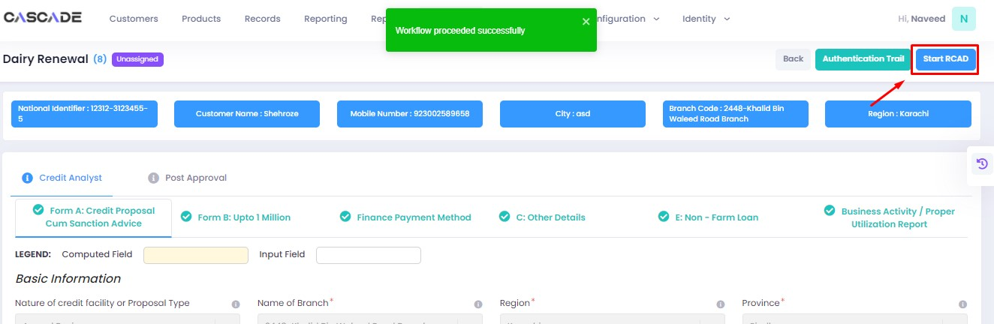

8. Fill all the required fields under ‘AT’ until no errors remain, then click on ‘validate’, then on ‘quick panel’ on the right side of the page.

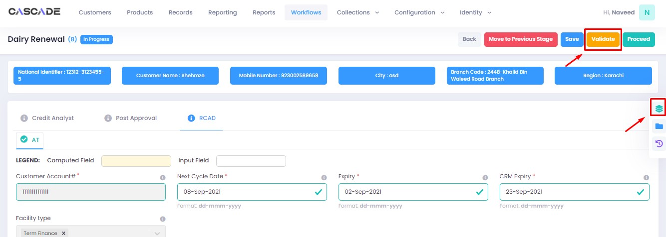

9. Upload the required documents or defer if required, then click on validate and then on proceed.





Checker

1. Now from the approver’s account, go to the workflows tab to view the in-progress journeys.



2. Select the product to show a list of the appropriate journeys. In this screenshot, you see the workflow with the status ‘Awaiting Authentication’.

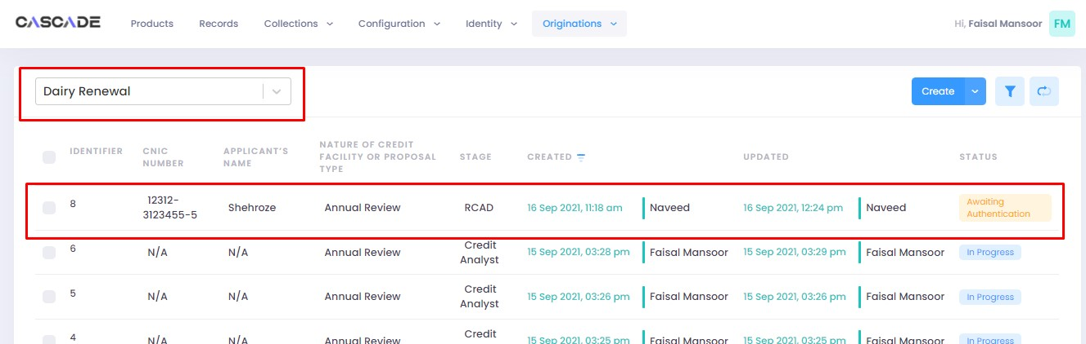

3. Click on ‘edit’ to proceed with the journey.

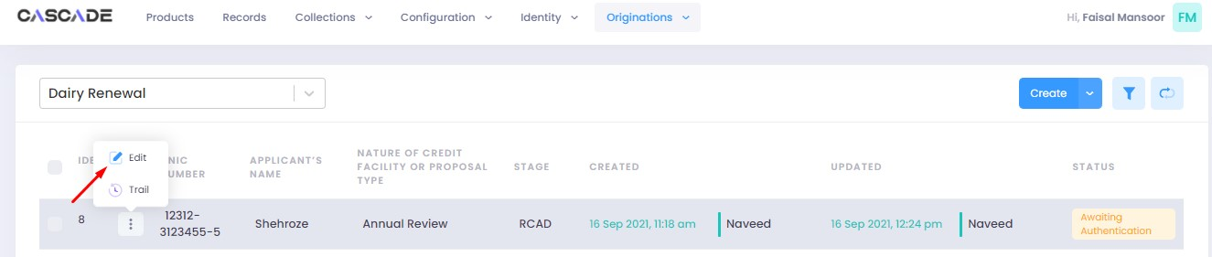

4. Now the approver will be able to see all the details of the journey filled by the maker of the workflow. After scrutinizing, click on the ‘authenticate’ button on the top right to approve or decline the application.

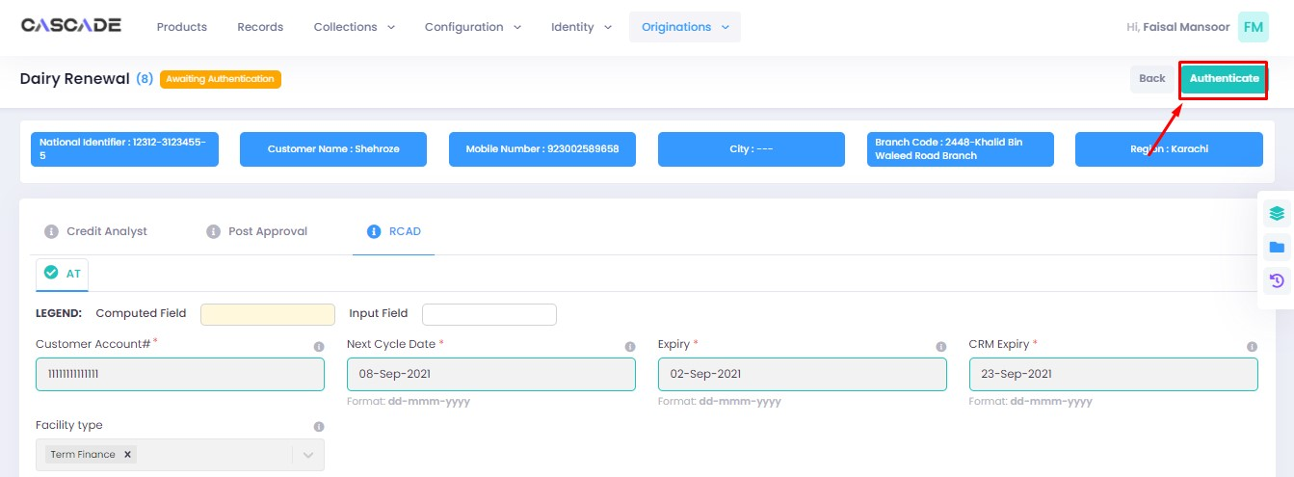

5. Fill the comment box with remarks, then ‘approve’, ‘decline’ or ‘discard’ the application. Recommending will move the application forward, declining it will destroy the application, and discarding it will send back the application to the maker.



6. Under the workflows tab, select ‘Dairy Renewal’ as the product then ‘unassigned’ from the filters to display the relevant application.

**Note:** Application will only be visible to account with relevant rights

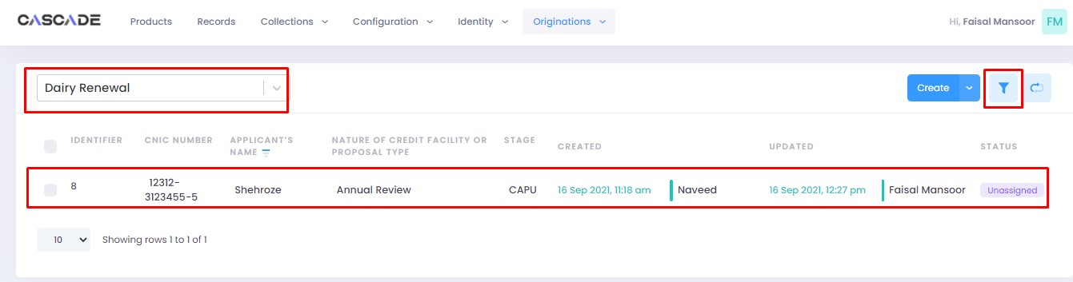

7. Then click on ‘edit’ to further proceed.

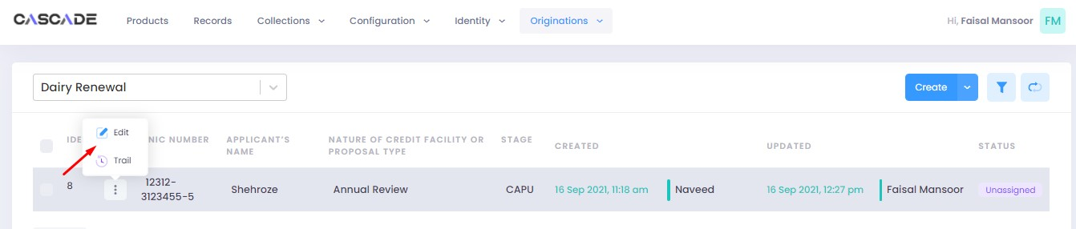

8. Now click on ‘Start CAPU’ to move to the next stage.

**Note**: CAPU can only be initiated and worked on from the account with relevant rights.

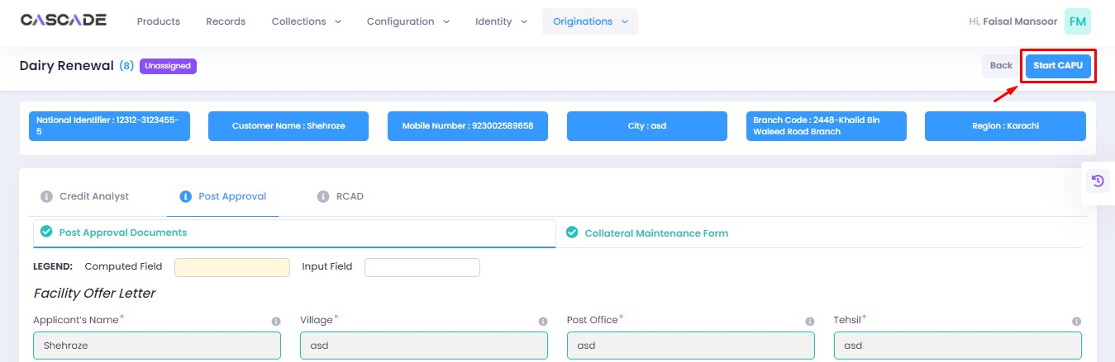

9. Fill all the required fields then click on validate (1) then on proceed (2).

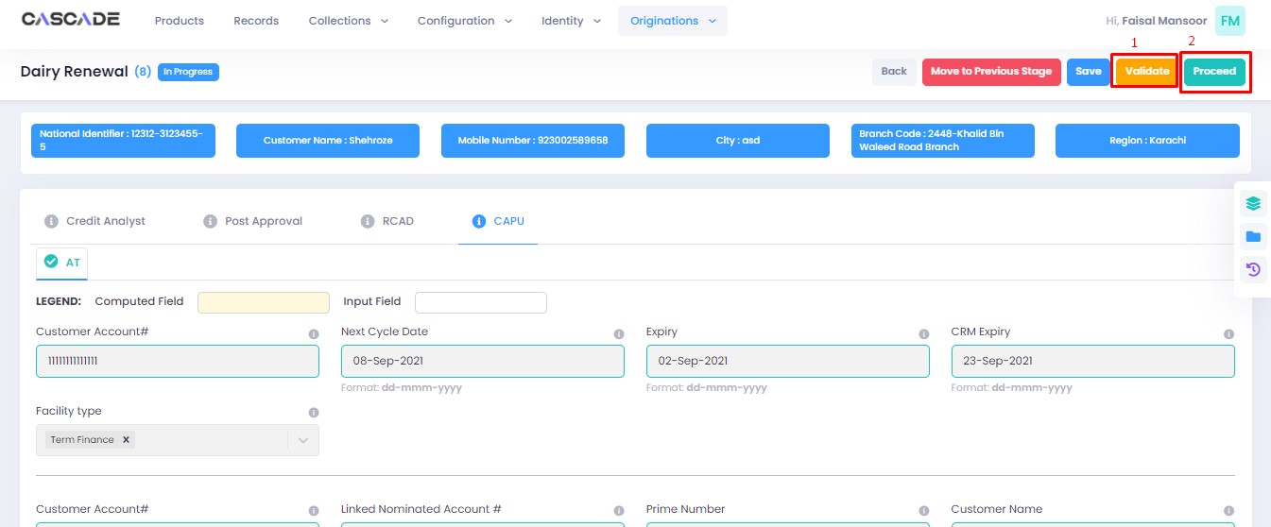

10. The application will now require approval by the CAPU checker.

CAPU checker will click on ‘authenticate’, leave remarks, then approve or decline the application.

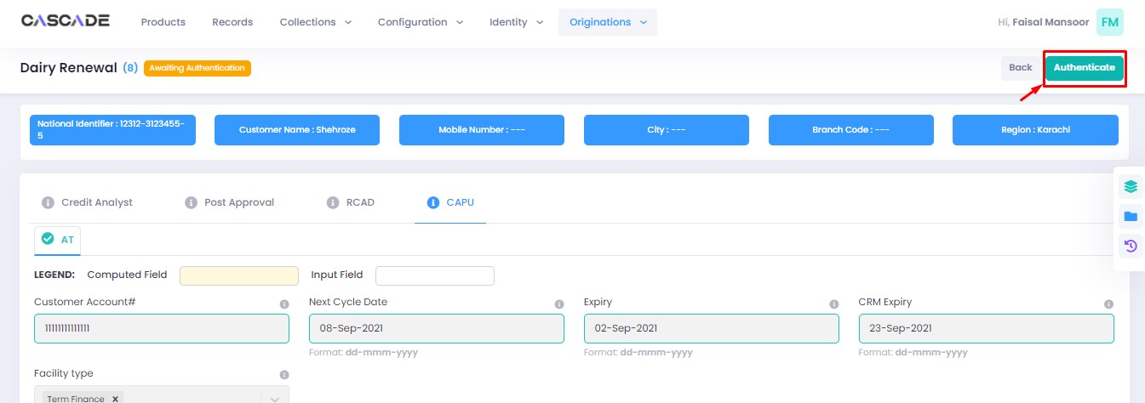

Fill the comment box with remarks, then ‘approve’, ‘decline’ or ‘discard’ the application. Recommending will move the application forward, declining it will destroy the application, and discarding it will send back the application to the maker.



11. The application will now be marked as completed and as ready to be disbursed.

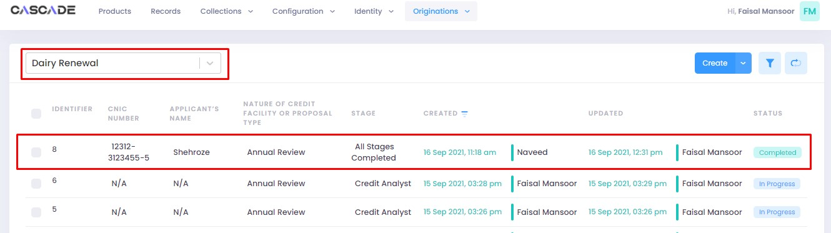

# Product: Tractor (Conventional)

Maker

1. Under the Workflows tab, select the product, then click on ‘create’ to start a new application.

**Note:** Products and workflows shown will vary according to the rights assigned to a user account.

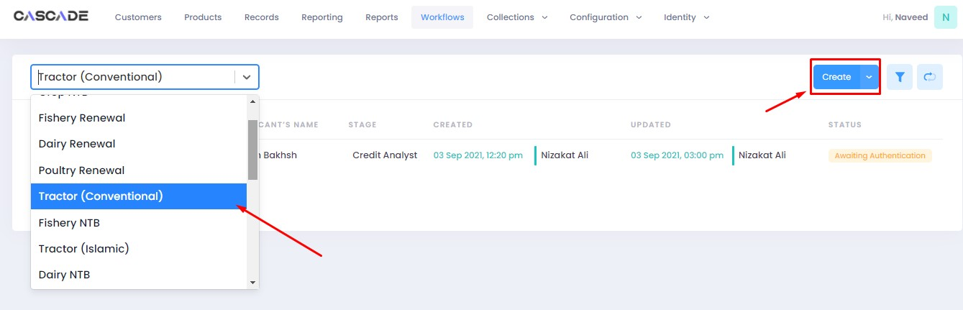

2. Fill the details, then click on ‘proceed’.

**Note**: Depending on the values selected under the fields ‘Is Lead Generation’ and ‘AFO’, new fields and stages in the workflow will appear.

**Lead Generation**: Will allow to manually add details of a prospect.

**AFO**: Allows for ‘data entry’ prior to any stage. The details will then be carried into the ‘credit analyst stage’.



3. When on the ‘credit analyst’ stage, you can create a deviation by clicking on ‘quick panel’ on right side of the page.



4. Then under ‘deviations/exceptions’ you will see all the available deviations. Click on the one applicable to the application, leave remarks then click ‘create’.





5. Once created, the created deviation will show as ‘pending’ in the quick panel and will require approval from an approving authority before the application can be processed further.



6. After filling all the fields, click on validate to check for errors or missing fields. Once there are no errors left, click on the next Group to proceed with the journey.

**Note**: Form B will appear according to the ‘proposed loan amount’ (Up to 1 million or Over 1 million) entered in Form A.

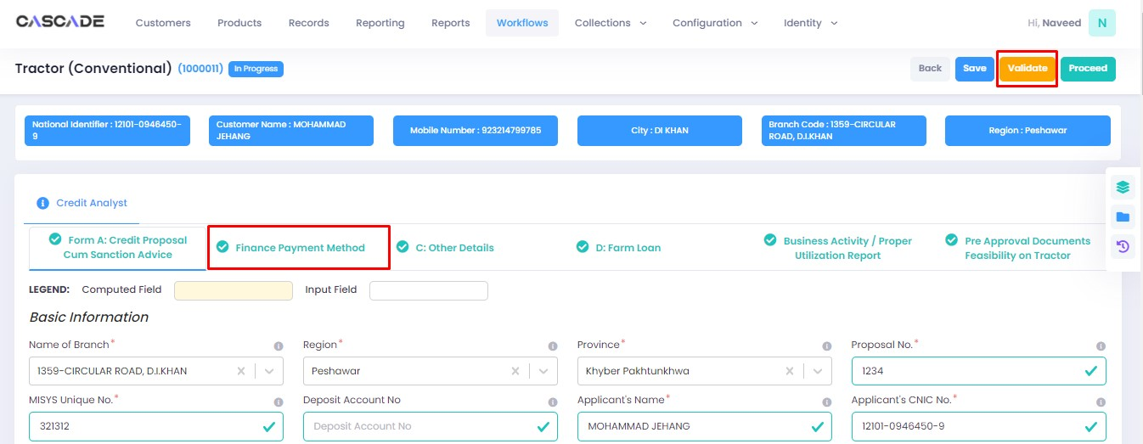

7. Fill all the required fields in the rest of the groups, then click on validate, then click on quick panel.

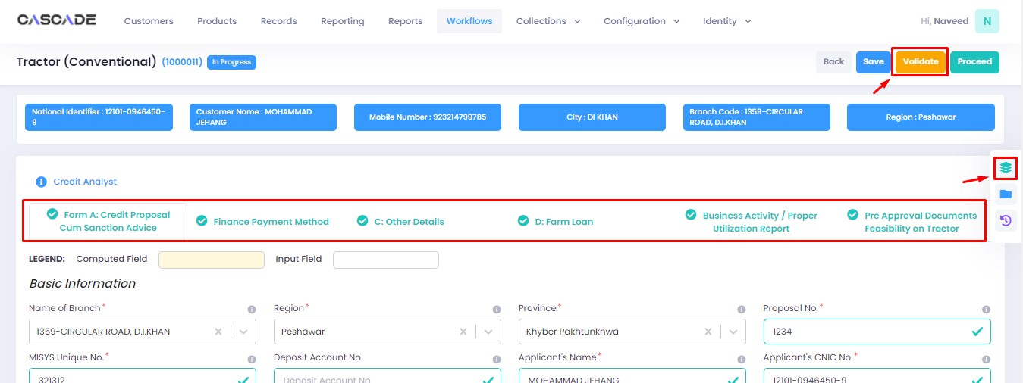

8. Under the ‘check list’ tab, you will see a list of the required documents and checks. Run all the checks and upload the required documents to proceed. Or defer if required.



9. After going through the checklist, click on validate, and then proceed to move to the next stage.

**Note**: The workflow will now require approval from an approver.

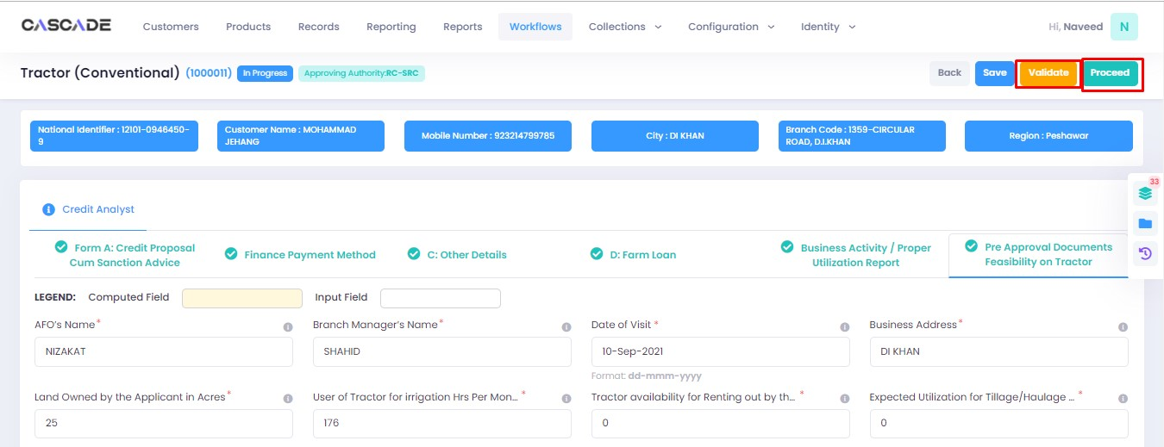

Checker

1. Now from the approver’s account, go to the workflows tab to view the in-progress journeys.



2. Select the product to show a list of the appropriate journeys. In this screenshot, you see the workflow with the status ‘Awaiting Authentication’.

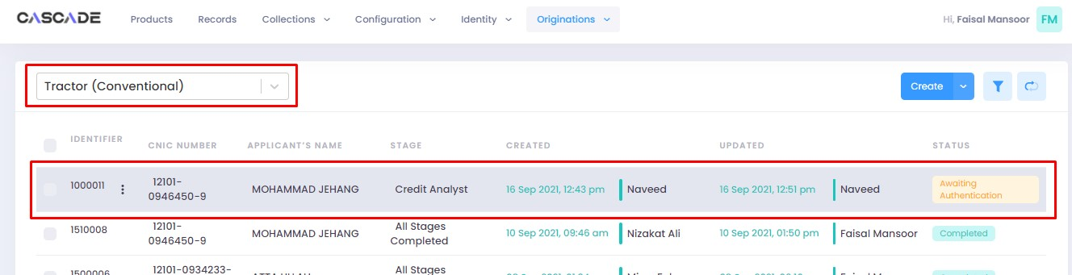

3. Click on ‘edit’ to proceed with the journey.

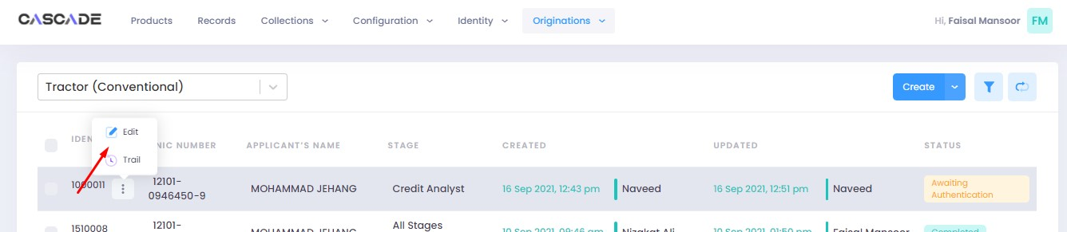

4. Now the approver will be able to see all the details of the journey filled by the maker of the workflow. After scrutinizing, click on the ‘authenticate’ button on the top right to approve or decline the application.

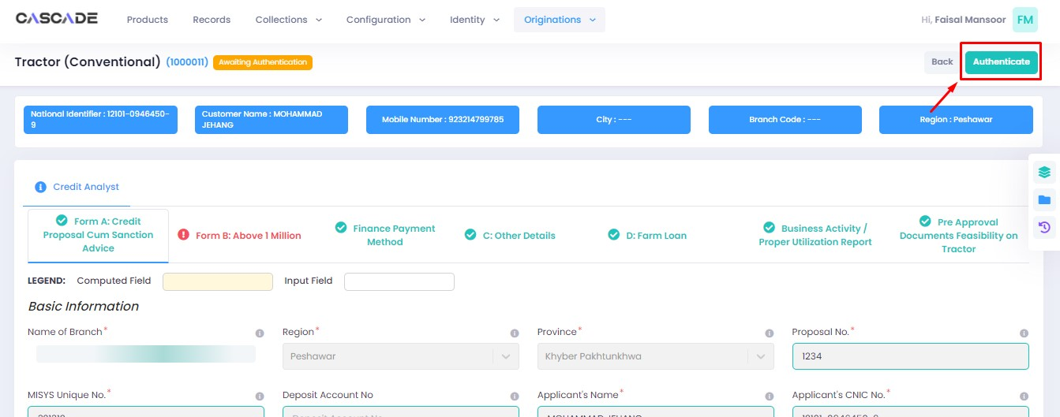

5. Fill the comment box with remarks, then ‘recommend’, ‘decline’ or ‘discard’ the application. Recommending will move the application forward, declining it will destroy the application, and discarding it will send back the application to the maker.



6. The application will require multiple recommendations from the relevant accounts until it is ‘approved’ by an account with appropriate rights. The screenshot below shows the names of the accounts the application has gone through so far with their comments.



7. After the first recommendation, the second recommender will see the ‘move back’ button which will send the application back to the first recommender. In case of having gone through multiple recommendations the ‘move back’ button will send the application back to the previous approver.



8. After all the ‘recommendations’, the application will require an ‘approval’ from an account with appropriate rights.



Maker

1. Once the application has been authenticated, it will reappear under the account of the ‘maker’. Go to the ‘workflows’ tab, then select the product, ‘Tractor Conventional’ in this case, to show relevant applications, then select ‘unassigned’ in the filters. You will now see the concerned application with a status of ‘unassigned’.

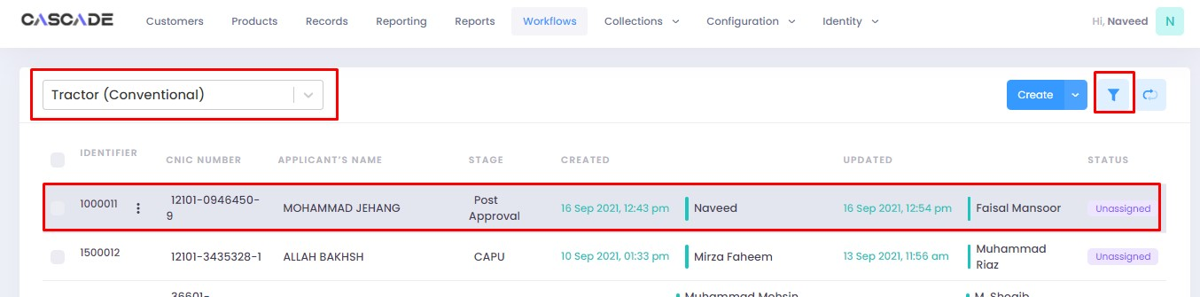



2. Click on ‘edit’, then click on ‘Start Post Approval’ to start the next stage.

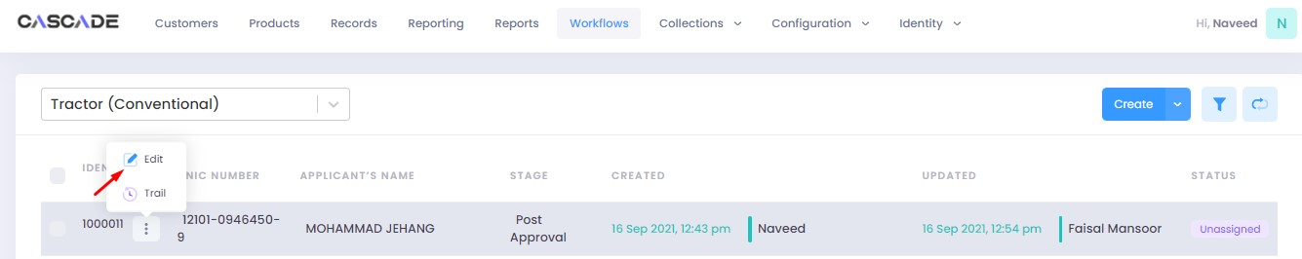

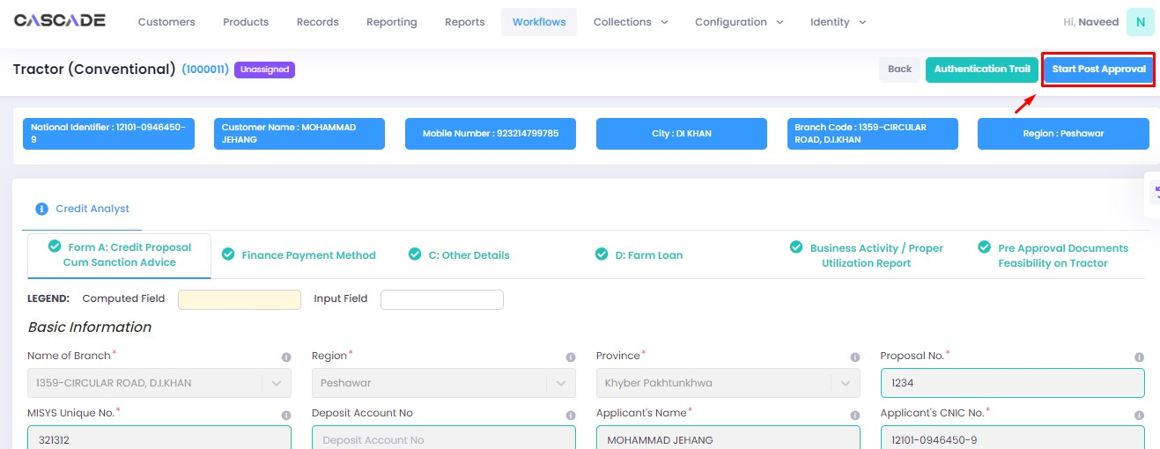

3. Fill all the required fields under ‘Post Approval Documents’ until no errors remain, then click on validate (1), then on the next group (2).

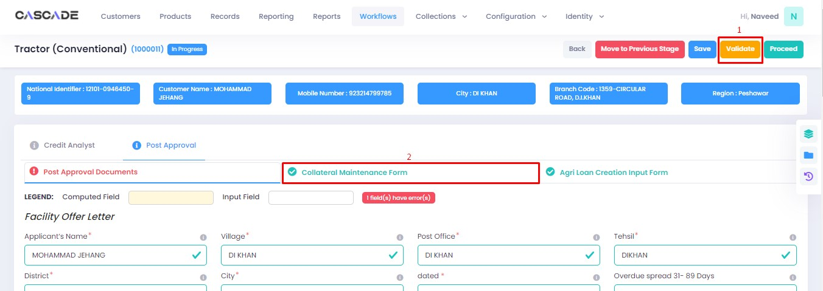

4. Fill all the required fields in rest of the groups, then click on validate (1), then on ‘quick panel’ (2).

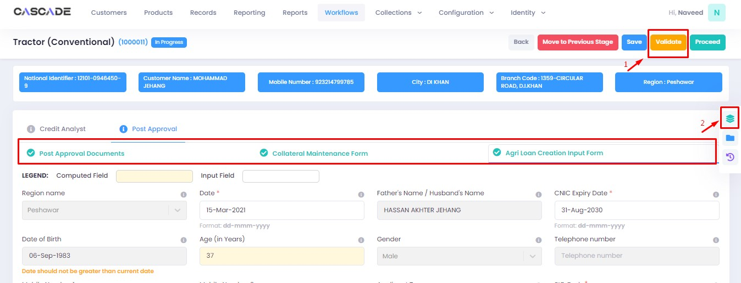

5. Here you will see the items that are pending before the application can be processed further. Upload the required documents to proceed. Or defer if inapplicable.



6. After uploading all the required documents, click on validate (1) then click on proceed (2).

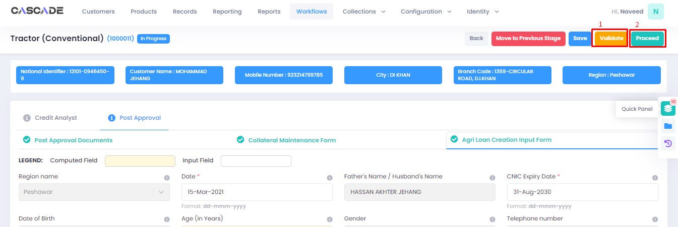

7. Now click on ‘Start RCAD’ to start the next stage in the workflow.

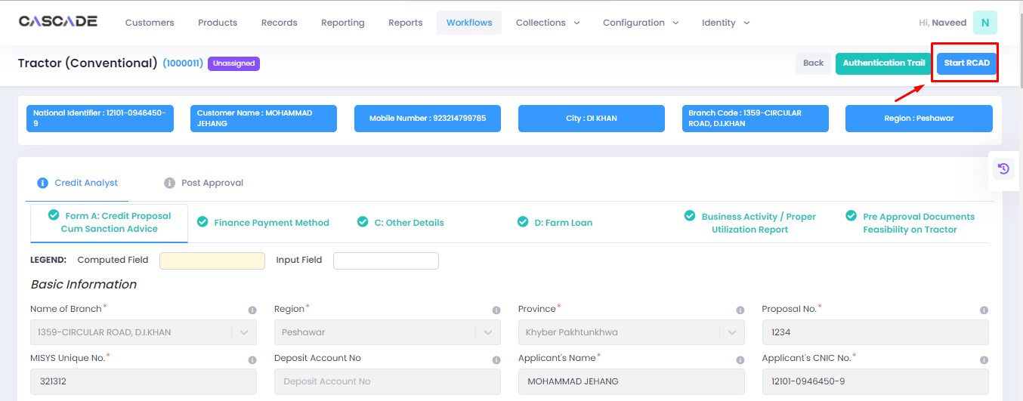

8. Fill all the required fields under all groups until no errors remain, then click on ‘validate’, then on ‘quick panel’ on the right side of the page.

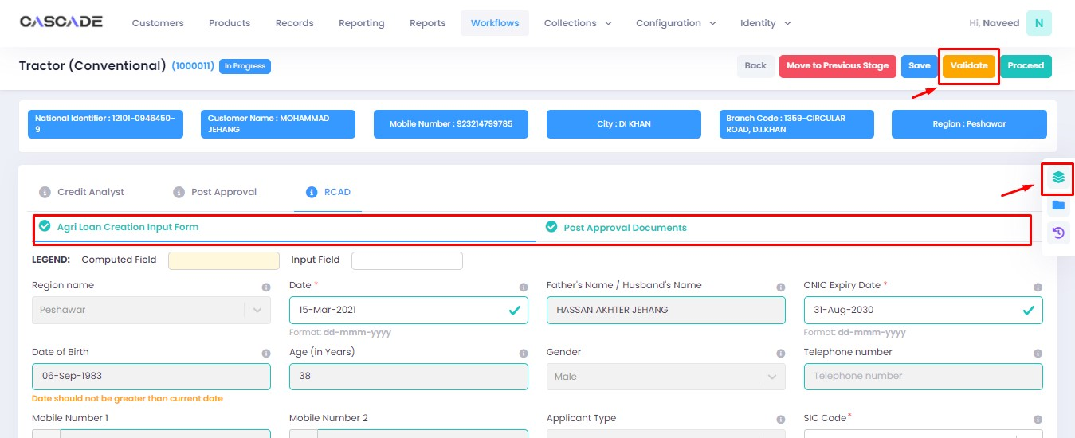

9. Upload the required documents or defer if required, then click on validate and then on proceed.

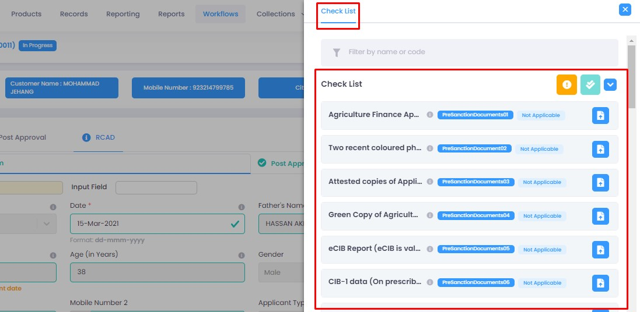

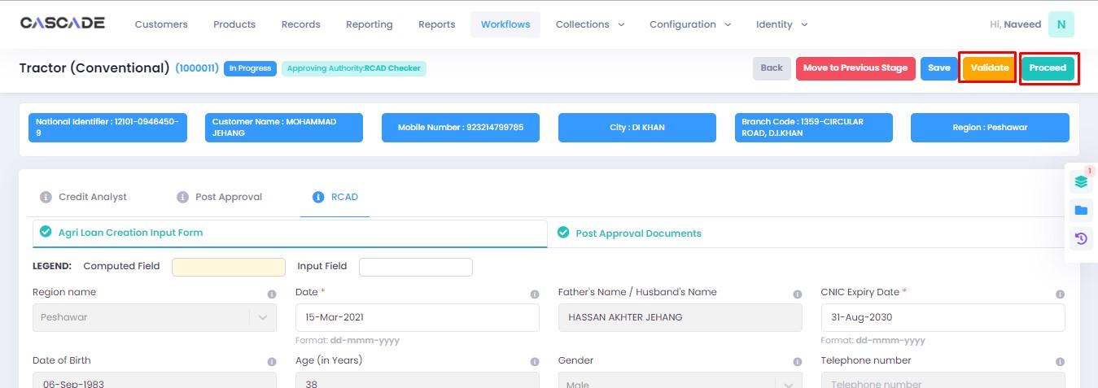

Checker

1. Now from the approver’s account, go to the workflows tab to view the in-progress journeys.



2. Select the product to show a list of the appropriate journeys. In this screenshot, you see the workflow with the status ‘Awaiting Authentication’.

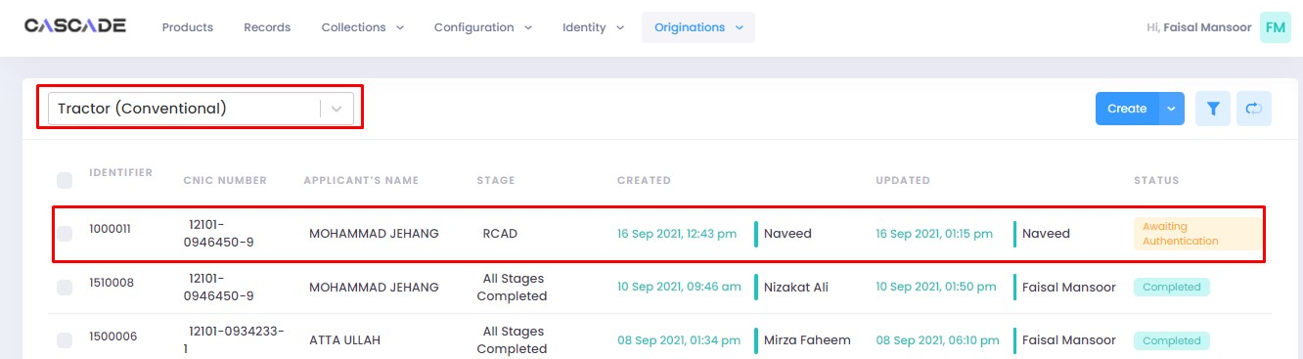

3. Click on ‘edit’ to proceed with the journey.

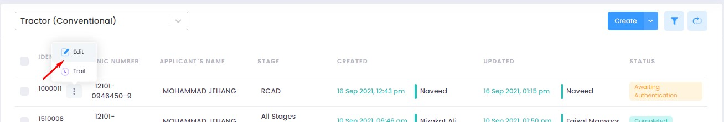

4. Now the approver will be able to see all the details of the journey filled by the maker of the workflow. After scrutinizing, click on the ‘authenticate’ button on the top right to approve or decline the application.

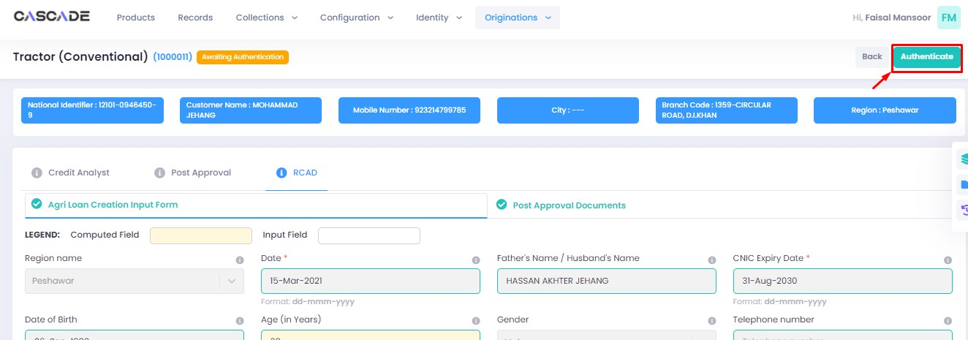

5. Fill the comment box with remarks, then ‘approve’, ‘decline’ or ‘discard’ the application. Recommending will move the application forward, declining it will destroy the application, and discarding it will send back the application to the maker.



6. Under the workflows tab, select ‘Tractor Conventional’ as the product then ‘unassigned’ from the filters to display the relevant application.

**Note**: Application will only be visible to account with relevant rights.

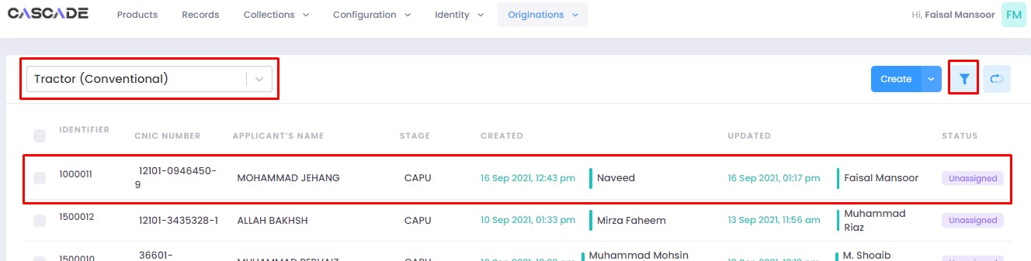

7. Then click on ‘edit’ to further proceed.

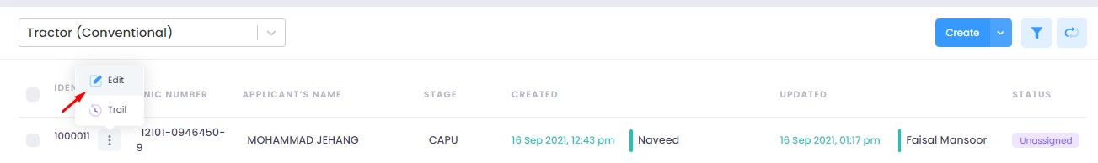

8. Now click on ‘Start CAPU’ to move to the next stage.

**Note**: CAPU can only be initiated and worked on from the account with relevant rights.

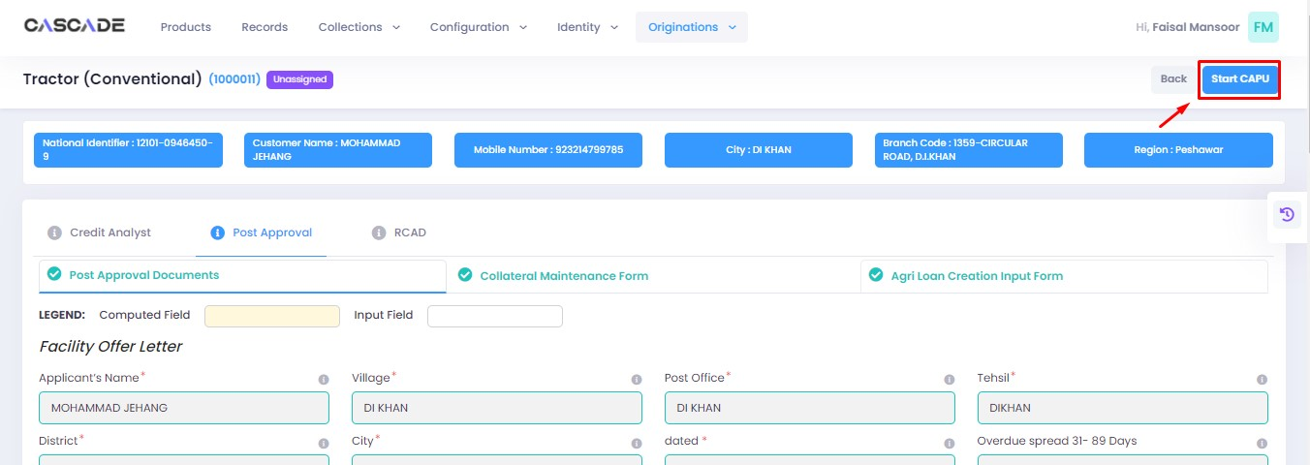

9. Fill all the required fields under all groups then click on validate then on proceed.

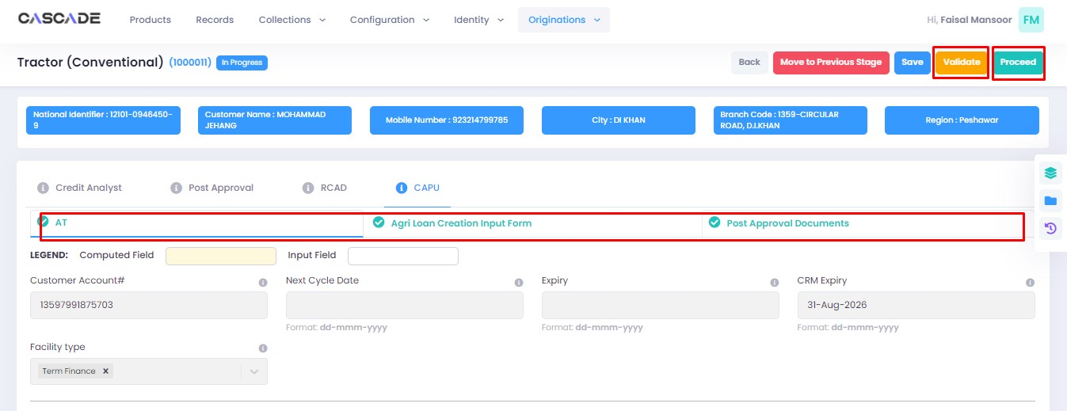

10. The application will now require approval by the CAPU checker.

CAPU checker will click on ‘authenticate’, leave remarks, then approve or decline the application.

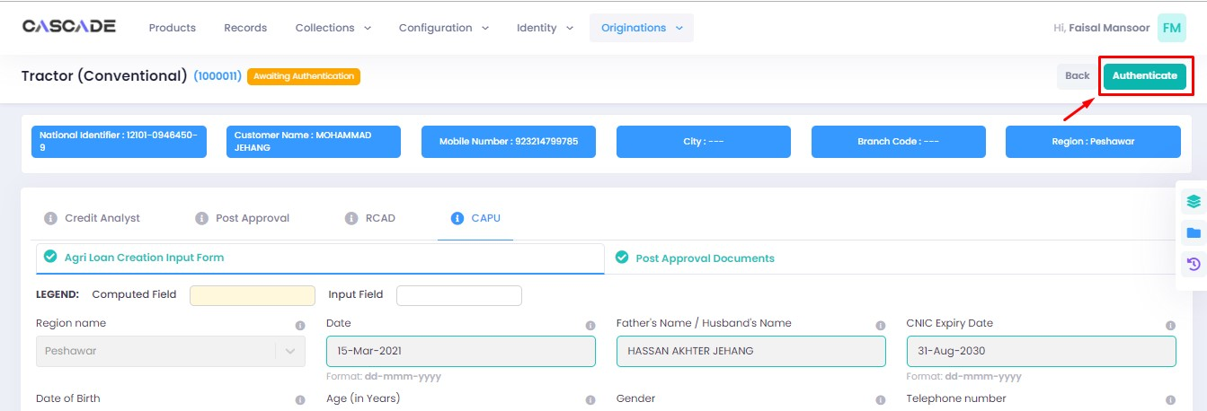



11. The application will now be marked as completed and ready to be disbursed.

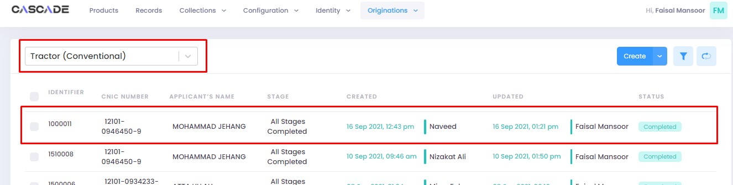

# Product: Tractor (Islamic)

Maker

1. Under the Workflows tab, select the product, then click on ‘create’ to start a new application.

**Note:** Products and workflows shown will vary according to the rights assigned to a user account.

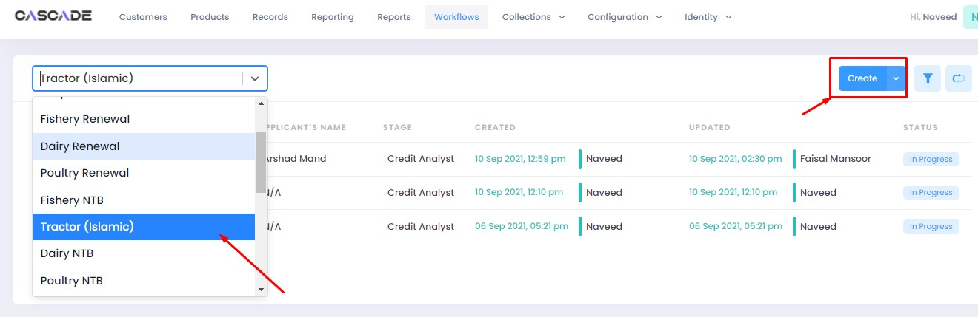

2. Fill the details, then click on ‘proceed’.

**Note**: Depending on the values selected under the fields ‘Is Lead Generation’ and ‘AFO’, new fields and stages in the workflow will appear.

**Lead Generation**: Will allow to manually add details of a prospect.

**AFO**: Allows for ‘data entry’ prior to any stage. The details will then be carried into the ‘credit analyst stage’.



3. When on the ‘credit analyst’ stage, you can create a deviation by clicking on ‘quick panel’ on right side of the page.



4. Then under ‘deviations/exceptions’ you will see all the available deviations. Click on the one applicable to the application, leave remarks then click ‘create’.





5. Once created, the created deviation will show as ‘pending’ in the quick panel and will require approval from an approving authority before the application can be processed further.



6. After filling all the fields, click on validate to check for errors or missing fields. Once there are no errors left, click on the next Group to proceed with the journey.

**Note:** Form B will appear according to the ‘proposed loan amount’ (Up to 1 million or Over 1 million) entered in Form A.

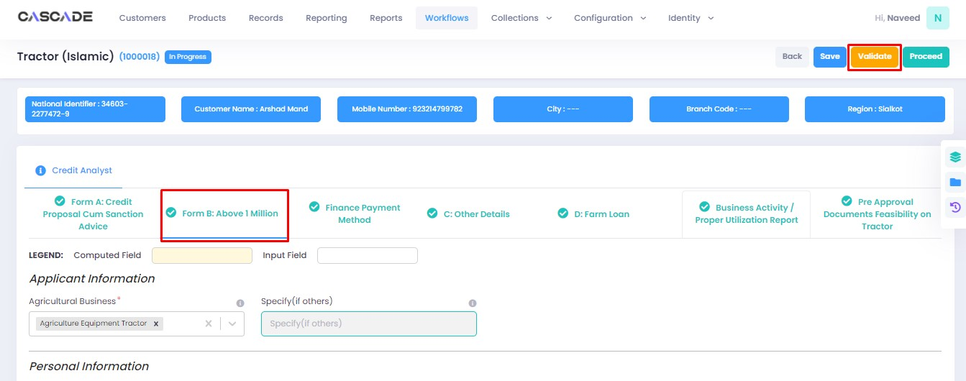

7. Fill all the required fields in the rest of the groups, then click on validate, then click on quick panel.

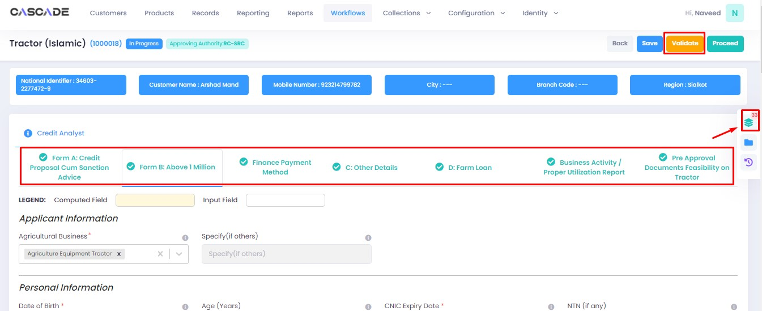

8. Under the ‘check list’ tab, you will see a list of the required documents and checks. Run all the checks and upload the required documents to proceed. Or defer if required.



9. After going through the checklist, click on validate, and then proceed to move to the next stage.

**Note:** The workflow will now require approval from an approver

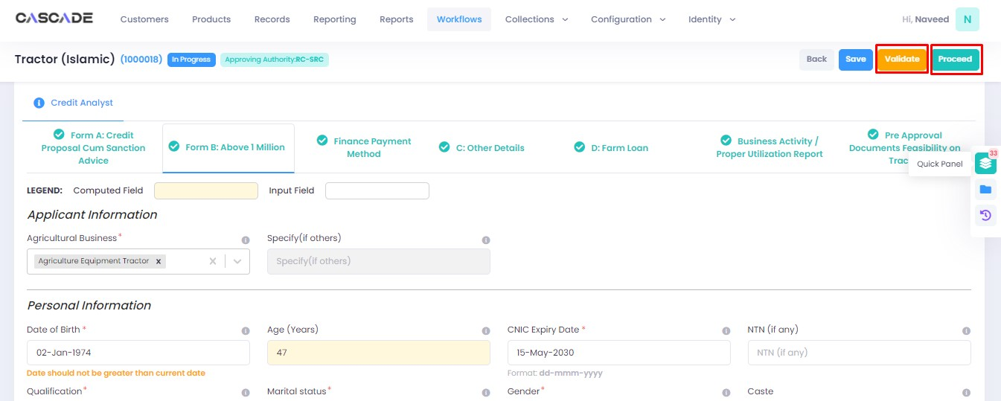

Checker

1. Now from the approver’s account, go to the workflows tab to view the in-progress journeys.



2. Select the product to show a list of the appropriate journeys. In this screenshot, you see the workflow with the status ‘Awaiting Authentication’.

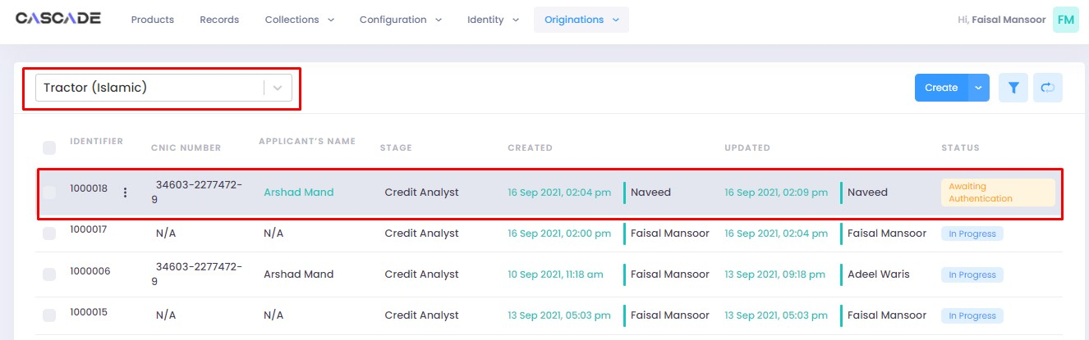

3. Click on ‘edit’ to proceed with the journey.

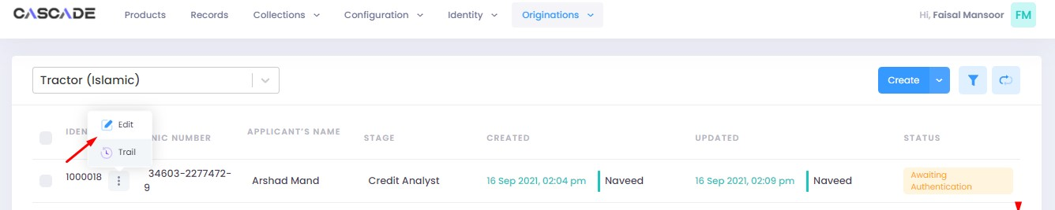

4. Now the approver will be able to see all the details of the journey filled by the maker of the workflow. After scrutinizing, click on the ‘authenticate’ button on the top right to approve or decline the application.

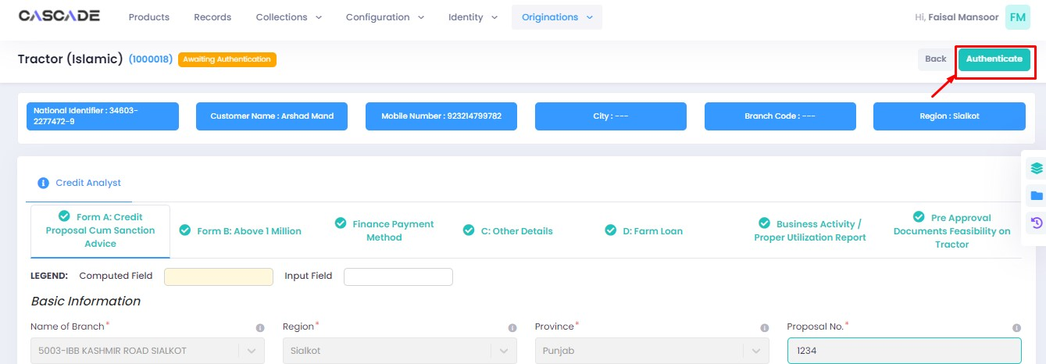

5. Fill the comment box with remarks, then ‘recommend’, ‘decline’ or ‘discard’ the application. Recommending will move the application forward, declining it will destroy the application, and discarding it will send back the application to the maker.



6. The application will require multiple recommendations from the relevant accounts until it is ‘approved’ by an account with appropriate rights. The screenshot below shows the names of the accounts the application has gone through so far with their comments.



7. After the first recommendation, the second recommender will see the ‘move back’ button which will send the application back to the first recommender. In case of having gone through multiple recommendations the ‘move back’ button will send the application back to the previous approver.



8. After all the ‘recommendations’, the application will require an ‘approval’ from an account with appropriate rights.



Maker

1. Once the application has been authenticated, it will reappear under the account of the ‘maker’. Go to the ‘workflows’ tab, then select the product, ‘Tractor (Islamic) in this case, to show relevant applications, then select ‘unassigned’ in the filters. You will now see the concerned application with a status of ‘unassigned’.

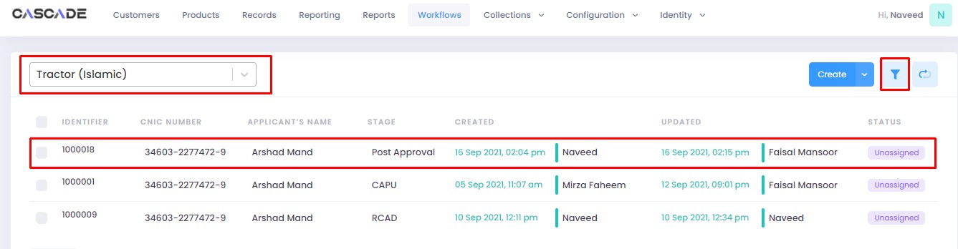



2. Click on ‘edit’, then click on ‘Start Post Approval’ to start the next stage.

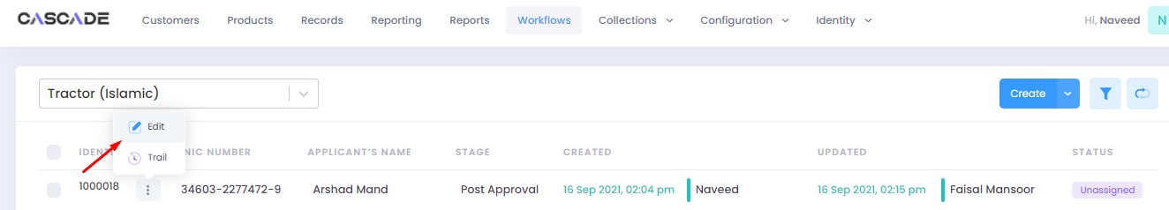

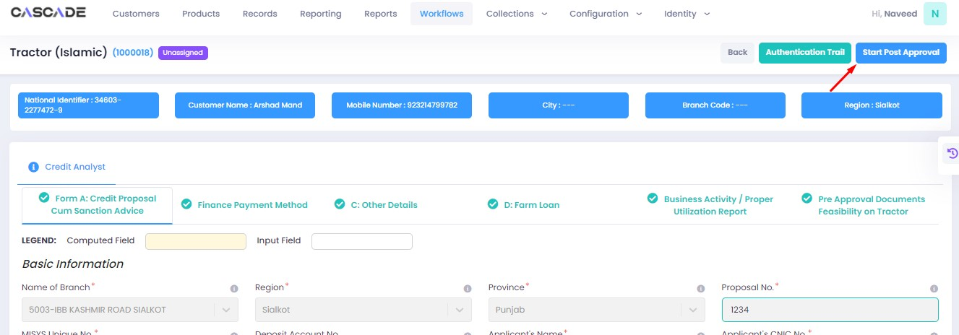

3. Fill all the required fields under ‘Post Approval Documents’ until no errors remain, then click on validate (1), then on the next group (2).

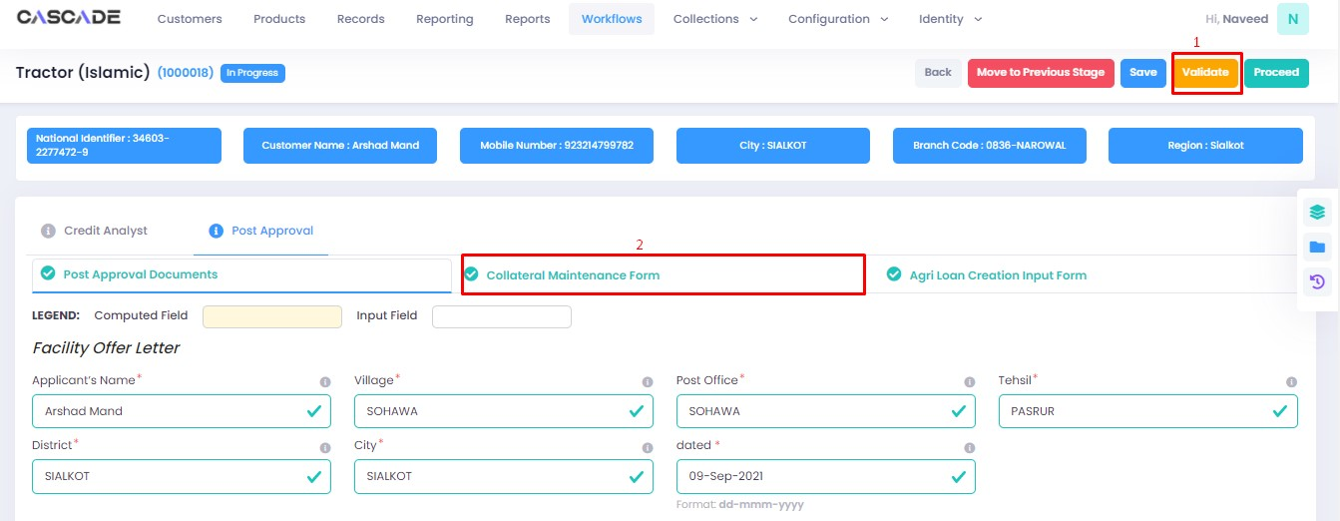

4. Fill all the required fields in rest of the groups, then click on validate (1), then on ‘quick panel’ (2).

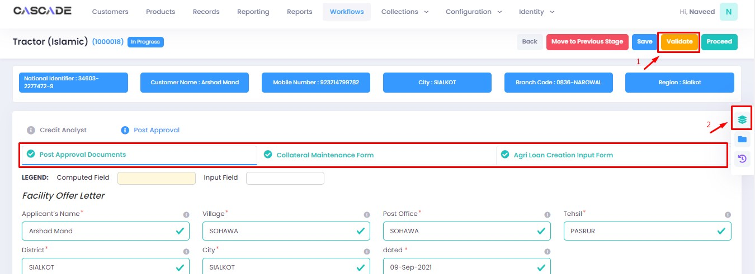

5. Here you will see the items that are pending before the application can be processed further. Upload the required documents to proceed. Or defer if inapplicable.



6. After uploading all the required documents, click on validate (1) then click on proceed (2).



7. Now click on ‘Start RCAD’ to start the next stage in the workflow.

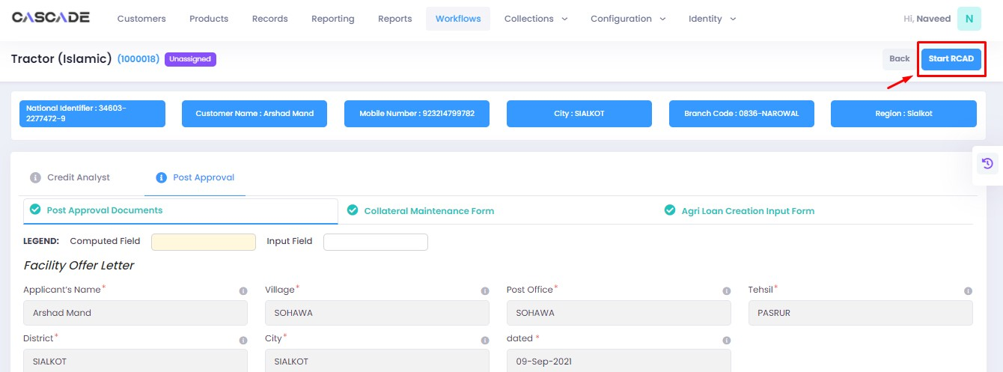

8. Fill all the required fields under all groups until no errors remain, then click on ‘validate’, then on ‘quick panel’ on the right side of the page.

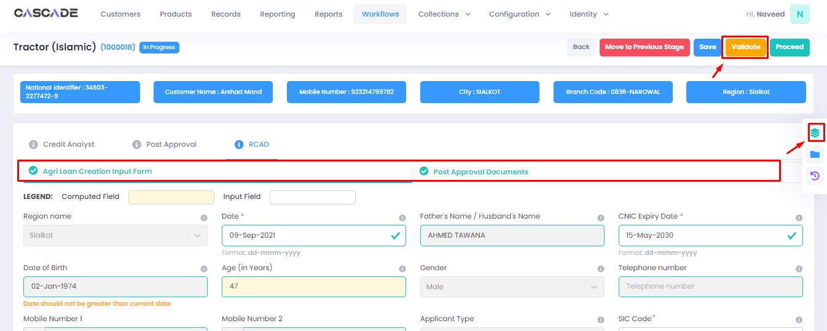

9. Upload the required documents or defer if required, then click on validate and then on proceed.

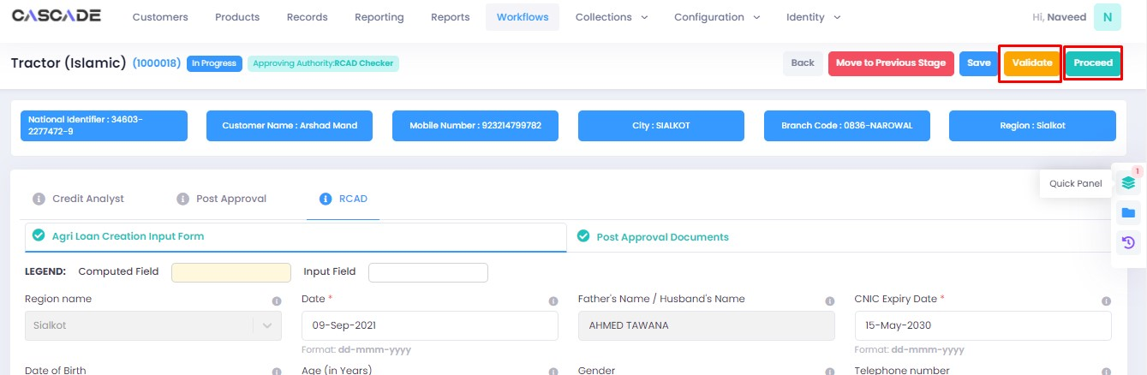

Checker

1. Now from the approver’s account, go to the workflows tab to view the in-progress journeys.



2. Select the product to show a list of the appropriate journeys. In this screenshot, you see the workflow with the status ‘Awaiting Authentication’.

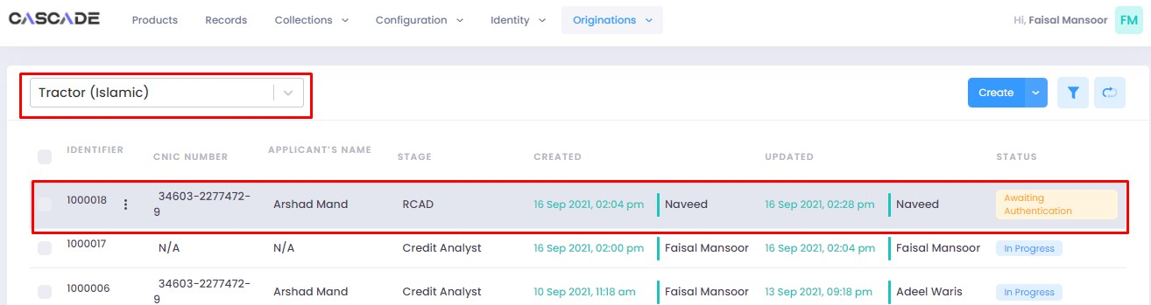

3. Click on ‘edit’ to proceed with the journey.

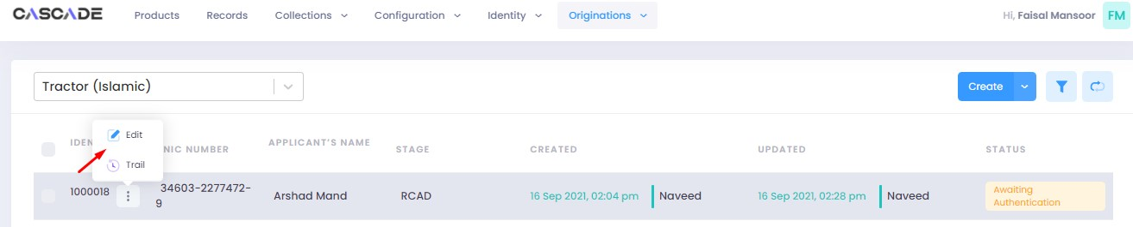

4. Now the approver will be able to see all the details of the journey filled by the maker of the workflow. After scrutinizing, click on the ‘authenticate’ button on the top right to approve or decline the application.

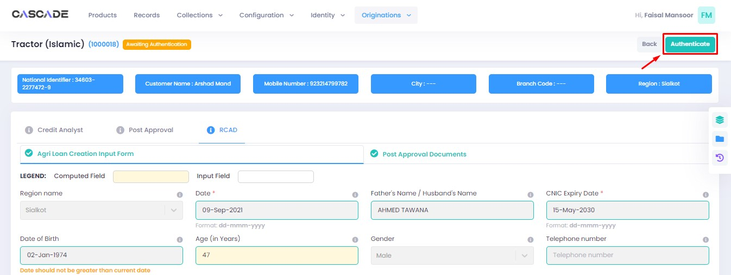

5. Fill the comment box with remarks, then ‘approve’, ‘decline’ or ‘discard’ the application. Recommending will move the application forward, declining it will destroy the application, and discarding it will send back the application to the maker.



6. Under the workflows tab, select ‘Tractor (Islamic)’ as the product then ‘unassigned’ from the filters to display the relevant application.

**Note**: Application will only be visible to account with relevant rights.

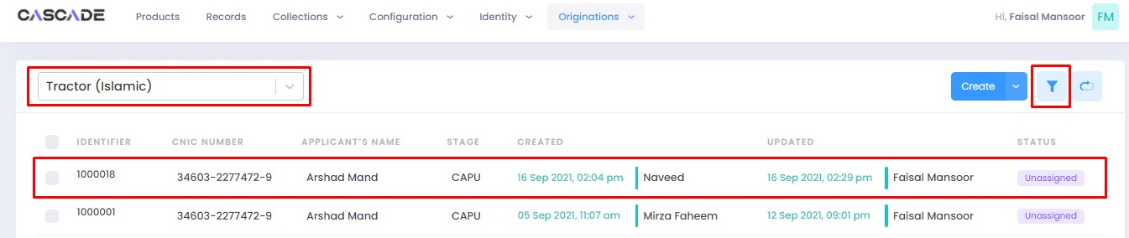

7. Then click on ‘edit’ to further proceed.

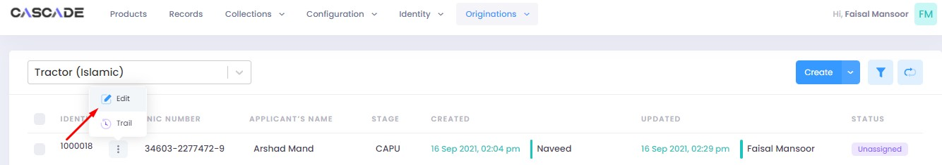

8. Now click on ‘Start CAPU’ to move to the next stage.

**Note**: CAPU can only be initiated and worked on from the account with relevant rights.

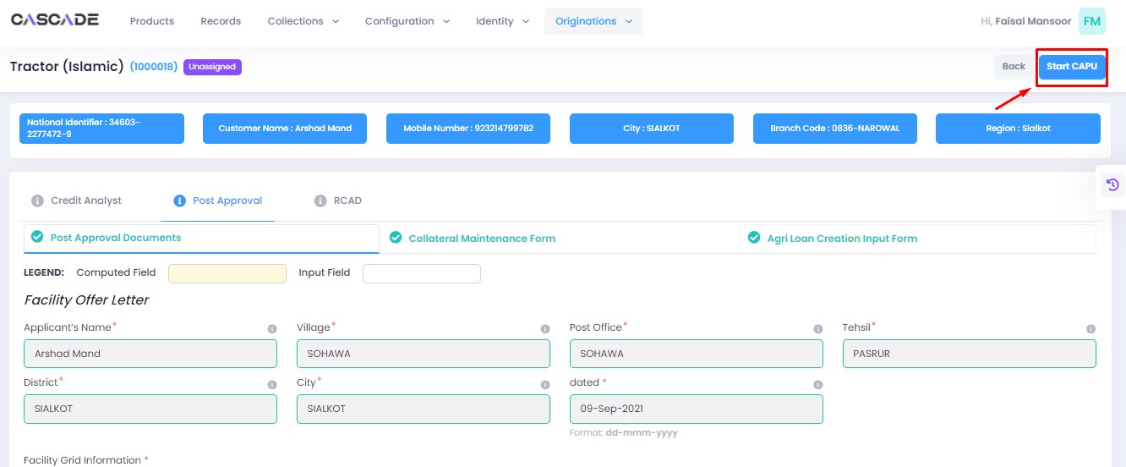

9. Fill all the required fields under all groups then click on validate then on proceed.

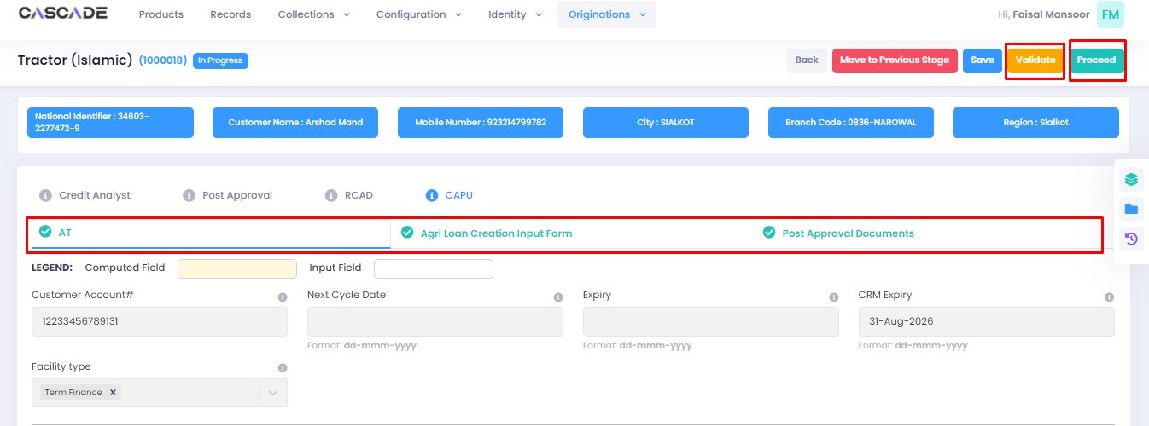

10. The application will now require approval by the CAPU checker.

CAPU checker will click on ‘authenticate’, leave remarks, then approve or decline the application.

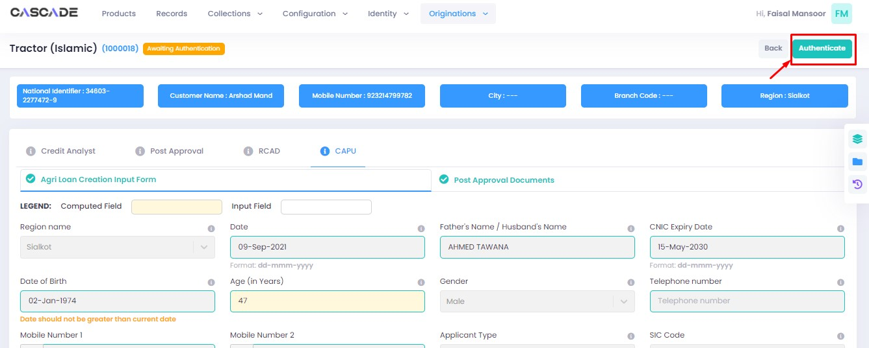

Fill the comment box with remarks, then ‘approve’, ‘decline’ or ‘discard’ the application. Recommending will move the application forward, declining it will destroy the application, and discarding it will send back the application to the maker.



11. The application will now be marked as completed and ready to be disbursed.

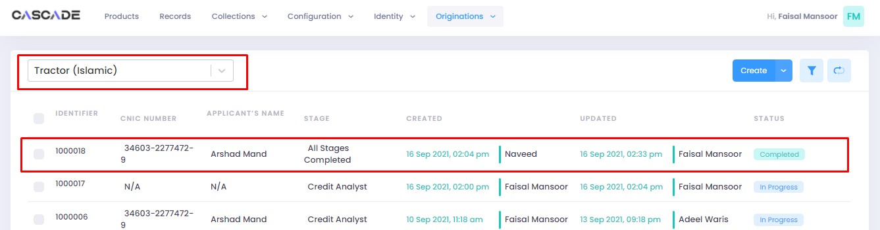

# Product: Release Memo

Maker

1. Under the Workflows tab, select the product, then click on ‘create’ to start a new application.

**Note:** Products and workflows shown will vary according to the rights assigned to a user account.

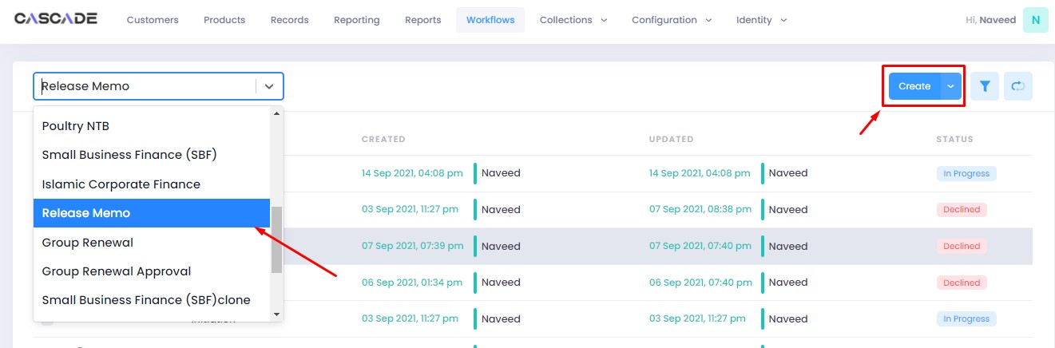

2. Fill the details, then click on ‘proceed’.

**Note**: Depending on the values selected under the field ‘AFO’, new fields and stages in the workflow will appear.

**AFO**: Allows for ‘data entry’ prior to any stage. The details will then be carried into the ‘credit analyst stage’.

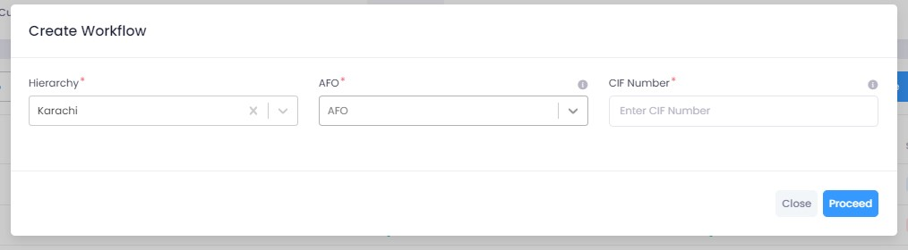

3. After filling all the fields, click on validate to check for errors or missing fields. Once there are no errors left, click on proceed to proceed with the journey.

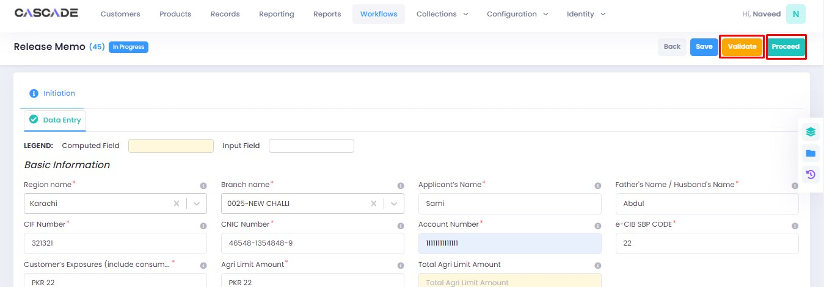

4. Click on ‘Start Credit Analyst’ to start the next stage.

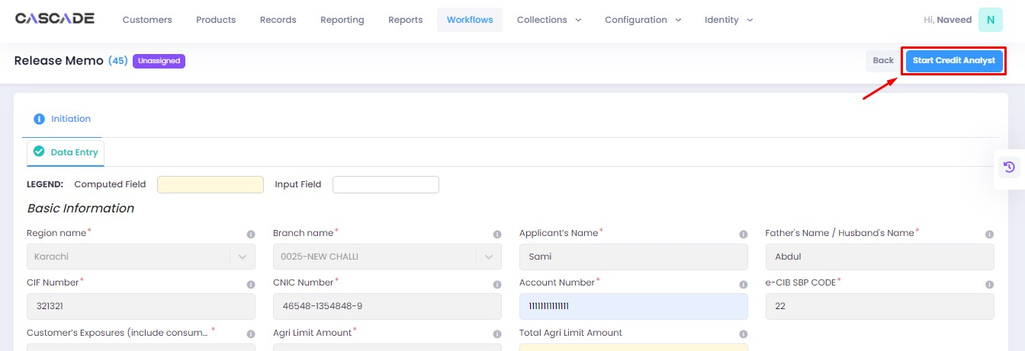

5. Similar to the last stage, fill all the required fields under this stage until all groups are duly filled. Make changes in this stage if any. Then click on ‘validate’, then on ‘proceed’.

**Note**: The workflow will now require approval from an approver.

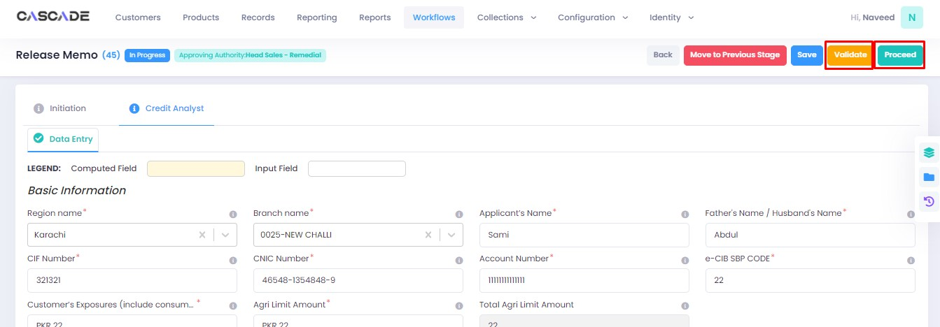

Checker

1. Now from the approver’s account, go to the workflows tab to view the in-progress journeys.



2. Select the product to show a list of the appropriate journeys. In this screenshot, you see the workflow with the status ‘Awaiting Authentication’.

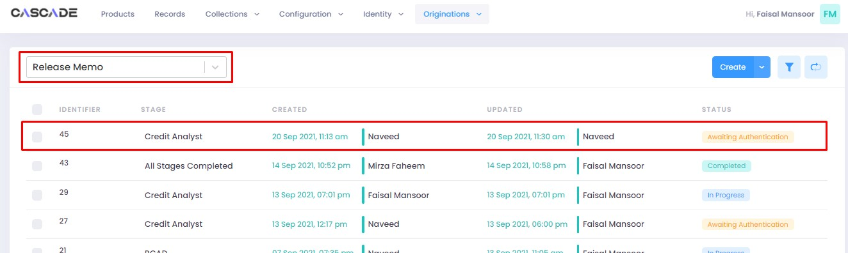

3. Click on ‘edit’ to proceed with the journey.

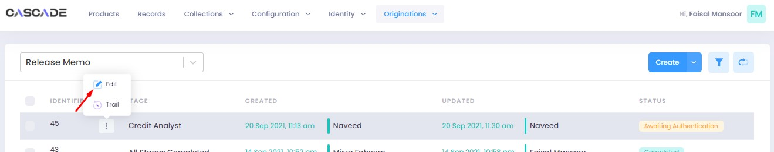

4. Now the approver will be able to see all the details of the journey filled by the maker of the workflow. After scrutinizing, click on the ‘authenticate’ button on the top right to approve or decline the application.



Fill the comment box with remarks, then ‘recommend’, ‘decline’ or ‘discard’ the application. Recommending will move the application forward, declining it will destroy the application, and discarding it will send back the application to the maker.

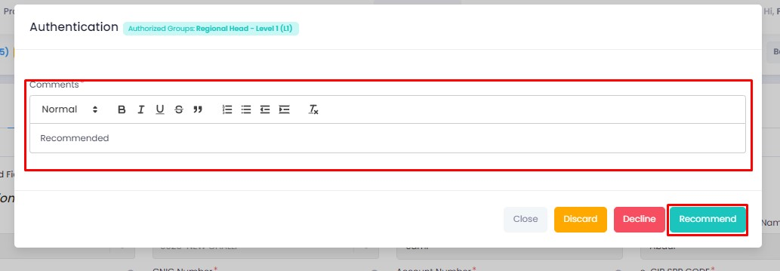

6. The application will require multiple recommendations from the relevant accounts until it is ‘approved’ by an account with appropriate rights. The screenshot below shows the names of the accounts the application has gone through so far with their comments.



7. After all the ‘recommendations’, the application will require an ‘approval’ from an account with appropriate rights.

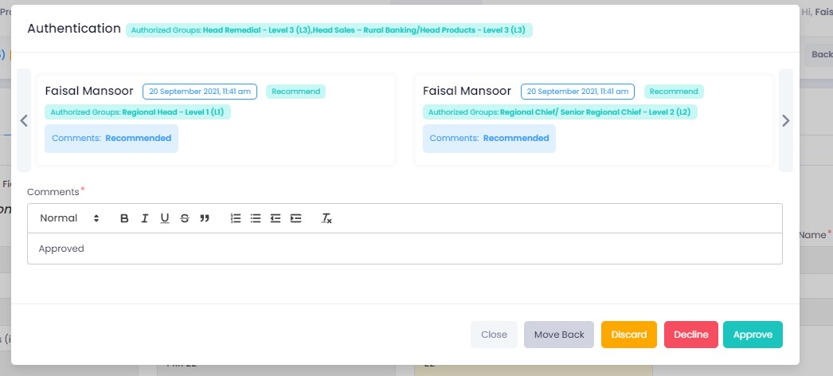

Maker

1. Once the application has been authenticated, it will reappear under the account of the ‘maker’. Go to the ‘workflows’ tab, then select the product, ‘Release Memo’ in this case, to show relevant applications, then select ‘unassigned’ in the filters. You will now see the concerned application with a status of ‘unassigned’.

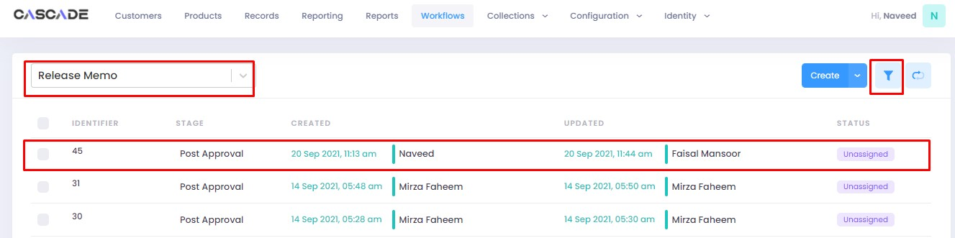

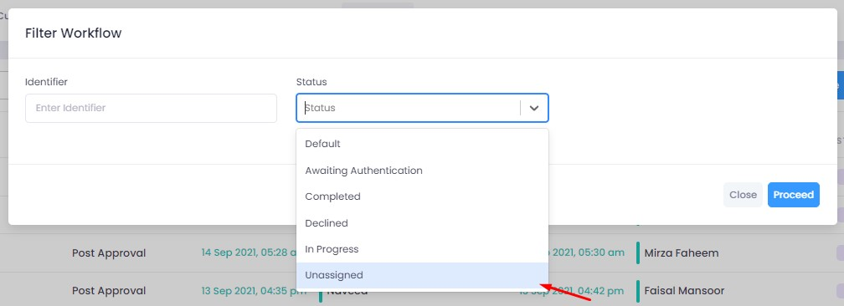

2. Click on ‘edit’, then click on ‘Start Post Approval’ to start the next stage.

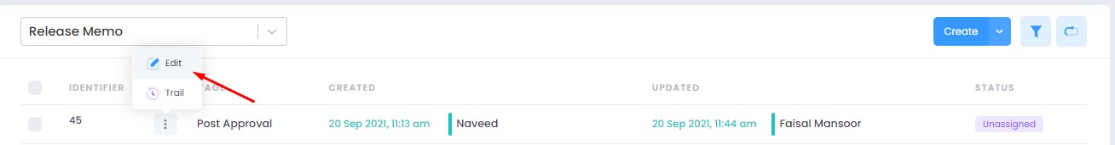

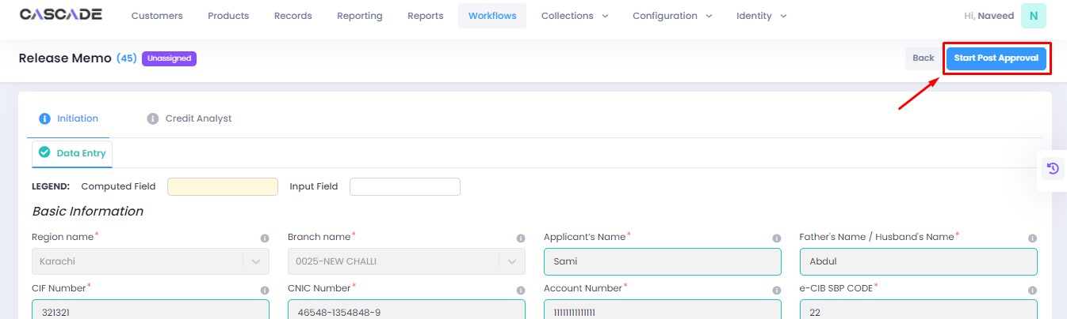

3. Fill all the required fields until no errors remain, then click on validate (1), then on proceed (2).

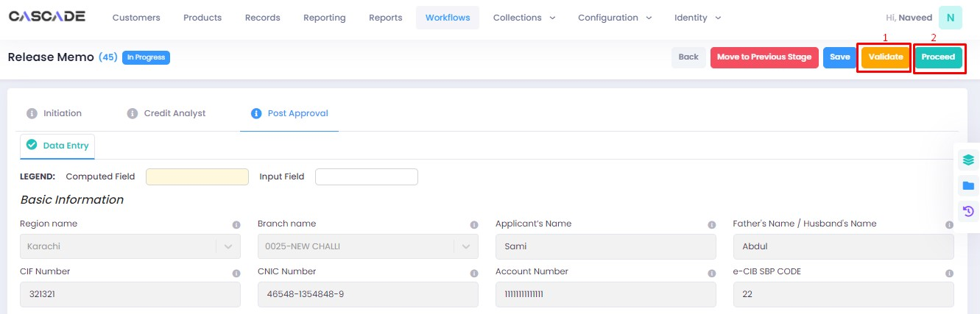

4. Now click on ‘Start RCAD’ to start the next stage in the workflow.

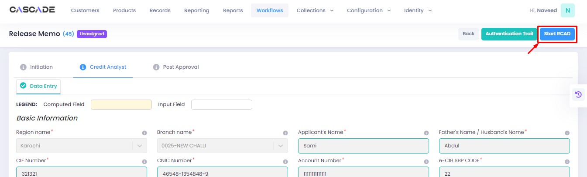

8. Fill all the required fields under until no errors remain, then click on ‘validate’, then on ‘proceed’.

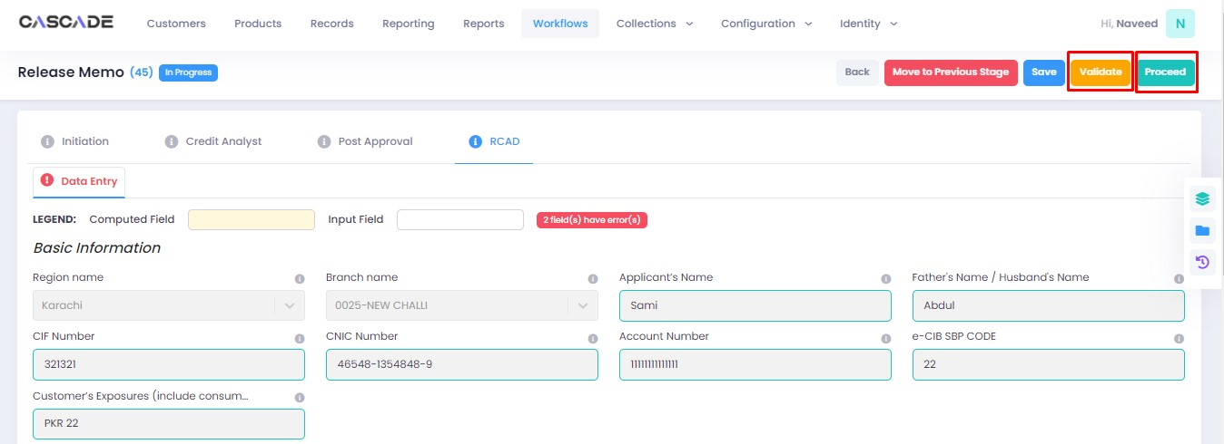

Checker

1. Now from the approver’s account, go to the workflows tab to view the in-progress journeys.



2. Select the product to show a list of the appropriate journeys. In this screenshot, you see the workflow with the status ‘Awaiting Authentication’.

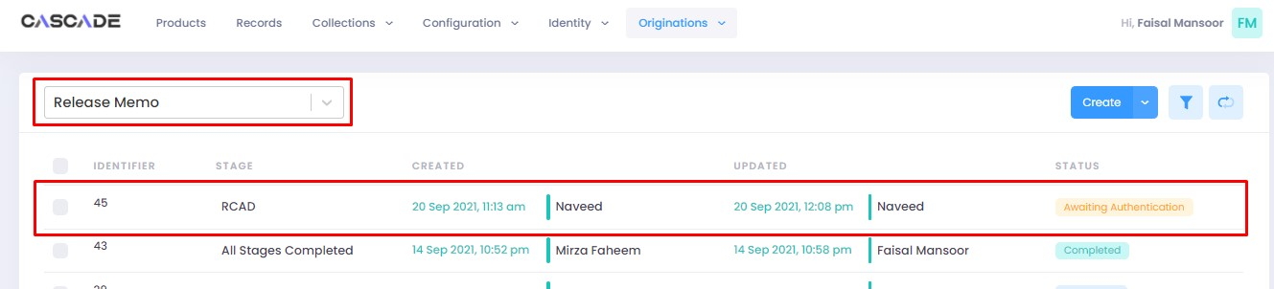

3. Click on ‘edit’ to proceed with the journey.

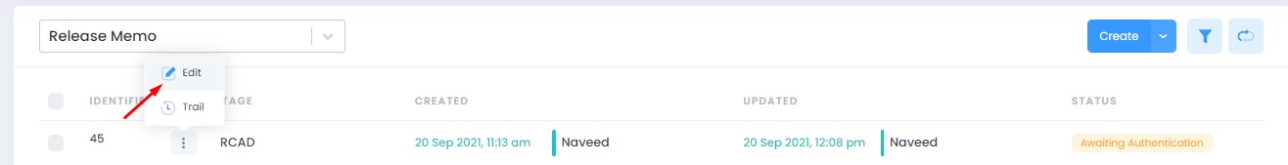

4. Now the approver will be able to see all the details of the journey filled by the maker of the workflow. After scrutinizing, click on the ‘authenticate’ button on the top right to approve or decline the application.

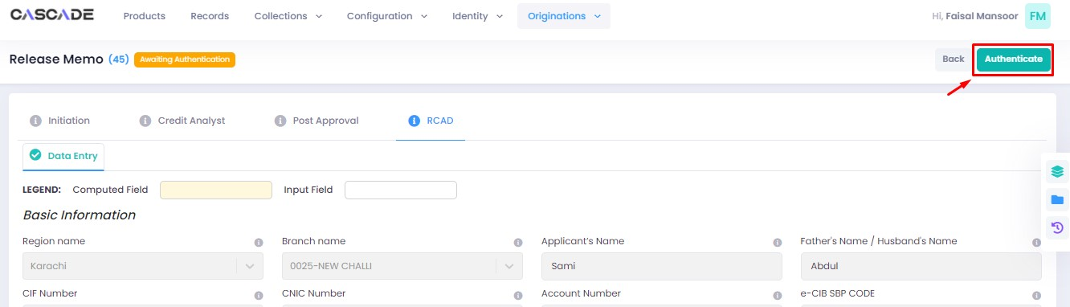

5. Fill the comment box with remarks, then ‘approve’, ‘decline’ or ‘discard’ the application. Recommending will move the application forward, declining it will destroy the application, and discarding it will send back the application to the maker.



6. The application will now be marked as completed.



# Product: Group Renewal Approval

Maker

1. Under the Workflows tab, select the product, then click on ‘create’ to start a new application.

**Note:** Products and workflows shown will vary according to the rights assigned to a user account.

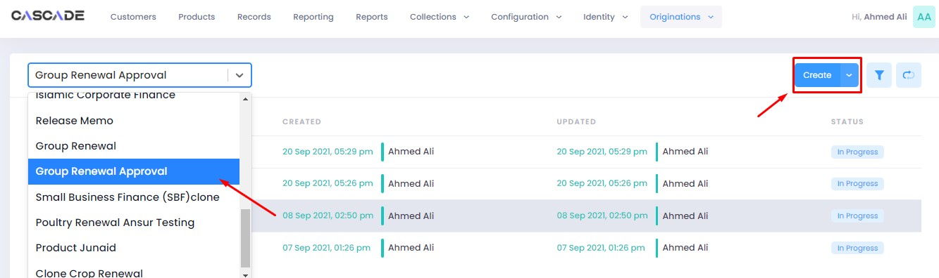

2. Enter the GRN Approval Date then click ‘proceed’.

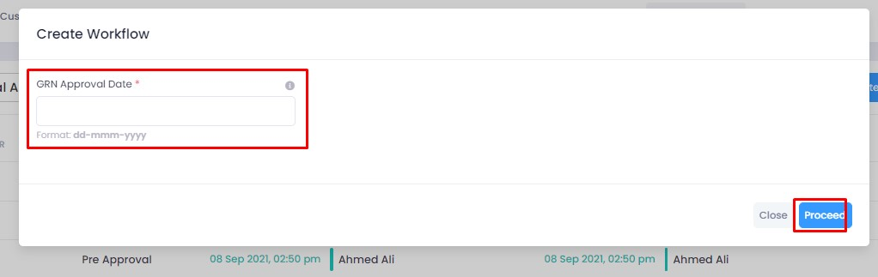

3. Click on ‘add’ then ‘import from excel’ to upload excel data file. 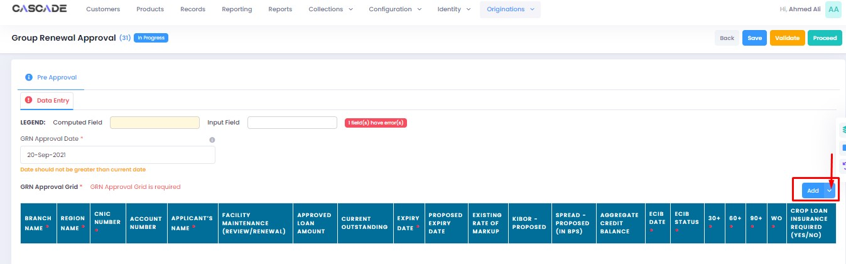

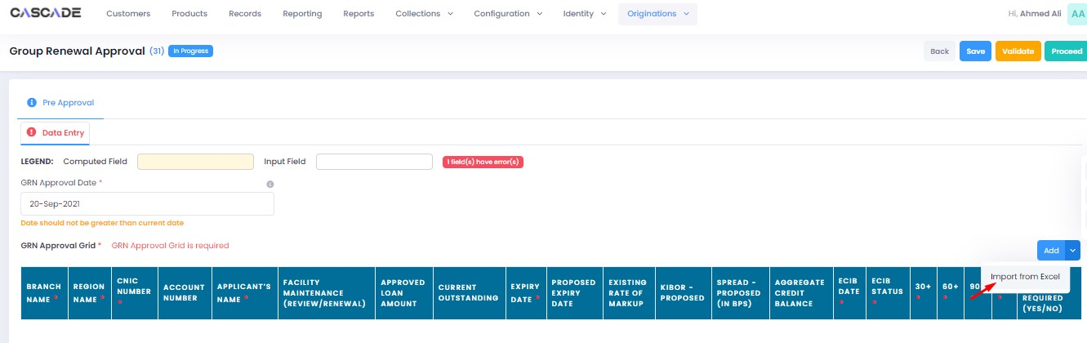

4. Select the excel file then click on ‘open’. (Sample excel file attached)



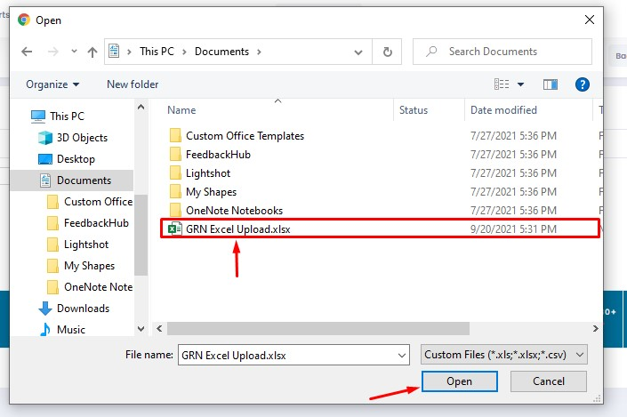

5. All data present in the excel file will now show in a grid on the interface. After the data has been uploaded, click on ‘validate’ and then ‘proceed’.

**Note:** The workflow will now require approval from an approver.

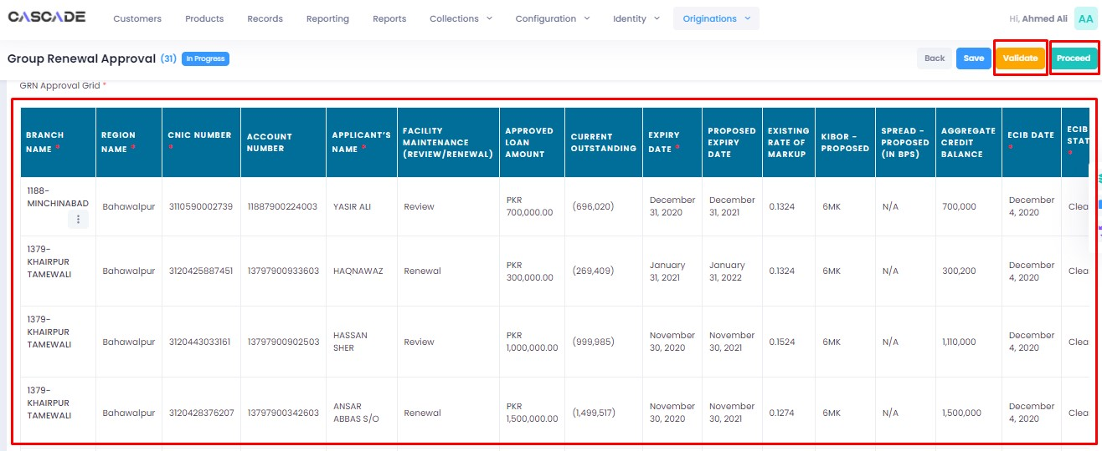

Checker

1. Now from the approver’s account, go to the workflows tab to view the in-progress journeys.



2. Select the product to show a list of the appropriate journeys. In this screenshot, you see the workflow with the status ‘Awaiting Authentication’. Click on ‘edit’ to proceed.

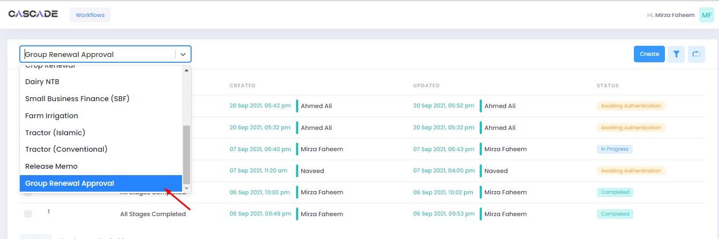

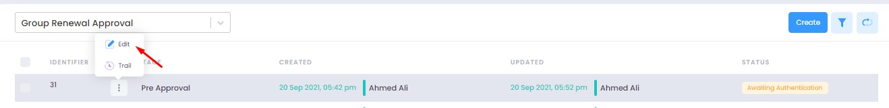

3. Now the approver will be able to see all the details of the journey filled by the maker of the workflow. After scrutinizing, click on the ‘authenticate’ button on the top right to recommend or decline the application.

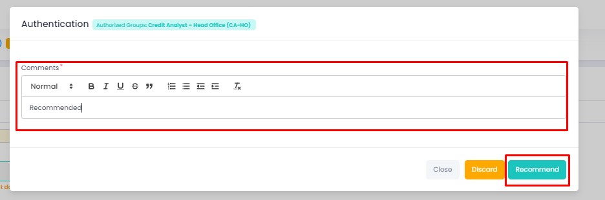

6. The application will require multiple recommendations from the relevant accounts until it is ‘approved’ by an account with appropriate rights. The screenshot below shows the names of the accounts the application has gone through so far with their comments.

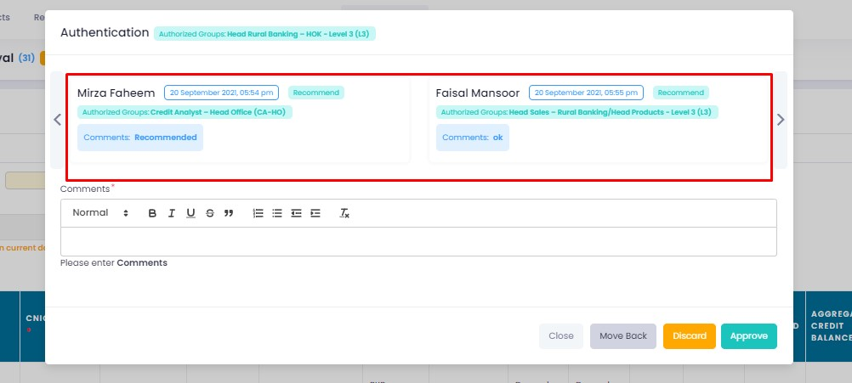

7. After all the ‘recommendations’, the application will require an ‘approval’ from an account with appropriate rights. Fill in the comments then click on ‘approve’.

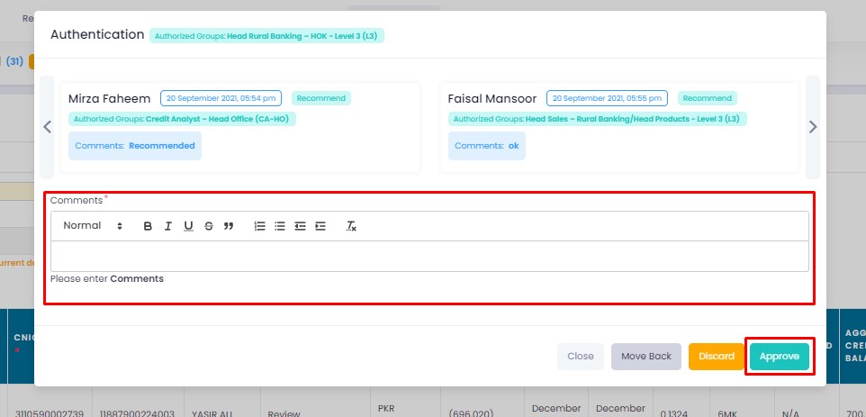

8. You will now see the workflow as completed.

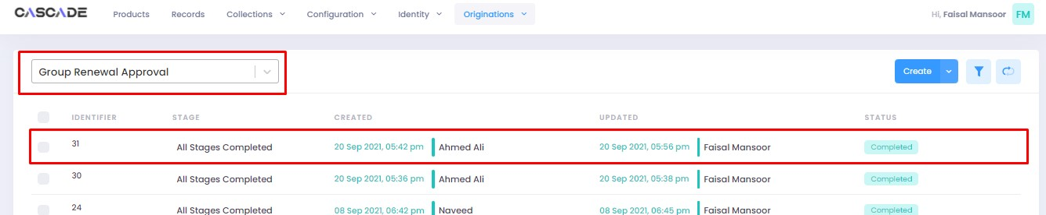

9. Now under workflows, select ‘group renewal’ as the product, then go to filters and select ‘unassigned’.

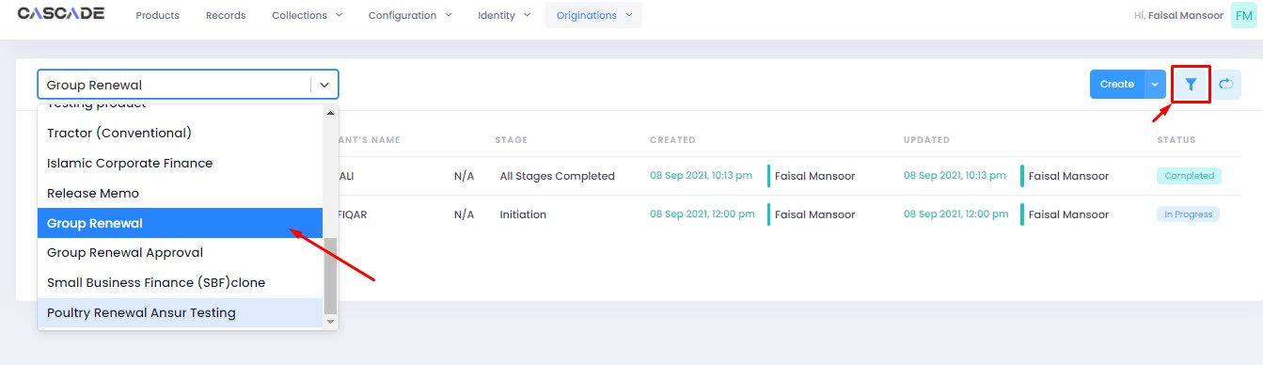

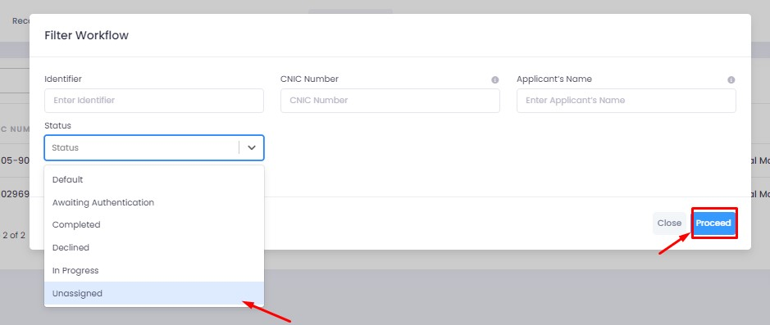

10. You will now see all the applications entered with the excel file.

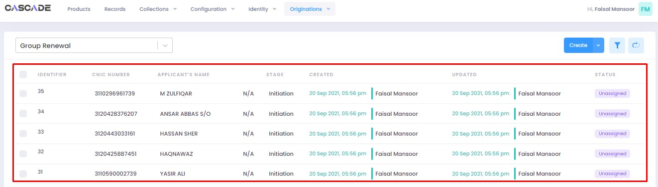

11. Select and click on ‘edit’ on the workflow you would like to proceed with.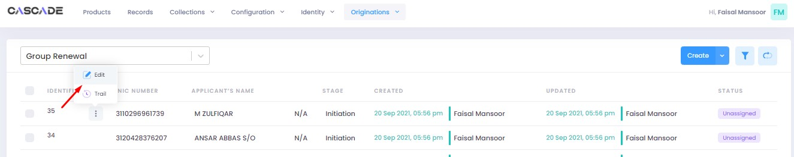

12. Click on ‘start initiation’.

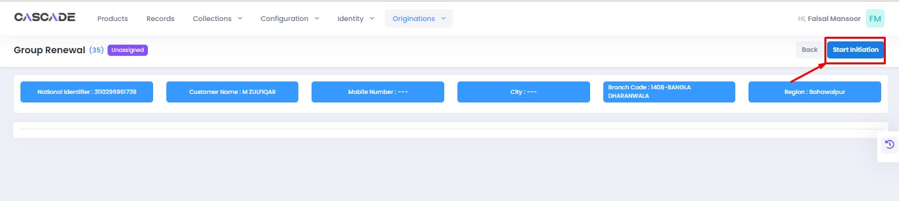

13. Now proceed with the workflow as per any product.

